SOFTWARE ARCHITECTURE AND DESIGN SPECIFICATION
Task Manager Application
Practical Mini-Project Version — v1.0
Project | Task Manager Application
Version | 1.0
Author | Akula Sai Nandan Royal (Dev Lead — PES1UG24CS553)
Date | 02-10-2026

Revision History
Version | Date | Author | Change Summary
1.0 | 02-10-2026 | Akula Sai Nandan Royal | Initial version mapping SRS functional requirements to system architecture.

Approvals
Role | Name | Signature / Date
Dev Lead | Akula Sai Nandan Royal | Akula Sai Nandan Royal
Project Manager | Anirudh Dharane | Anirudh Dharane
QA Lead | Chiranthan HG | Chiranthan HG
SRS Lead | Mohith N | Mohith N

1. Introduction

1.1 Purpose
This document specifies the architecture and design of the Task Manager Application.

1.2 Scope
This architecture covers the application’s user services: user authentication (registration, login, logout) and task management workflows (CRUD operations, status updates, priority filtering).

1.3 Audience
Developers, QA engineers, security auditors, instructors, and project managers.

1.4 Definitions
API, JWT, CRUD, SPA, Bcrypt, Middleware. See the Glossary in Section 5.1.

2. Document Overview

2.1 How to Use This Document
This document provides architectural deliverables including UML diagrams, architecture pattern justifications, threat models, and API design for the development phase.

2.2 Related Documents
- Software Requirements Specification (SRS) v1.0
- Software Test Plan (STP) v1.0
- Requirement Traceability Matrix (RTM)

3. Architecture

3.1 Goals & Constraints
- Goals: Secure authentication, reliable data persistence, and high availability.
- Constraints: Single-language stack (JavaScript) for rapid development, and strict data isolation constraints.

3.2 Stakeholders & Concerns
Stakeholder | Concerns
Customers | Security of personal tasks, intuitive UI, availability.
Developers | Modularity, clean API contracts, maintainability.
QA Engineers | Clear testability of core APIs.

3.3 Component (UML) Diagram
Figure 1 shows the three layers of the system and the main components within them.
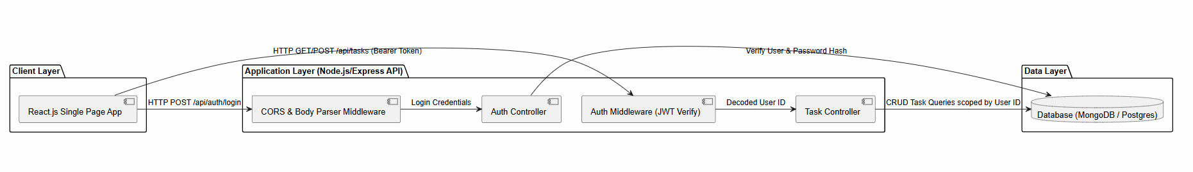
Figure 1: UML Component Diagram

3.4 Component Descriptions
Component | Description
React.js UI | Handles customer input/output, rendering the task dashboard and forms.
Auth Service / Controller | Validates user credentials, hashes passwords, and issues JWTs.
Task Processor / Controller | Processes all task creations, updates, reads, and deletions.
Express API / Middleware | Handles routing, CORS, and request body parsing.
Database | Persistent storage for User accounts and Task records.

3.5 Chosen Architecture Pattern and Rationale
A Layered (Three-Tier Client-Server) architecture was chosen for clear separation of concerns between the presentation logic, business rules, and data access. Microservices were rejected as overly complex for a standard task management scale.

3.6 Technology Stack & Data Stores
Layer | Technology
Frontend | React.js
Backend APIs | Node.js + Express.js
Database | MongoDB or PostgreSQL
Transport security | TLS/HTTPS encryption
Authentication | JWT and Bcrypt

3.7 Risks & Mitigations
Risk | Mitigation
Unauthorized access to tasks via API endpoint exploitation. | Implementation of an Auth Middleware that rejects any request lacking a valid JWT signature.

3.8 Traceability to Requirements
SRS Requirement | Architecture Component
FR-01, FR-02, SEC-01 (Registration/Login) | Auth Service / Controller
FR-04, FR-05, FR-06, FR-07 (Task CRUD) | Task Processor / Controller

3.9 Security Architecture
Threat modeling (STRIDE):
Threat | Mitigation
Spoofing | Mitigated by JWT expiry claims.
Tampering | Mitigated by JWT cryptographic signatures.
Information disclosure | Mitigated by TLS and Bcrypt password hashing.
Denial of Service (DoS) | Mitigated by Express rate limiting.
Elevation of Privilege | Mitigated by strict database query isolation requiring req.user.id matches.

4. Design

4.1 Design Overview
The system is designed with layered modules (UI, Routing, Controllers, Data Access) to ensure separation of concerns and easier maintenance.

4.2 UML Sequence Diagrams
Sequence Diagram 1: Login Flow
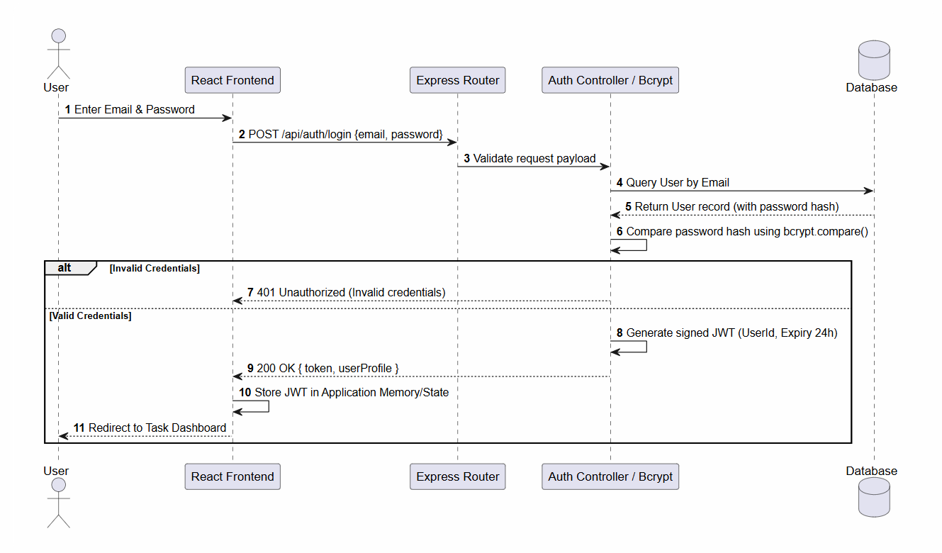
Figure 2: Sequence Diagram 1 — Login Flow
Sequence Diagram 2: Task Creation Flow
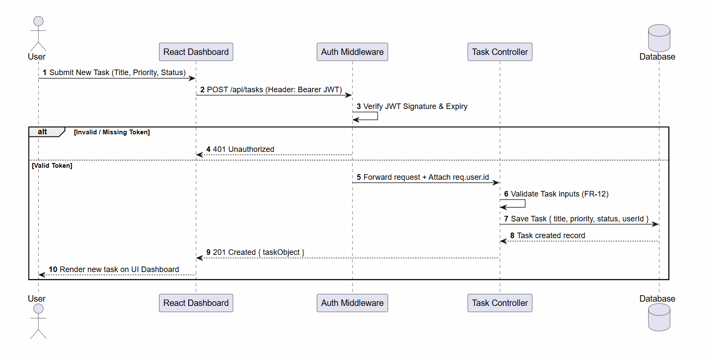
Figure 3: Sequence Diagram 2 — Task Creation Flow

4.3 API Design
Component 1: Auth Service
Endpoint | /api/auth/login
Method | POST
Request | {email, password}
Response | {token, userId}
Errors | 400 Bad Request, 401 Unauthorized (Invalid credentials).
Component 2: Task Service
Endpoint | /api/tasks
Method | POST
Request | {title, priority, status}
Response | {taskObject}
Errors | 401 Unauthorized (Missing JWT), 400 Bad Request (Missing Title).

4.4 Error Handling, Logging & Monitoring
Standardized HTTP error messages (e.g., 400, 401, 403, 404, 500) will be used across the API. No sensitive user information or internal stack traces will be exposed in system logs or client responses.

4.5 UX Design
The React dashboard UI will feature clear visual hierarchies, accessible input forms, and distinct color-coding for High, Medium, and Low task priorities.

4.6 Open Issues & Next Steps
Future enhancements out of scope for v1.0 include: real-time collaboration, external calendar integrations, and automated email notifications.

5. Appendices

5.1 Glossary
Term | Definition
API | Application Programming Interface.
JWT | JSON Web Token.
Bcrypt | Cryptographic hash function used for passwords.
CRUD | Create, Read, Update, Delete.
SPA | Single Page Application.
Middleware | Request-processing layer in the Express API that runs before route handlers (for example, CORS, body parsing, JWT verification).

5.2 References
- IEEE Std 830-1998 (SRS Standards).
- OWASP Top 10 Application Security Risks.

5.3 Tools
PlantUML, draw.io, Node.js, Express.js, React.js, Postman.

