Student name: ĐẶNG HOÀNG VŨ | HE161687
Student name: LÊ ĐỨC SƠN THÀNH | HE182597
STUDENT NAME: TRẦN ĐỨC MẠNH | HE176535
Student name: CAO HỒNG ĐỨC | HE176581
Student name: NGUYỄN TRUNG KIÊN | he176725
Student name: NGUYỄN ĐỨC LƯƠNG | he180059
Student name: NGUYỄN QUANG DŨNG | he180481
Student name: VŨ ĐỨC TRUNG | he161769
Teacher: Mai Ngọc Lương

DBI202 – DATABASE OF library MANAGEMENT SYSTEM

April 2024, 4, 24
ASSIGNMENT

TABLE OF CONTENTS

INTRODUCE THE PROBLEM

Describe the problem…………………………………………………………………………………………………....

OBJECT TO BE STORED………………………………………………………………………………………………………..

SCOPE OF THE PROBLEM……………………………………………………………………………............................

User……………………………………………………………………………............................................................

Description of the system's operations

ER model of the system

SET-UP ENTITY – RELATIONSHIP …………………………………………………………………………………………...

Difinitition entity – attributE ……………………………………………………………………………………….

Database and ENTITY RELATIONSHIP DIAGRAM (ERD)

DIAGRAM overview……..……………………………………………………………………………………………………........

Data requirements specification (data dictionary)
- COLUMN.................................................................................................................................
- DATA TYPE..............................................................................................................................
- SIZE..........................................................................................................................................
- DESCRIPTION...........................................................................................................................

List of data constraints
- UNIQUE KEY CONSTRAINTS.....................................................................................................
- CHECK CONSTRAINTS..............................................................................................................
- FOREIGN KEY CONSTRAINTS...................................................................................................
- Not Null...................................................................................................................................

Physical installation

PUBLISHER……………………………………………………………………………………………………………………………....

KINDOFBOOK……………………………………………………………………………………………………………………….....

BOOKS….……………………………………………………………………………………………………………………………….....

STAFFS………………………………………………………………………………………………………………………………….....

READERS……………………………………………………………………………………………………………………………….....

BORROW……..……………………………………………………………………………………………………………………….....

BORROWBOOKS_DETAILS……..………………………………………………………………………………………………....

BOOKS_RETURN……..…………………………………………………………………………………………………………….....

COMPENSATION……..……………………………………………………………………………………………………………......

Practice SQL

QUERY USING ORDER BY……………………………………………………………………………………………………….......

QUERY USING INNER JOIN……………………………………………………………………………………………………........

QUERY USING AGGREGATE FUNCTIONS………………………………………………………………………………........

QUERY USING THE GROUP BY AND HAVING CLAUSES……………………………………………………………......

QUERY THAT USES A SUB-QUERY AS A RELATION…………………………………………………………………........

QUERY THAT USES PARTIAL MATCHING IN THE WHERE CLAUSE………………………………………............

STORE PROCEDURE………………………………………………………………………………………………………………........

View……………………………………………………………….……………………………………………………………….............

Function…………………………………………………………………………………………………………………………………….

TRIGGER……………………………………………………………………………………………………………………………….........

IMPLEMENTATION

INTRODUCE THE PROBLEM

Describe the problem
Nowadays, in a highly technological society, human productivity is made more efficient through the development of electronic gadgets. Technologies are important and helpful in everyone's life. With when systematically arranged in a room of private home for such collection the advance of such modernization in education, one way to globalize the process of research is to realize that technology is advancing at an incredibly fast pace. A library is a place in which literary and artistic material such as books, periodicals, newspapers, pamphlets, prints, records, and tapes, are kept for reading, for reference, or for lending.
It is a collection of such materials, esperally. A library management system is made to have fast process transaction for searching book titles, borrowing books, returning books, computing penalties and generating an accurate report. Library is an important part of the academic sector as well as some professional sectors too like, the efficiency of a library lies on how the books are arranged and how easily one can get the books of their choice. Generally, what we see today is the manual library management system where process of operation is very much hectic. Library is a place in which we get information in any format and from many sources. This involves the utilization for processing, accessing and retrieving the information that can effectively support the process of student's learning. decision-making and scholastic approaches. Because of the organized approach and systematic management of the information, the accessibility and retrieval in the library can be easy.

Object to be stored
- Each person who borrows books needs to have a separate account to manage information instead of checking the physical library account, that information includes necessary personal information such as phone number, address, gender, etc. count, date of birth...
- Each employee of the library also has a separate account to manage the borrowing of books from the library, and has more information of the same staff as the person who borrows the book.
- Books are categorized by publisher and book genre, one producer can produce many books and one genre can have many books.
- The book loan voucher will have a link between an employee and a borrower to represent each time a book is borrowed containing information about the date of borrowing.
- The details of the loan slip will store information about the loan slip, borrowed books, number of books borrowed and return date.
- SCOPE OF THE PROBLEM
This study was created to better manage the library around FPT University.
- USER
- General Readers.
- Students.
- Teachers.
- Visitors and Tourists.
- Librarians.
- Library staff.

Description of the system's operations
Keyword:
PDT:Trainning department
CBGV:Teacher staff
HSSV: Student,
CBTV: Library monitor
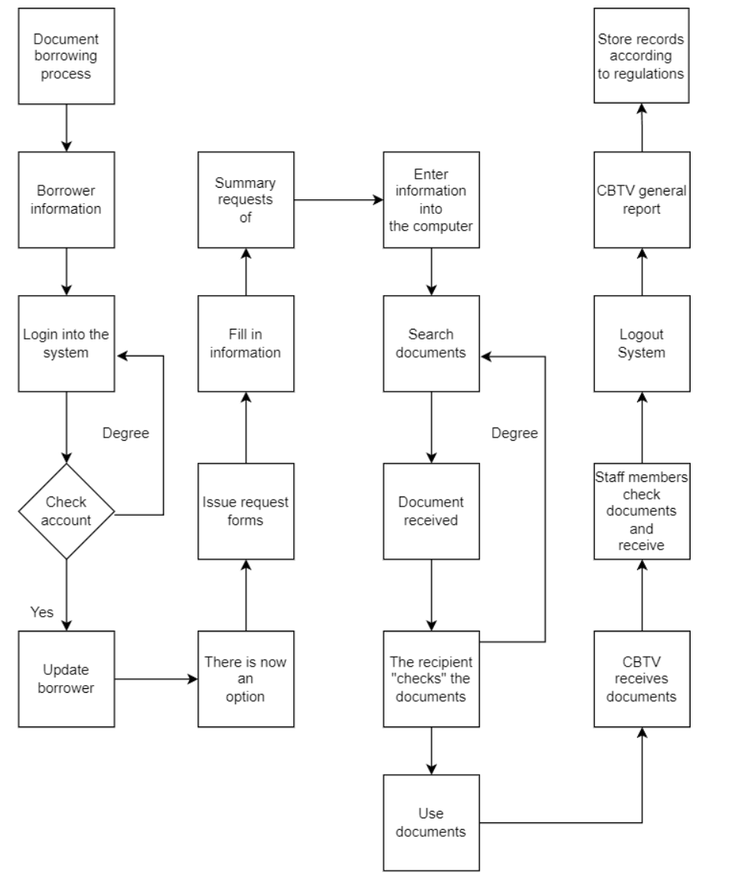

STT | Step | Specific description | Implementing department/unit | Coordinating department/unit | Result | Completion deadline
1 | Login into the system | Students provide password accounts to staff | CBGV, HSSV | CBTV | Login into the system
2 | The system records account and password | Staff members receive library account bs | CBTV |  | Logged in successfully
3 | Check account password | Staff checks the information and authenticity of the reader's account and password. If it is wrong, please read again. | CBTV | CBTV,HSSV | Complete inspection
4 | There is now an option to read books online and return books | After the staff member has checked the library accounts, the reader will be notified to look up the code of the document to borrow | CBGV, HSSV | CBTV | Look up the document code
5 | Issue request forms | CBTV issues request forms to readers | CBTV | CBGV, HSSV | Request form is issued
6 | Fill in the information in the request form | Readers fill out all information in the request form | CBGV, HSSV | CBTV | The request form is filled in with the necessary information
7 | Summary of requests | Staff compiles request forms to proceed with document retrieval | CBTV |  | Summary of requests
8 | Enter information into the computer | Staff members enter information into the computer (readers, documents, etc.) | CBTV | CBGV, HSSV | Borrowed document data is updated to the computer
9 | Search documents | CBTV searches and retrieves documents in the warehouse | CBTV | CBGV, HSSV | Document found
10 | Document received | Readers receive documents from CBTV | CBTV | CBGV, HSSV | Documents are delivered to readers
11 | The recipient checks the documents | Readers check the documents (information in the request form, document status, etc.), if not correct, please ask the staff to check and send the correct documents. | CBGV, HSSV | CBTV | Documents are checked
12 | Use documents | Readers can use it online on the website or can borrow it at home. In case of borrowing to take home, you must register and follow the instructions of the staff (commitment, time, deposit equivalent to the value of documents - if any). to the value of documents - if any). | CBGV, HSSV | CBTV | Use documents
13 | The library has received documents | Readers return materials after use; CBTV receives documents | CBTV | CBGV, HSSV | Readers complete procedures to return documents
14 | Check library | Staff members check documents, receive documents and update them on the computer. If the documents are damaged or do not match the borrowed documents, readers are requested to check and return the correct documents as received. In case of extensive damage or tearing, the compensation level will depend on reality. | CBTV | CBGV, HSSV | Documents are checked and returned
15 | Logout app | Readers leave the website | CBGV, HSSV | CBTV | Library accounts are paid
16 | Synthetic | CBTV reports summarizing the number of readers who come to borrow and return documents at the library | CBTV |  | Report summarizing the number of readers borrowing and returning documents at the library
17 | Storage | Store records according to regulations | CBTV |  | Records are archived

ER model of the system

Set-up entity – relationship
* Some symbols used in the model

- Key / identifier attribute | MaNV  Attibute
- Attribute description / description | Attribute
- Entity | ENTITY
- Weak entity | WEAK ENTIRY
- Relationship | Relationship
- Connectivity (force) = 1

- Connectivity = N

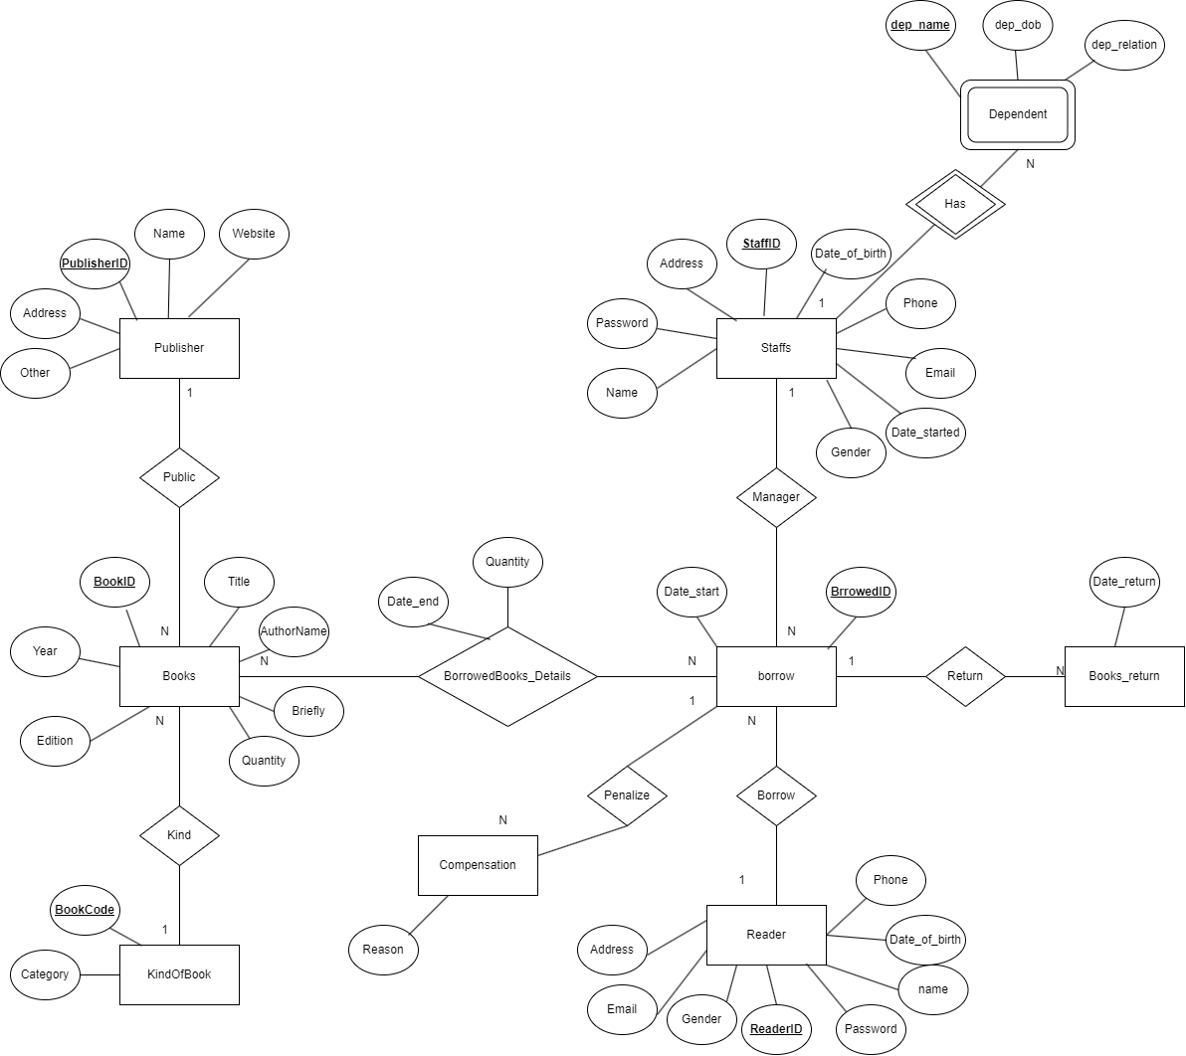

Difinitition entity – attributE
Base on the problem description and management objectives, we can present several entities and attributes of the entity as follow:
- Publisher: PublisherID, Name, Address, Website, Other.
- KindOfBook: BookCode, Category.
- Books: BookID, BookCode, PublisherID, Title, AuthorName, Year, Edition, Quantity, Brief.
- Staffs: StaffID, Password, Name, Date_of_birth, Address, Gender, Phone, Email, Date-started.
- Dependent: StaffID, dep_name, dep_dob, dep_relation
- Readers: ReaderID, Password, Name, Date_of_birth, Address, Gender, Email.
- Borrow: BorrowedID, StaffID, ReaderID, Date_start.
- BorrowBooks_details: BorrowID, BookID, Quantity, Date_end.
- Books_return: BorrowID,Date_return.
- Compensation: BorrowedID, Reason.

Database and ENTITY RELATIONSHIP DIAGRAM
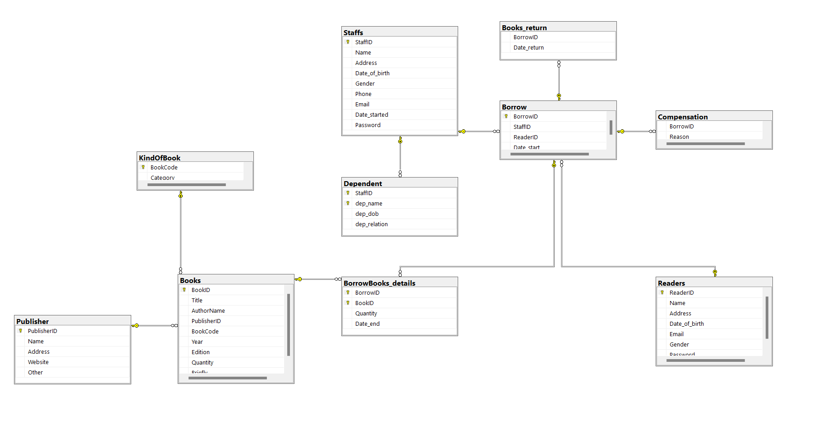

Data requirements specification (data dictionary)
Publisher
 | Data Type | Size | Description
PublisherID | Char | 50 | This is the ID of the publisher.
Name | nvarchar | 200 | This is the name of the publisher.
Address | nvarchar | 200 | This is the address of the publisher.
Website | char | 100 | This is the website of the publisher.
Other | nvarchar | 200 | This contains other information about the publisher.

KindOfBook
 | Data Type | Size | Description
BookCode | Char | 50 | This is the code of the book.
Category | nvarchar | 200 | This is the category of the book.

Books

 | Data Type | Size | Description
BookID | Char | 50 | This is the ID primar key of table book
BookCode | Char | 50 | This is the code of the book.
PublisherID | nvarchar | 200 | This is the ID of the publisher of the book.
Title | nvarchar | 100 | This is the title of the book.
AuthorName | nvarchar | 100 | This is the name of the author of the book.
Year | int | - | This is the year of publication of the book.
Edition | int | - | This is the edition number of the book.
Quantity | int | - | This is the quantity of books available.
Brief | nvarchar | 100 | This contains a brief description about the book.

Staffs
 | Data Type | Size | Description
StaffID | nvarchar | 50 | This is an auto-generated unique identifier for each staff member.
Password | Char | 50 | This is a password for staff login.
Name | nvarchar | 100 | This is a name of a staff member.
Date_of_birth | Date | 200 | This is a date of birth of a staff member.
Address | nvarchar | 200 | This is an address of a staff member.
Gender | bit |  | Gender of staff member 0 is women and 1 is men.
Phone | char | 50 | This is a phone number of staff member.

Dependent:
 | Datatype | Size | Description
StaffID | Char | 50 | This is id of staff work on library
Dep_name | Nvarchar | 50 | Thís is name of dependent person of staff
Dep_dob | Date |  | This is date of birth of person who have relation with staffs
Dep_relation | Nvarchar | 10 | This is kind of relation of dependent with staff

Readers
 | Data Type | Size | Description
ReaderID | Char | 50 | This is an auto-generated unique identifier for each reader.
Password | Char | 50 | This is a password for reader login.
Name | nvarchar | 100 | This is a name of a reader.
Date_of_birth | Date | - | This is a date of birth of a reader.
Address | nvarchar | 200 | This is an address of a reader.
Gender | bit | - | Gender of reader 0 is women and 1 is men.
Email | char | 100 | This is an email of a reader.

Borrow
 | Data Type | Size | Description
BorrowedID | Auto-generated Unique Identifier | - | This is an auto-generated unique identifier for each borrow transaction.
StaffID | Char | 50 | This is used to identify specific employees during book loan transactions.-
ReaderID | Char | 50 | This is used to identify specific readers in book borrowing transactions.-
Date_start | Date | - | This is the start date of the borrow transaction.

BorrowBooks_details
 | Data Type | Size | Description
BorrowID | Char | 50 | This is an auto-generated unique identifier for each borrow transaction.
BookID | Char | 50 | This is an auto-generated unique identifier for each book.
Quantity | int | - | This is the quantity of books borrowed in a transaction.
Date_end | Date | - | This is the end date of the borrow transaction.
Books_return
 | Data Type | Size | Description
BorrowID | Char | 50 | This is an auto-generated unique identifier for each borrow transaction.
Date_return | Date | - | This is the return date of the borrowed books.
Compensation
 | Data Type | Size | Description
BorrowedID | Char | 50 | This is an auto-generated unique identifier for each borrow transaction.
Reason | Text | - | This is the reason return book to library.

VI. List of data constraints

1) Unique Key Constraints:
PublisherID in the Publisher table must be unique.
BookCode in the KindOfBook table must be unique.
BookID in the Books table must be unique.
StaffID in the Staffs table must be unique.
ReaderID in the Readers table must be unique.
BorrowedID in the Borrow table must be unique.
BorrowedID and BookID in the BorrowBooks_details tables must be unique.

2) Check Constraints:
Year in the Books table must check that it is not greater than the current year .
Date_of_birth in the Staffs and Readers tables must check that it is not greater than the current date.
Gender in the Staffs and Readers tables must check that it is only accepted as 0 or 1.
Phone in the Staffs table must check for a valid phone number format and must be 10 digits.
Email in the Readers table must check the format xxxxxxx@fpt.edu.vn
ReaderID in the Readers table must follow a specific format [A-Z][A-Z]xxxxx.
StaffID in the Staffs table must follow a specific format FUxxxxxx.

3) Foreign Key Constraints:
BookCode in the Books table must be a foreign key referencing BookCode in the KindOfBook table.
PublisherID in the Books table must be a foreign key referencing PublisherID in the Publisher table.
ReaderID in the Borrow table must be a foreign key referencing ReaderID in the Readers table.
StaffID in the Borrow table must be a foreign key referencing StaffID in the Staffs table.
BorrowID in the BorrowBooks_details table must be a foreign key referencing BorrowID in the Borrow table.
BookID in the BorrowBooks_details table must be a foreign key referencing BookID in the Books table.
BorrowID in the Books_return table must be a foreign key referencing BorrowID in the Borrow table.
BorrowID in the Compensation table must be a foreign key referencing BorrowID in the Borrow table.

Not Null
PublisherID, Name, Address, BookCode, Category in the Publisher table is Not Null
BookCode, Category in the KindOfBook table is Not Null
BookID, Title, PublisherID, BookCode, Quantity in the Books table is Not Null
StaffID, Name, Date_of_birth, Gender, Date_started, Password in the Staffs table is Not Null
ReaderID, Name, Date_of_birth, Gender, Password in the Readers table is Not Null
BorrowID, StaffID, ReaderID, Date_start in the Borrow table is Not Null
BorrowID, BookID, Quantity, Date_end in the BorrowBooks_details table is Not Null
BorrowID, Date_return, in the Books_return table is Not Null
BorrowID, Reason in the Compensation table is Not Null

VII) Physical installation

I using Microsoft SQL Server 2019, this server build intelligent, mission-critical applications using a scalable, hybrid database platform that has everything built from in memory performance and advanced security to in-database analytics.

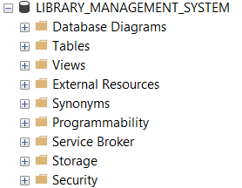

Create table publisher
Entity - Attribute:
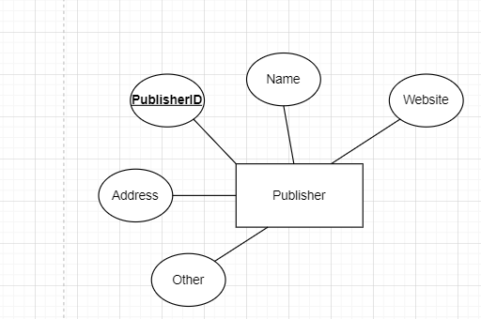

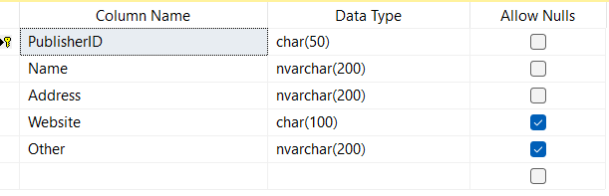
Code:
--create table Pulisher
CREATE TABLE Publisher(
PublisherID char(50) NOT NULL PRIMARY KEY,
Name nvarchar(200) NOT NULL,
Address nvarchar(200) NOT NULL,
Website char(100),
Other nvarchar(200))

Ouput:
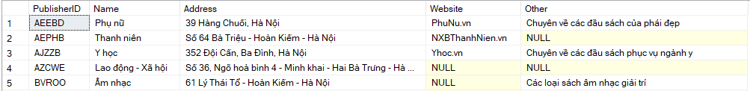

Create table kindofbook
Entity - Attribute:
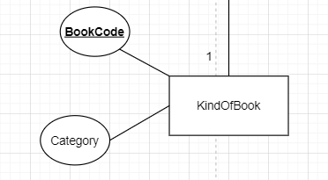

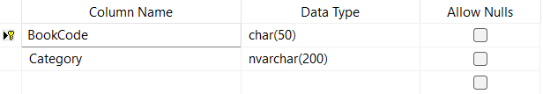
Code:
--create table KindOfBook
CREATE TABLE KindOfBook(
BookCode char(50) NOT NULL PRIMARY KEY,
Category nvarchar(200) NOT NULL)
Ouput:
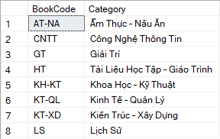

Create table Books
Entity - Attribute:
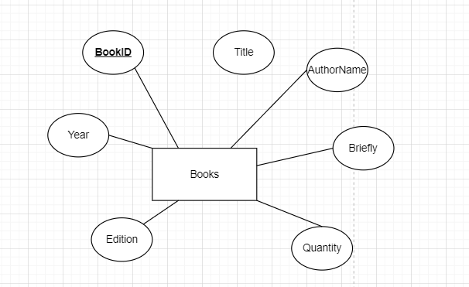
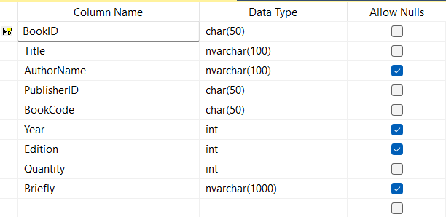
Code:
--create table Books
create table Books(
BookID char(50) NOT NULL PRIMARY KEY,
Title nvarchar(100) NOT NULL,
AuthorName nvarchar(100),
PublisherID char(50) NOT NULL,
BookCode char(50) NOT NULL,
Year int check (Year <= YEAR(getDate())),
Edition int,
Quantity int NOT NULL,
Briefly nvarchar(1000)
constraint fk_Books_KindOfBook FOREIGN KEY(BookCode) references KindOfBook(BookCode),
constraint fk_Books_Publisher FOREIGN KEY(PublisherID) references Publisher(PublisherID)
)
Ouput:
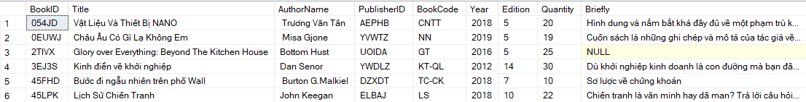

Create table Staffs
Entity - Attribute:
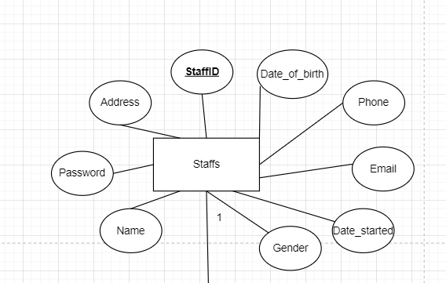

Code:
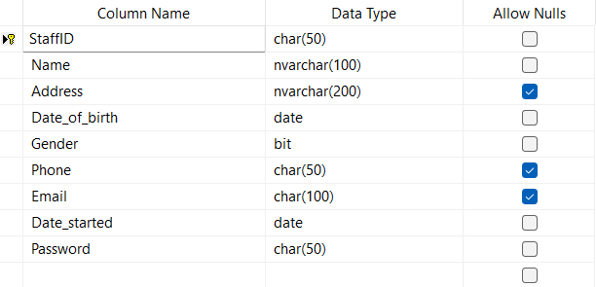
--create table Staffs
CREATE TABLE Staffs(
StaffID char(50) NOT NULL PRIMARY KEY CHECK (StaffID like 'FU[0-9][0-9][0-9][0-9][0-9][0-9]'),
Name nvarchar(100) NOT NULL,
Address nvarchar(200),
Date_of_birth date NOT NULL check (Date_of_birth < getDate()),
Gender bit NOT NULL check (Gender like 0 or Gender like 1),
Phone char(50) UNIQUE CHECK (Phone like '[0-9][0-9][0-9][0-9][0-9][0-9][0-9][0-9][0-9][0-9]'),
Email char(100),
Date_started date NOT NULL,
Password char(50) NOT NULL
)
Ouput:
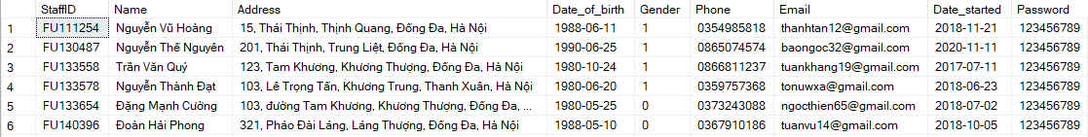
- CREATE TABLE DEPENDENT
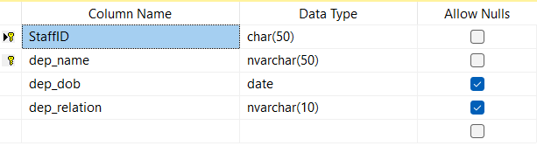
create table Dependent(
StaffID char(50),
dep_name nvarchar(50),
dep_dob date,
dep_relation nvarchar(10),

primary key(StaffID, dep_name),
foreign key(StaffID) references Staffs(StaffID)
)
Ouput:
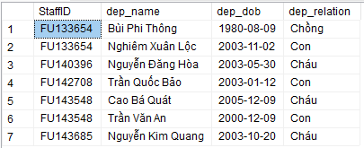

Create table Readers
Entity - Attribute:
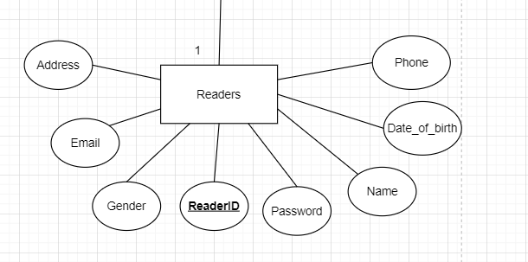

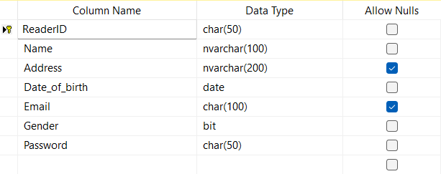
Code:
--create table Readers
create table Readers(
ReaderID char(50) NOT NULL PRIMARY KEY CHECK (ReaderID like '[A-Z][A-Z][0-9][0-9][0-9][0-9][0-9][0-9]'),
Name nvarchar(100) NOT NULL,
Address nvarchar(200),
Date_of_birth date NOT NULL check (Date_of_birth < getDate()),
Email char(100) CHECK(Email like '%@fpt.edu.vn'),
Gender bit NOT NULL check (Gender like 0 or Gender like 1),
Password char(50) NOT NULL
)
Ouput:
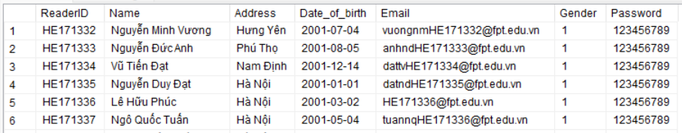

Create table Borrow
Entity - Attribute:
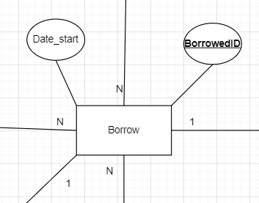
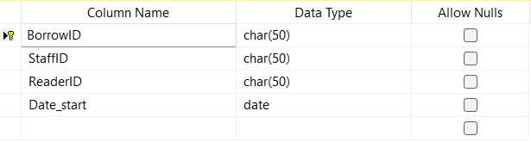
Code:
--create table Borrow
create table Borrow(
BorrowID char(50) NOT NULL PRIMARY KEY,
StaffID char(50) NOT NULL,
ReaderID char(50) NOT NULL,
Date_start date NOT NULL,
constraint fk_Borrow_Readers FOREIGN KEY(ReaderID) references Readers(ReaderID),
constraint fk_Borrow_Staffs FOREIGN KEY(StaffID) references Staffs(StaffID))
Ouput:
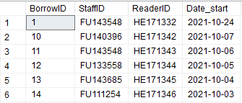

Create table Borrowbooks_details
Entity - Attribute:
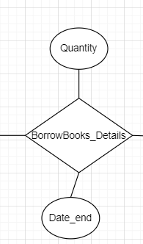
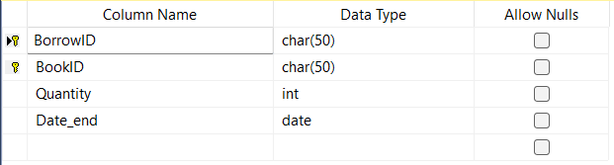
Code:
--create table BorrowBooks_details
CREATE TABLE BorrowBooks_details(
BorrowID char(50) NOT NULL,
BookID char(50) NOT NULL,
Quantity int NOT NULL,
Date_end date NOT NULL,
constraint fk_BorrowBooks_details_Borrow FOREIGN KEY(BorrowID) references Borrow(BorrowID),
constraint fk_BorrowBooks_details_Books FOREIGN KEY(BookID) references Books(BookID)
primary key(BorrowID,BookID))
Ouput:
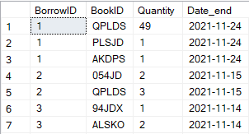

Create table BOOKs_return
Entity - Attribute:
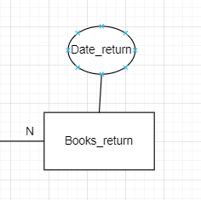
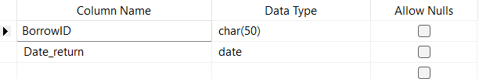
Code:
--create table Books_return
CREATE TABLE Books_return(
BorrowID char(50) NOT NULL,
Date_return date NOT NULL,
constraint fk_Books_return_Borrow FOREIGN KEY(BorrowID) references Borrow(BorrowID))
Ouput:
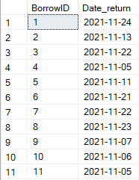

Create table Compensation
Entity - Attribute:
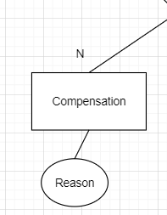
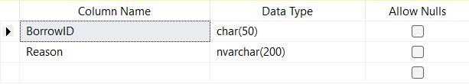
Code:
--create table Compensation
create table Compensation(
BorrowID char(50) NOT NULL,
Reason nvarchar(200) NOT NULL,
constraint fk_PHAT_MUONSACH FOREIGN KEY(BorrowID) references Borrow(BorrowID))
Ouput:
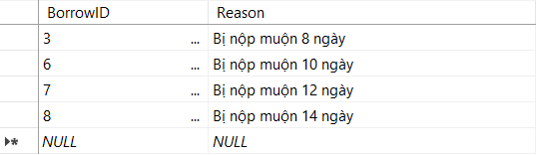

PRACTICE SQL

Query using order by
Code:
SELECT * FROM Staffs s
ORDER BY s.Name
Result:
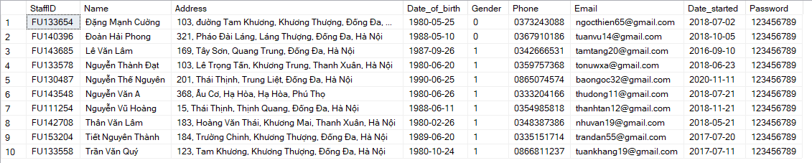
We use query containing ORDER BY to sort the list ascending or descending by the values of a domain. SELECT * FROM Staffs command give us all record in Staffs table and then sort the records ascending by name

Query using inner join
Code1:
SELECT b.BookID, b.Title, b.Year, p.Website FROM Books b
inner join Publisher p
ON b.PublisherID = p.PublisherID
WHERE b.Year = 2018
Result1:
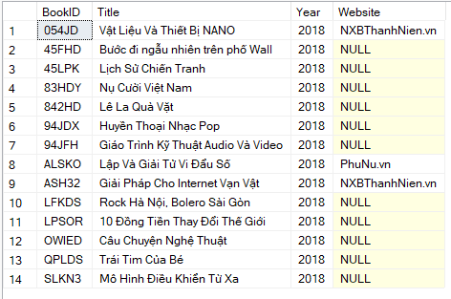
We use INNER JOIN to select book publish in 2018 and its website
Code2:
select s.StaffID, s.Name, COUNT(b.BorrowID) as [NumberOfBrrow] from Staffs as s
inner join Borrow as b on s.StaffID = b.StaffID
group by s.StaffID, s.Name
Result2:
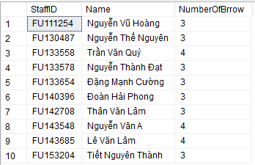
Count the number of book borrowing tickets each employee has created

Query using aggregate functions
Code:
SELECT COUNT(B.BookID) FROM Books B, Publisher P
WHERE B.PublisherID = P.PublisherID
AND P.Name = N'Kim Đồng'
Result:
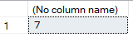
We use function COUNT() with parameter BookID to count the number of book has publisher name is Kim Đồng
Code:
SELECT TOP(5) b.BookID, b.Title, b.AuthorName, b.Quantity FROM Books as b
ORDER BY Quantity DESC

Result:
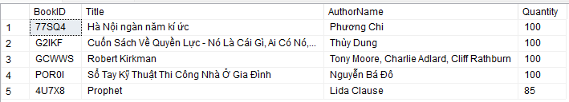
We use function TOP() to select top 5 with the most number of books

Query using the group by and having clauses
Code:
SELECT S.StaffID, S.Name, COUNT(B.BorrowID) AS TOTALMANAGE FROM Staffs S, Borrow B
WHERE S.StaffID = B.StaffID
GROUP BY S.StaffID, S.Name
HAVING COUNT(B.BorrowID) > 3
Result:
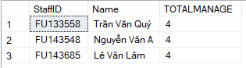
We use GROUP BY and HAVING clauses to count staffs manage more than 3 bills

Query that uses a sub-query as a relation
Code1:
declare @maxTotalBorrows int
set @maxTotalBorrows = (select top 1 COUNT(bd.BookID) as TotalBorrows from Books as b
inner join BorrowBooks_details as bd on b.BookID = bd.BookID
group by b.BookID
order by TotalBorrows desc)

select b.BookID, b.Title, COUNT(bd.BookID) as TotalBorrows from Books as b
inner join BorrowBooks_details as bd on b.BookID = bd.BookID
group by b.BookID, b.Title
having COUNT(bd.BookID) = @maxTotalBorrows
Result1:
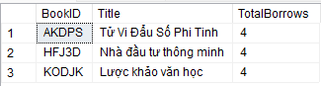
We using subquery to find the most books borrowed by reader and get in into having clause
Code2:

declare @maxNumberOfBorrowedBooks int

set @maxNumberOfBorrowedBooks = (select top 1 sum(bd.Quantity) as [NumberOfBorrowedBooks] from Readers as r
inner join Borrow as b on r.ReaderID = b.ReaderID
inner join BorrowBooks_details as bd on b.BorrowID = bd.BorrowID
group by r.ReaderID, r.Name
order by sum(bd.Quantity) desc)

select r.ReaderID, r.Name, sum(bd.Quantity) as [NumberOfBorrowedBooks] from Readers as r
inner join Borrow as b on r.ReaderID = b.ReaderID
inner join BorrowBooks_details as bd on b.BorrowID = bd.BorrowID
group by r.ReaderID, r.Name
having sum(bd.Quantity) = @maxNumberOfBorrowedBooks
Result2:
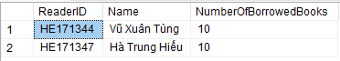
We use subquery to find the reader borrowed most book and get it into having clause

Query that uses partial matching in the where clause
Code:
SELECT *
FROM Books
WHERE Title like N'%Trí Tuệ%' and Quantity > 10
Result:
We use PARTIAL MATCHING in the WHERE clauses to combine binding conditions

Store procedure
Code:
CREATE PROC check_Quantity @Book_ID CHAR(10), @NumberofBooks INT OUTPUT
AS
BEGIN
SET @NumberofBooks = (SELECT Quantity
FROM Books WHERE BookID = @Book_ID)
END

DECLARE @t INT
EXEC check_Quantity'054JD', @t OUTPUT
SELECT @t AS Quantity
Result:
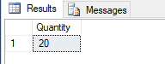
We use procedure to check the quantity of books for which the book's ID is entered by the librarian or user.

View
Code:
create view Book_have_most_edition as
select b.BookID, b.Title, b.AuthorName, b.Year, b.Edition from Books as b
where b.Edition = (select MAX(b1.Edition) from Books as b1)
select * from Book_have_most_edition
Result:
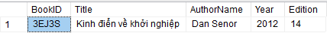
We create view to display the book have the most edition

Function
create function so_luong_sach_theo_nha_xuat_ban(@PublisherID char(50))
returns int
as
begin
return (select COUNT(b.BookID) as [so_luong_sach] from Publisher as p
inner join Books as b on p.PublisherID = b.PublisherID
group by p.PublisherID
having p.PublisherID =@PublisherID)
end
declare @count_book int
set @count_book = dbo.so_luong_sach_theo_nha_xuat_ban('UOIDA')
select @count_book as [Count Book]
Result:
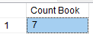
Enter of a Publisher ID and print number the books of them

Trigger
Code1:
CREATE TRIGGER checkCompensation
ON Books_return AFTER INSERT
AS
BEGIN
DECLARE @borrowID CHAR(50);
DECLARE @date_end INT
SELECT @borrowID = i.BorrowID, @date_end = DATEDIFF(day,bd.Date_end,i.Date_return) FROM inserted i,
(SELECT DISTINCT bd.BorrowID, bd.Date_end FROM BorrowBooks_details bd) AS bd
WHERE bd.BorrowID = i.BorrowID
IF(@date_end >0)
BEGIN
INSERT INTO Compensation(BorrowID,Reason) VALUES
(@borrowID, N'Bị nộp muộn ' + CONVERT(NVARCHAR(200),@date_end) + N' ngày')
END
END

insert into Books_return values (14, '2025-12-25')
Result1:
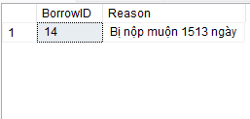
Add overdue loan slip to the table compensation
Code2:
CREATE TRIGGER checkRemainQuanity
ON BorrowBooks_details AFTER INSERT
AS
BEGIN
DECLARE @quantity INT;
SELECT @quantity = (SELECT b.Quantity - (SELECT sum(b.Quantity) FROM inserted i, BorrowBooks_details b
WHERE i.BookID = b.BookID)
FROM Books b, inserted i WHERE b.BookID = i.BookID)
IF(@quantity<0)
BEGIN
PRINT 'Not enough quantity'
DELETE FROM BorrowBooks_details
where Quantity = (SELECT i.Quantity FROM inserted i) and
BorrowID = (SELECT i.BorrowID FROM inserted i)
and BookID = (SELECT i.BookID FROM inserted i)
END
END
insert into BorrowBooks_details values (13, '0EUWJ', 1000, '2021-12-22')
Result2:
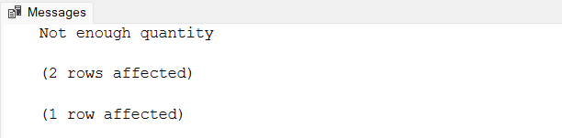
Check to see if the quantity of books is enough for the borrower

THE END

