Please add you drescription bellow:

1. Idea of game 2d/3d
2. Story of the game
3. Characters
4. Actions
5. Levels
6. Progression
7. Inventory

2d Game

WE can develop a game using a ball that crush different objects e.g angry birds.

E.g Games

Angry Birds model

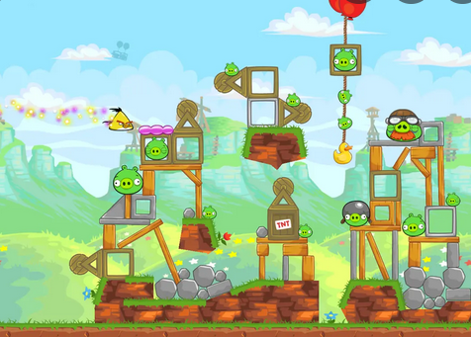

2D Platformer / Mario

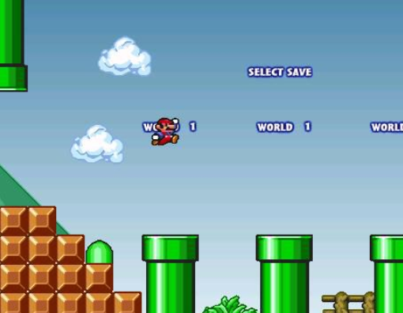

Game example

We will create a character, and this character should have a set of proprieties described bellow:

1. Basic movement left/right, jump, including [“dash”](https://www.youtube.com/watch?v=w4YV8s9Wi3w) and double jump.
2. Choose a character from Unity Asset store.
3. Describe a game theme and environment. [E.g of asset](https://assetstore.unity.com/packages/2d/environments/nature-pixel-art-base-assets-free-151370)
4. Challenges: e.g collect rewards and fight with enemies
5. Choose VFX and Sound effects
6. [Create a Game menu](https://www.youtube.com/watch?v=zc8ac_qUXQY&t=41s)