Hierarchial Clustering in Python with scikit-learn

About the algorithm:
Hierarchical clustering starts by treating each observation as a separate cluster. Then, it repeatedly executes the following two steps: (1) identify the two clusters that are closest together
(2) merge the two most similar clusters. This iterative process continues until all the clusters are merged together.

About the dataset:
The dataset has some basic data about customers like Customer ID, age, gender, annual income and spending score. Spending Score of the customer is based on parameters like customer behavior and purchasing data. Market basket analysis needs understanding the customers like who can be easily converge [Target Customers] so that the sense can be given to marketing team and plan the strategy accordingly.

Code:
# Hierarchical Clustering

# Importing the libraries
import numpy as np
import matplotlib.pyplot as plt
import pandas as pd

# Importing the dataset
dataset = pd.read_csv('Mall_Customers.csv')
X = dataset.iloc[:, [3, 4]].values

# Using the dendrogram to find the optimal number of clusters
import scipy.cluster.hierarchy as sch
dendrogram = sch.dendrogram(sch.linkage(X, method = 'ward'))
plt.title('Dendrogram')
plt.xlabel('Customers')
plt.ylabel('Euclidean distances')
plt.show()

# Training the Hierarchical Clustering model on the dataset
from sklearn.cluster import AgglomerativeClustering
hc = AgglomerativeClustering(n_clusters = 5, affinity='euclidean', linkage='ward')
y_hc = hc.fit_predict(X)

# Visualising the clusters
plt.scatter(X[y_hc == 0, 0], X[y_hc == 0, 1], s = 100, c = 'red', label = 'Cluster 1')
plt.scatter(X[y_hc == 1, 0], X[y_hc == 1, 1], s = 100, c = 'blue', label = 'Cluster 2')
plt.scatter(X[y_hc == 2, 0], X[y_hc == 2, 1], s = 100, c = 'green', label = 'Cluster 3')
plt.scatter(X[y_hc == 3, 0], X[y_hc == 3, 1], s = 100, c = 'cyan', label = 'Cluster 4')
plt.scatter(X[y_hc == 4, 0], X[y_hc == 4, 1], s = 100, c = 'magenta', label = 'Cluster 5')
plt.title('Clusters of customers')
plt.xlabel('Annual Income (k$)')
plt.ylabel('Spending Score (1-100)')
plt.legend()
plt.show()

Output:
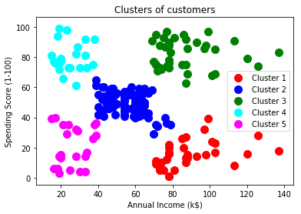

K-Means Clustering in Python with scikit-learn

About the algorithm:
This algorithm will help to tackle unlabeled datasets (i.e. the datasets that do not have any class-labels). K-Means falls under the category of centroid-based clustering. So, the algorithm works by:
1. Taking any two centroids or data points initially.
2. After choosing the centroids, (say C1 and C2) the data points are assigned to any of the Clusters (let’s take centroids = clusters for the time being) depending upon the distance between them and the centroids.
3. The algorithm will continue updating cluster centroids until they cannot be updated anymore. The updation takes place in the following manner:
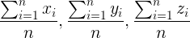
(where n = number of objects belonging to that particular cluster)

About the dataset:
The sinking of the RMS Titanic is one of the most infamous shipwrecks in history. Although there was some element of luck involved in surviving the sinking, some groups of people were more likely to survive than others, such as women, children, and the upper-class. In the dataset, the training set contains several records about the passengers of Titanic. It has 12 features capturing information about PassengerId, Survived, Passenger class, Name, Sex, Age, SibSp, Parch, Ticket, Fare, Cabin, Port of Embarkation. The dataset's label is ‘survival’ which denotes the survivial status of a particular passenger. The records can be clustered into two i.e. the ones who survived and the ones who did not. Dropping the 'survival' column from the dataset makes it unlabeled. It's the task of K-Means to cluster the records of the datasets if they survived or not.

Code:
# Dependencies
import pandas as pd
import numpy as np
from sklearn.cluster import KMeans
from sklearn.preprocessing import LabelEncoder
from sklearn.preprocessing import MinMaxScaler
import seaborn as sns
import matplotlib.pyplot as plt

# Load the train and test datasets to create two DataFrames
train = pd.read_csv('train.csv')
test = pd.read_csv('test.csv')

#checking presence of missing values
#print(train.isna().sum())
#print(test.isna().sum())

# Fill missing values with mean column values in the train set
train.fillna(train.mean(), inplace=True)
# Fill missing values with mean column values in the test set
test.fillna(test.mean(), inplace=True)

#see the survival count of passengers with respect to the features
#train[['Pclass', 'Survived']].groupby(['Pclass'], as_index=False).mean().sort_values(by='Survived', ascending=False)
#train.info()

train = train.drop(['Name','Ticket', 'Cabin','Embarked'], axis=1)
test = test.drop(['Name','Ticket', 'Cabin','Embarked'], axis=1)

labelEncoder = LabelEncoder()
labelEncoder.fit(train['Sex'])
labelEncoder.fit(test['Sex'])
train['Sex'] = labelEncoder.transform(train['Sex'])
test['Sex'] = labelEncoder.transform(test['Sex'])

# Let's investigate if you have non-numeric data left
#train.info()
#test.info()

X = np.array(train.drop(['Survived'], 1).astype(float))
y = np.array(train['Survived'])

#print(X.shape)
#print(y)

#KMeans(algorithm='auto', copy_x=True, init='k-means++', max_iter=600,n_clusters=2, n_init=10, n_jobs=1, precompute_distances='auto',random_state=None, tol=0.0001, verbose=0)
kmeans = KMeans(n_clusters=2, max_iter=600, algorithm = 'auto')
scaler = MinMaxScaler()
X_scaled = scaler.fit_transform(X)
kmeans.fit(X_scaled)

correct = 0
for i in range(len(X)):
predict_me = np.array(X[i].astype(float))
predict_me = predict_me.reshape(-1, len(predict_me))
prediction = kmeans.predict(predict_me)
# print(prediction[0],y[i])
if (prediction[0] == y[i]):
correct += 1

#print(correct)
#print(len(X))
print("Accuracy:")
print(float(correct)/float(len(X)))

Output:
K-Means clustered the records of the datasets if they survived or not (0 or 1).
Accuracy : 0.626262626263

OPTICS Clustering in Python with scikit-learn

About the algorithm:
This algorithm produces a visualization of Reachability distances and uses this visualization to cluster the data. Its basic idea is similar to DBSCAN, but it addresses one of DBSCAN's major weaknesses: the problem of detecting meaningful clusters in data of varying density. To do so, the points of the database are (linearly) ordered such that spatially closest points become neighbors in the ordering.

About the dataset:
The dataset has some basic data about customers like Customer ID, age, gender, annual income and spending score. Spending Score of the customer is based on parameters like customer behavior and purchasing data. Market basket analysis needs understanding the customers like who can be easily converge [Target Customers] so that the sense can be given to marketing team and plan the strategy accordingly.

Code:
import numpy as np
import pandas as pd
import matplotlib.pyplot as plt
from matplotlib import gridspec
from sklearn.cluster import OPTICS, cluster_optics_dbscan
from sklearn.preprocessing import normalize, StandardScaler

X = pd.read_csv('Customers.csv')

# Dropping irrelevant columns
drop_features = ['CustomerID', 'Gender']
X = X.drop(drop_features, axis = 1)

# Handling the missing values if any
X.fillna(method ='ffill', inplace = True)

# Scaling the data to bring all the attributes to a comparable level
scaler = StandardScaler()
X_scaled = scaler.fit_transform(X)

# Normalizing the data so that the data
# approximately follows a Gaussian distribution
X_normalized = normalize(X_scaled)

# Converting the numpy array into a pandas DataFrame
X_normalized = pd.DataFrame(X_normalized)

# Renaming the columns
X_normalized.columns = X.columns

# Building the OPTICS Clustering model
optics_model = OPTICS(min_samples = 10, xi = 0.05, min_cluster_size = 0.05)

# Training the model
optics_model.fit(X_normalized)

# Producing the labels according to the DBSCAN technique with eps = 0.5
labels1 = cluster_optics_dbscan(reachability = optics_model.reachability_, core_distances = optics_model.core_distances_, ordering = optics_model.ordering_, eps = 0.5)

# Producing the labels according to the DBSCAN technique with eps = 2.0
labels2 = cluster_optics_dbscan(reachability = optics_model.reachability_, core_distances = optics_model.core_distances_, ordering = optics_model.ordering_, eps = 2)

# Creating a numpy array with numbers at equal spaces till
# the specified range
space = np.arange(len(X_normalized))

# Storing the reachability distance of each point
reachability = optics_model.reachability_[optics_model.ordering_]

# Storing the cluster labels of each point
labels = optics_model.labels_[optics_model.ordering_]

# Defining the framework of the visualization
plt.figure(figsize =(10, 7))
G = gridspec.GridSpec(2, 3)
ax1 = plt.subplot(G[0, :])
ax2 = plt.subplot(G[1, 0])

# Plotting the Reachability-Distance Plot
colors = ['c.', 'b.', 'r.', 'y.', 'g.']
for Class, colour in zip(range(0, 5), colors):
Xk = space[labels == Class]
Rk = reachability[labels == Class]
ax1.plot(Xk, Rk, colour, alpha = 0.3)
ax1.plot(space[labels == -1], reachability[labels == -1], 'k.', alpha = 0.3)
ax1.plot(space, np.full_like(space, 2., dtype = float), 'k-', alpha = 0.5)
ax1.plot(space, np.full_like(space, 0.5, dtype = float), 'k-.', alpha = 0.5)
ax1.set_ylabel('Reachability Distance')
ax1.set_title('Reachability Plot')

# Plotting the OPTICS Clustering
colors = ['c.', 'b.', 'r.', 'y.', 'g.']
for Class, colour in zip(range(0, 5), colors):
Xk = X_normalized[optics_model.labels_ == Class]
ax2.plot(Xk.iloc[:, 0], Xk.iloc[:, 1], colour, alpha = 0.3)

ax2.plot(X_normalized.iloc[optics_model.labels_ == -1, 0],
X_normalized.iloc[optics_model.labels_ == -1, 1],
'k+', alpha = 0.1)
ax2.set_title('OPTICS Clustering')

Output:
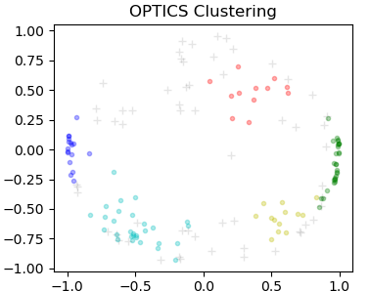

Principle Component analysis (PCA) in Python with scikit-learn

About the algorithm:
Principal component analysis (PCA) is an unsupervised technique used to preprocess and reduce the dimensionality of high-dimensional datasets while preserving the original structure and relationships inherent to the original dataset so that machine learning models can still learn from them and be used to make accurate predictions. PCA can be thought of as a clustering algorithm not unlike other clustering methods, such as k-means clustering. Once the principal components are computed, a low-dimensional view of the data can be generated by plotting the first principal component (PC1) against the second principal component (PC2).
A simple algorithm for PCA is as follows:
- Normalize the Data - This is often necessary if the features in your feature set are measured in different units. A common way of normalizing the features in your data set is to convert them to z-scores.
- Calculate the covariance matrix.
- Compute the eigen values and vectors.
- Re-orient the data.
- Plot the data (PC1 against PC2)

About the dataset:
The dataset has information related to wine like Alcohol, Malic_Acid, Ash, Ash_Alcanity, Magnesium, Total_Phenols, Flavanoids, Nonflavanoid_Phenols, Proanthocyanins, Color_Intensity, Hue, OD280, Proline, Customer_Segment. Dropping the 'Customer_Segment' column from the dataset makes it unlabeled. It's the task of PCA to cluster the records of the datasets into different segements.

Code:
# Principal Component Analysis (PCA)

# Importing the libraries
import numpy as np
import matplotlib.pyplot as plt
import pandas as pd

# Importing the dataset
dataset = pd.read_csv('Wine.csv')
X = dataset.iloc[:, :-1].values
y = dataset.iloc[:, -1].values

# Splitting the dataset into the Training set and Test set
from sklearn.model_selection import train_test_split
X_train, X_test, y_train, y_test = train_test_split(X, y, test_size = 0.2, random_state = 0)

# Feature Scaling
from sklearn.preprocessing import StandardScaler
sc = StandardScaler()
X_train = sc.fit_transform(X_train)
X_test = sc.transform(X_test)

# Applying PCA
from sklearn.decomposition import PCA
pca = PCA(n_components = 2)
X_train = pca.fit_transform(X_train)
X_test = pca.transform(X_test)

# Training the Logistic Regression model on the Training set
from sklearn.linear_model import LogisticRegression
classifier = LogisticRegression(random_state = 0)
classifier.fit(X_train, y_train)

# Making the Confusion Matrix
from sklearn.metrics import confusion_matrix, accuracy_score
y_pred = classifier.predict(X_test)
cm = confusion_matrix(y_test, y_pred)
print(cm)
accuracy_score(y_test, y_pred)

# Visualising the Training set results
from matplotlib.colors import ListedColormap
X_set, y_set = X_train, y_train
X1, X2 = np.meshgrid(np.arange(start = X_set[:, 0].min() - 1, stop = X_set[:, 0].max() + 1, step = 0.01),
np.arange(start = X_set[:, 1].min() - 1, stop = X_set[:, 1].max() + 1, step = 0.01))
plt.contourf(X1, X2, classifier.predict(np.array([X1.ravel(), X2.ravel()]).T).reshape(X1.shape),
alpha = 0.75, cmap = ListedColormap(('red', 'green', 'blue')))
plt.xlim(X1.min(), X1.max())
plt.ylim(X2.min(), X2.max())
for i, j in enumerate(np.unique(y_set)):
plt.scatter(X_set[y_set == j, 0], X_set[y_set == j, 1],
c = ListedColormap(('red', 'green', 'blue'))(i), label = j)
plt.title('Logistic Regression (Training set)')
plt.xlabel('PC1')
plt.ylabel('PC2')
plt.legend()
plt.show()

# Visualising the Test set results
from matplotlib.colors import ListedColormap
X_set, y_set = X_test, y_test
X1, X2 = np.meshgrid(np.arange(start = X_set[:, 0].min() - 1, stop = X_set[:, 0].max() + 1, step = 0.01),
np.arange(start = X_set[:, 1].min() - 1, stop = X_set[:, 1].max() + 1, step = 0.01))
plt.contourf(X1, X2, classifier.predict(np.array([X1.ravel(), X2.ravel()]).T).reshape(X1.shape),
alpha = 0.75, cmap = ListedColormap(('red', 'green', 'blue')))
plt.xlim(X1.min(), X1.max())
plt.ylim(X2.min(), X2.max())
for i, j in enumerate(np.unique(y_set)):
plt.scatter(X_set[y_set == j, 0], X_set[y_set == j, 1],
c = ListedColormap(('red', 'green', 'blue'))(i), label = j)
plt.title('Logistic Regression (Test set)')
plt.xlabel('PC1')
plt.ylabel('PC2')
plt.legend()
plt.show()

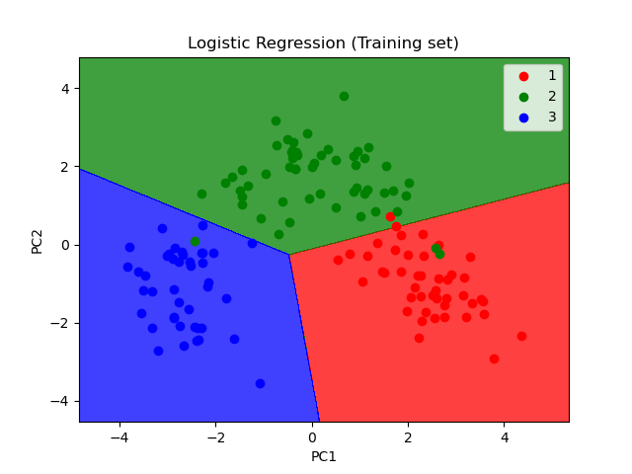
Output:

