EX 1 SMS APP WITH ENCRYPTION

AIM:
To develop an application in android that invokes the built-in SMS app to send SMS.

DESCRIPTION:
An application in android mobile that shall be used to send SMS either by using SMSManager API or Intents based on our requirements. If SMSManager API is used, it will directly send SMS from our application. In case if Intent with proper action is used(ACTION_VIEW), it will invoke a built-in SMS app to send SMS from our application. Use any available built in algorithms to encrypt and decrypt the SMS so as to ensure security.

DEVICE SPECIFICATIONS:
App API version: API 26
Screen Size: 5.5”
OS: Android OREO (4.2)

CODE:

ACTIVITY_MAIN.XML

<?xml version="1.0" encoding="utf-8"?>
<LinearLayout xmlns:android="http://schemas.android.com/apk/res/android"
xmlns:app="http://schemas.android.com/apk/res-auto"
xmlns:tools="http://schemas.android.com/tools"
android:layout_width="match_parent"
android:orientation="vertical"
android:layout_height="match_parent"
tools:context=".MainActivity">

<TextView
android:layout_width="match_parent"
android:layout_height="wrap_content"
android:gravity="center"
android:textSize="40dp"
android:text="SMS Application"
app:layout_constraintBottom_toBottomOf="parent"
app:layout_constraintLeft_toLeftOf="parent"
app:layout_constraintRight_toRightOf="parent"
app:layout_constraintTop_toTopOf="parent" />

<TextView
android:layout_width="match_parent"
android:layout_height="wrap_content"
android:id="@+id/phone_number_text"
android:text="Details"
android:gravity="center"
android:layout_marginTop="60dp"
android:textSize="25dp"
/>

<EditText
android:layout_width="wrap_content"
android:layout_height="wrap_content"
android:hint="Enter Phone Number"
android:id="@+id/phone_number"
android:layout_gravity="center"
android:layout_marginTop="20dp"
android:width="200dp"
/>

<EditText
android:layout_width="wrap_content"
android:layout_height="wrap_content"
android:hint="SMS Body"
android:id="@+id/sms_body"
android:layout_gravity="center"
android:layout_marginTop="10dp"
android:width="200dp"
/>

<Button
android:layout_width="wrap_content"
android:layout_height="wrap_content"
android:text="Send"
android:id="@+id/sms_this_app"
android:layout_gravity="center"
android:layout_marginTop="30dp"
/>

<Button
android:layout_width="wrap_content"
android:layout_height="wrap_content"
android:text="Open"
android:id="@+id/sms_different_app"
android:layout_gravity="center"
android:layout_marginTop="20dp"
/>

</LinearLayout>

ACTIVITY_RECEIVED_SMS.XML

<?xml version="1.0" encoding="utf-8"?>
<androidx.coordinatorlayout.widget.CoordinatorLayout xmlns:android="http://schemas.android.com/apk/res/android"
xmlns:app="http://schemas.android.com/apk/res-auto"
xmlns:tools="http://schemas.android.com/tools"
android:layout_width="match_parent"
android:layout_height="match_parent"
tools:context=".ReceivedSMS">

<com.google.android.material.floatingactionbutton.FloatingActionButton
android:id="@+id/fab"
android:layout_width="wrap_content"
android:layout_height="wrap_content"
android:layout_gravity="bottom|end"
android:layout_margin="@dimen/fab_margin"
app:srcCompat="@android:drawable/ic_dialog_email" />

<ListView
android:id="@+id/listView"
android:layout_width="match_parent"
android:layout_height="match_parent" />

</androidx.coordinatorlayout.widget.CoordinatorLayout>

CONTENT_RECEIVED_SMS.XML

<?xml version="1.0" encoding="utf-8"?>
<androidx.constraintlayout.widget.ConstraintLayout xmlns:android="http://schemas.android.com/apk/res/android"
xmlns:app="http://schemas.android.com/apk/res-auto"
android:layout_width="match_parent"
android:layout_height="match_parent"
app:layout_behavior="@string/appbar_scrolling_view_behavior"></androidx.constraintlayout.widget.ConstraintLayout>

FRAGMENT_FIRST.XML

<?xml version="1.0" encoding="utf-8"?>
<androidx.constraintlayout.widget.ConstraintLayout xmlns:android="http://schemas.android.com/apk/res/android"
xmlns:app="http://schemas.android.com/apk/res-auto"
xmlns:tools="http://schemas.android.com/tools"
android:layout_width="match_parent"
android:layout_height="match_parent"
tools:context=".FirstFragment">

<TextView
android:id="@+id/textview_first"
android:layout_width="wrap_content"
android:layout_height="wrap_content"
android:text="@string/hello_first_fragment"
app:layout_constraintBottom_toTopOf="@id/button_first"
app:layout_constraintEnd_toEndOf="parent"
app:layout_constraintStart_toStartOf="parent"
app:layout_constraintTop_toTopOf="parent" />

<Button
android:id="@+id/button_first"
android:layout_width="wrap_content"
android:layout_height="wrap_content"
android:text="@string/next"
app:layout_constraintBottom_toBottomOf="parent"
app:layout_constraintEnd_toEndOf="parent"
app:layout_constraintStart_toStartOf="parent"
app:layout_constraintTop_toBottomOf="@id/textview_first" />
</androidx.constraintlayout.widget.ConstraintLayout>

FRAGMENT_SECOND.XML

<?xml version="1.0" encoding="utf-8"?>
<androidx.constraintlayout.widget.ConstraintLayout xmlns:android="http://schemas.android.com/apk/res/android"
xmlns:app="http://schemas.android.com/apk/res-auto"
xmlns:tools="http://schemas.android.com/tools"
android:layout_width="match_parent"
android:layout_height="match_parent"
tools:context=".SecondFragment">

<TextView
android:id="@+id/textview_second"
android:layout_width="wrap_content"
android:layout_height="wrap_content"
app:layout_constraintBottom_toTopOf="@id/button_second"
app:layout_constraintEnd_toEndOf="parent"
app:layout_constraintStart_toStartOf="parent"
app:layout_constraintTop_toTopOf="parent" />

<Button
android:id="@+id/button_second"
android:layout_width="wrap_content"
android:layout_height="wrap_content"
android:text="@string/previous"
app:layout_constraintBottom_toBottomOf="parent"
app:layout_constraintEnd_toEndOf="parent"
app:layout_constraintStart_toStartOf="parent"
app:layout_constraintTop_toBottomOf="@id/textview_second" />
</androidx.constraintlayout.widget.ConstraintLayout>

MAINACTIVITY.JAVA
package com.example.smsmanagerapp;

import androidx.appcompat.app.AppCompatActivity;
import androidx.core.app.ActivityCompat;
import androidx.core.content.ContextCompat;

import android.Manifest;
import android.content.Intent;
import android.content.pm.PackageManager;
import android.net.Uri;
import android.os.Bundle;
import android.telephony.SmsManager;
import android.util.Log;
import android.view.Menu;
import android.view.View;
import android.widget.Button;
import android.widget.EditText;
import android.widget.Toast;

import com.example.smsmanagerapp.AESHelper;

public class MainActivity extends AppCompatActivity {

Button sendButton, openButton;
EditText phoneNumber, smsBody;
String phoneNo, message;
private static final int MY_SMS_PERMISSION_REQUEST = 0;

@Override
protected void onCreate(Bundle savedInstanceState) {
super.onCreate(savedInstanceState);
setContentView(R.layout.activity_main);

sendButton = findViewById(R.id.sms_this_app);
openButton = findViewById(R.id.sms_different_app);
phoneNumber = findViewById(R.id.phone_number);
smsBody = findViewById(R.id.sms_body);

sendButton.setOnClickListener(new View.OnClickListener() {
@Override
public void onClick(View view) {
sendMessage();
}
});

openButton.setOnClickListener(new View.OnClickListener() {
@Override
public void onClick(View view) {
openNextActivity();
}
});
}

private void openNextActivity() {
phoneNo = phoneNumber.getText().toString();
message = smsBody.getText().toString();
Intent smsIntent = new Intent(MainActivity.this, ReceivedSMS.class);
smsIntent.setData(Uri.parse("sms:" + phoneNo));
smsIntent.putExtra("sms_body", message);

try {
startActivity(smsIntent);
} catch(android.content.ActivityNotFoundException ex) {
Toast.makeText(MainActivity.this, ex.toString(), Toast.LENGTH_LONG).show();
}
}

private void sendMessage() {
phoneNo = phoneNumber.getText().toString();
message = smsBody.getText().toString();

if(ContextCompat.checkSelfPermission(this, Manifest.permission.SEND_SMS) != PackageManager.PERMISSION_GRANTED) {
if(ActivityCompat.shouldShowRequestPermissionRationale(this, Manifest.permission.SEND_SMS)){

} else {
ActivityCompat.requestPermissions(this, new String[] {Manifest.permission.SEND_SMS, Manifest.permission.READ_SMS}, MY_SMS_PERMISSION_REQUEST);
}
} else {
try {
String enc = AESHelper.encrypt(message, "testseed");
SmsManager smsManager = SmsManager.getDefault();
smsManager.sendTextMessage(phoneNo, null, enc, null, null);
Toast.makeText(getApplicationContext(), "SMS sent", Toast.LENGTH_LONG).show();
} catch(android.content.ActivityNotFoundException ex) {
Toast.makeText(getApplicationContext(), "SMS failed", Toast.LENGTH_LONG).show();
} catch (Exception e) {
e.printStackTrace();
}
}
}

@Override
public void onRequestPermissionsResult(int requestCode, String permissions[], int[] grantResults) {
if (requestCode == MY_SMS_PERMISSION_REQUEST) {
if (grantResults.length > 0 && grantResults[0] == PackageManager.PERMISSION_GRANTED) {
String enc = AESHelper.encrypt(message, "testseed");
SmsManager smsManager = SmsManager.getDefault();
smsManager.sendTextMessage(phoneNo, null, enc, null, null);
Toast.makeText(getApplicationContext(), "SMS sent", Toast.LENGTH_LONG).show();
} else {
Toast.makeText(getApplicationContext(), "SMS failed", Toast.LENGTH_LONG).show();
}
}
}
}

AESHELPER.JAVA

package com.example.smsmanagerapp;

import java.io.UnsupportedEncodingException;
import java.security.MessageDigest;
import java.security.NoSuchAlgorithmException;
import java.util.Arrays;
import java.util.Base64;

import javax.crypto.Cipher;
import javax.crypto.spec.SecretKeySpec;

public class AESHelper {

private static SecretKeySpec secretKey;
private static byte[] key;

public static void setKey(String myKey)
{
MessageDigest sha = null;
try {
key = myKey.getBytes("UTF-8");
sha = MessageDigest.getInstance("SHA-1");
key = sha.digest(key);
key = Arrays.copyOf(key, 16);
secretKey = new SecretKeySpec(key, "AES");
}
catch (NoSuchAlgorithmException e) {
e.printStackTrace();
}
catch (UnsupportedEncodingException e) {
e.printStackTrace();
}
}

public static String encrypt(String strToEncrypt, String secret)
{
try
{
setKey(secret);
Cipher cipher = Cipher.getInstance("AES/ECB/PKCS5Padding");
cipher.init(Cipher.ENCRYPT_MODE, secretKey);
return Base64.getEncoder().encodeToString(cipher.doFinal(strToEncrypt.getBytes("UTF-8")));
}
catch (Exception e)
{
System.out.println("Error while encrypting: " + e.toString());
}
return null;
}

public static String decrypt(String strToDecrypt, String secret)
{
try
{
setKey(secret);
Cipher cipher = Cipher.getInstance("AES/ECB/PKCS5PADDING");
cipher.init(Cipher.DECRYPT_MODE, secretKey);
return new String(cipher
.doFinal(Base64.getDecoder().decode(strToDecrypt)));
}
catch (Exception e)
{
System.out.println("Error while decrypting: " + e.toString());
}
return null;
}
}
package com.example.smsmanagerapp;

import java.io.UnsupportedEncodingException;
import java.security.MessageDigest;
import java.security.NoSuchAlgorithmException;
import java.util.Arrays;
import java.util.Base64;

import javax.crypto.Cipher;
import javax.crypto.spec.SecretKeySpec;

public class AESHelper {

private static SecretKeySpec secretKey;
private static byte[] key;

public static void setKey(String myKey)
{
MessageDigest sha = null;
try {
key = myKey.getBytes("UTF-8");
sha = MessageDigest.getInstance("SHA-1");
key = sha.digest(key);
key = Arrays.copyOf(key, 16);
secretKey = new SecretKeySpec(key, "AES");
}
catch (NoSuchAlgorithmException e) {
e.printStackTrace();
}
catch (UnsupportedEncodingException e) {
e.printStackTrace();
}
}

public static String encrypt(String strToEncrypt, String secret)
{
try
{
setKey(secret);
Cipher cipher = Cipher.getInstance("AES/ECB/PKCS5Padding");
cipher.init(Cipher.ENCRYPT_MODE, secretKey);
return Base64.getEncoder().encodeToString(cipher.doFinal(strToEncrypt.getBytes("UTF-8")));
}
catch (Exception e)
{
System.out.println("Error while encrypting: " + e.toString());
}
return null;
}

public static String decrypt(String strToDecrypt, String secret)
{
try
{
setKey(secret);
Cipher cipher = Cipher.getInstance("AES/ECB/PKCS5PADDING");
cipher.init(Cipher.DECRYPT_MODE, secretKey);
return new String(cipher
.doFinal(Base64.getDecoder().decode(strToDecrypt)));
}
catch (Exception e)
{
System.out.println("Error while decrypting: " + e.toString());
}
return null;
}
}

FIRSTFRAGMENT.JAVA

package com.example.smsmanagerapp;

import android.os.Bundle;
import android.view.LayoutInflater;
import android.view.View;
import android.view.ViewGroup;

import androidx.annotation.NonNull;
import androidx.fragment.app.Fragment;
import androidx.navigation.fragment.NavHostFragment;

public class FirstFragment extends Fragment {

@Override
public View onCreateView(
LayoutInflater inflater, ViewGroup container,
Bundle savedInstanceState
) {
// Inflate the layout for this fragment
return inflater.inflate(R.layout.fragment_first, container, false);
}

public void onViewCreated(@NonNull View view, Bundle savedInstanceState) {
super.onViewCreated(view, savedInstanceState);

view.findViewById(R.id.button_first).setOnClickListener(new View.OnClickListener() {
@Override
public void onClick(View view) {
NavHostFragment.findNavController(FirstFragment.this)
.navigate(R.id.action_FirstFragment_to_SecondFragment);
}
});
}
}

RECEIVEDSMS.JAVA

package com.example.smsmanagerapp;

import android.content.Intent;
import android.database.Cursor;
import android.net.Uri;
import android.os.Bundle;

import com.google.android.material.floatingactionbutton.FloatingActionButton;
import com.google.android.material.snackbar.Snackbar;

import androidx.appcompat.app.AppCompatActivity;
import androidx.appcompat.widget.Toolbar;

import android.view.View;
import android.widget.AdapterView;
import android.widget.ArrayAdapter;
import android.widget.ListView;
import android.widget.Toast;

import java.util.ArrayList;
import java.util.List;

public class ReceivedSMS extends AppCompatActivity {

public List<String> getSMS(){
List<String> sms = new ArrayList<String>();
Uri uriSMSURI = Uri.parse("content://sms/sent");
Cursor cur = getContentResolver().query(uriSMSURI, null, null, null, null);

while (cur != null && cur.moveToNext()) {
String address = cur.getString(cur.getColumnIndex("address"));
String body = cur.getString(cur.getColumnIndexOrThrow("body"));
sms.add("Number: " + address + "\nMessage: " + body);
}

if (cur != null) {
cur.close();
}
return sms;
}

@Override
protected void onCreate(Bundle savedInstanceState) {
super.onCreate(savedInstanceState);
setContentView(R.layout.activity_received_s_m_s);
Intent intent = getIntent();
String value = intent.getStringExtra("key");

final ListView list = findViewById(R.id.listView);
List<String> arrayList = getSMS();
ArrayAdapter<String> arrayAdapter = new ArrayAdapter<String>(this, android.R.layout.simple_list_item_1, arrayList);
list.setAdapter(arrayAdapter);
list.setOnItemClickListener(new AdapterView.OnItemClickListener() {
@Override
public void onItemClick(AdapterView<?> parent, View view, int position, long id) {
String clickedItem = (String) list.getItemAtPosition(position);
String separator = "Message: ";
int sepPos = clickedItem.indexOf(separator);
String mes = clickedItem.substring(sepPos + separator.length());
mes = AESHelper.decrypt(mes, "testseed");
Toast.makeText(ReceivedSMS.this, "The decrypted SMS is: " + mes, Toast.LENGTH_LONG).show();
}
});
}
}

SECONDFRAGMENT.JAVA

package com.example.smsmanagerapp;

import android.os.Bundle;
import android.view.LayoutInflater;
import android.view.View;
import android.view.ViewGroup;

import androidx.annotation.NonNull;
import androidx.fragment.app.Fragment;
import androidx.navigation.fragment.NavHostFragment;

public class SecondFragment extends Fragment {

@Override
public View onCreateView(
LayoutInflater inflater, ViewGroup container,
Bundle savedInstanceState
) {
// Inflate the layout for this fragment
return inflater.inflate(R.layout.fragment_second, container, false);
}

public void onViewCreated(@NonNull View view, Bundle savedInstanceState) {
super.onViewCreated(view, savedInstanceState);

view.findViewById(R.id.button_second).setOnClickListener(new View.OnClickListener() {
@Override
public void onClick(View view) {
NavHostFragment.findNavController(SecondFragment.this)
.navigate(R.id.action_SecondFragment_to_FirstFragment);
}
});
}
}

OUTPUT:
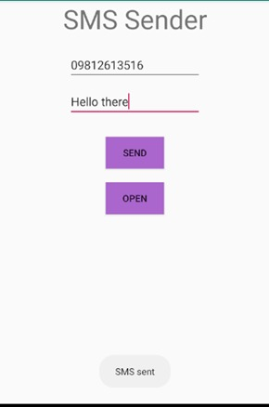
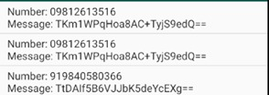

RESULT:
The created app uses the built-in SMS application to send and receive messages. The app also encrypts the sent message for extra security.

EX 2 RECORD MEDIA

AIM:
To develop an application in android that records and stores media files(audio).

DESCRIPTION:
Use MediaRecorder APIs to record audio. Request permission to record audio before that and also use MediaMuxer to record multiple channels.

DEVICE SPECIFICATIONS:
App API version: API 26
Screen Size: 5.5”
OS: Android OREO (4.2)

CODE:

ACTIVITY_MAIN.XML

<RelativeLayout xmlns:androclass="http://schemas.android.com/apk/res/android"
xmlns:tools="http://schemas.android.com/tools"
android:layout_width="match_parent"
android:layout_height="match_parent"
android:paddingBottom="@dimen/activity_vertical_margin"
android:paddingLeft="@dimen/activity_horizontal_margin"
android:paddingRight="@dimen/activity_horizontal_margin"
android:paddingTop="@dimen/activity_vertical_margin"
tools:context=".MainActivity">

<Button
android:id="@+id/button1"
android:layout_width="wrap_content"
android:layout_height="wrap_content"
android:layout_alignParentLeft="true"
android:layout_alignParentTop="true"
android:layout_marginLeft="68dp"
android:layout_marginTop="50dp"
android:text="Start Recording"
android:onClick="startRecording"
/>

<Button
android:id="@+id/button2"
android:layout_width="wrap_content"
android:layout_height="wrap_content"
android:layout_alignLeft="@+id/button1"
android:layout_below="@+id/button1"
android:layout_marginTop="64dp"
android:text="Stop Recording"
android:onClick="stopRecording"
/>

</RelativeLayout>

MAINACTIVITY.JAVA

package com.javatpoint.mediarecorder;
import java.io.File;
import java.io.IOException;
import android.app.Activity;
import android.content.ContentResolver;
import android.content.ContentValues;
import android.content.Intent;
import android.media.MediaRecorder;
import android.net.Uri;
import android.os.Bundle;
import android.os.Environment;
import android.provider.MediaStore;
import android.util.Log;
import android.view.View;
import android.widget.Button;
import android.widget.Toast;

public class MainActivity extends Activity{
MediaRecorderrecorder;
Fileaudiofile=null;
staticfinalStringTAG="MediaRecording";
ButtonstartButton,stopButton;

@Override
publicvoidonCreate(BundlesavedInstanceState){
super.onCreate(savedInstanceState);
setContentView(R.layout.activity_main);
startButton=(Button)findViewById(R.id.button1);
stopButton=(Button)findViewById(R.id.button2);
}

public void startRecording(View view) throws IOException {
startButton.setEnabled(false);
stopButton.setEnabled(true);
//Creatingfile
Filedir=Environment.getExternalStorageDirectory();
try{
audiofile=File.createTempFile("sound", ".3gp", dir);
}
catch(IOExceptione){
Log.e(TAG, "externalstorageaccesserror");
return;
}
//Creating Media Recorder and specifying audio source, output format, encoder & output format
recorder= new MediaRecorder();
recorder.setAudioSource(MediaRecorder.AudioSource.MIC);
recorder.setOutputFormat(MediaRecorder.OutputFormat.THREE_GPP);
recorder.setAudioEncoder(MediaRecorder.AudioEncoder.AMR_NB);
recorder.setOutputFile(audiofile.getAbsolutePath());
recorder.prepare();
recorder.start();
}

publicvoid stopRecording(Viewview){
startButton.setEnabled(true);
stopButton.setEnabled(false);
//stopping recorder
recorder.stop();
recorder.release();
//after stopping the recorder, create the sound file and add it to media library.
addRecordingToMediaLibrary();
}

protected void addRecordingToMediaLibrary(){
//creating content values of size 4
ContentValues values= new ContentValues(4);
long current=System.currentTimeMillis();
values.put(MediaStore.Audio.Media.TITLE, "audio"+audiofile.getName());
values.put(MediaStore.Audio.Media.DATE_ADDED, (int)(current/1000));
values.put(MediaStore.Audio.Media.MIME_TYPE, "audio/3gpp");
values.put(MediaStore.Audio.Media.DATA, audiofile.getAbsolutePath());

//creating content resolver and storing it in the external content uri
ContentResolver contentResolver=getContentResolver();
Uri base=MediaStore.Audio.Media.EXTERNAL_CONTENT_URI;
Uri new Uri=contentResolver.insert(base, values);

//sending broadcast message to scan the media file so that it can be available
sendBroadcast(new Intent(Intent.ACTION_MEDIA_SCANNER_SCAN_FILE, newUri));
Toast.makeText(this,"AddedFile"+newUri, Toast.LENGTH_LONG).show();
}

private void muxing() {

String outputFile = "";

String TAG="tag";
try {

outputFile = getOutputMediaFile(2).toString();
MediaExtractor videoExtractor = new MediaExtractor();
FileInputStream fileInputStream = new FileInputStream(file);
FileDescriptor afdd = fileInputStream.getFD();

videoExtractor.setDataSource(afdd);

MediaExtractor audioExtractor = new MediaExtractor();
audioExtractor.setDataSource("/storage/emulated/0/a.m4a");

Log.d(TAG, "Video Extractor Track Count " + videoExtractor.getTrackCount());
Log.d(TAG, "Audio Extractor Track Count " + audioExtractor.getTrackCount());

MediaMuxer muxer = new MediaMuxer(outputFile, MediaMuxer.OutputFormat.MUXER_OUTPUT_MPEG_4);

videoExtractor.selectTrack(0);
MediaFormat videoFormat = videoExtractor.getTrackFormat(0);
int videoTrack = muxer.addTrack(videoFormat);

audioExtractor.selectTrack(0);
MediaFormat audioFormat = audioExtractor.getTrackFormat(0);
int audioTrack = muxer.addTrack(audioFormat);

Log.d(TAG, "Video Format " + videoFormat.toString());
Log.d(TAG, "Audio Format " + audioFormat.toString());

boolean sawEOS = false;
int frameCount = 0;
int offset = 100;
int sampleSize = 256 * 1024;
ByteBuffer videoBuf = ByteBuffer.allocate(sampleSize);
ByteBuffer audioBuf = ByteBuffer.allocate(sampleSize);
MediaCodec.BufferInfo videoBufferInfo = new MediaCodec.BufferInfo();
MediaCodec.BufferInfo audioBufferInfo = new MediaCodec.BufferInfo();

videoExtractor.seekTo(0, MediaExtractor.SEEK_TO_CLOSEST_SYNC);
audioExtractor.seekTo(0, MediaExtractor.SEEK_TO_CLOSEST_SYNC);

muxer.start();

while (!sawEOS) {
videoBufferInfo.offset = offset;
videoBufferInfo.size = videoExtractor.readSampleData(videoBuf, offset);

if (videoBufferInfo.size < 0 || audioBufferInfo.size < 0) {
Log.d(TAG, "saw input EOS.");
sawEOS = true;
videoBufferInfo.size = 0;

} else {
videoBufferInfo.presentationTimeUs = videoExtractor.getSampleTime();
videoBufferInfo.flags = videoExtractor.getSampleFlags();
muxer.writeSampleData(videoTrack, videoBuf, videoBufferInfo);
videoExtractor.advance();

frameCount++;
Log.d(TAG, "Frame (" + frameCount + ") Video PresentationTimeUs:" + videoBufferInfo.presentationTimeUs + " Flags:" + videoBufferInfo.flags + " Size(KB) " + videoBufferInfo.size / 1024);
Log.d(TAG, "Frame (" + frameCount + ") Audio PresentationTimeUs:" + audioBufferInfo.presentationTimeUs + " Flags:" + audioBufferInfo.flags + " Size(KB) " + audioBufferInfo.size / 1024);

}
}

Toast.makeText(getApplicationContext(), "frame:" + frameCount, Toast.LENGTH_SHORT).show();

boolean sawEOS2 = false;
int frameCount2 = 0;
while (!sawEOS2) {
frameCount2++;

audioBufferInfo.offset = offset;
audioBufferInfo.size = audioExtractor.readSampleData(audioBuf, offset);

if (videoBufferInfo.size < 0 || audioBufferInfo.size < 0) {
Log.d(TAG, "saw input EOS.");
sawEOS2 = true;
audioBufferInfo.size = 0;
} else {
audioBufferInfo.presentationTimeUs = audioExtractor.getSampleTime();
audioBufferInfo.flags = audioExtractor.getSampleFlags();
muxer.writeSampleData(audioTrack, audioBuf, audioBufferInfo);
audioExtractor.advance();

Log.d(TAG, "Frame (" + frameCount + ") Video PresentationTimeUs:" + videoBufferInfo.presentationTimeUs + " Flags:" + videoBufferInfo.flags + " Size(KB) " + videoBufferInfo.size / 1024);
Log.d(TAG, "Frame (" + frameCount + ") Audio PresentationTimeUs:" + audioBufferInfo.presentationTimeUs + " Flags:" + audioBufferInfo.flags + " Size(KB) " + audioBufferInfo.size / 1024);

}
}

Toast.makeText(getApplicationContext(), "frame:" + frameCount2, Toast.LENGTH_SHORT).show();

muxer.stop();
muxer.release();

} catch (IOException e) {
Log.d(TAG, "Mixer Error 1 " + e.getMessage());
} catch (Exception e) {
Log.d(TAG, "Mixer Error 2 " + e.getMessage());
}
}

}

OUTPUT:

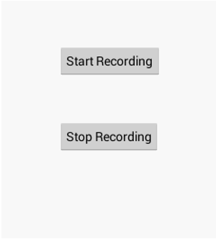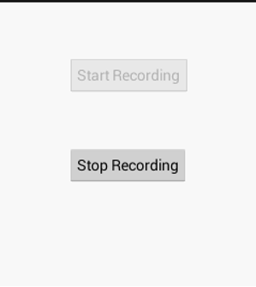

RESULT:
An application which records audio using MediaRecorder and muxes it using MediaMuxer was created.

EX 3 MEDIA PLAYER

AIM:
To develop an application in android that uses mediaplayer to run audio and video files

DESCRIPTION:
Use MediaPlayer class is the primary API for playing sound and video, and AudioManager class manages audio sources and audio output on a device. Make sure whether manifest has the appropriate declarations to allow the use of related features like Internet Permission and Wake Lock Permission

DEVICE SPECIFICATIONS:
App API version: API 26
Screen Size: 5.5”
OS: Android OREO (4.2)

CODE:

ACTIVITY_MAIN.XML

<RelativeLayout xmlns:android="http://schemas.android.com/apk/res/android"
xmlns:tools="http://schemas.android.com/tools" android:layout_width="match_parent"
android:layout_height="match_parent" android:paddingLeft="@dimen/activity_horizontal_margin"
android:paddingRight="@dimen/activity_horizontal_margin"
android:paddingTop="@dimen/activity_vertical_margin"
android:paddingBottom="@dimen/activity_vertical_margin" tools:context=".MainActivity">

<TextView android:id="@+id/textview_time"
android:text="@string/hello_world" android:layout_width="wrap_content"
android:layout_height="wrap_content"
android:layout_alignParentTop="true"
android:layout_alignParentLeft="true"
android:layout_alignParentStart="true"
android:layout_alignParentRight="true"
android:layout_alignParentEnd="true" />

<SurfaceView
android:layout_width="fill_parent"
android:layout_height="fill_parent"
android:id="@+id/surfaceView"
android:layout_alignParentBottom="true"
android:layout_alignParentRight="true"
android:layout_alignParentEnd="true"
android:layout_below="@+id/textview_time"
android:layout_alignParentLeft="true"
android:layout_alignParentStart="true" />

</RelativeLayout>

MAINACTIVITY.JAVA

package com.example.exp3;

import androidx.appcompat.app.AppCompatActivity;

import android.content.Context;
import android.media.AudioManager;
import android.media.MediaPlayer;

import android.content.res.AssetFileDescriptor;
import android.net.wifi.WifiManager;
import android.os.Bundle;
import android.os.PowerManager;
import android.view.Menu;
import android.view.MenuItem;
import android.view.SurfaceHolder;
import android.view.SurfaceView;
import android.widget.TextView;
import android.view.ViewGroup.LayoutParams;

import java.io.IOException;
import java.util.Timer;
import java.util.TimerTask;

public class MainActivity extends AppCompatActivity implements
MediaPlayer.OnCompletionListener, MediaPlayer.OnPreparedListener,
SurfaceHolder.Callback {
private MediaPlayer sampleMediaPlayer;
private final Runnable playbackTimeUpdateTask = new Runnable() {
public void run() {
if (sampleMediaPlayer.isPlaying()) {
int playtime;
int duration;
TextView textView;
textView = (TextView)findViewById(R.id.textview_time);
duration = sampleMediaPlayer.getDuration();
playtime = sampleMediaPlayer.getCurrentPosition();
textView.setText(String.valueOf(playtime) + " ms / " + String.valueOf(duration + " ms"));
}
}
};
class PlaybackTimerTask extends TimerTask {
@Override
public void run() {
// Updating TextView must be in UI thread
runOnUiThread(playbackTimeUpdateTask);
}
}
private Timer playbackTimer = null;
private PlaybackTimerTask timerTask = null;

// SurfaceView and SurfaceHolder for MediaPlayer video surface
private SurfaceView videoSurfaceView;
private SurfaceHolder surfaceHolder;
@Override
protected void onCreate(Bundle savedInstanceState) {
super.onCreate(savedInstanceState);
setContentView(R.layout.activity_main);

sampleMediaPlayer = new MediaPlayer();
sampleMediaPlayer.setScreenOnWhilePlaying(true);
sampleMediaPlayer.setOnCompletionListener(this);
sampleMediaPlayer.setOnPreparedListener(this);

// Set MediaPlayer video playback surface
videoSurfaceView = (SurfaceView)findViewById(R.id.surfaceView);
surfaceHolder = videoSurfaceView.getHolder();
// MediaPlayer.setDisplay() will be called in :surfaceCreated() callback
surfaceHolder.addCallback(this);
}

@Override
public boolean onCreateOptionsMenu(Menu menu) {
// Inflate the menu; this adds items to the action bar if it is present.
getMenuInflater().inflate(R.menu.menu_main, menu);
return true;
}

@Override
public boolean onOptionsItemSelected(MenuItem item) {
// Handle action bar item clicks here. The action bar will
// automatically handle clicks on the Home/Up button, so long
// as you specify a parent activity in AndroidManifest.xml.
int id = item.getItemId();

//noinspection SimplifiableIfStatement
if (id == R.id.action_audio) {
try {
String url = "https://www.examenglish.com/leveltest/audio/B2_04.mp3";
// your URL here
sampleMediaPlayer
.setAudioStreamType(AudioManager.STREAM_MUSIC);
sampleMediaPlayer.setDataSource(url);
sampleMediaPlayer.prepare();
sampleMediaPlayer.start();
}
catch (IOException e) {
e.printStackTrace();
}
return true;
}
if (id == R.id.action_video) {
String videoPath;
videoPath = "https://www.apple.com/105/media/ae/iphone-11-pro/2019/3bd902e4-0752-4ac1-95f8-6225c32aec6d/films/product/iphone-11-pro-product-tpl-cc-ae-2019_1280x720h.mp4";
try {
sampleMediaPlayer.reset();
sampleMediaPlayer.setDataSource(videoPath);
sampleMediaPlayer.prepareAsync();
TextView t = (TextView)findViewById(R.id.textview_time);
t.setText("Loading...");
}
catch (IOException e) {
e.printStackTrace();
}
return true;
}

return super.onOptionsItemSelected(item);
}

// Implementation of MediaPlayer Listener callbacks
@Override
public void onCompletion(MediaPlayer mp) {
TextView t = (TextView)findViewById(R.id.textview_time);
t.setText("Complete");
}

@Override
public void onPrepared(MediaPlayer mp) {
TextView t = (TextView)findViewById(R.id.textview_time);
MediaPlayer.TrackInfo info[] = mp.getTrackInfo();
t.setText(info[0].toString());

sampleMediaPlayer.start();

// Cancel previous Timer
if (playbackTimer != null) {
playbackTimer.cancel();
timerTask.cancel();
}

// Once Timer is canceled, it is required to create a new timer.
playbackTimer = new Timer();
timerTask = new PlaybackTimerTask();
// Timer starts after 1000 ms with 1000 ms period
playbackTimer.schedule(timerTask, 1000, 1000);
}

// Implementation of SurfaceHolder callbacks
@Override
public void surfaceCreated(SurfaceHolder holder) {
sampleMediaPlayer.setDisplay(holder);
}

@Override
public void surfaceChanged(SurfaceHolder holder, int format, int width, int height) {

}

@Override
public void surfaceDestroyed(SurfaceHolder holder) {

}
}

OUTPUT:
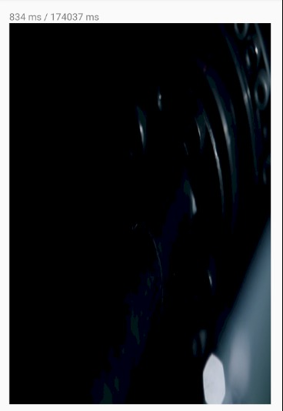
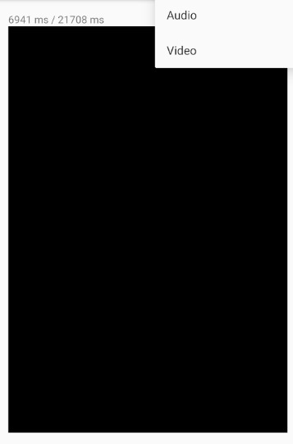

RESULT:
The created app uses MediaPlayer to play both audio and video files.

EX 4 TEXT TO SPEECH

AIM:
To develop an application in android that converts text to speech

DESCRIPTION:
A TextToSpeech instance can only be used to synthesize text once it has completed its initialization. Implement the TextToSpeech.OnInitListener to be notified of the completion of the initialization.

DEVICE SPECIFICATIONS:
App API version: API 26
Screen Size: 5.5”
OS: Android OREO (4.2)

CODE:

ACTIVITY_MAIN.XML

<?xml version="1.0" encoding="utf-8"?>
<LinearLayout xmlns:android="http://schemas.android.com/apk/res/android"
xmlns:app="http://schemas.android.com/apk/res-auto"
xmlns:tools="http://schemas.android.com/tools"
android:layout_width="match_parent"
android:layout_height="match_parent"
android:gravity="center"
android:orientation="vertical"
android:paddingLeft="20dp"
android:paddingRight="20dp"
tools:context=".MainActivity">

<TextView
android:id="@+id/textView"
android:layout_width="match_parent"
android:layout_height="wrap_content"
android:layout_marginBottom="50dp"
android:gravity="center_horizontal"
android:text="Android Text to Speech (TTS) Demo"
android:textAppearance="@style/TextAppearance.AppCompat.Headline" />

<EditText
android:id="@+id/et"
android:layout_width="match_parent"
android:layout_height="wrap_content"
android:background="@drawable/edit_text_style"
android:hint="Enter the text here"
android:paddingBottom="10dp"
android:paddingLeft="10dp"
android:paddingRight="10dp"
android:paddingTop="10dp" />

<Button
android:id="@+id/btn"
android:layout_width="wrap_content"
android:layout_height="wrap_content"
android:layout_marginVertical="10dp"
android:elevation="0dp"
android:paddingHorizontal="30dp"
android:text="Click to convert text to speech" />

</LinearLayout>

MAINACTIVITY.JAVA
package com.javapapers.texttospeechdemo;

import android.speech.tts.TextToSpeech;
import android.support.v7.app.AppCompatActivity;
import android.os.Bundle;
import android.util.Log;
import android.view.View;
import android.widget.Button;
import android.widget.EditText;
import android.widget.Toast;

import java.util.Locale;

public class MainActivity extends AppCompatActivity {
private TextToSpeech textToSpeech;
private Button btn;
private EditText editText;

@Override
public void onCreate(Bundle savedInstanceState) {
super.onCreate(savedInstanceState);
setContentView(R.layout.activity_main);
btn = (Button) findViewById(R.id.btn);

editText = (EditText) findViewById(R.id.et);
textToSpeech = new TextToSpeech(getApplicationContext(), new TextToSpeech.OnInitListener() {
@Override
public void onInit(int status) {
if (status == TextToSpeech.SUCCESS) {
int ttsLang = textToSpeech.setLanguage(Locale.US);

if (ttsLang == TextToSpeech.LANG_MISSING_DATA
|| ttsLang == TextToSpeech.LANG_NOT_SUPPORTED) {
Log.e("TTS", "The Language is not supported!");
} else {
Log.i("TTS", "Language Supported.");
}
Log.i("TTS", "Initialization success.");
} else {
Toast.makeText(getApplicationContext(), "TTS Initialization failed!", Toast.LENGTH_SHORT).show();
}
}
});

btn.setOnClickListener(new View.OnClickListener() {

@Override
public void onClick(View arg0) {

String data = editText.getText().toString();
Log.i("TTS", "button clicked: " + data);
int speechStatus = textToSpeech.speak(data, TextToSpeech.QUEUE_FLUSH, null);

if (speechStatus == TextToSpeech.ERROR) {
Log.e("TTS", "Error in converting Text to Speech!");
}
}

});
}

@Override
public void onDestroy() {
super.onDestroy();
if (textToSpeech != null) {
textToSpeech.stop();
textToSpeech.shutdown();
}
}
}

OUTPUT:
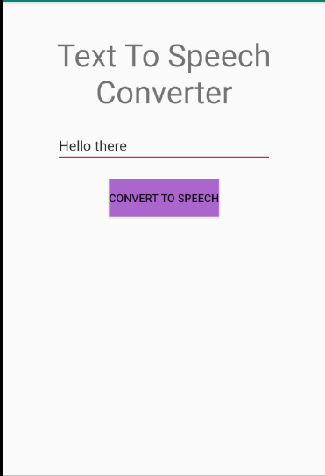
RESULT:
The app was created and the text input was converted to speech output.

EX 5 IMAGE CAPTURE USING CAMERA

AIM:
To develop an application in android that captures the image using built in camera

DESCRIPTION:
use the ACTION_IMAGE_CAPTURE or ACTION_VIDEO_CAPTURE action to open a camera app and receive the resulting photo or video. Specify the URI location where you'd like the camera to save the photo or video, in theEXTRA_OUTPUT extra. Request the camera featureTake a photo with a camera app. Savethe full-size photo using getExternalStoragePublicDirectory(), with the DIRECTORY_PICTURES argument

DEVICE SPECIFICATIONS:
App API version: API 26
Screen Size: 5.5”
OS: Android OREO (4.2)

CODE:

ACTIVITY_MAIN.XML

<RelativeLayout xmlns:androclass="http://schemas.android.com/apk/res/android"
xmlns:tools="http://schemas.android.com/tools"
android:layout_width="match_parent"
android:layout_height="match_parent"
tools:context=".MainActivity">

<Button
android:id="@+id/button1"
android:layout_width="wrap_content"
android:layout_height="wrap_content"
android:layout_alignParentBottom="true"
android:layout_centerHorizontal="true"
android:text="Take a Photo">
</Button>

<ImageView
android:id="@+id/imageView1"
android:layout_width="fill_parent"
android:layout_height="fill_parent"
android:layout_above="@+id/button1"
android:layout_alignParentTop="true"
android:src="@drawable/ic_launcher">
</ImageView>
</RelativeLayout>

MAINACTIVITY.JAVA

package com.example.simplecamera;

import android.app.Activity;
import android.content.Intent;
import android.graphics.Bitmap;
import android.os.Bundle;
import android.view.Menu;
import android.view.View;
import android.widget.Button;
import android.widget.ImageView;

public class MainActivity extends Activity {
private static final int CAMERA_REQUEST= 1888;
ImageView imageView;
public void onCreate(Bundle savedInstanceState){

super.onCreate(savedInstanceState);
setContentView(R.layout.activity_main);

imageView = (ImageView) this.findViewById(R.id.imageView1);
Button photoButton =(Button) this.findViewById(R.id.button1);

photoButton.setOnClickListener(new View.OnClickListener(){

@Override
public void onClick(View v){
Intent cameraIntent=
new Intent(android.provider.MediaStore.ACTION_IMAGE_CAPTURE);
startActivityForResult(cameraIntent, CAMERA_REQUEST);
}
});
}

protected void onActivityResult(int requestCode, int resultCode, Intent data){
if(requestCode==CAMERA_REQUEST){
Bitmap photo = (Bitmap) data.getExtras().get("data");
imageView.setImageBitmap(photo);
}
}

private void cameraIntent() throws IOException
{
if (checkPermissions()){
final String dir =
Environment.getExternalStoragePublicDirectory(Environment.DIRECTORY_PICTURES)
+ "/picFolder/";
File newdir = new File(dir);
newdir.mkdirs();
String file = dir+"photo.jpg";
File newfile = new File(file);
try {
newfile.createNewFile();
}
catch (IOException e)
{
e.printStackTrace();
}

mCurrentPhotoPath = Uri.fromFile(newfile);

Intent takePictureIntent = new Intent(MediaStore.ACTION_IMAGE_CAPTURE);
takePictureIntent.putExtra(MediaStore.EXTRA_OUTPUT, mCurrentPhotoPath);
startActivityForResult(takePictureIntent, REQUEST_CAMERA);
}
}

@Override
public booleanonCreateOptionsMenu(Menu menu){
getMenuInflater().inflate(R.menu.activity_main, menu);
return true;
}

}

OUTPUT:

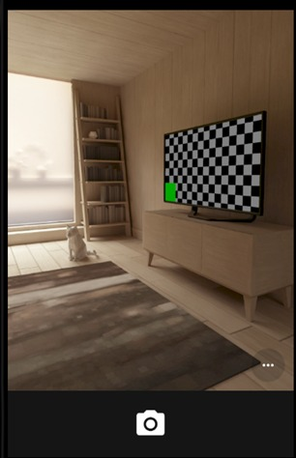
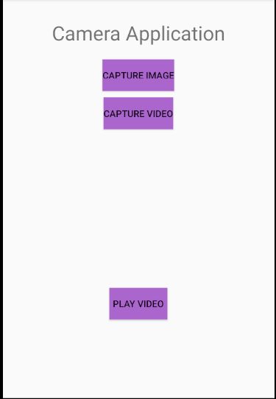

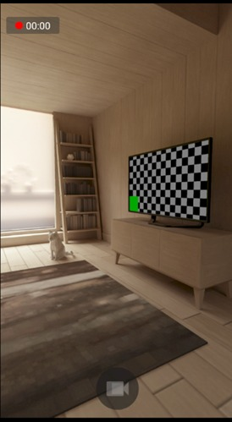
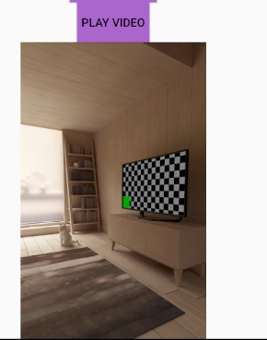

RESULT:

The created app successfully takes photo using the built-in camera and stores them in a file location.

