DEVELOPER GUIDE
STOCKS PULSE
From Anomalies to Forecasts

1. Introduction
The comprehensive technical documentation for StocksPulse, a system for detecting and forecasting stock price anomalies, is available in this Developer Guide. To assist developers with maintaining, expanding, or deploying the application, it provides an explanation of the project's architecture, setup guidelines, dependencies, and essential modules.

2. System Requirements
- Programming Language: Python 3.9+
- Frameworks: Streamlit, scikit-learn, Prophet, Plotly
- Other Tools: yFinance, TA (Technical Analysis library), BeautifulSoup, Twilio API
- OS Compatibility: Windows, macOS, Linux
3. Installation & Setup
Clone the repository:
git clone https://github.com/yourusername/stockspulse.git
Create and activate a virtual environment:
python -m venv venv
source venv/bin/activate # For Linux/Mac
venv\Scripts\activate # For Windows
Install dependencies:
pip install -r requirements.txt
Add your secrets for email and Twilio in .streamlit/secrets.toml:
sender_email="your_email@gmail.com"
sender_pass="your_password"
twilio_sid="your_twilio_sid"
twilio_auth="your_twilio_auth_token"
twilio_number="whatsapp:+14155238886"

4. Project Structure
stockspulse/
│── app.py # Main application file
│── requirements.txt # Dependencies
│── /data # Sample datasets
│── /assets # Logo and banner images
│── /docs # User & Developer Guides
│── /notebooks # Experimental Jupyter notebooks
│── /models # Saved ML models (optional)
│── .streamlit/secrets.toml # Credentials and secrets

5. Fundamental Modules

- Data Management
fetch_ticker_df: Uses yFinance to download stock data.
basic_preprocess: Sorts, interpolates, and cleans up missing values.
feature_engineer: Incorporates features such as volatility, moving averages, and RSI.

- Finding Anomalies
supports the Local Outlier Factor, One-Class SVM, and Isolation Forest.
utilizes StandardScaler to normalize features.
uses Plotly to provide visualization (heatmap, candlestick, and line chart).

- Making predictions
Prophet-powered with adjustable seasonality.
offers evaluation metrics, projections, and confidence ranges.
CSV download option for export.

- Dashboard for the Portfolio
manages several tickers.
shows current anomalies, short forecasts, and price history.

- Integration of News
retrieves RSS feeds for Google News.
displays designed news cards and parses using BeautifulSoup.

- Reporting
Forecasts and anomalies are exported to CSV and PDF files.
Reports can be sent by WhatsApp (Twilio API) or email (SMTP).

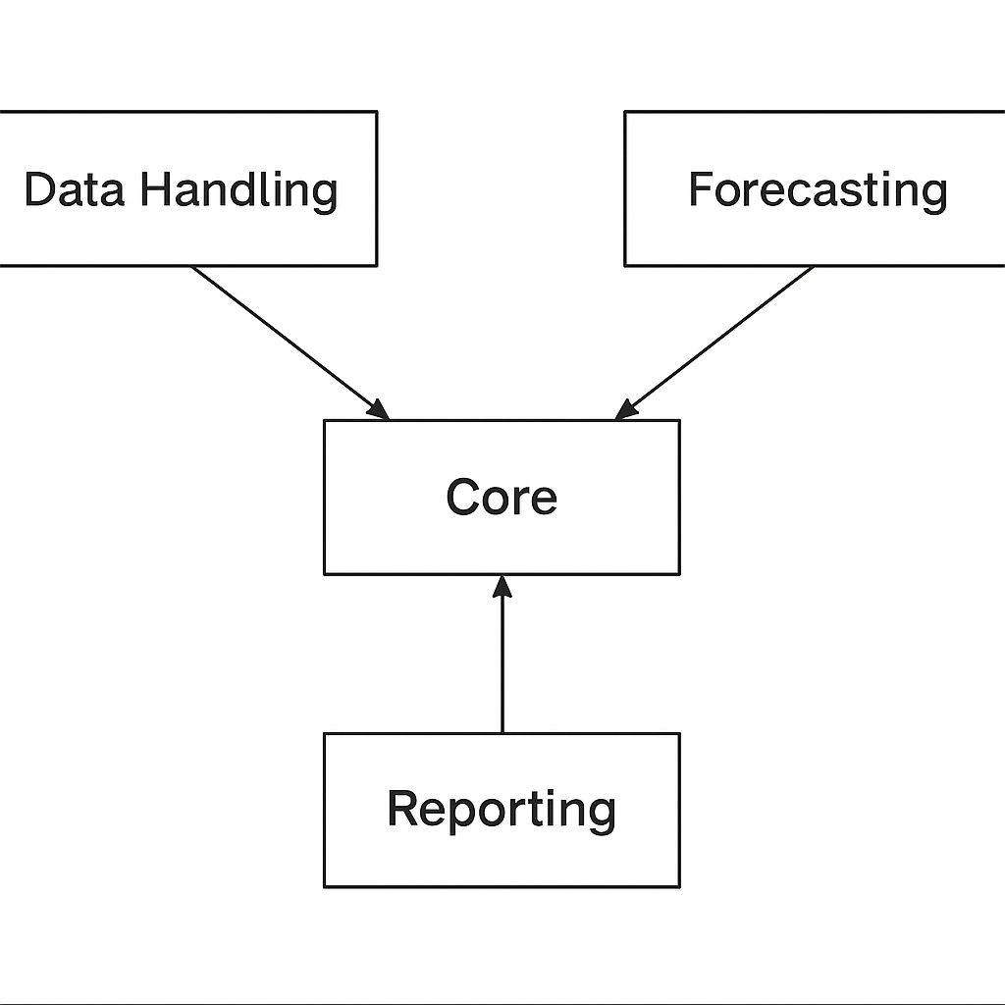

- Continuing the Project
- Include fresh models for anomaly detection (autoencoders, LSTMs, etc.).
- ARIMA or hybrid models can be used to improve forecasting.
- Utilize interactive dashboards to improve reporting.
- Link to APIs for real-time stock data.

- Troubleshooting
- BeautifulSoup parser problem -> install lxml.
- Problems installing Prophet: install Pystan first.
- Twilio number problem ← Verify that WhatsApp has the sandbox number enabled.
- Streamlit cache problems → use streamlit cache clean to clear the cache

- System Architecture

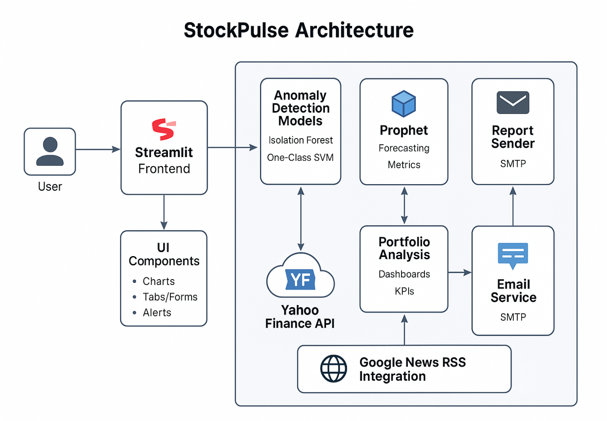

- Data Flow/Pipeline

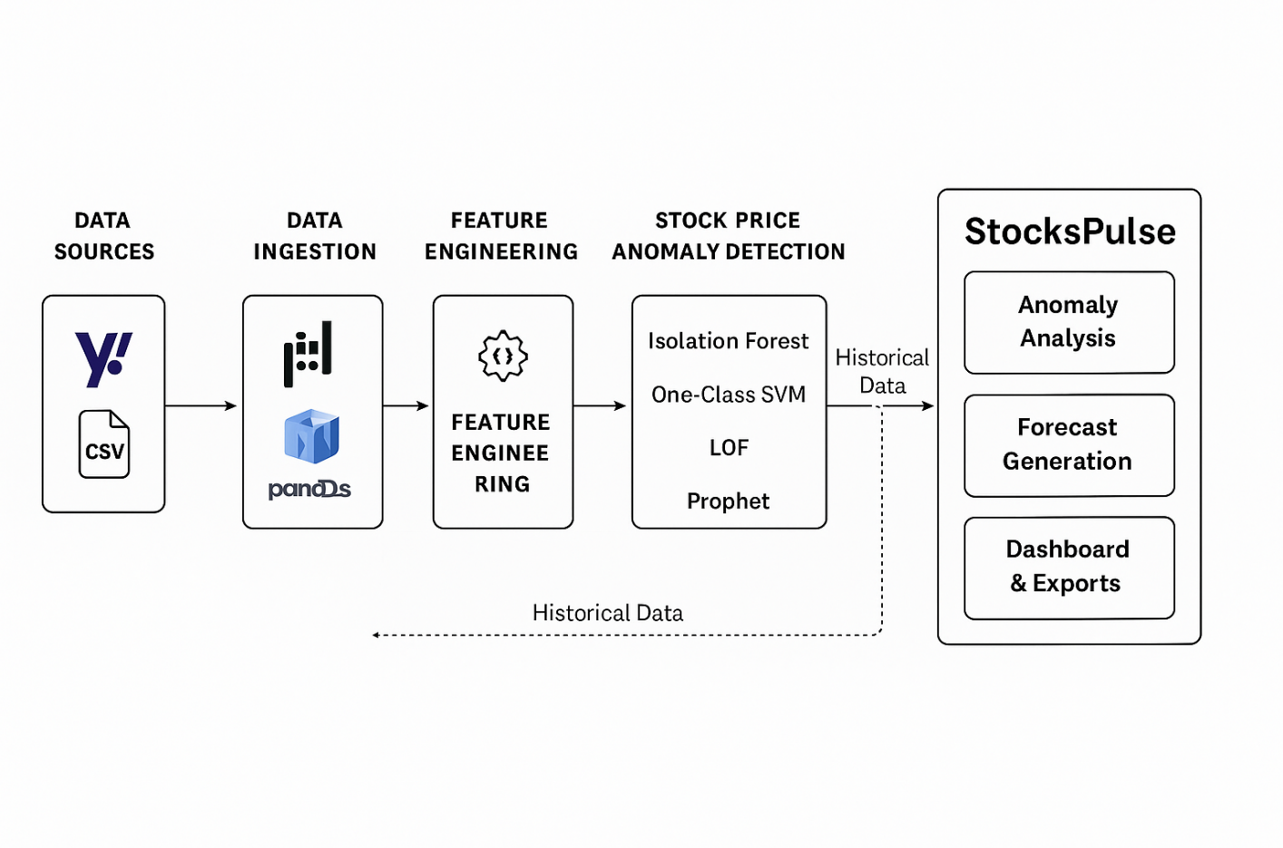
- Sequence Flow

