USER GUIDE
STOCK PULSE
From Anomalies to Forecasts

INTRODUCTION
Welcome to StockPulse: Anomaly Detection & Forecasting System, an online tool driven by machine learning that makes it simple for analysts, investors, and fans to identify anomalous market activity and predict future stock values.
It's crucial to remain ahead of abrupt changes in the market in the fast-paced financial world of today. To find abnormalities in stock price movements, StockPulse blends cutting-edge algorithms (Isolation Forest, One-Class SVM, and Local Outlier Factor) with user-friendly visuals. Additionally, it makes use of prophet-based forecasting models to provide actionable insights into both short- and long-term price trends.

- The purpose of this user guide is to assist you:
- Recognize StockPulse's characteristics.
- Find out how to load data (from CSV or Yahoo Finance).
- Examine your portfolio dashboard, which is updated in real time.
- Make use of sophisticated techniques to forecast trends and identify anomalies.
- Use Google News RSS feeds to access news insights.
- Results can be exported and shared by WhatsApp, CSV, PDF, or email reports.
- With its straightforward and contemporary interface, which is based on Streamlit
- StockPulse allows users of all skill levels—from novice traders to seasoned pros—to derive valuable information without the need for intricate coding.

OVERVIEW
StockPulse is an interactive web application that blends financial data analysis and machine learning. Through a straightforward and user-friendly interface, it allows users to manage many tickers, predict future trends, and identify anomalous stock price fluctuations.
While the forecasting module uses Prophet to make detailed accuracy predictions about future movements, the anomaly detection module uses models such as Isolation Forest, One-Class SVM, and Local Outlier Factor to find anomalies in price data. In addition to price history, short forecasts, and recent anomalies, a portfolio dashboard provides users with an overview of several companies.
Other features include the ability to send reports immediately via email, export choices in CSV and PDF, and interaction with real-time stock news. With the help of Streamlit, Plotly, yFinance, scikit-learn, and Prophet, StockPulse offers traders, analysts, and students alike compelling insights in an approachable and useful manner.

PURPOSE
The goal of StockPulse is to provide a clever and intuitive platform that enables people to comprehend stock market behavior more fully. Because financial data is frequently complicated, erratic, and impacted by a myriad of variables, it can be challenging for users to spot anomalies or predict future trends. In order to overcome this difficulty, StockPulse combines sophisticated forecasting models with anomaly detection powered by machine learning, offering actionable insights that are clear and precise.
The project's goal is to close the gap between advanced data science techniques and real-world financial decision-making. StockPulse streamlines the analytical process without sacrificing accuracy by displaying results through automatic reports, interactive dashboards, and clear visualizations. In addition to helping analysts, researchers, and investors make well-informed decisions, it aims to make sophisticated financial analysis more approachable for novices who might not have any prior knowledge of data science or trading tactics.

BACKGROUND STUDY
Economic policy, world events, and investor attitude are just a few of the many variables that impact the stock market, which is a dynamic and extremely volatile environment. Traditional analysis techniques frequently fail to detect hidden patterns, odd price fluctuations, or accurately predict future trends due to the increasing complexity of financial markets. Because of this difficulty, machine learning and artificial intelligence are being used more and more in financial analytics.

According to recent research, anomaly detection methods like Isolation Forest, One-Class SVM, and Local Outlier Factor are useful for spotting unusual market activity that can indicate opportunities or dangers. In a similar vein, sophisticated forecasting tools such as Facebook Prophet have demonstrated value in identifying long-term patterns, trends, and seasonality in stock prices. Compared to traditional statistical methods, these techniques provide researchers, analysts, and investors with more precise and timely information.
By combining these strategies into a single, interactive platform, StockPulse expands on this framework. It offers a comprehensive tool that not only identifies anomalies in stock price movements but also forecasts future market behavior by fusing anomaly detection, forecasting, and portfolio analysis. The project creates a strong framework for decision assistance and education by utilizing both academic research and real-world financial technology applications.

GLOSSERY
An explanation of key words and ideas used in the StockPulse project can be found in the glossary section of the user manual. It makes it easier for users to comprehend the system's technical jargon, particularly for individuals who might not be experienced with finance or machine learning. The glossary guarantees that readers can readily understand how anomaly detection and forecasting features operate by offering definitions of algorithms, tools, and indications. For both technical and non-technical users, it serves as a rapid reference point.

Term | Definition
Anomaly Detection | A machine learning process used to identify unusual patterns or data points in stock price movements that differ significantly from the expected trend.
Forecasting | The use of time series models, such as Prophet, to predict future stock prices based on historical data and trends.
Isolation Forest | An anomaly detection algorithm that isolates observations by randomly selecting features and splitting values, making anomalies easier to detect.
One-Class SVM | A machine learning algorithm that learns a boundary around normal data and classifies points outside this boundary as anomalies.
Local Outlier Factor (LOF) | An anomaly detection algorithm that measures the local deviation of data density, identifying points that significantly differ from their neighbors.
Prophet | A forecasting model developed by Facebook, designed to capture seasonality, trends, and irregular events in time series data.
RSI (Relative Strength Index) | A technical indicator that measures the speed and magnitude of recent price changes to evaluate overbought or oversold conditions in stocks.
Volatility | A statistical measure of how much a stock price fluctuates over time, often used to assess risk.
Portfolio Dashboard | A feature in the application that allows users to analyze multiple stocks simultaneously, providing an overview of performance, forecasts, and anomalies.
KPI (Key Performance Indicator) | Metrics displayed in the app to summarize important insights, such as the number of anomalies detected, anomaly percentage, and anomaly scores.
CSV (Comma-Separated Values) | A file format that stores tabular data in plain text, used for exporting anomalies, forecasts, and portfolio reports.
Streamlit | The framework used to build the StockPulse application, enabling interactive data visualization and user-friendly interfaces in Python.
yFinance | A Python library used to fetch real-time and historical stock market data directly from Yahoo Finance.
TA (Technical Analysis Library) | A Python package for computing common technical indicators, such as RSI and moving averages.
Twilio | A cloud communications platform used in StockPulse to send reports and alerts via WhatsApp or email.

USER INTERFACE
This project's user interface, which combines a tab-based main workspace with a sidebar for data input, was created with clarity and ease of use in mind. With the use of simple controls, users can easily import stock data, analyze anomalies, create forecasts, and manage portfolios. Rich visualizations, KPI cards, and export options for further study are included with each tab's results. Both novice and expert users can interact with complex models in an easy-to-understand manner because to the clear layout.

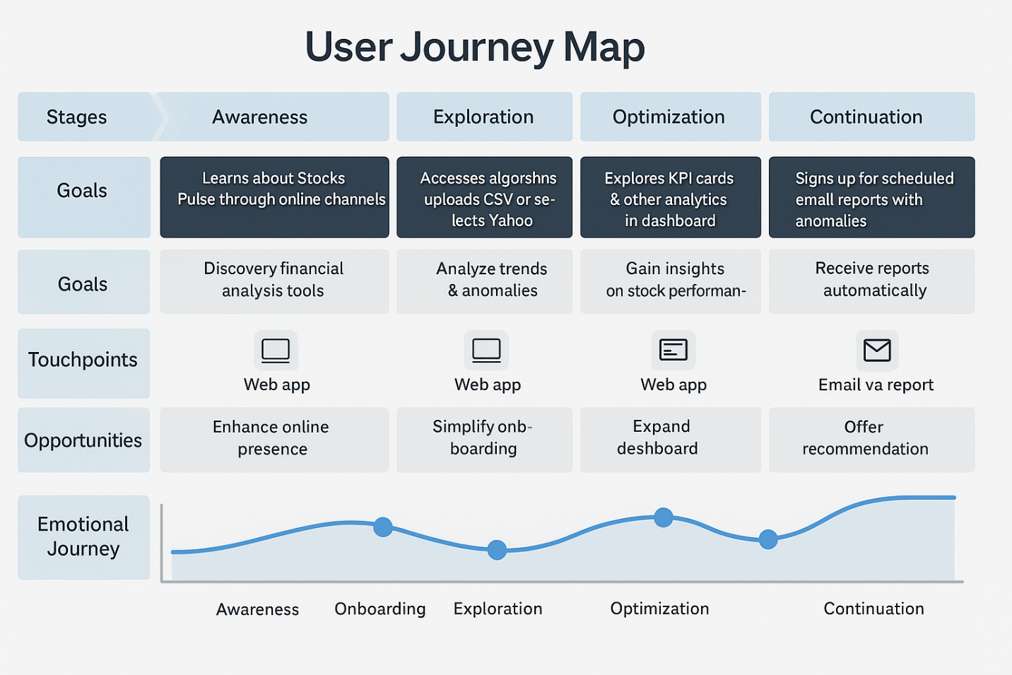

NAVIGATION
The sidebar and the main interface are the two primary sections of StockPulse's navigation. Users can upload a CSV file or input a ticker and date range from Yahoo Finance to load data into the sidebar. Additionally, it offers a portfolio loader that allows you to enter numerous stock tickers for combined examination.
Each tab in the main interface corresponds to a fundamental system function. The about/tech stack part, live stock news, forecasting, anomaly detection, portfolio dashboards, and the email report tool are all accessible to users. Users may handle data, investigate anomalies, predict stock prices, and obtain insights or reports with ease because to this straightforward framework.

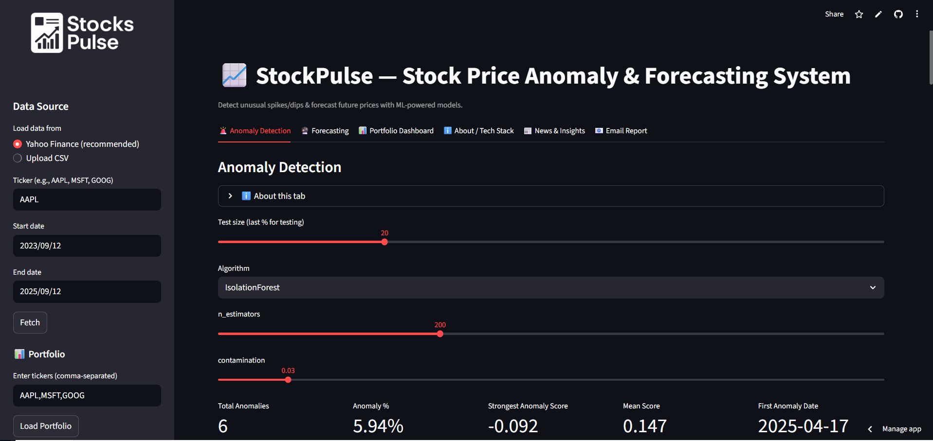
SIDE BAR
The main control panel for entering and managing data in StockPulse is the sidebar. Users can either upload their own CSV file with stock information including date, open, high, low, close, and volume, or they can import stock data straight from Yahoo Finance by entering the ticker symbol and date range. Because of this versatility, users can work with historical datasets of their choosing as well as current market data.
The sidebar has a portfolio loader in addition to single-stock data, allowing users to enter several stock tickers in a manner separated by commas. A comparative portfolio analysis is made possible by the system's automatic retrieval and processing of data for every ticker after it has been loaded. Users can view market movements and the behavior of particular stocks more broadly thanks to this tool.

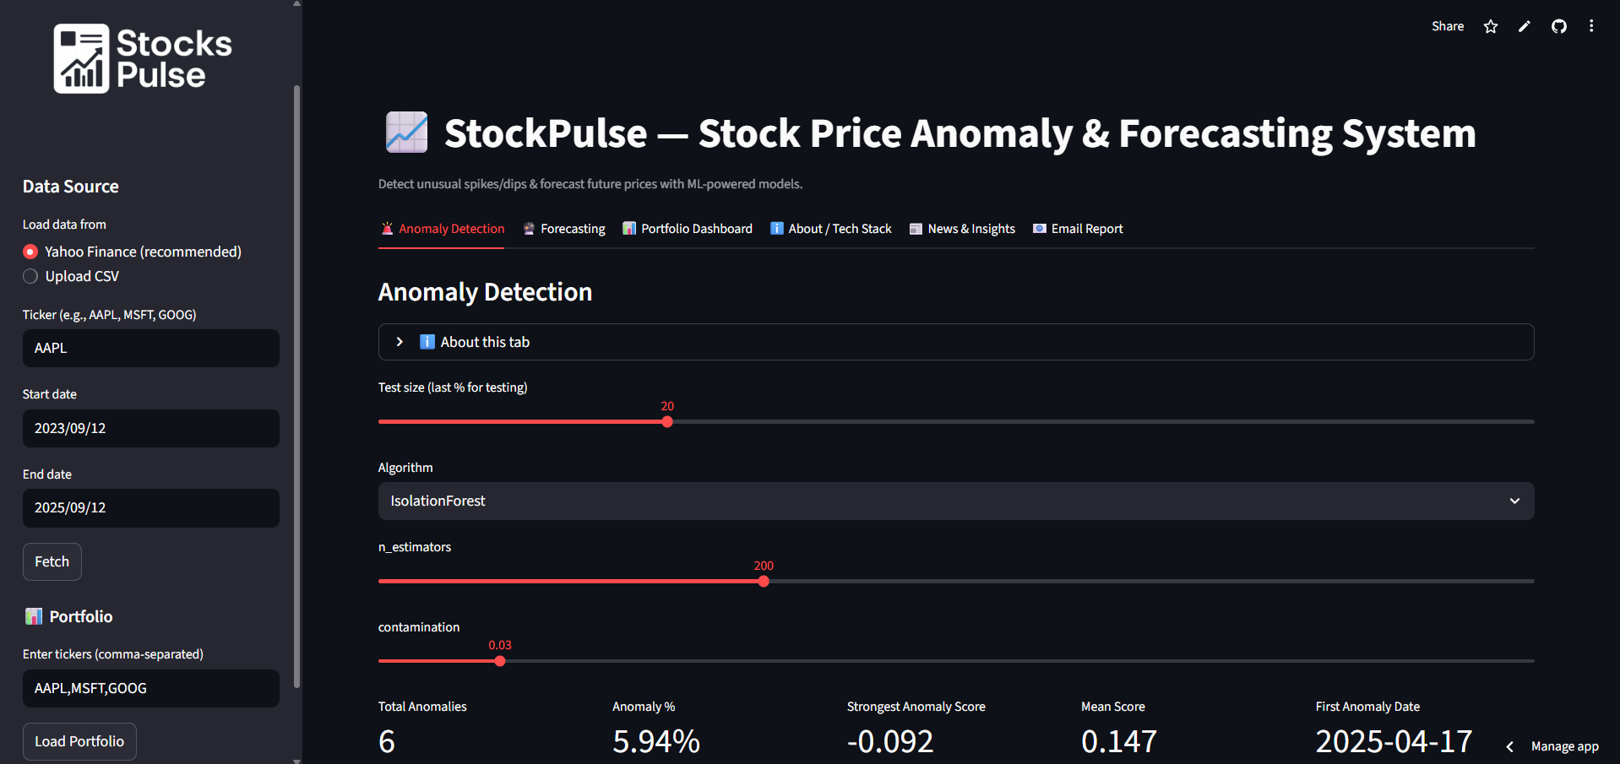
MAIN DASHBOARD
The StockPulse main interface is separated into several tabs after the dataset has been successfully loaded. Every tab is devoted to a particular system function, giving users an organized process for forecasting and stock analysis. Users may effortlessly switch between anomaly detection, forecasting, portfolio monitoring, technology overview, news updates, and report generation thanks to the dashboard's user-friendly interface.


ANOMOLY DETECTION TAB
The main feature of StockPulse is the Anomaly Detection tab, which allows users to spot odd stock price patterns that diverge from typical market trends. Users can set up various machine learning models, like Isolation Forest, One-Class SVM, and Local Outlier Factor, to examine the data once it has been loaded. The system gives customers flexibility in determining what defines an abnormality by allowing them to customize factors such as neighborhood size, contamination rate, and test size.

Anomalies in the dataset can be trained and visualized in real time with this tab. Interactive charts like line plots and candlesticks are used to present the results, and anomalies are prominently emphasized for easier interpretation. Users are shown critical performance indicators including the overall number of anomalies and the anomaly percentage in addition to visual insights.

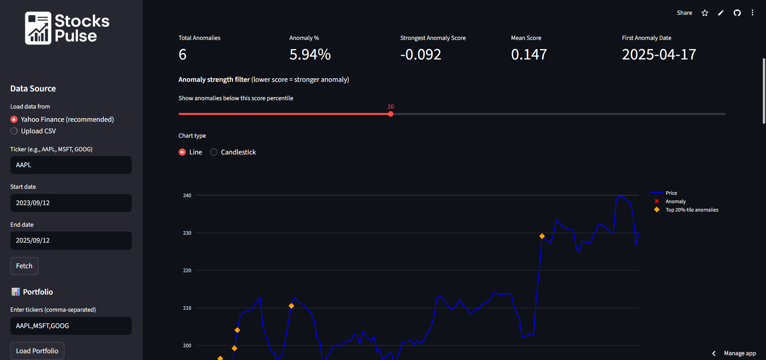
Advanced analytics such as score distribution histograms, RSI against return scatter plots, volatility-return bubble plots, and monthly anomaly heatmaps are also included in this tab. A drill-down explorer allows users to observe price fluctuations within a specified time span and concentrate on particular anomaly dates to facilitate in-depth examination.

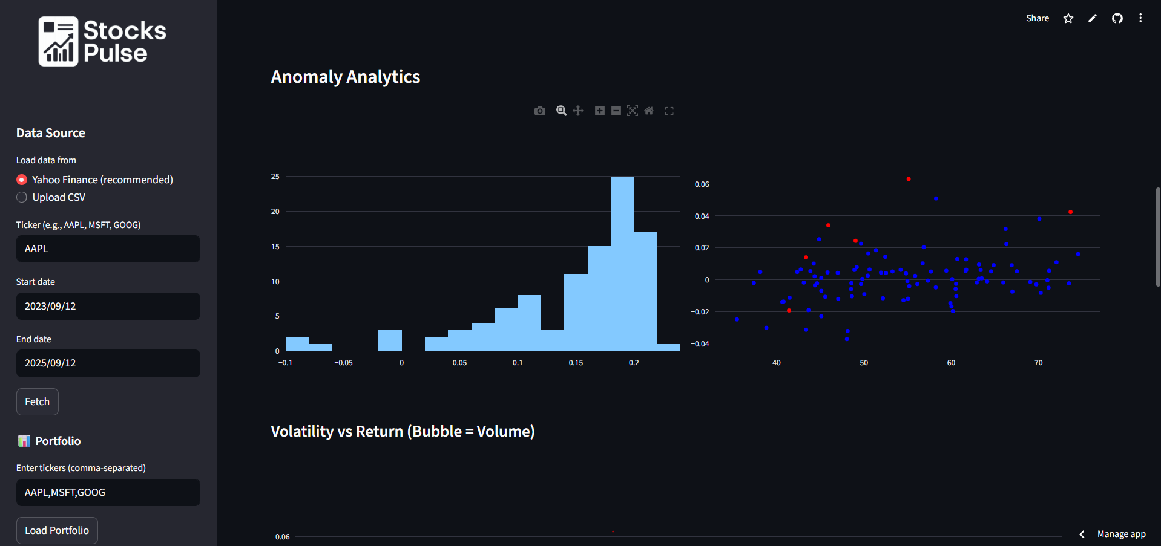



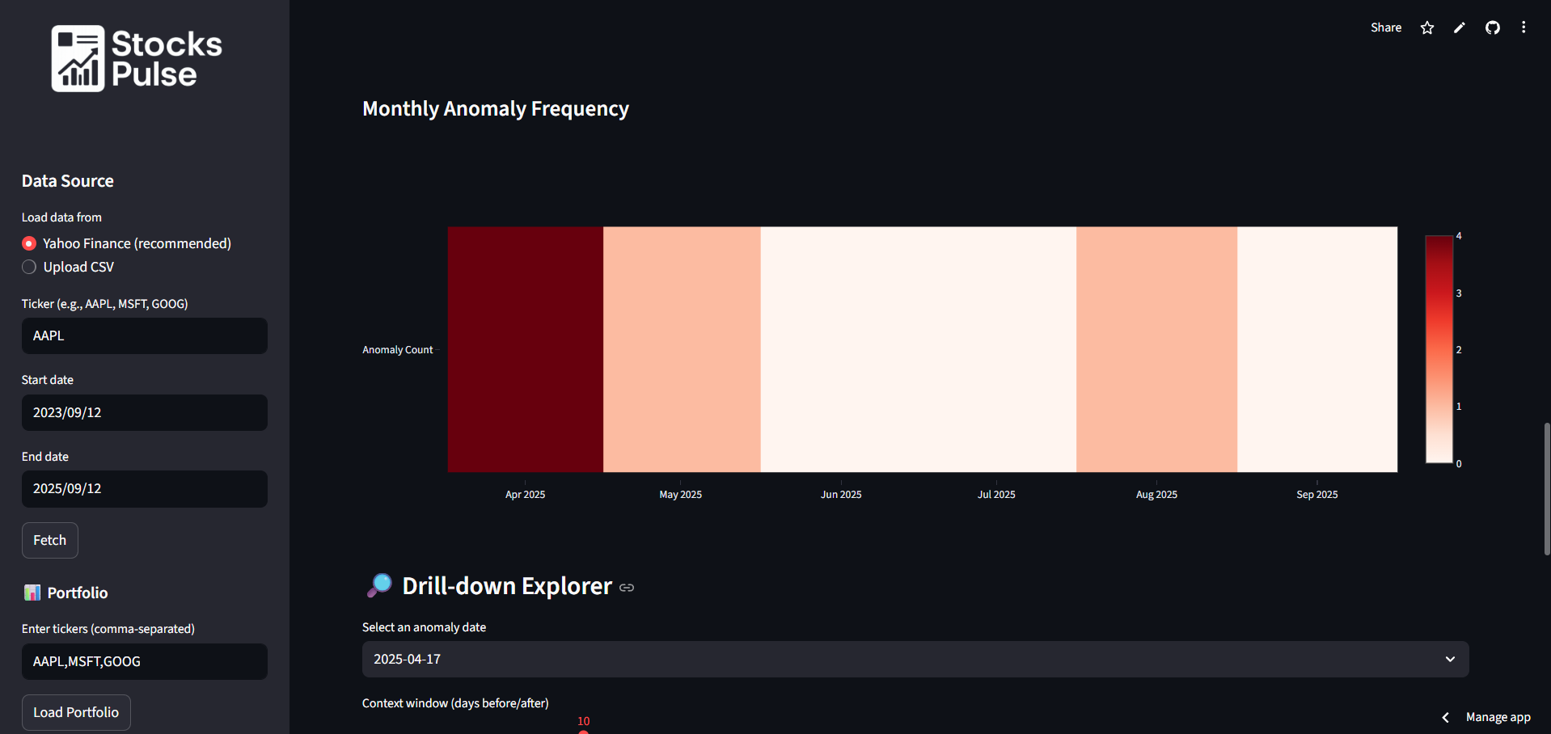

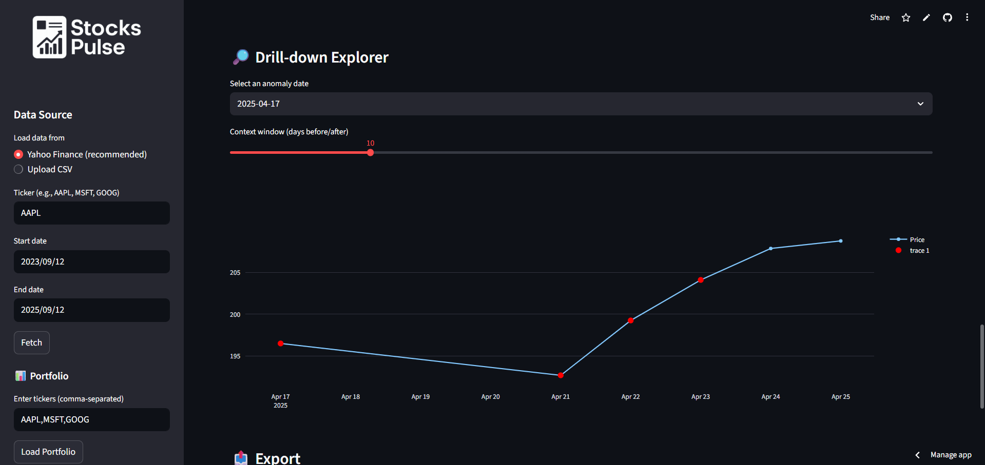

Lastly, anomalies can be exported for offline inspection and reporting in PDF or CSV formats.
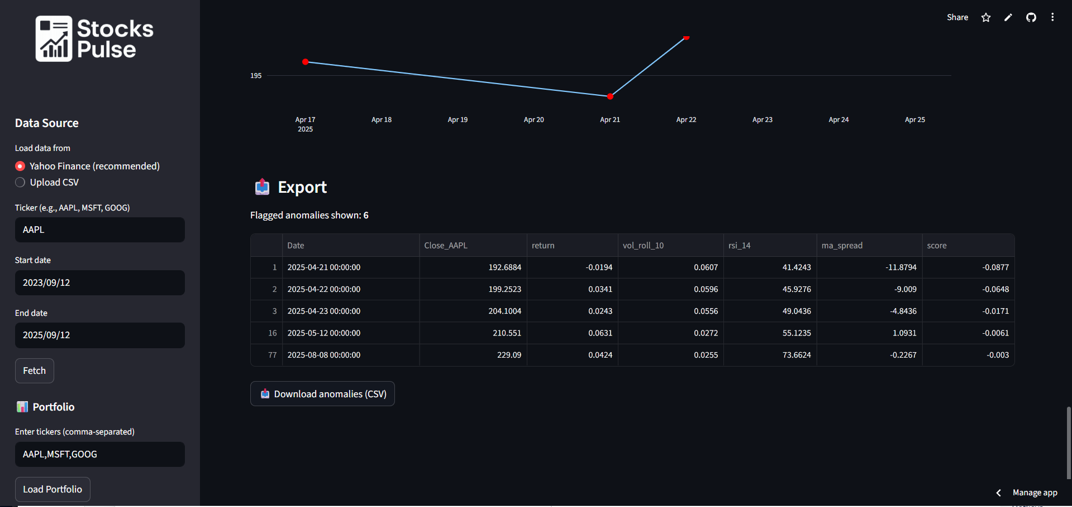

FORECASTING TAB

With the help of sophisticated time series models, users can forecast future stock values in the forecasting area. Fundamentally, it enables the choice of models like Prophet, with ARIMA scheduled for incorporation in the future. This guarantees forecast flexibility and accommodates various user requirements.
By choosing how many days they want to forecast into the future, users can determine the prediction horizon inside this tab. Whether the customer needs a longer outlook or short-term projections, this feature enables customization and flexibility.

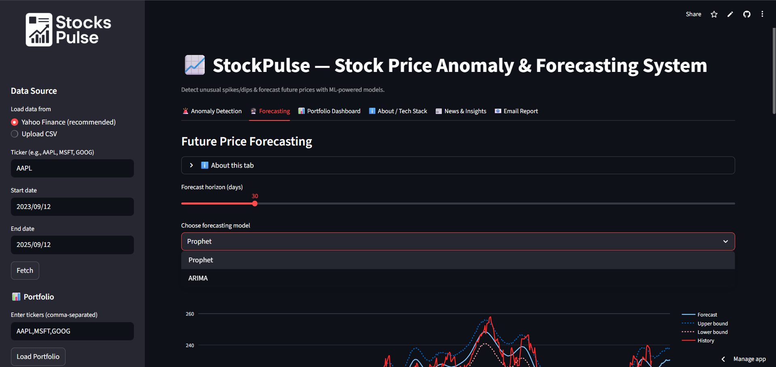
The system offers visuals that incorporate anticipated values, along with upper and lower confidence intervals, with historical pricing data. Users can more easily understand both the trend and the prediction uncertainty thanks to these displays.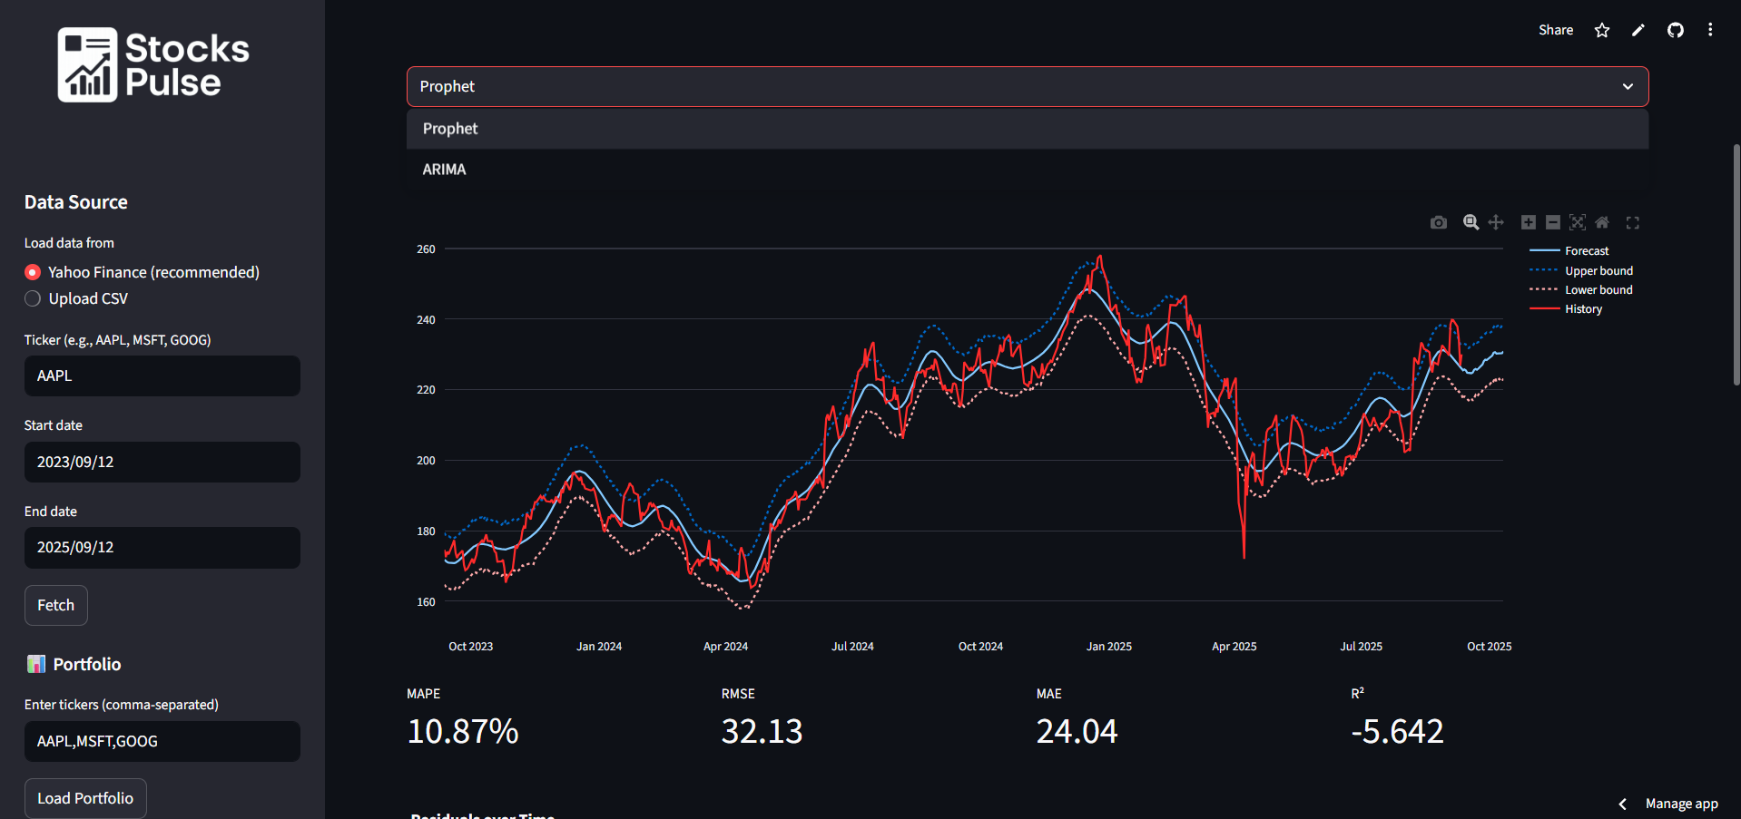
Evaluation measures including Mean Absolute Percentage Error (MAPE), Root Mean Squared Error (RMSE), Mean Absolute Error (MAE), and R2 scores are included in the forecasting tab to guarantee dependability. With the use of these measures, users can assess how well the predicted outcomes perform in comparison to past data.
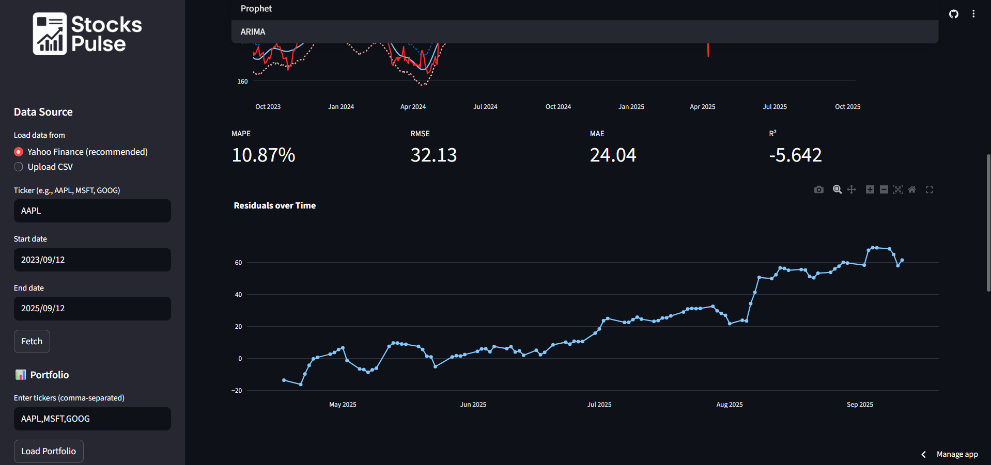
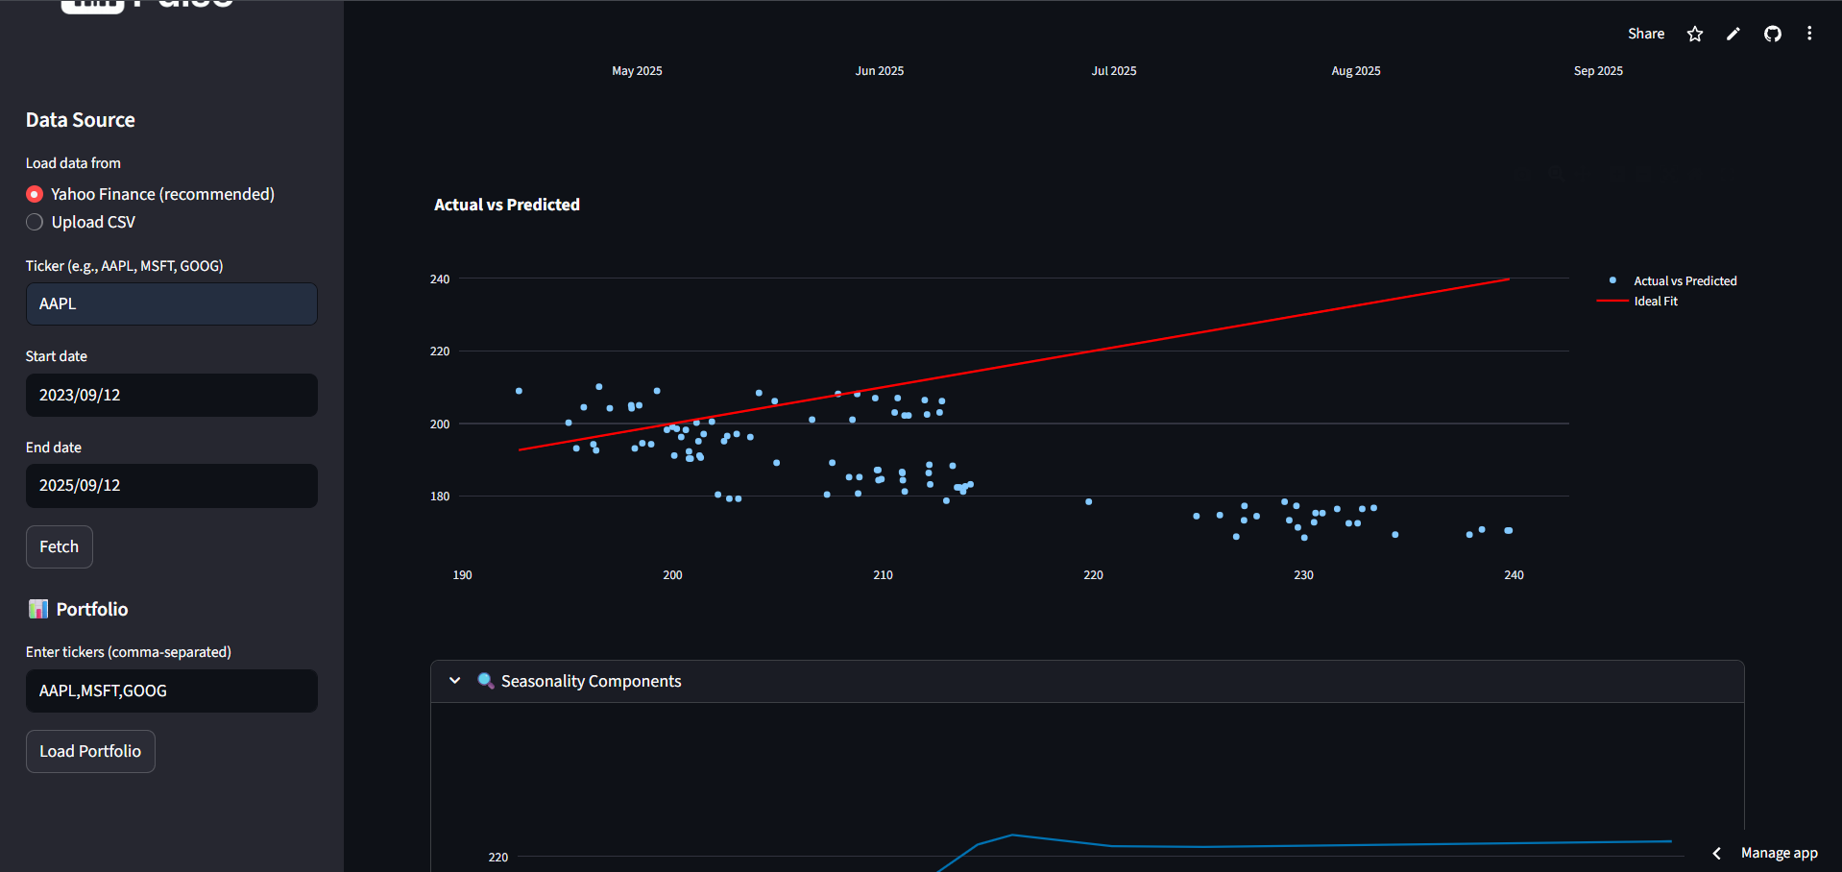
The part also offers seasonality breakdowns and residual analysis for more in-depth understanding. This enables users to examine if errors are distributed consistently over time and comprehend patterns in their data, such as weekly or annual trends.
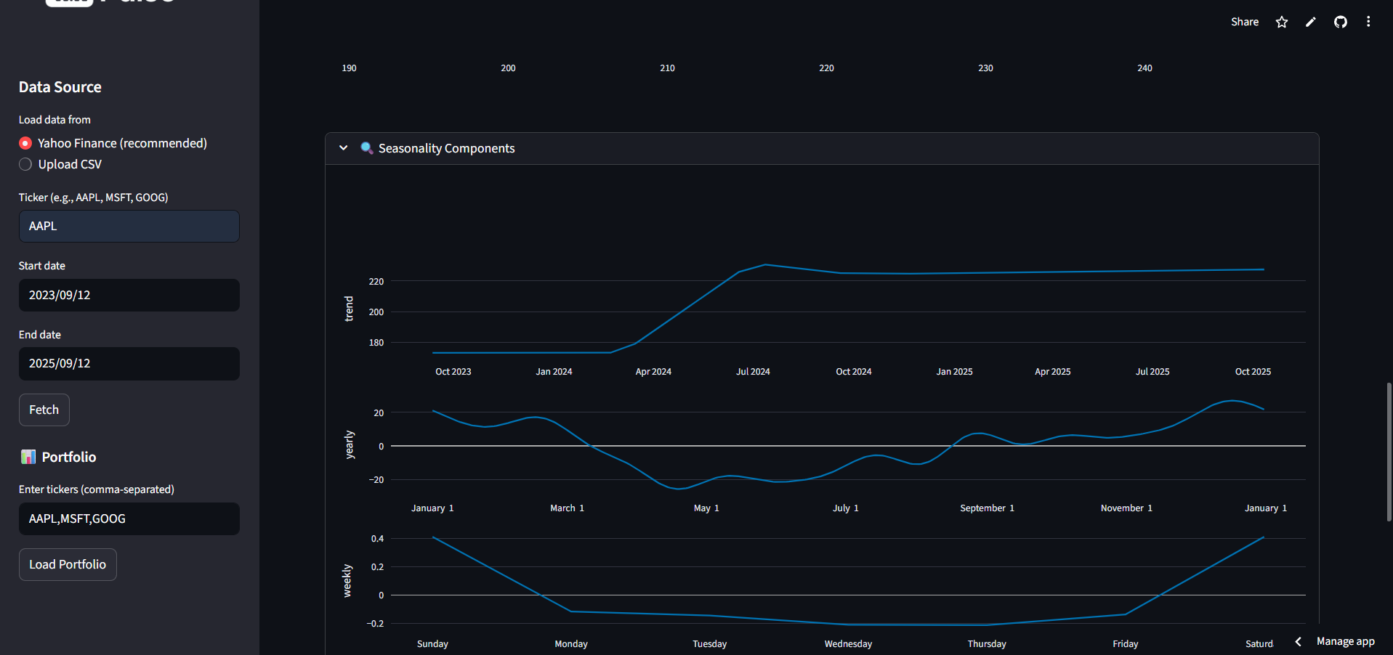
Lastly, users can download forecast findings in CSV format using the export tool available on the forecasting tab. This guarantees that predictions are accessible for reporting, documentation, or additional study beyond the application in addition to being visual.

