CSCE 3444.002
Sudip Khadka
Pete Maselli
Xavier Rosado

Team 4 Proposal
Mean Green Thumb

1) Problem
Many people want to grow a garden but don't know what to plant, when to plant it, or how to take care of it. New gardeners often buy plants that don't grow well where they live. They plant too early or too late. They water too much or not enough.
This problem matters because it wastes people's time and money, and it makes them give up on gardening before they really get started. Beginners especially need this help, since they don't yet have the experience to know what works in their area.

2) Who will use it?
Mean Green Thumb is for beginner gardeners, roughly ages 20 to 30, who are new to growing plants. They have the energy and time to work in a garden, but they don't have the knowledge yet.
They don't want to spend hours searching the internet for answers. They want one simple place that tells them what to do based on exactly where they live.

3) What will it do?
- It will find a person's growing zone from their zip code so people can know which plants will actually grow well where they live.
- It will suggest plants based on the season and local soil so people can pick the right plants at the right time.
- It will send alerts about weather that could harm plants so people can protect their garden before it's too late.
- It will build a simple planting calendar so people can know exactly when to plant and when to expect results.
- It will let local gardeners share tips and advice so people can learn from others gardening in the same area.

4) Example of User Story
A new gardener named Dave opens the app for the first time to figure out what to plant in his backyard. He types in his zip code. The app shows him his growing zone and a short list of plants that will do well right now. He picks tomatoes and peppers.
The app tells him when to plant them and when to expect them to sprout. A week later, the app sends him an alert about a frost coming that night and tells him to cover his plants. He does, and his plants survive.
This helps him grow a garden successfully for the first time, without spending hours searching online.

5) Round Robin
Team brainstorm notes for Green Thumb:
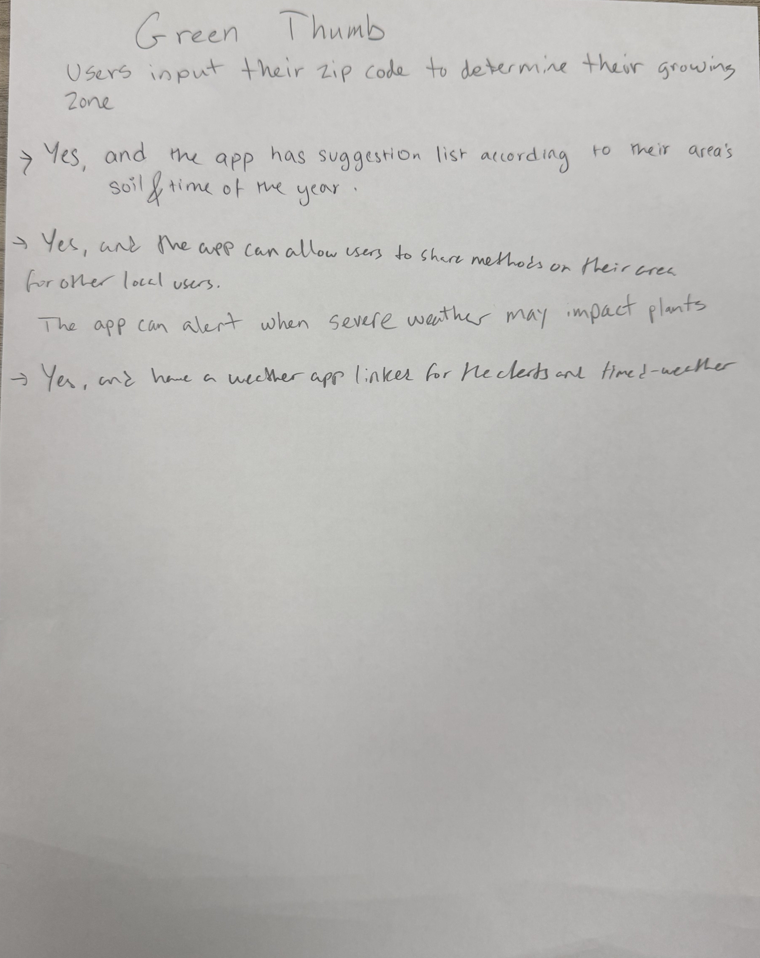

Team brainstorm notes for "Where's the Beef?":
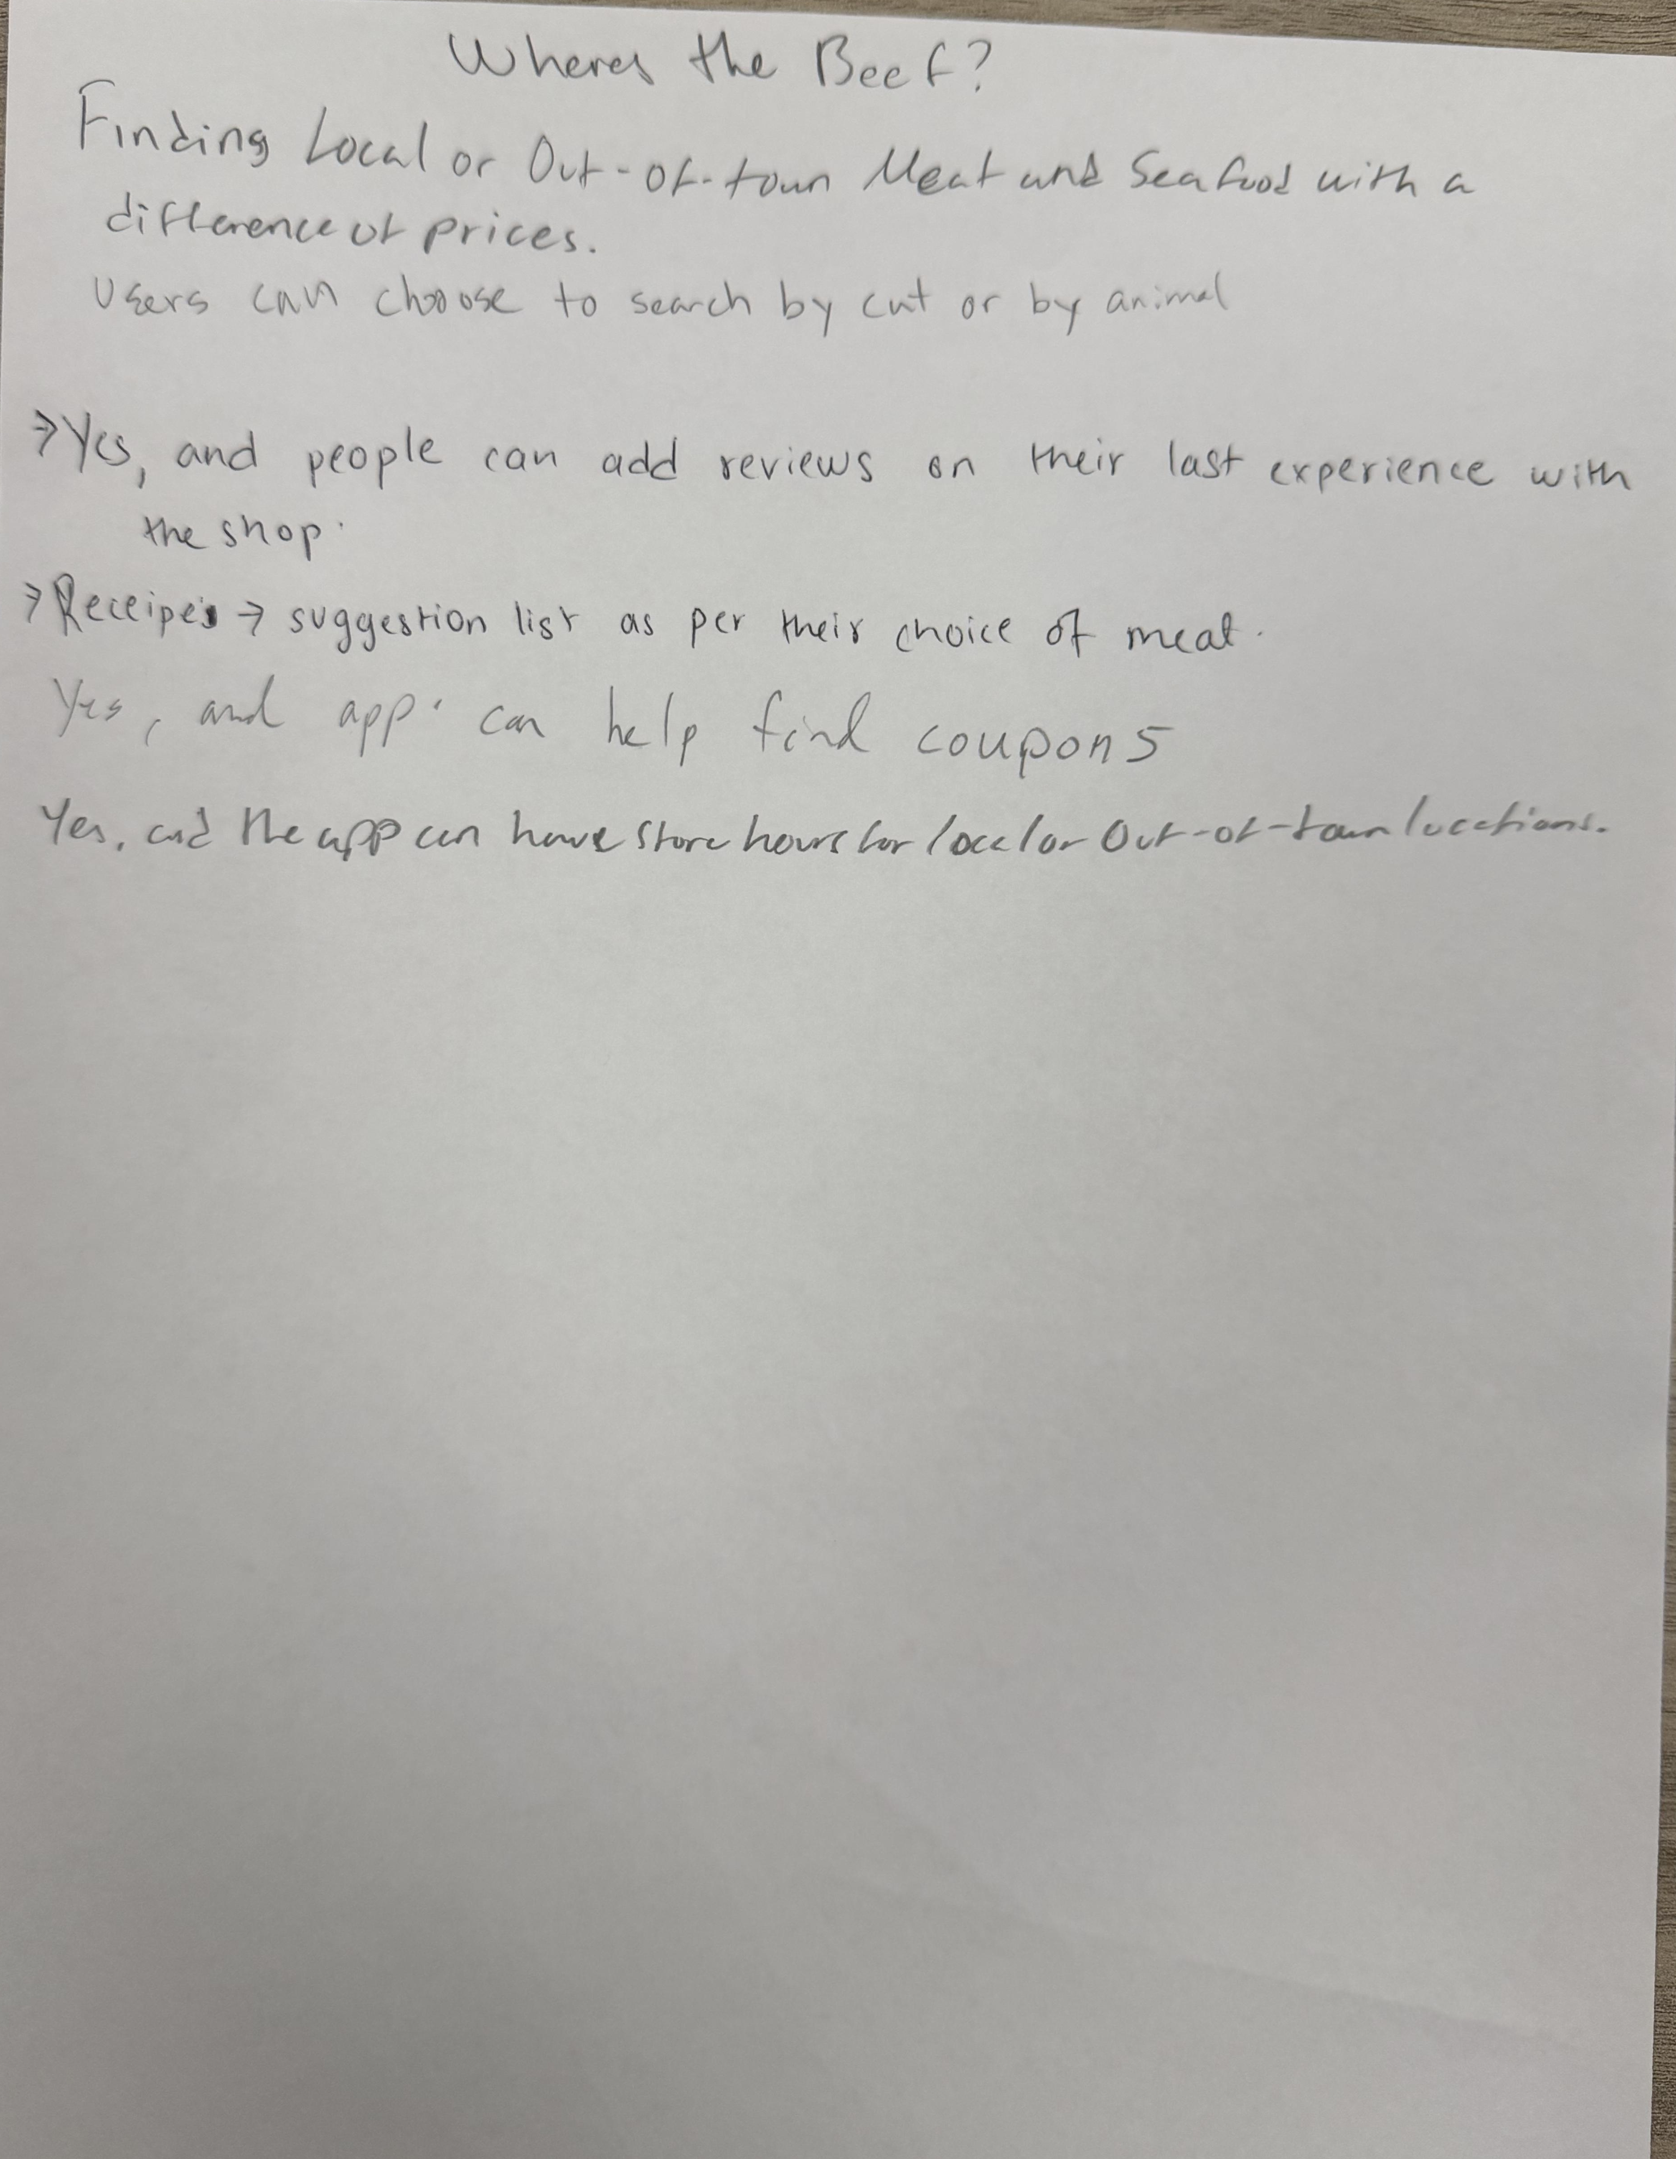

Character page "Dirt Nap Dave" proto-persona:
