Software Design Document
Mean Green Thumb

Team #: 4
Course: CSCE 3444.002 Software Engineering, Fall 2026
Instructor: Jiang Wei Lei
Date of Submission: 5 Oct 2026

Team Member | Student ID
Sudip Khadka | 11591520
Pete Maselli | 11808816
Xavier Rosado | 11678489

Section 1: Class Diagram
RegisteredUser - Represents someone with an Account. Holds their email, hashed password, zip code, assigned growing zone, and whether they’ve enabled notifications. Its methods handle registering, authenticating a login, saving a plant (creating a SavedPlant) and posting a tip.
GrowingZone - Represents a USDA hardiness zone, storing its zone code and regional data. It can look up which plants are in season on a given date and refresh its region data when the USDA source updates.
Plant - Represents a plant species with its name, description, and recommended planting time. It can report its own care tasks and check whether it’s in season for a given date and zone.
SavedPlant (MyPlantsEntry) - The join between a RegisteredUser and a Plant, tracking when it was planted. It manages the care tasks tied to that specific saved plant: adding one, listing pending tasks, and marking a task complete.
CareTask - A single to-do item tied to a SavedPlant (watering, pest check, etc.), with a description, due date, and completion status. It can mark itself complete, get rescheduled, or report whether it’s overdue.
Tip - A community gardening tip authored by a RegisteredUser and tagged with a growing zone, holding its text and timestamp. It can be published or edited.
Scheduler - A background actor that runs on a fixed interval (checkIntervalHours) and checks each registered user for severe weather, generating WeatherAlerts when needed.
WeatherAlert - A notification generated by the Scheduler for a RegisteredUser, holding a message and the time it was sent, with a method to send it (as an email, per FR-05/UC-05).

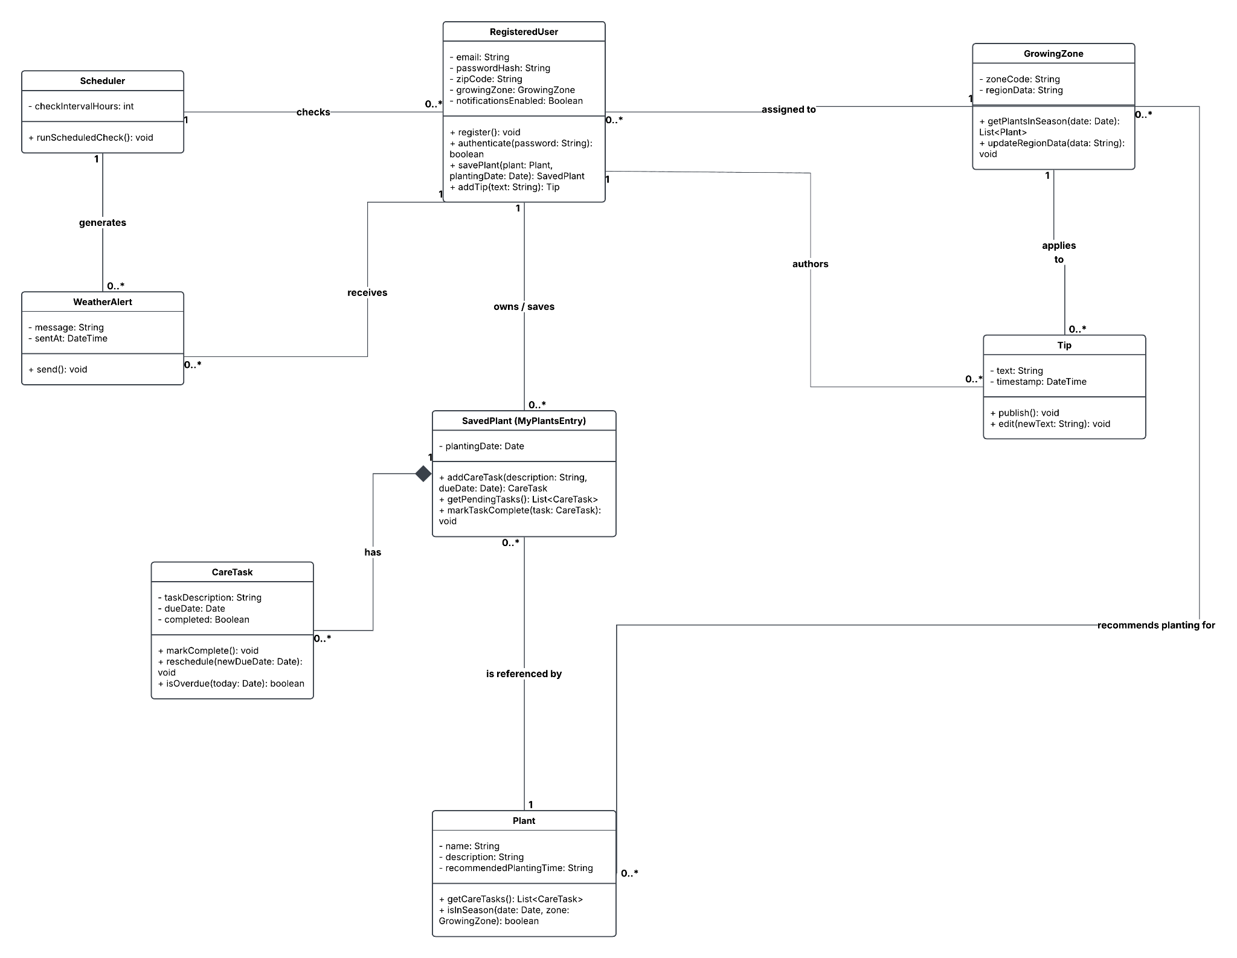

Section 2: System / Information Architecture Diagram 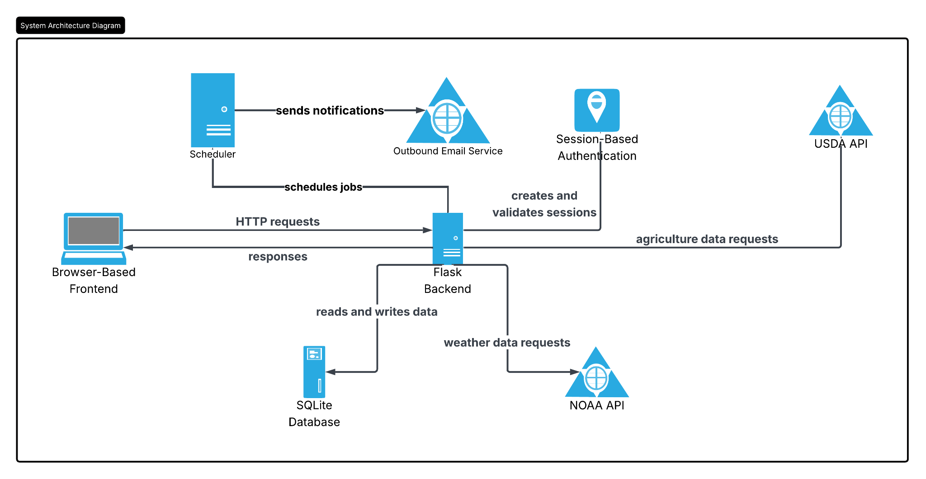
The Browser-based frontend communicates with the Flask backend over HTTP, sending requests and receiving responses. The backend creates and validates sessions through session-based authentication and persists application data by reading from and writing to SQLite. It retrieves external data from the USDA and NOAA APIs to support growing zone lookups and weather forecasts. Separately, the Scheduler runs on an interval and schedules jobs, which sends severe weather notifications through the Outbound Email Service.

Section 3: Sequence Diagrams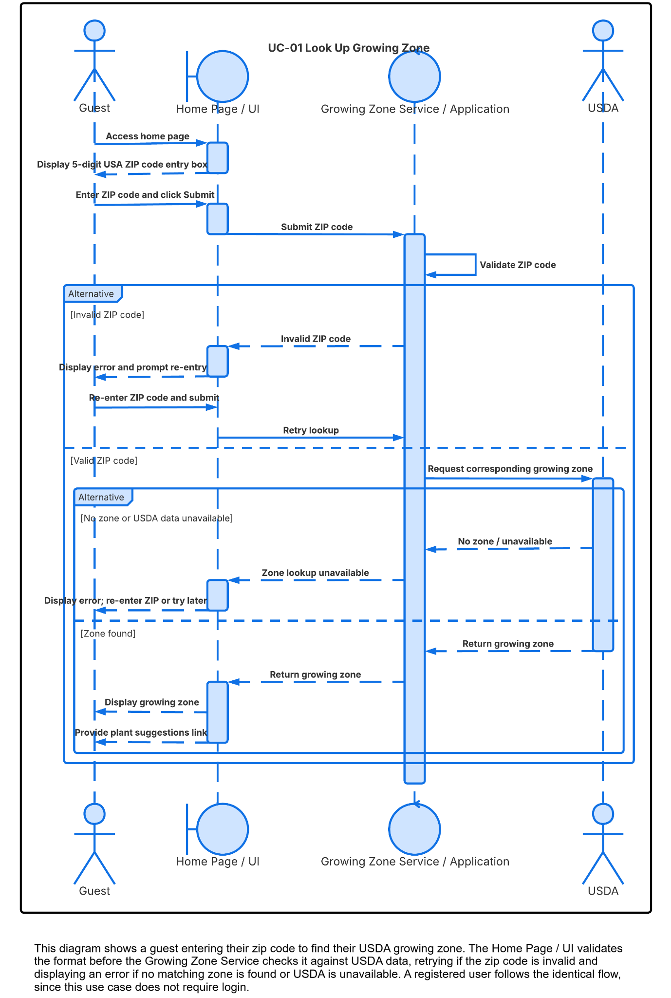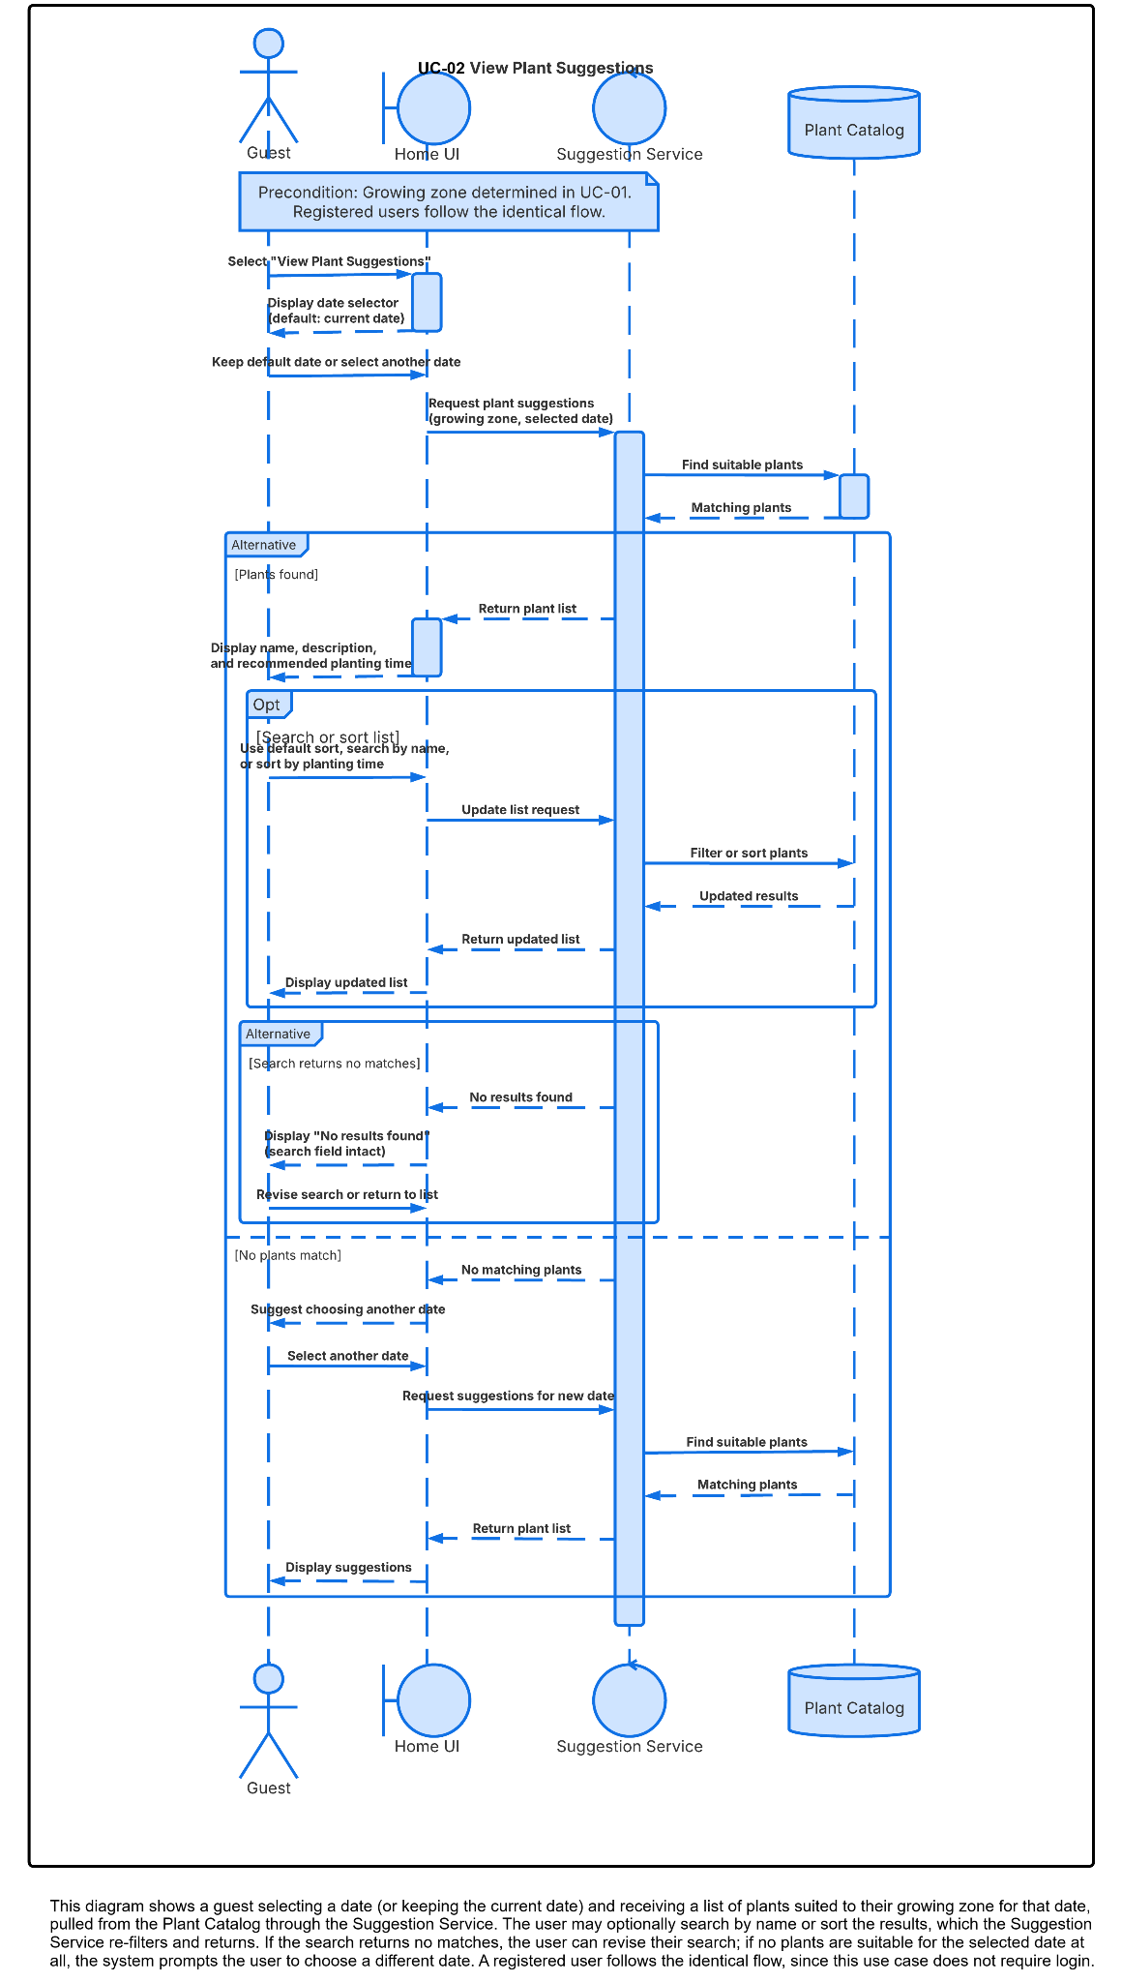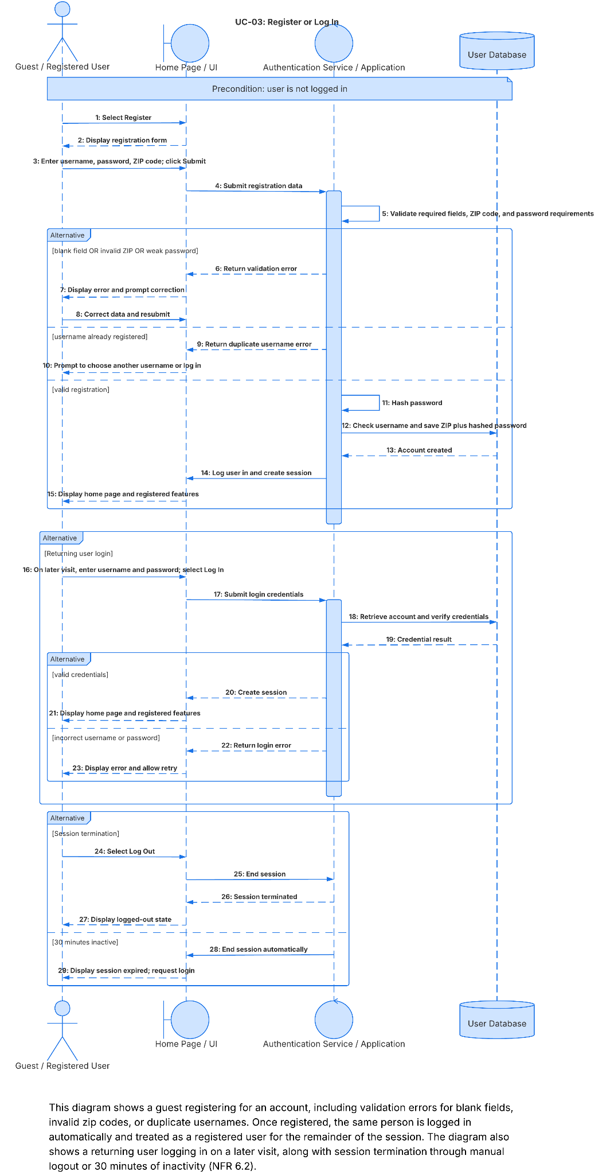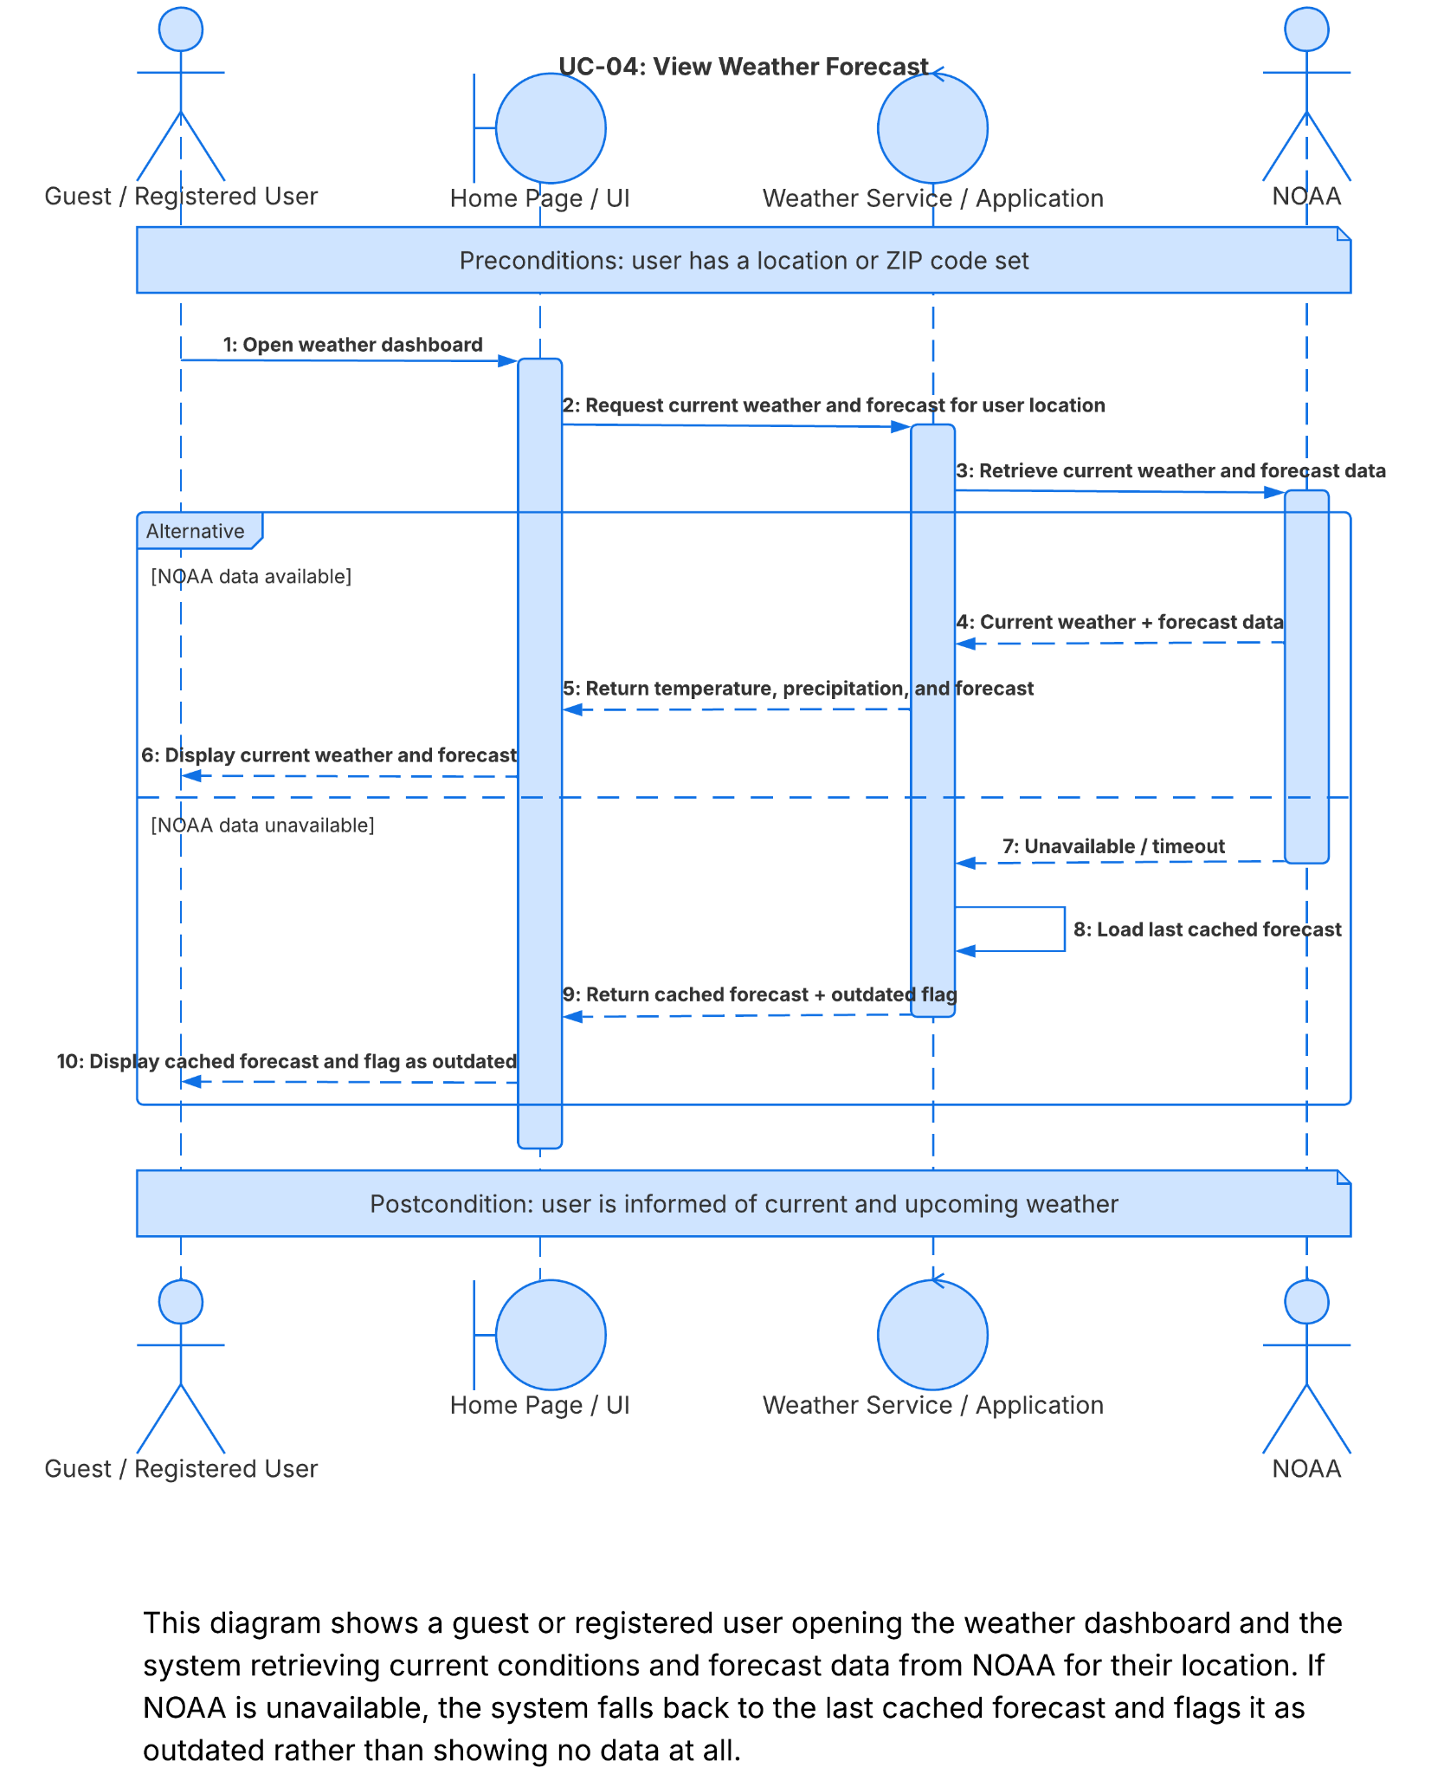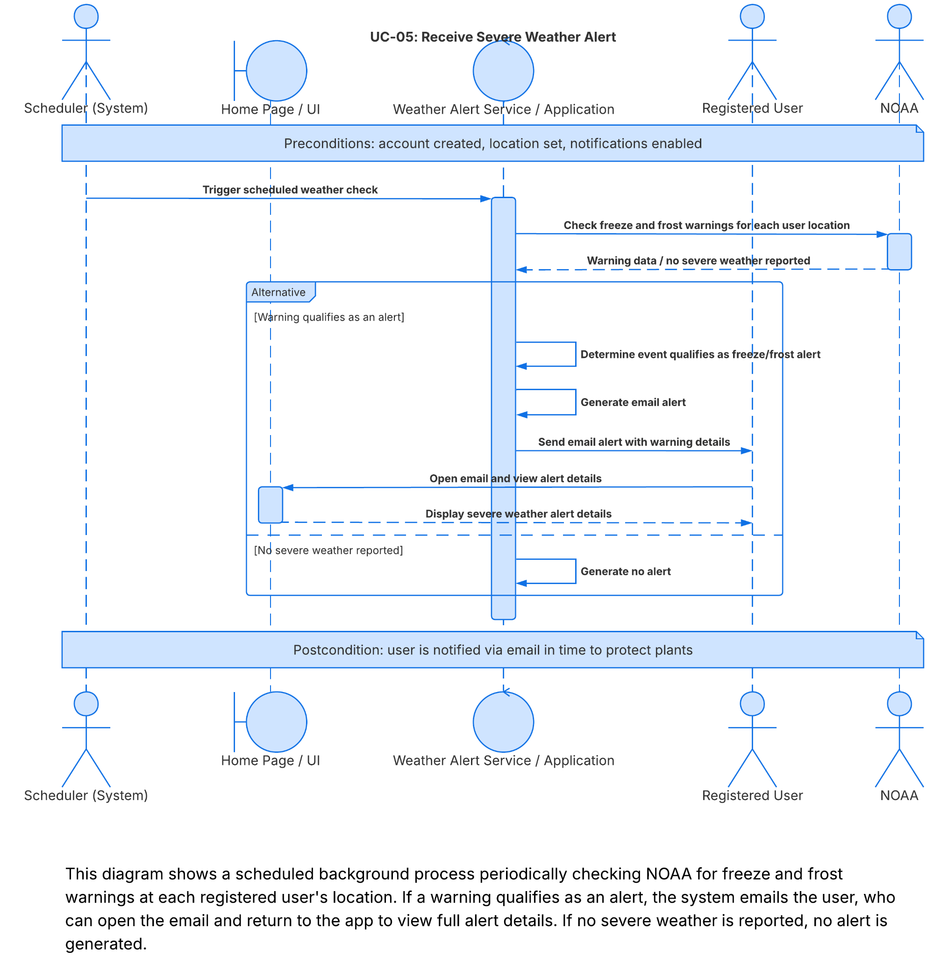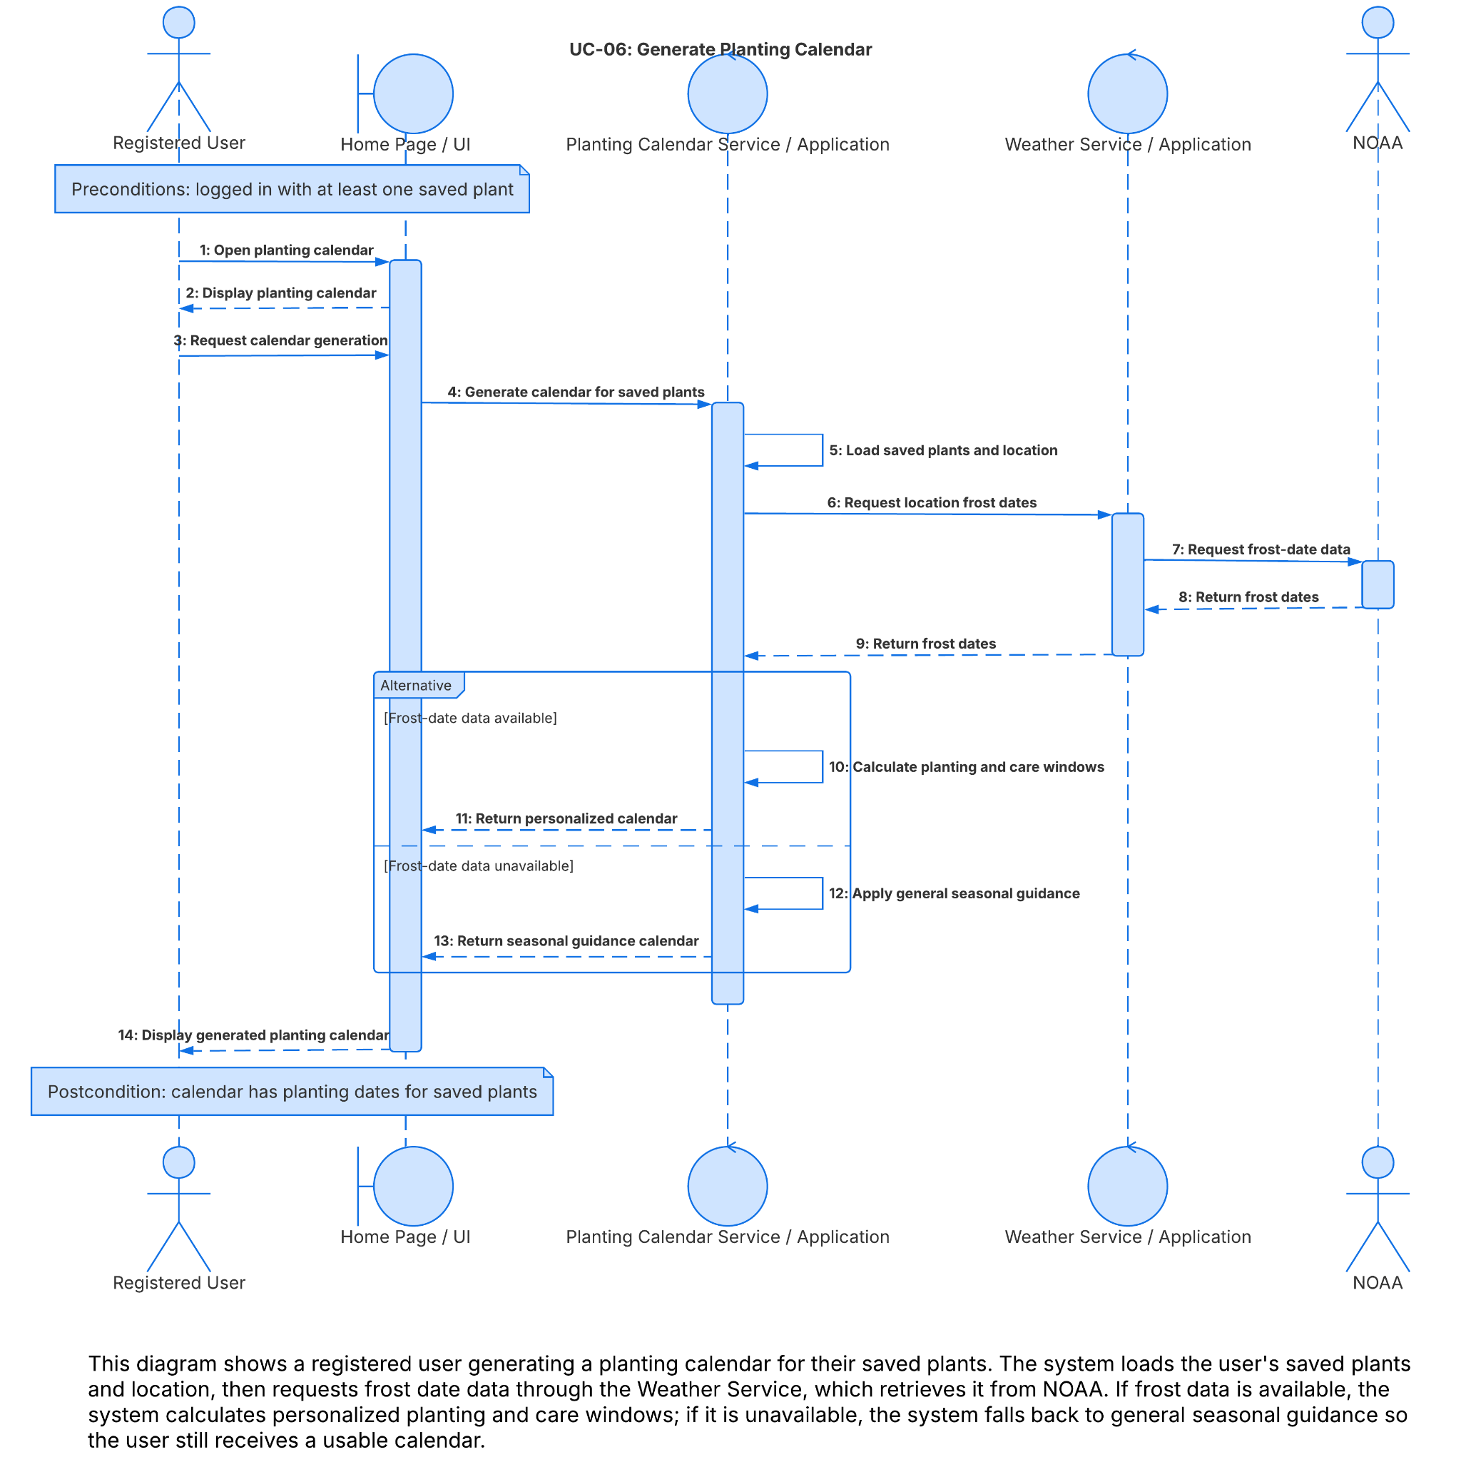
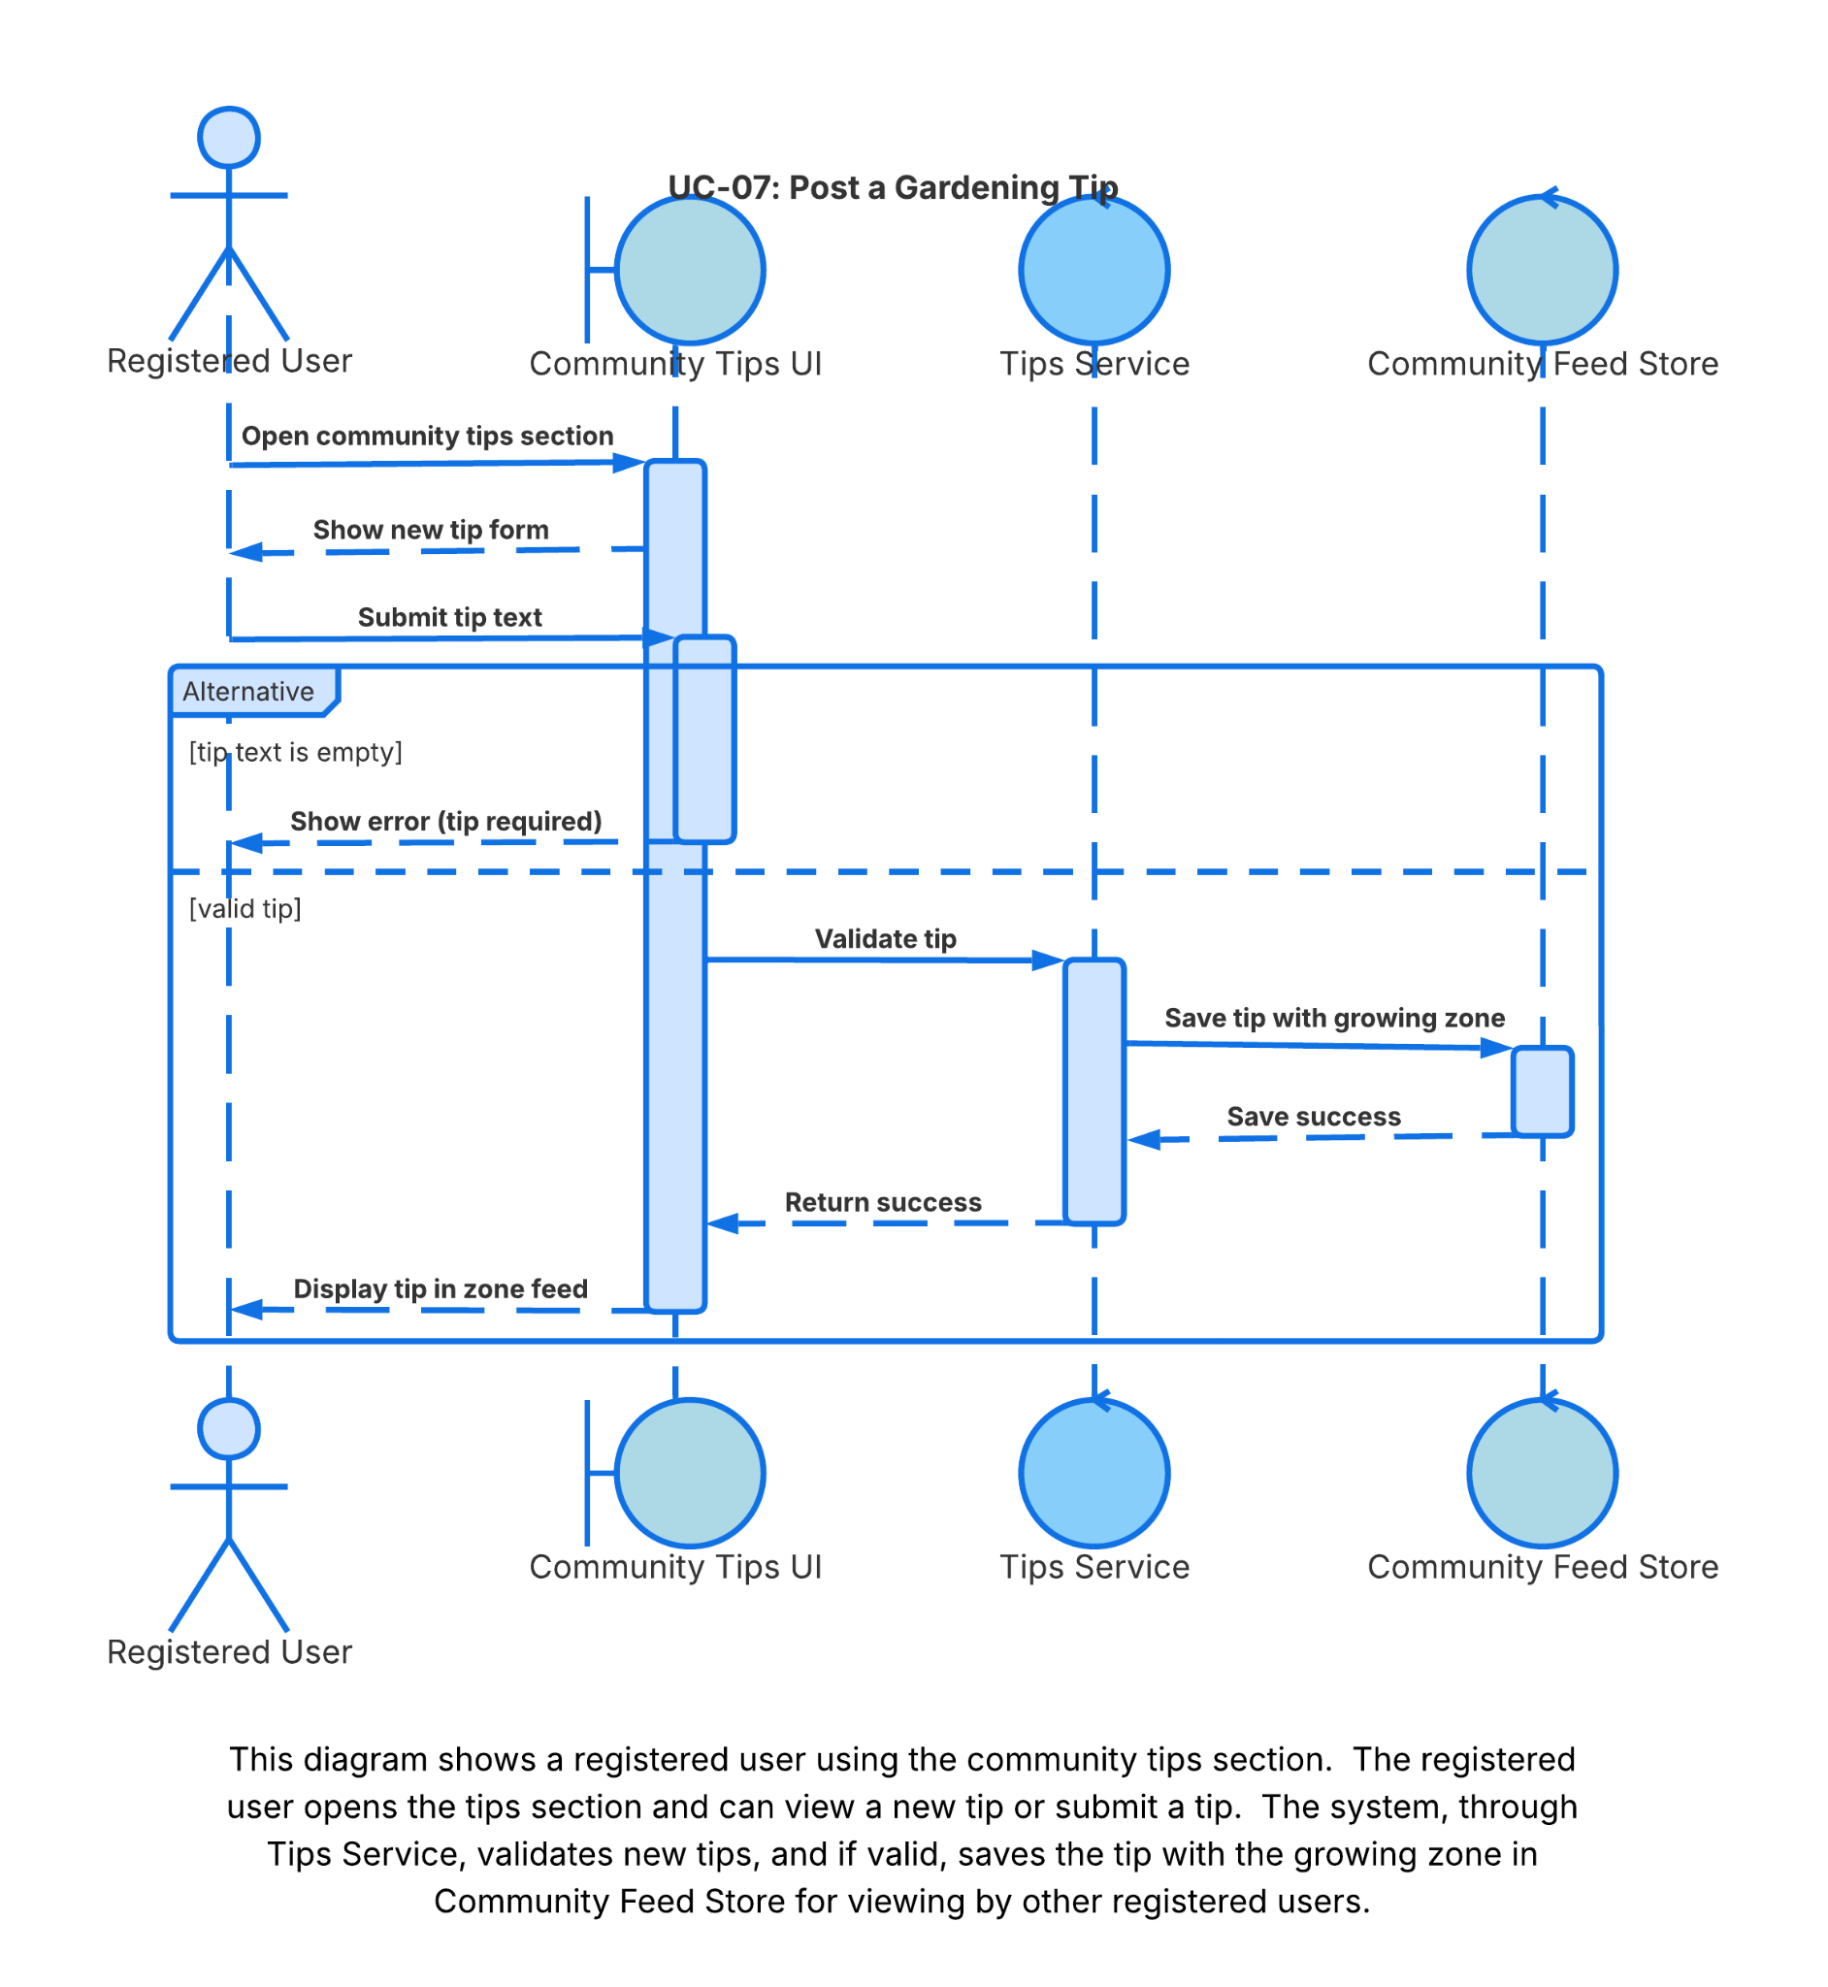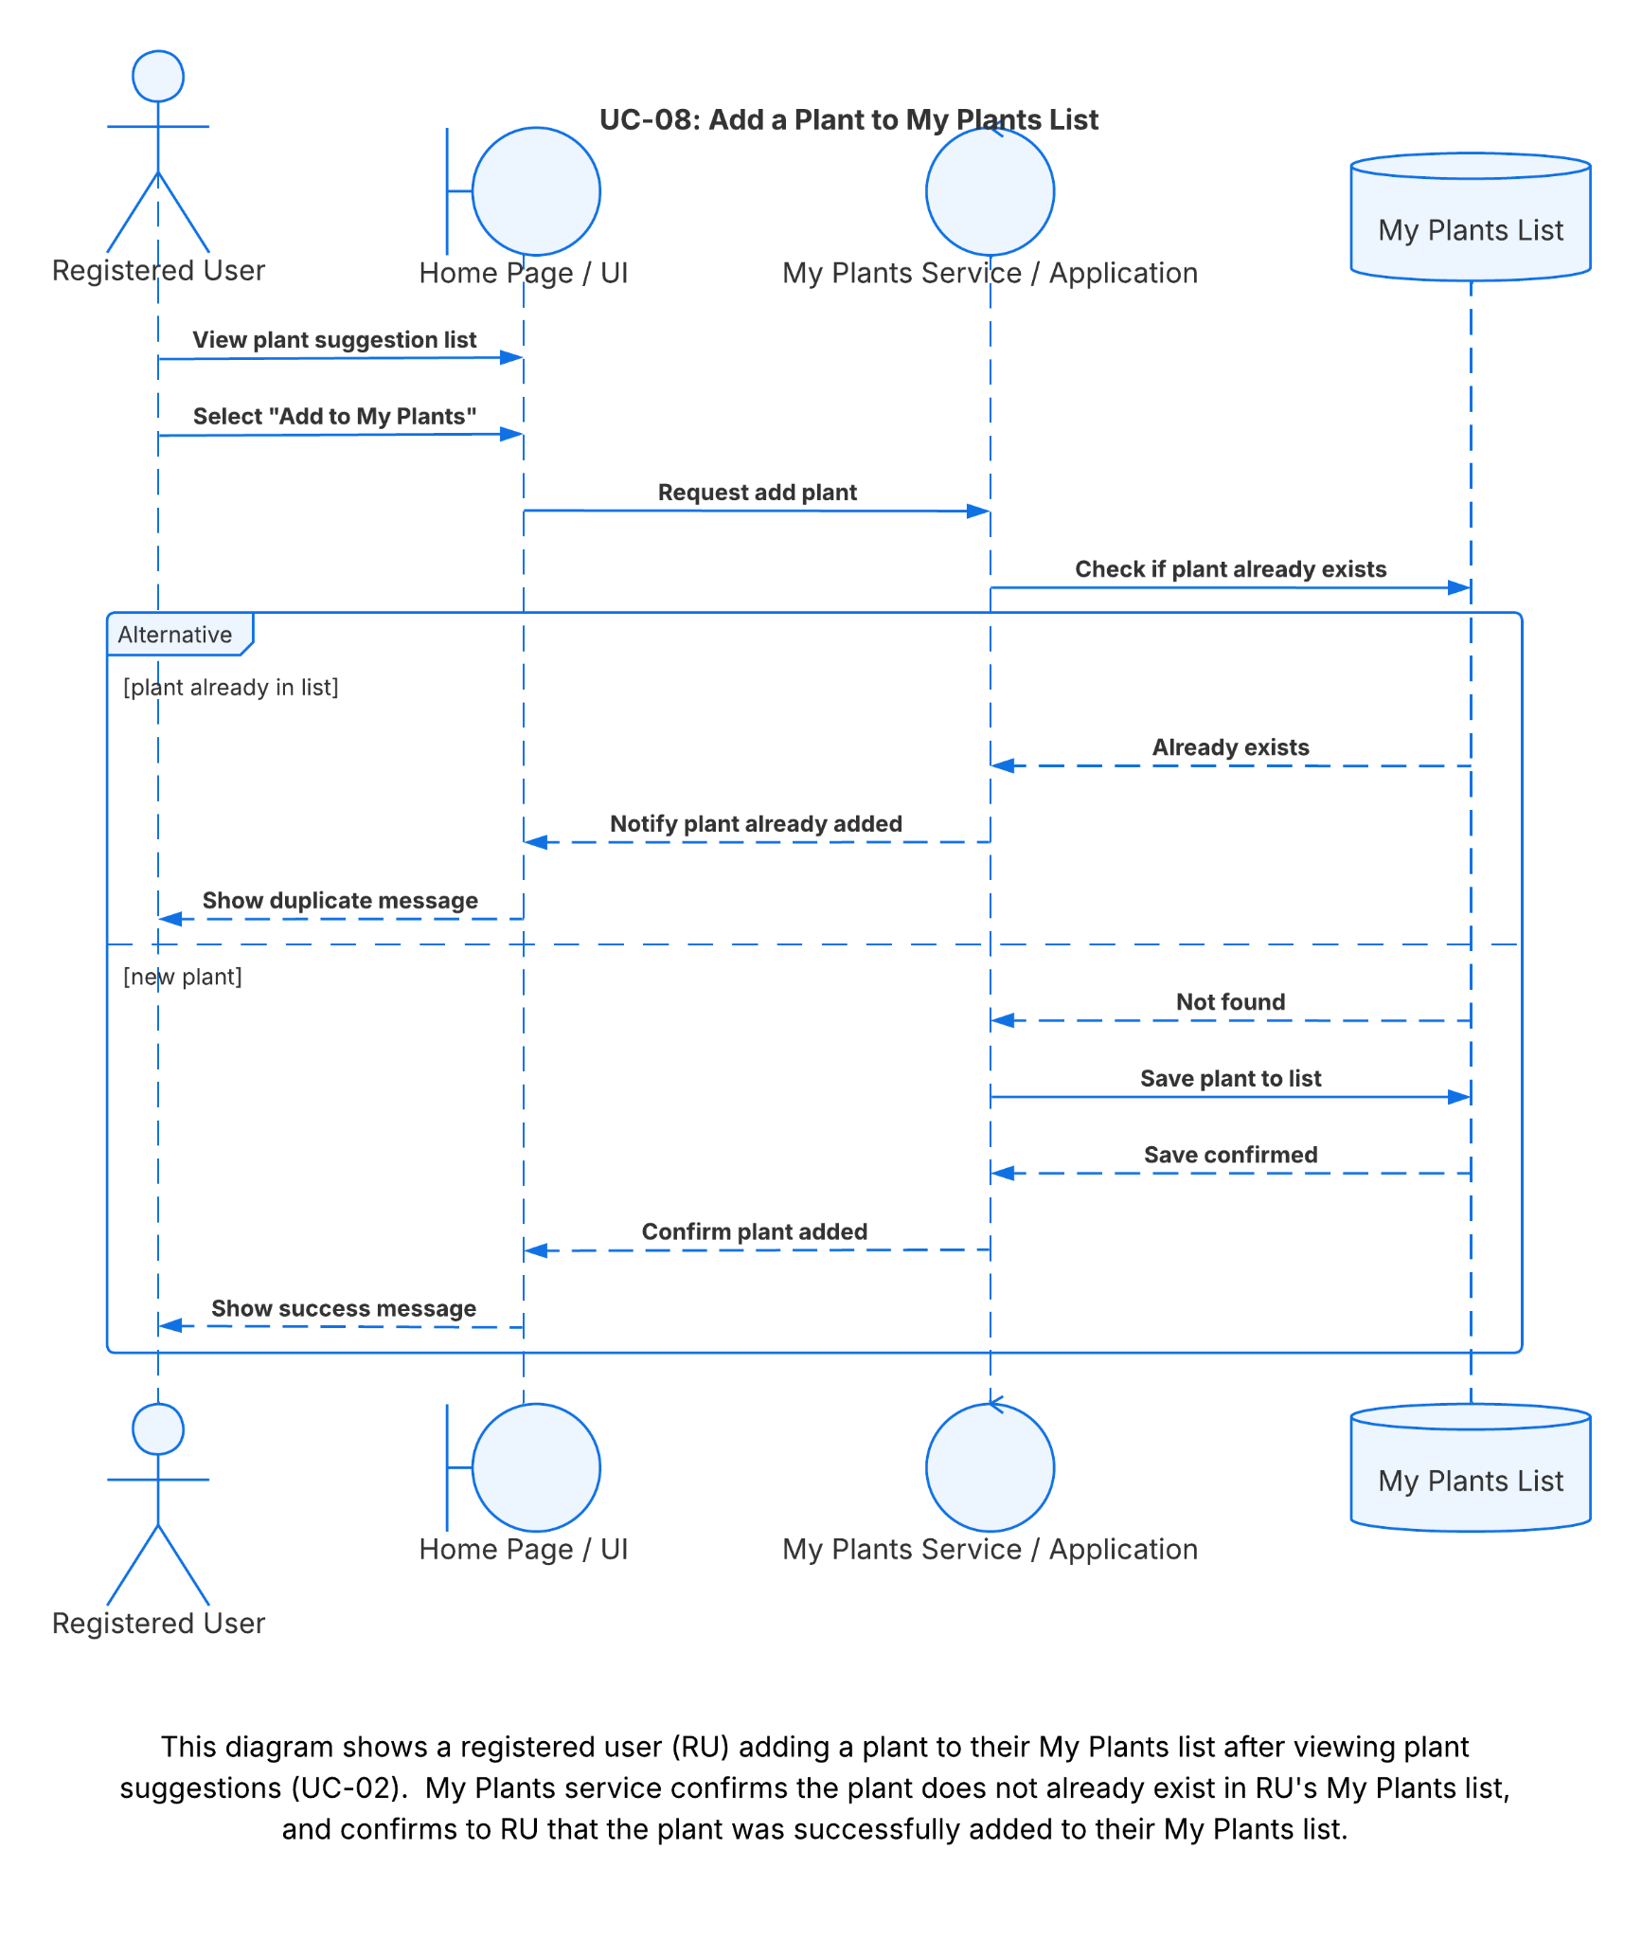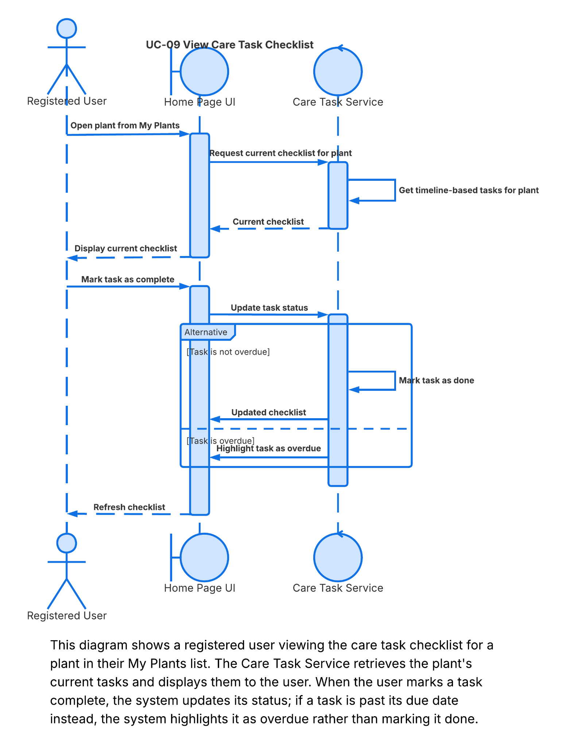
Section 4: User Interface Wireframes / Mockups
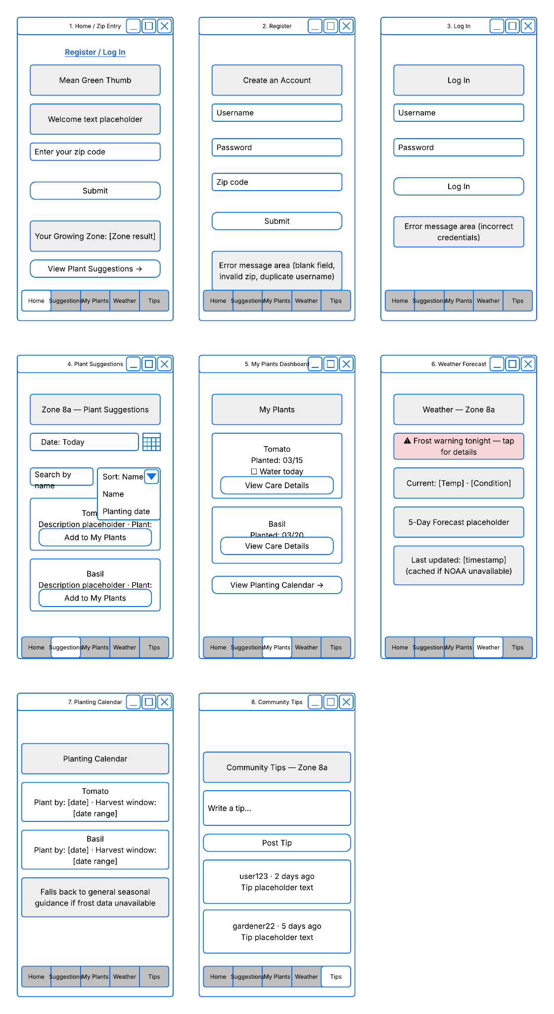
Section 5: ER Diagram / Data Model
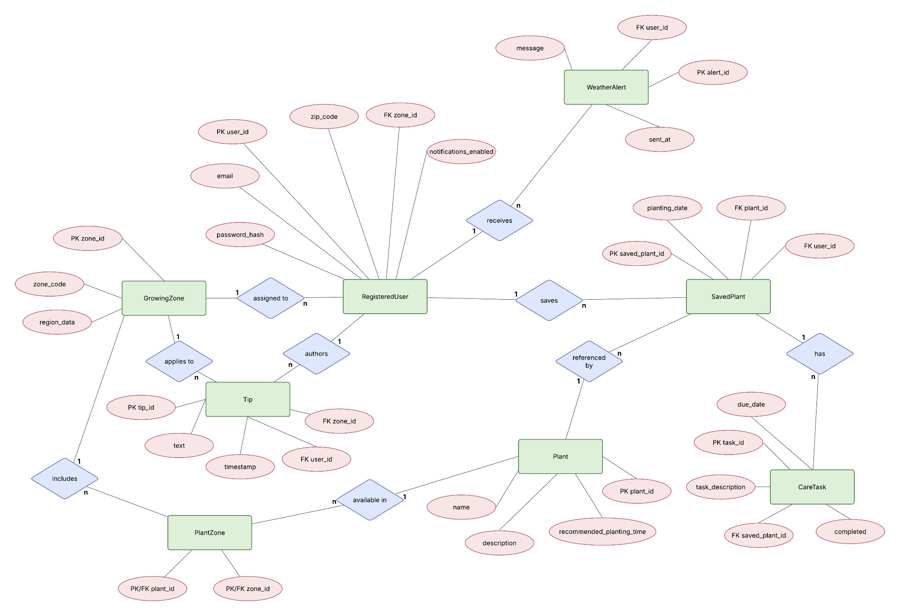
PK = Primary Key
FK = Foreign Key
Section 6: Individual Contributions
Name | Student ID | Work Completed
Sudip Khadka | 11591520 | Created Class Diagram, Lead on creating ER Diagram
Pete Maselli | 11808816 | Created Sequence Diagrams, Helped with ER Diagram and Class Diagram. Built Software design document skeleton.
Xavier Rosado | 11678489 | Created System Architecture Diagram, Helped with ER Diagram and Creating Sequence Diagrams

