HRMS Testing — Change Requirements & Bug Report
This document outlines all identified issues, expected behaviors, and required changes across the HRMS system modules. Each requirement is described in detail so developers and the AI system can accurately understand the problem, the expected workflow, and the precise fix required.

Section 1: Reported Issues — Sakshi

Issue 1: Dropdown Options Do Not Match Defined Workflow
Module: Super Admin Module
Navigation Path: Super Admin → [Relevant Module] → Dropdown Field
Current Behavior (Issue):
The dropdown options currently displayed in the Super Admin module do not correspond to the workflow that has been defined and configured for the system. The available options in the dropdown appear to be generic or default values that do not reflect the actual business process.
Expected Behavior:
The dropdown options must be updated to exactly match the workflow options as configured in the Super Admin module. The values shown in the dropdown should be dynamically or statically aligned with the predefined workflow steps so that data entry is consistent and accurate.
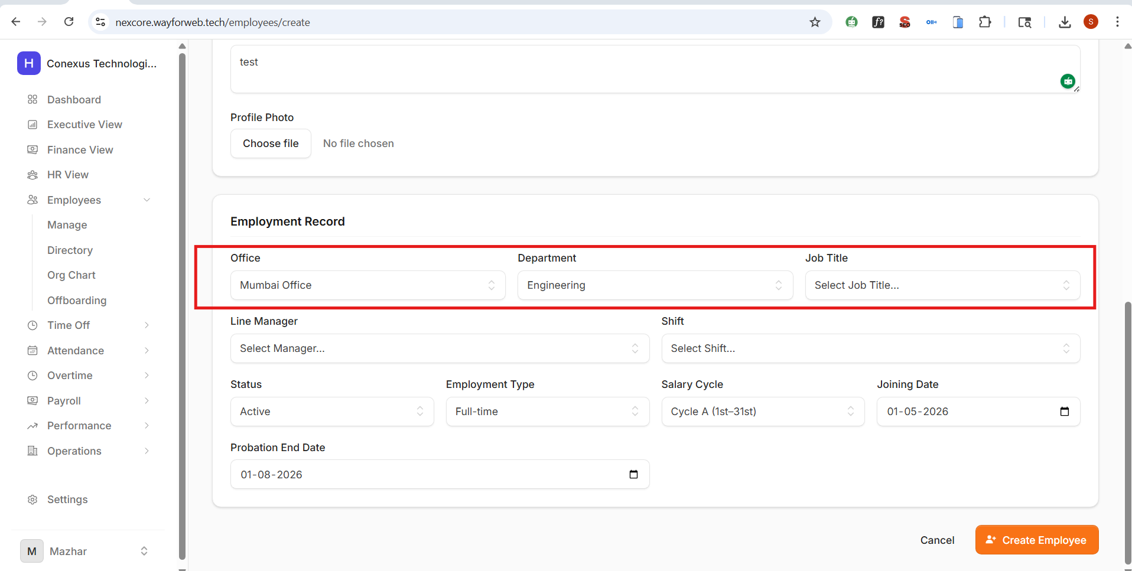
Issue 2: Salary Cycle Options Do Not Match Configured Options
Module: Super Admin Module
Navigation Path: Super Admin → [Payroll / Salary Settings] → Salary Cycle
Current Behavior (Issue):
The salary cycle dropdown in the Super Admin module is displaying options that do not match the exact salary cycle configurations that have been set up in the system. This causes a mismatch between what is available to the user and what is actually configured.
Expected Behavior:
The salary cycle dropdown must display options that exactly match the salary cycle entries configured in the system. Any pre-existing or placeholder options that differ from the actual configuration must be removed or replaced. The field should reflect live or correctly seeded configuration data.
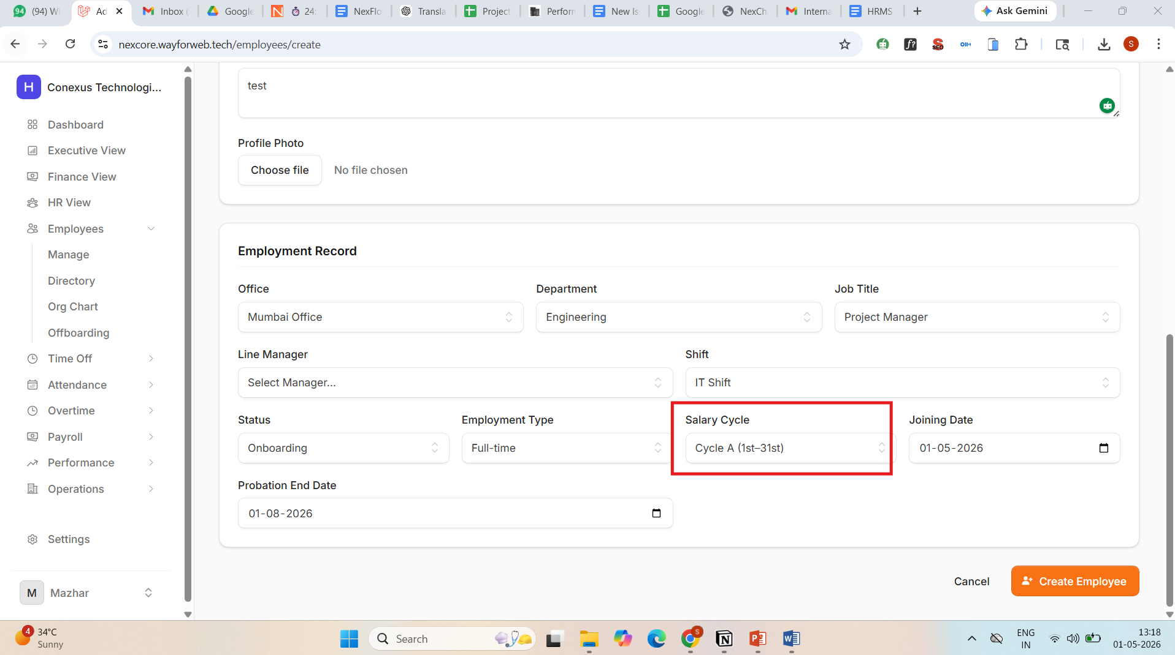
Issue 3: Error Occurs When Adding a New Employee via Super Admin Module
Module: Super Admin Module
Navigation Path: Super Admin → People → Manage Employees → Add New Employee
Current Behavior (Issue):
When a Super Admin attempts to add a new employee through the Super Admin module, an error is thrown during the submission or processing step. The exact error message is visible in the attached screenshot. This prevents the successful creation of a new employee record.
Expected Behavior:
The system should allow the Super Admin to successfully add a new employee without any errors. All required fields should be validated properly before submission, and upon successful save, the new employee record should be created in the database and displayed in the employee list.
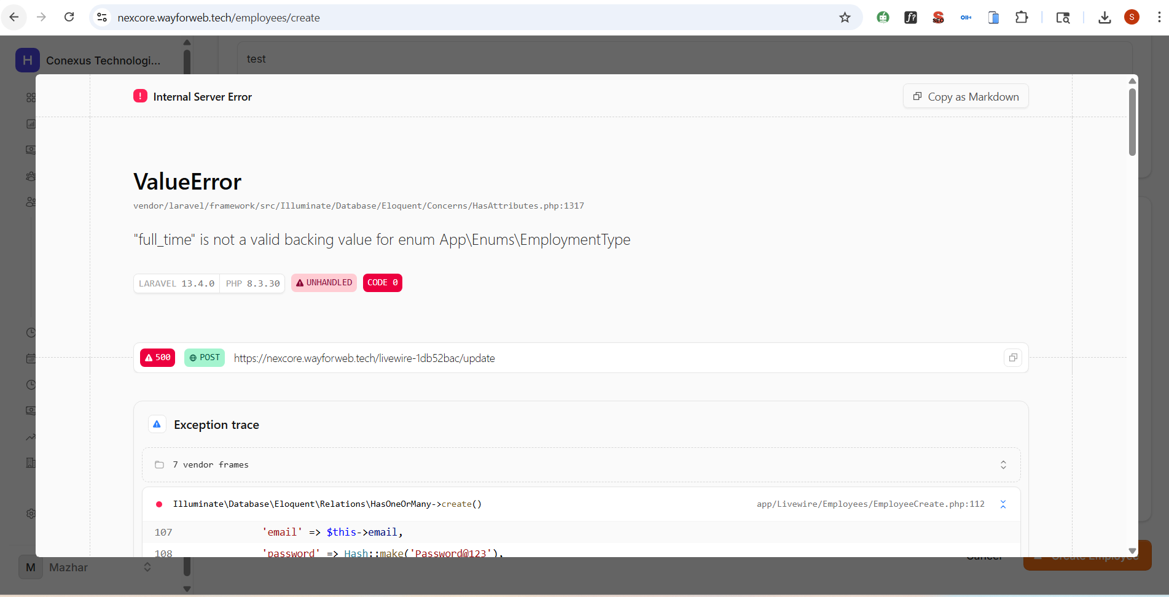
Issue 4: No Success Confirmation Message Shown After Form Submission
Module: Employee Module
Navigation Path: Employee Module → [Any Request-Based Action] → Submit
Current Behavior (Issue):
When an employee submits any type of request (e.g., leave request, expense claim, regularization, etc.) through the Employee module, no success confirmation is displayed to the user. As a result, the employee cannot tell whether the request was submitted successfully or if it failed silently.
Expected Behavior:
Upon successful form submission for any request-based functionality within the Employee module, a visible success snackbar notification must appear on screen. The message should clearly state that the request was submitted successfully. This behavior must be implemented consistently across all request forms in the Employee module.
Issue 5: Super Admin Does Not Receive Leave Request Notification
Module: Employee Module / Super Admin Module
Navigation Path: Employee Module → Leave → Apply Sick Leave
Current Behavior (Issue):
When an employee submits a sick leave request from the Employee module, the Super Admin does not receive any notification or alert in their module. The Super Admin is only able to view the leave request after manually searching for the employee by name. There is no automated notification mechanism in place.
Expected Behavior:
When an employee submits any leave request, the Super Admin should automatically receive a real-time notification in their module (inbox, notification bell, or notification panel). The notification should include the employee's name, the type of leave, and the requested dates. The Super Admin should not need to perform a manual search to discover pending leave requests.
⚠️ Additional Note: This same notification issue exists in the reverse direction — the Employee module also does not receive notifications when their leave is approved, rejected, or cancelled. Both notification flows (Employee → Super Admin and Super Admin → Employee) must be fixed.
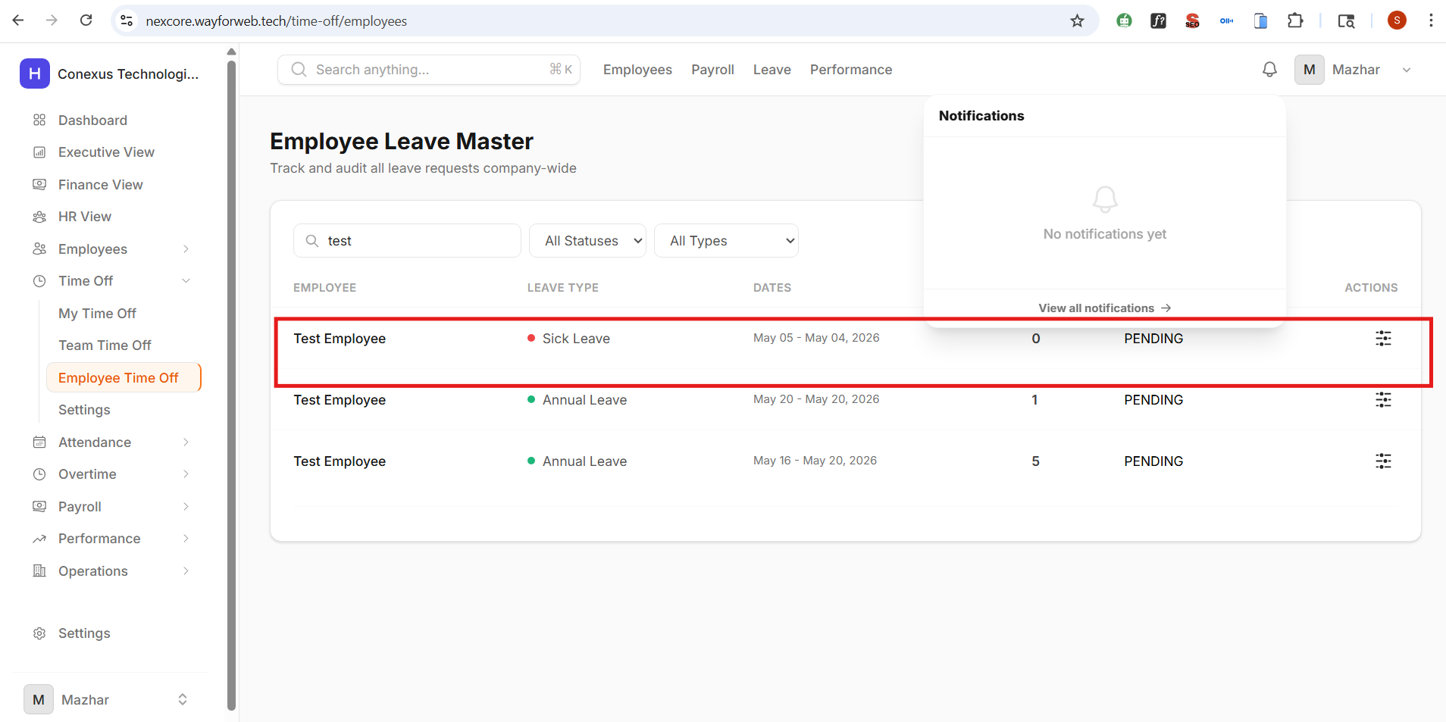
Issue 6: Error Occurs When Approving Leave; Cancellation Saves Instead
Module: Super Admin Module / Employee Module
Navigation Path: Super Admin → Leave Management → Approve Leave
Current Behavior (Issue):
When the Super Admin attempts to approve a leave request, an error message (shown in red) is displayed, and the leave is not approved. However, when the Super Admin then attempts to cancel the same leave, it is saved as cancelled successfully. This indicates a bug specifically in the approval action. The expected red error indicator is not appearing as it should when this error occurs.
Expected Behavior:
The approval action for leave requests must execute without errors. Upon clicking "Approve," the system should process the approval, update the leave status to "Approved," and send the appropriate notification to the employee. No error should be thrown during this process, and the UI should clearly reflect the updated status after approval.
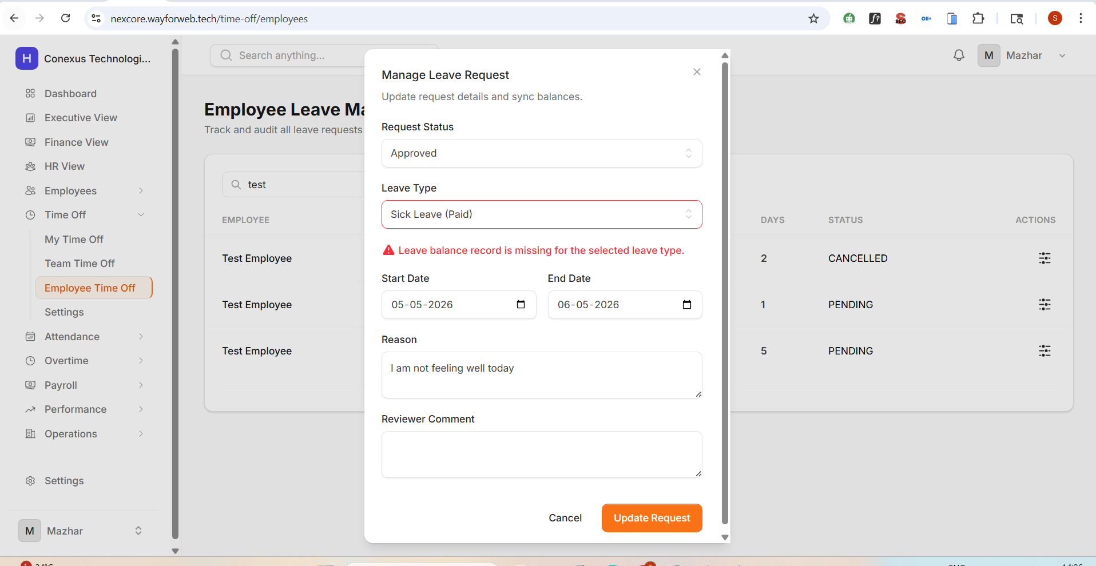
Issue 7: Notification System Is Completely Non-Functional Across All Modules
Module: All Modules
Navigation Path: Super Admin / HR / Employee / Manager → Notifications Panel
Current Behavior (Issue):
No notifications are being delivered or displayed across any module in the system. This includes the Super Admin, HR, Employee, and Manager modules. Events that should trigger notifications — such as leave requests, approvals, rejections, and cancellations — are generating no alerts for any user role.
Expected Behavior:
The notification system must function correctly for all modules. Every user role (Super Admin, HR, Employee, Manager) must receive relevant real-time notifications based on their role-specific events. The notification system should support both in-app notifications (bell icon / inbox) and status updates within the respective module dashboards.
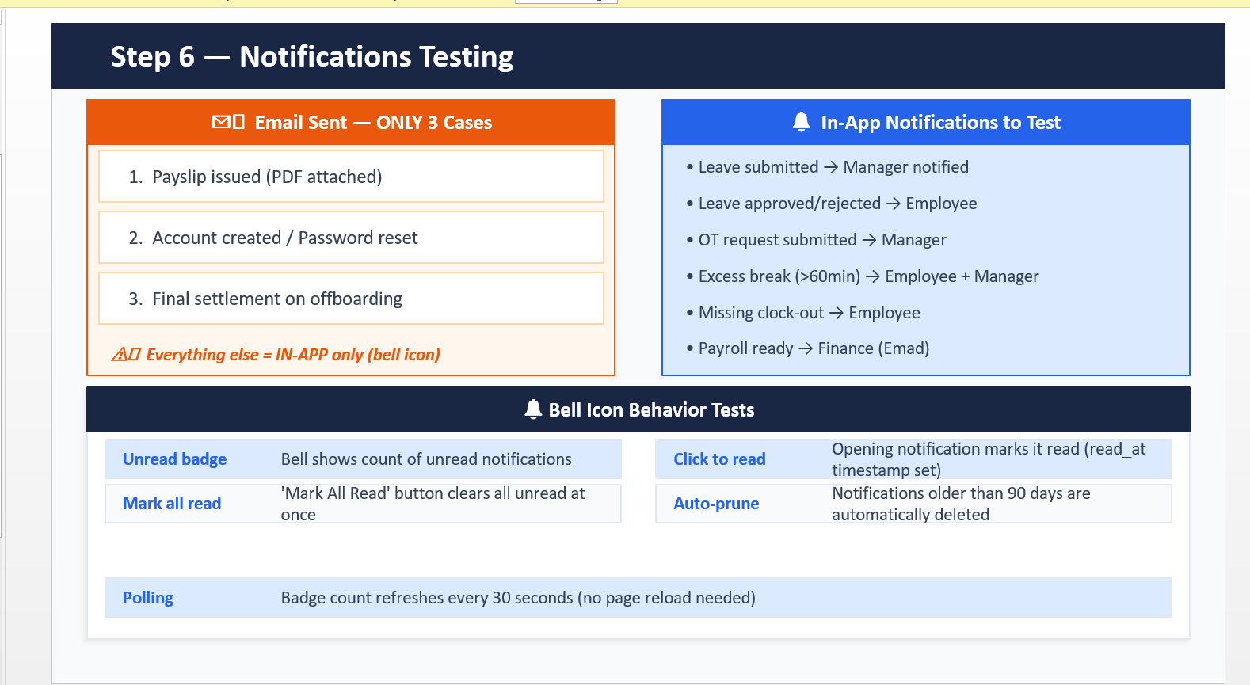
Issue 8: HR Can Directly Reject Leave Without Following the Approval Workflow
Module: HR Module
Navigation Path: HR Module → Leave Management → Reject Leave
Current Behavior (Issue):
The HR module currently allows the HR user to directly reject a leave request without checking whether the Super Admin has already approved it. This bypasses the required approval hierarchy. The correct process dictates that HR can only take action on a leave request after it has first been reviewed or approved by the Super Admin.
Expected Behavior:
The HR module must enforce the defined leave approval workflow. HR should not be able to reject a leave request that has not yet been processed by the Super Admin. If the Super Admin has not yet approved the leave, the reject option for HR should either be disabled, hidden, or display a warning message instructing HR to wait for Super Admin approval before proceeding. This role-based access control must be enforced at both the UI and API/backend levels.
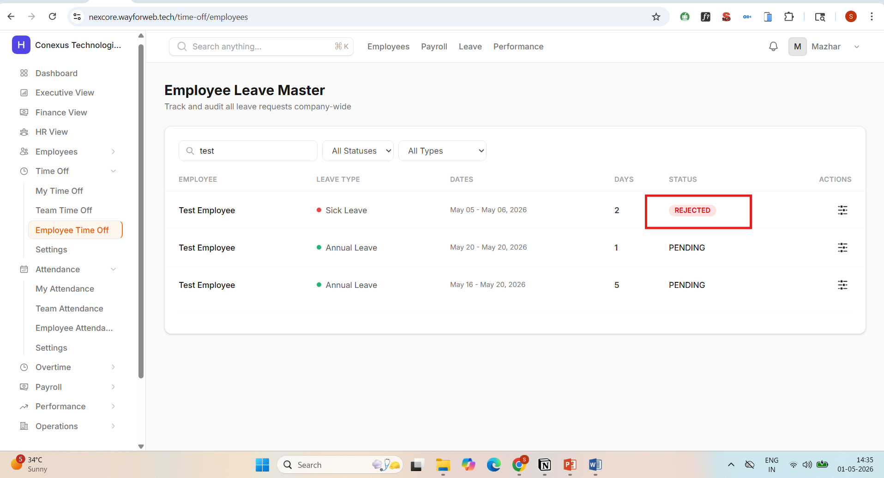
Issue 9: Super Admin Cannot Review Completed Employee Assessments
Module: Super Admin Module
Navigation Path: Super Admin → Assessments / Tests → View Submitted Test
Current Behavior (Issue):
When the Super Admin navigates to the assessments or test section to review a test submission made by an employee, an error occurs that prevents the content from loading. The Super Admin is unable to view the details of any completed assessment, rendering the review functionality completely broken.
Expected Behavior:
The Super Admin must be able to access and review all submitted employee assessments without errors. The assessment review page should load the employee's submitted answers, scores, and completion details correctly. All data associated with the completed assessment should be retrievable and displayed in a readable format.
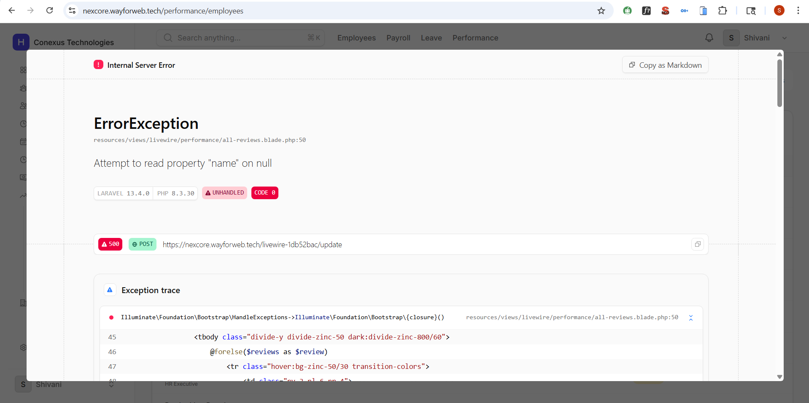
Issue 10: Feature or Page Is Not Working / Failing to Load
Module: Super Admin Module
Navigation Path: Super Admin → [Section is not loading correctly]
Current Behavior (Issue):
A specific feature or page within the system is not functioning. The page or component fails to load, returns an error, or displays blank content. The attached screenshot shows the current broken state.
Expected Behavior:
The identified feature or page should load and function correctly. All associated data must be fetched and rendered without errors. If the issue is related to a backend API failure, the relevant endpoint must be debugged and fixed.
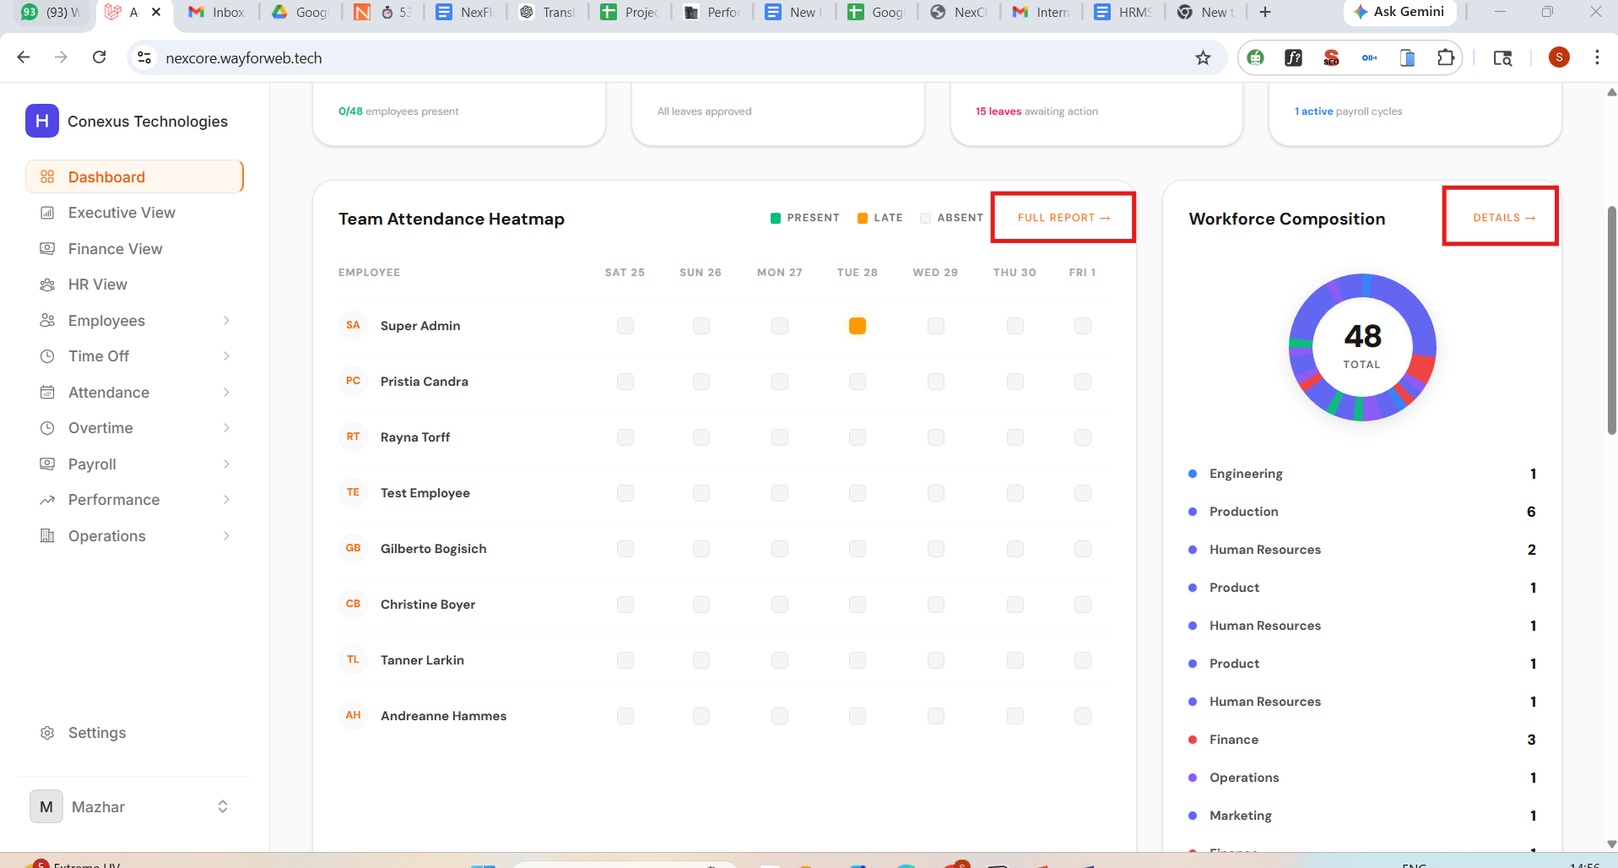
Issue 11: Search Functionality Is Not Working in the Team Performance Review Section
Module: Super Admin Module
Navigation Path: Super Admin → People → Team Performance Review → Search Bar
Current Behavior (Issue):
In the Team Performance Review section of the Super Admin module, the search bar does not return any results when a query is entered. Typing an employee name, team name, or any relevant keyword does not filter or surface any matching records.
Expected Behavior:
The search functionality in the Team Performance Review section must work correctly and return relevant results based on the entered keyword. Search should be implemented against key fields such as employee name, team, department, and review period. This fix must also be applied as a check across all other search bars in the system to ensure consistent search functionality throughout all modules.
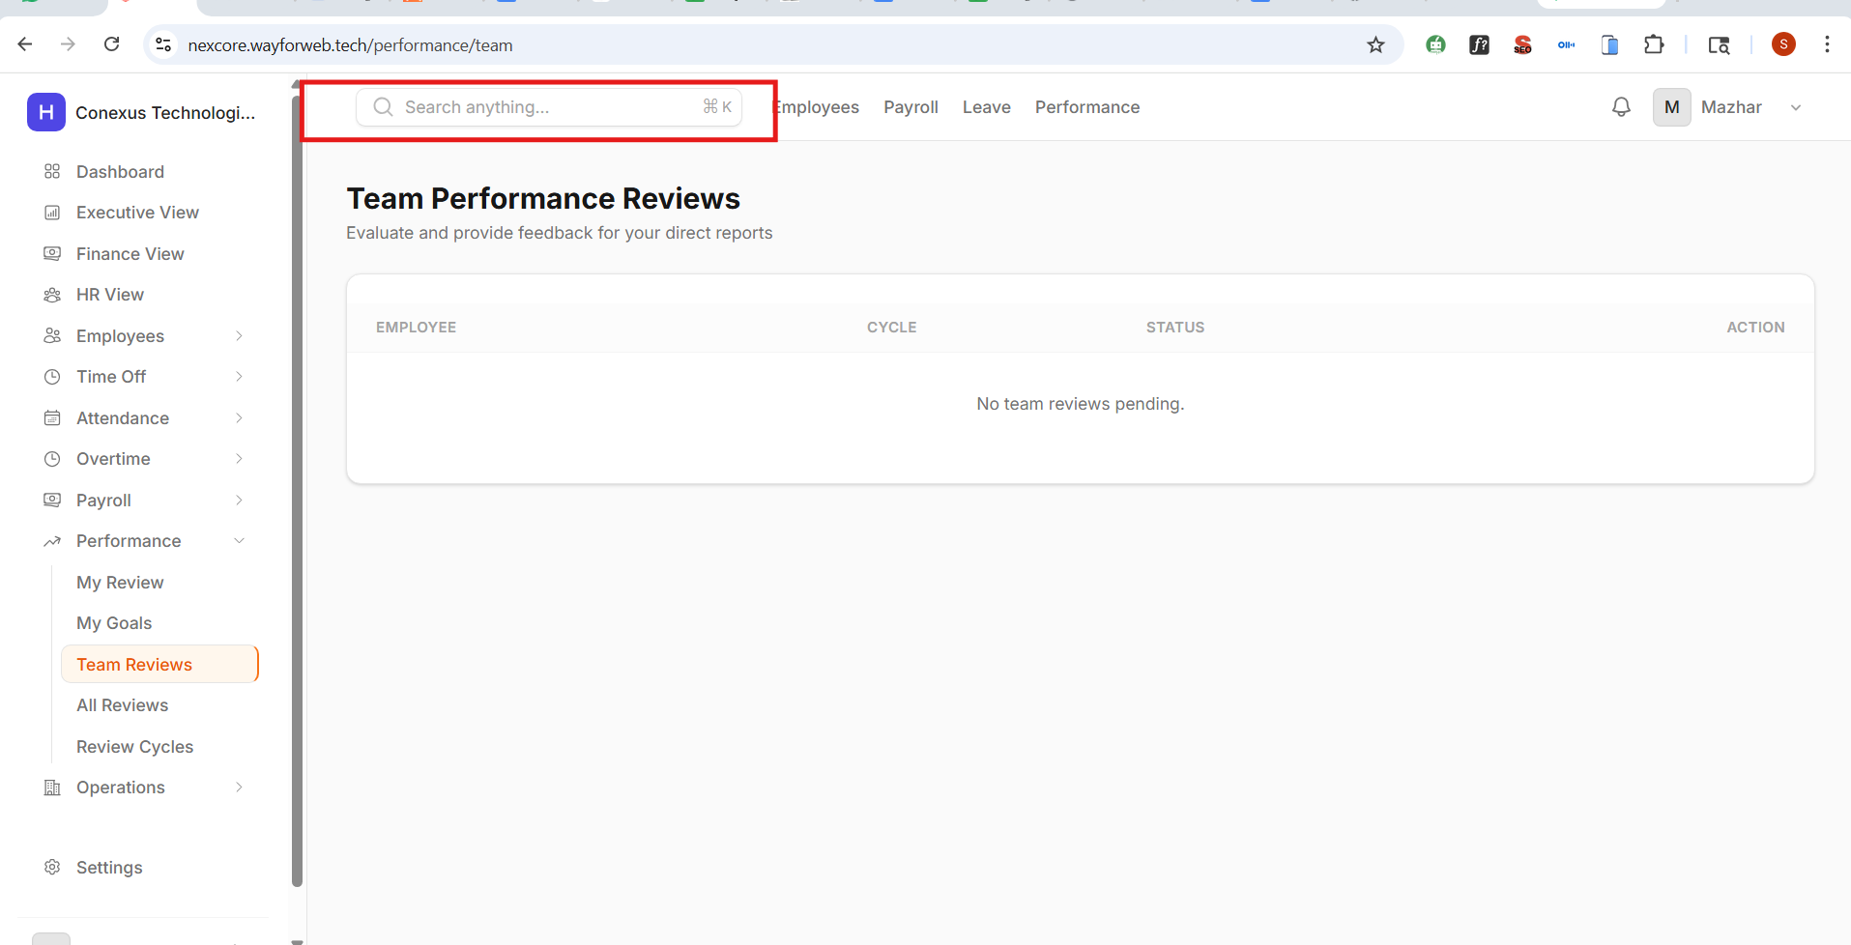
Issue 12: HR Can Directly Reject Clock-In Requests Without Super Admin Approval
Module: HR Module
Navigation Path: HR Module → Attendance / Time Tracking → Reject Clock-In Request
Current Behavior (Issue):
The HR module allows the HR user to directly reject an employee's clock-in request without verifying whether the Super Admin has already approved it. This bypasses the defined approval hierarchy, which requires Super Admin review before HR can take any follow-up action.
Expected Behavior:
The clock-in request rejection workflow must enforce the correct approval hierarchy. HR should only be permitted to reject a clock-in request after the Super Admin has first approved it. If the Super Admin has not yet reviewed the request, the rejection option for HR must be disabled or blocked with a clear message explaining that Super Admin approval is required before HR can proceed.
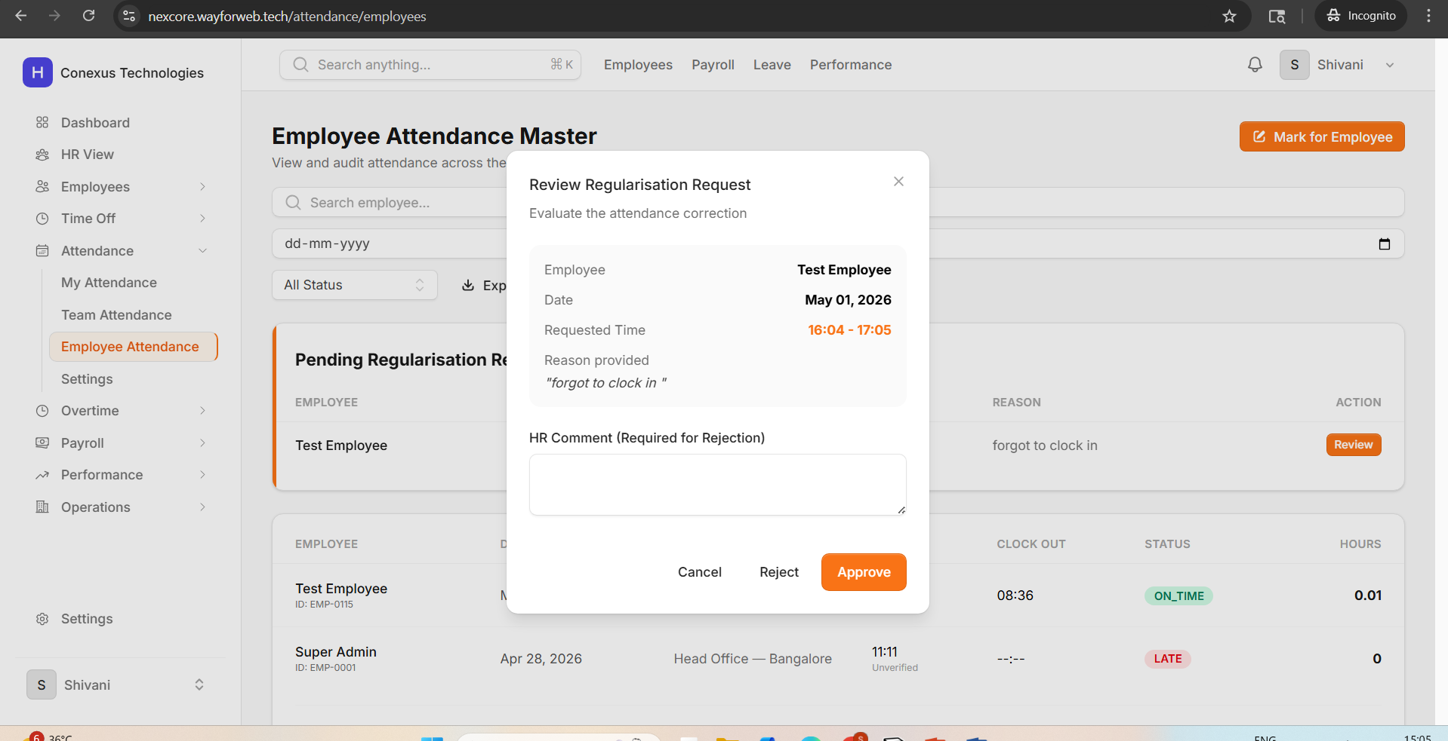
Issue 13: Newly Added Employee Appears at the Bottom of the List Instead of the Top; No Success Message
Module: Super Admin / HR Module
Navigation Path: Super Admin / HR → People → Manage Employees → Add New Employee
Current Behavior (Issue):
When a new employee is successfully added to the system, the record appears at the bottom (last position) of the employee list instead of at the top or in the first position where it was expected to appear. Additionally, no success confirmation message is shown after the employee is added, leaving the user uncertain about whether the action was completed.
Expected Behavior:
After a new employee is successfully added, the system should display a success notification message (e.g., "Employee added successfully"). The new employee record should appear in the correct position in the list — either at the top of the list (most recently added) or sorted according to the configured sort order (e.g., alphabetically or by ID). The list should refresh automatically after the record is created.
Issue 14: Manager Cannot Approve or Reject Requests from the Manager Module
Module: Manager Module
Navigation Path: Manager Module → Leave / Requests → Approve or Reject
Current Behavior (Issue):
When a Manager attempts to approve or reject a leave request or any other pending request from the Manager module, the action does not complete successfully. The system either does not respond, shows an error, or fails to update the request status.
Expected Behavior:
The Manager must be able to successfully approve or reject requests from within the Manager module. The action should update the request status in real time, persist the change in the database, and trigger the appropriate notifications to both the employee and the Super Admin or HR as required by the workflow.
Issue 15: Employees Cannot View Their Available Leave Balance Per Leave Type
Module: Employee Module
Navigation Path: Employee Module → Leave → Leave Balance / Leave Summary
Current Behavior (Issue):
In the Employee module, employees currently have no clear or accessible view of how many leave days they have available for each type of leave (e.g., Sick Leave, Casual Leave, Earned Leave, etc.). This information is either missing, unclear, or presented in a way that is difficult to interpret, leading to confusion when employees try to apply for leave.
Expected Behavior:
The Employee module must display a clear and easily accessible leave balance summary that shows the total entitlement, used leave days, and remaining available days for each leave type. This summary should be prominently visible — either on the leave application page or as a separate "My Leave Balance" section — so employees can make informed decisions when applying for leave.
Issue 16: Document Upload Option Is Missing in the Employee Module
Module: Employee Module
Navigation Path: Employee Module → Documents
Current Behavior (Issue):
The Employee module does not have an option for employees to upload or manage their personal documents (e.g., ID proofs, certifications, contracts). The document management feature is entirely absent from the employee-facing interface.
Expected Behavior:
An "Add Document" or document management section must be added to the Employee module. Employees should be able to upload documents in supported formats (PDF, JPG, PNG), view previously uploaded documents, and delete or replace documents as needed. This feature should be accessible from the employee's profile or a dedicated "Documents" tab.
Issue 17: Document Management Option Is Missing in the HR Module
Module: HR Module
Navigation Path: HR Module → Employee Profile / Documents
Current Behavior (Issue):
The HR module does not include a document management section. HR users are unable to upload, view, or manage employee-related documents from within the HR interface, which limits HR's ability to maintain complete employee records.
Expected Behavior:
A document management feature must be added to the HR module. HR users should be able to upload, view, and manage documents associated with employee profiles. The feature should support standard document formats and allow HR to categorize documents (e.g., identity documents, offer letters, performance reviews).

Section 2: Additional Issues — Sakshi

Issue 18: No Success Notification Shown After Saving Edited Information; No Auto-Redirect
Module: All Modules (Profile / Settings)
Navigation Path: Any Module → Edit Profile / Edit Information → Save
Current Behavior (Issue):
When a user edits their information and clicks the "Save" button, no confirmation notification is displayed to indicate that the update was successful. Additionally, the user is not automatically redirected back to the previous page after saving, requiring them to manually navigate away.
Expected Behavior:
After successfully saving any edited information, the system must display a success notification (e.g., "Information updated successfully") immediately. Following the notification, the system should automatically redirect the user back to the previous page or to the relevant profile/detail view. This behavior should be consistent across all edit forms in the system.
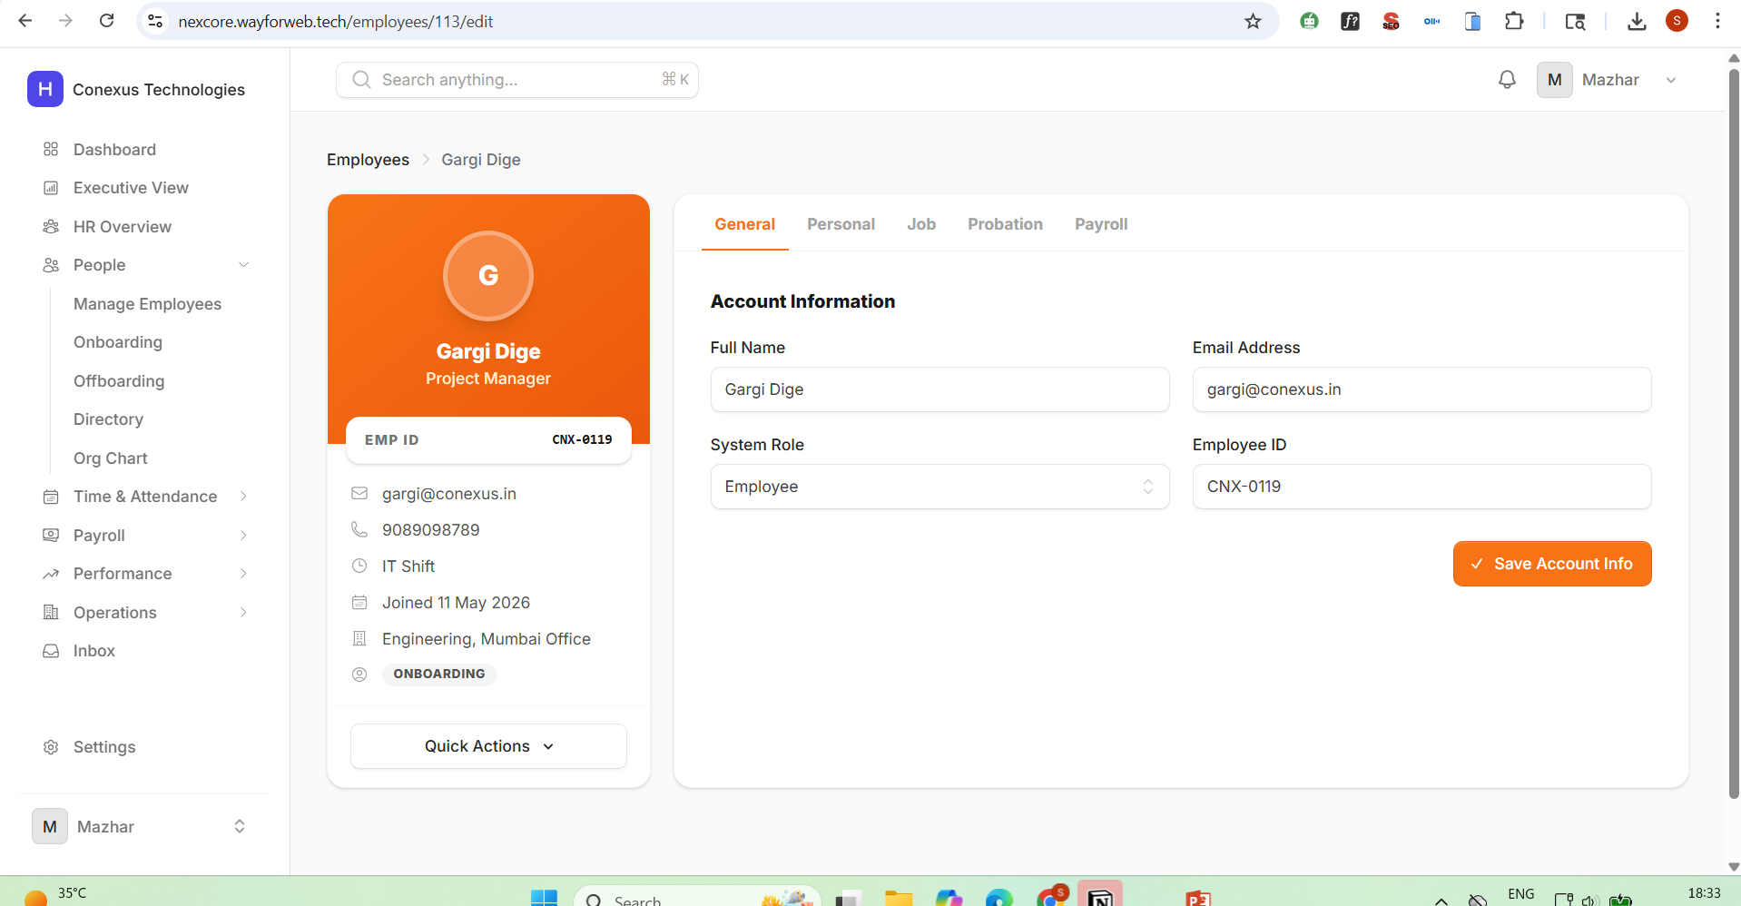
Issue 19: Success Snackbar Message Missing on All Employee Module Form Submissions
Module: Employee Module
Navigation Path: Employee Module → [Any Form] → Submit
Current Behavior (Issue):
Across all request and form submission flows in the Employee module, there is no visible success confirmation snackbar message shown after the user submits a form. This applies to leave applications, expense claims, regularization requests, and any other submission-based functionality.
Expected Behavior:
A success snackbar message must be displayed immediately after every successful form submission within the Employee module. The message should be non-intrusive (e.g., bottom or top of the screen), auto-dismiss after a few seconds, and clearly state that the action was completed successfully. This requirement applies to all submission-based functionality across the entire Employee module.
Issue 20: Leave Notification Redirects to Wrong URL When Clicked
Module: Admin Module / HR Module / Employee Module
Navigation Path: Admin / HR → Notification Panel → Click on Notification
Current Behavior (Issue):
When an employee submits a leave request from the Employee module, the resulting notification is correctly delivered to both the Admin and HR logins. However, when the Admin or HR user clicks on this notification, they are redirected to an incorrect URL that does not correspond to the relevant leave request or the expected destination page.
Expected Behavior:
Each notification, when clicked, must redirect the user to the exact page or record it refers to. In the case of a leave request notification, clicking it should take the Admin or HR user directly to the specific leave request detail page. All notification links must be validated to ensure they point to the correct destination URL across all notification types in the system.

Section 3: Reported Issues — Sohail

Issue 21: Status Column Lacks Visual Differentiation — No Text Color or Border Radius
Module: HR Module / Super Admin Module
Navigation Path: HR / Super Admin → Leave Management → Status Column
Current Behavior (Issue):
The "Status" column in the Leave Management table currently displays status values (e.g., Pending, Approved, Rejected) in plain text without any visual distinction. There is no color coding or styled badge applied to differentiate between statuses at a glance, making it difficult for users to quickly identify the state of leave requests.
Expected Behavior:
The status values in the Status column should be displayed as styled status badges using text color and border radius to visually differentiate each state. For example: "Approved" in green, "Pending" in orange/yellow, "Rejected" in red. Each status should appear as a pill/badge-style element with a rounded border and a corresponding background or text color to make the status immediately recognizable.
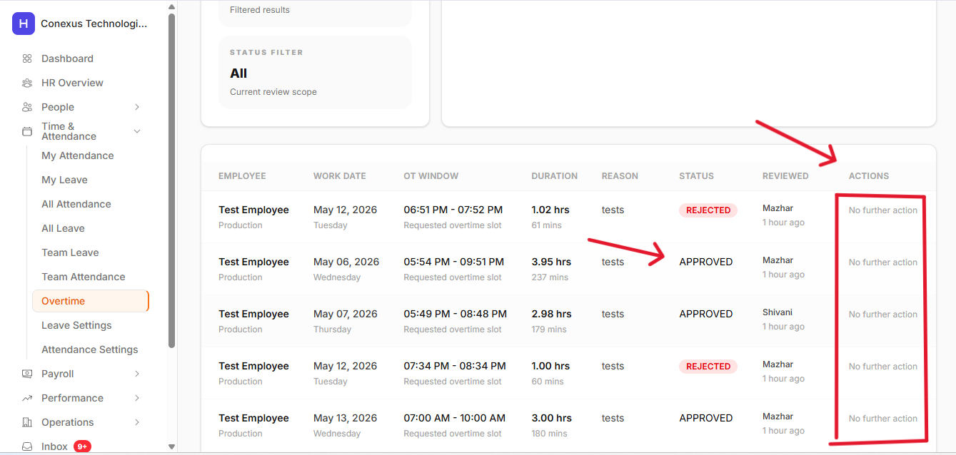
Issue 22: Overlapping Leave Dates Are Not Blocked — Approved Leave Conflict Not Prevented
Module: HR / Super Admin Module
Navigation Path: HR / Super Admin → Leave Management → Calendar or Leave Schedule View
Current Behavior (Issue):
The system is not preventing employees from applying for leave on dates that already have an approved leave entry. For example, for the period May 22–24, a leave was already approved, but the system allowed another overlapping leave request to be submitted without any warning or blocking mechanism.
Expected Behavior:
The system must validate leave request dates against existing approved leave entries. If an employee attempts to apply for leave on dates that already have an approved leave record, the system must block the submission and display a clear error message indicating the conflict. Overlapping leave dates with already-approved leave should not be allowed under any circumstances.
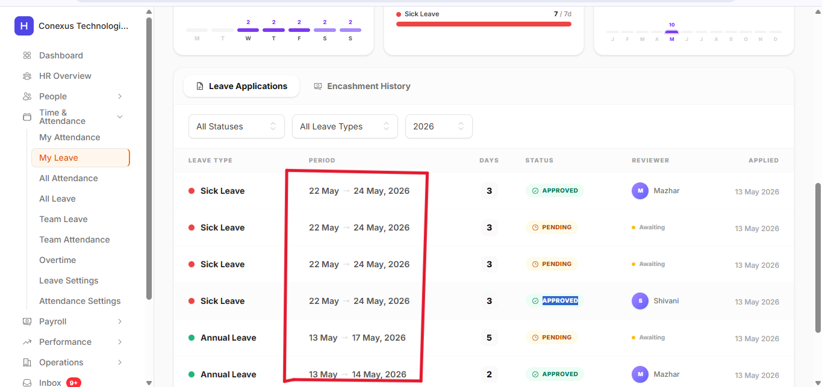
Issue 23: MDL and MDL Half-Day Leave Types Are Not Being Blocked for Overlapping Dates
Module: HR / Super Admin Module
Navigation Path: HR / Super Admin → Leave Management → MDL / Half-Day Leave Types
Current Behavior (Issue):
The "MDL" (Monthly Day Leave) and "MDL Half-Day" leave types are not being blocked when an employee attempts to apply for these leave types on dates that conflict with existing approved leaves. The system is allowing duplicate or conflicting leave submissions for these specific leave types.
Expected Behavior:
The leave conflict validation must also apply to MDL and MDL Half-Day leave types. If an employee has already received an approved MDL or MDL Half-Day leave, any subsequent application for the same or overlapping dates should be blocked. The validation logic should cover all leave types uniformly, including full-day and half-day variants.
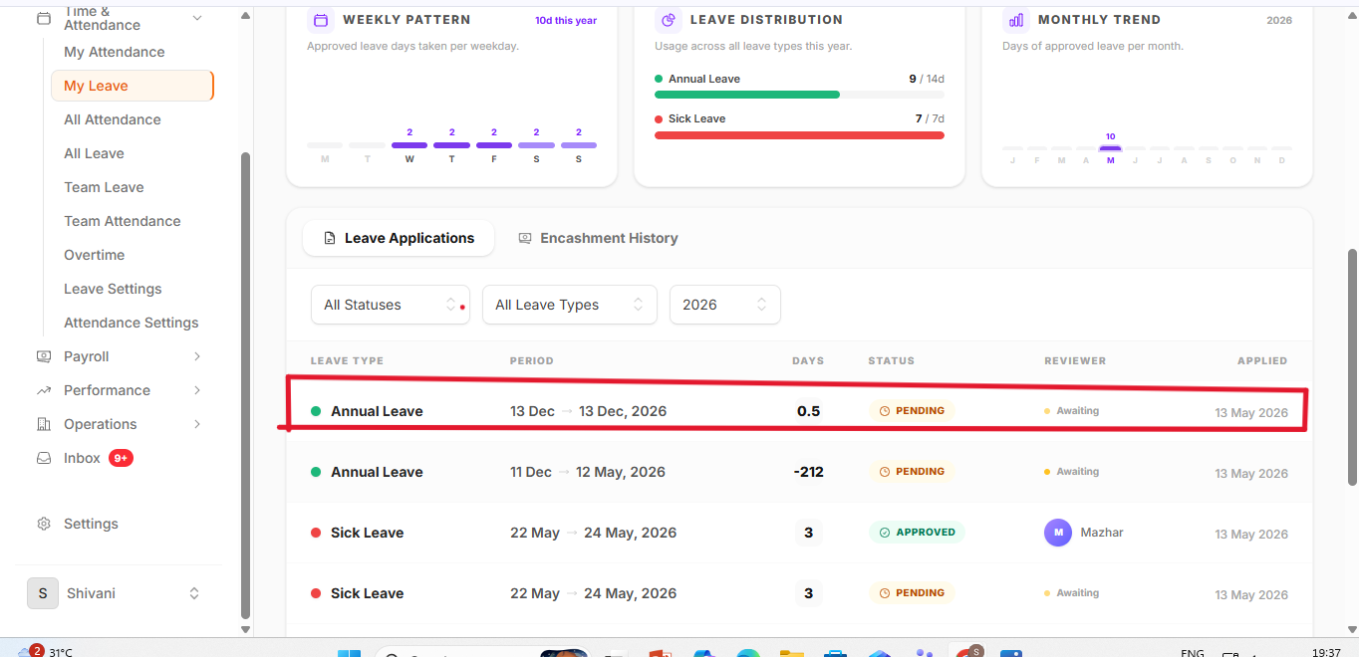
Issue 24: Status Column in HR Time & Attendance — All Leave Section Needs Styled Badges
Module: HR Module
Navigation Path: HR → Time & Attendance → All Leave → Status Column
Current Behavior (Issue):
In the HR module under Time & Attendance → All Leave, the Status column displays plain, unstyled text for leave statuses. There is no visual differentiation between statuses such as Approved, Pending, and Rejected.
Expected Behavior:
The Status column in the HR → Time & Attendance → All Leave section must display styled status badges using text color and border radius, consistent with the approach described in Issue 21. Each leave status should be visually distinct with appropriate color coding and a badge or pill-style layout.
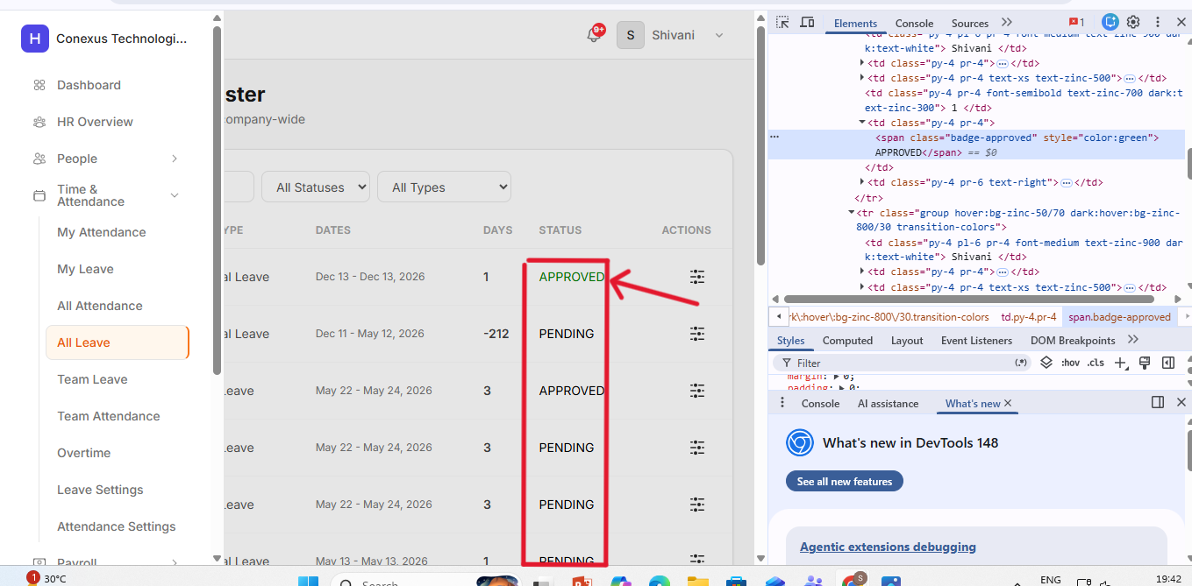
Issue 25: Expense Claim Form Submit Button Is Not Working
Module: Employee Module
Navigation Path: Employee → Finance → Expense Claim → New Claim → Submit
Current Behavior (Issue):
When an employee fills out the New Expense Claim form and clicks the "Submit" button, the form does not submit. The button appears unresponsive — clicking it produces no action, no validation message, no loading indicator, and no success or error response.
Expected Behavior:
The Submit button in the New Expense Claim form must function correctly. Upon clicking Submit, the system should validate all required fields, submit the form data to the backend, and display an appropriate success or error message to the user. The submitted claim should then appear in the employee's claim history and be visible to the HR/Admin for review.
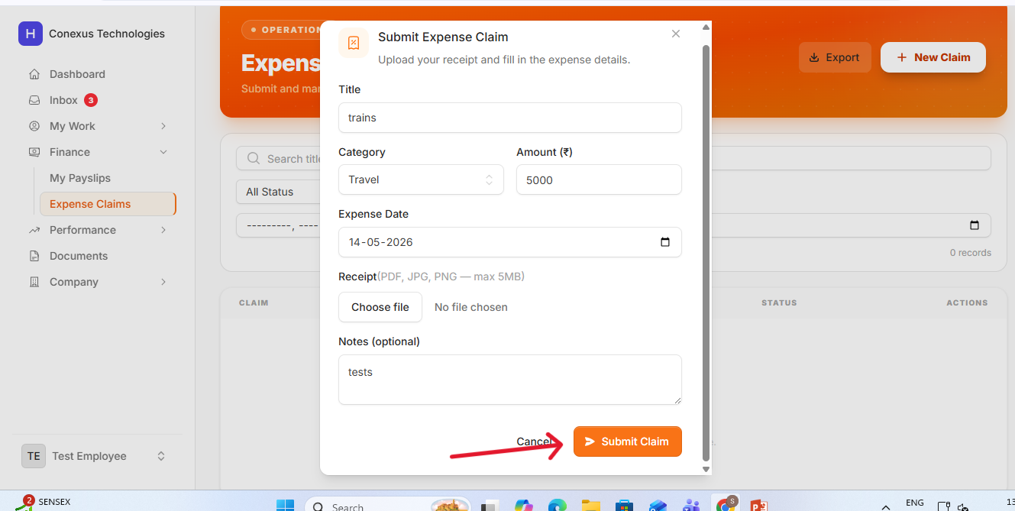
Issue 26: Incentive Form Submit Button Is Not Working in HR Module
Module: HR Module
Navigation Path: HR → Payroll → Incentives → Add Incentive → Submit
Current Behavior (Issue):
When the HR user fills in the Add Incentive form and clicks the Submit button, the form does not submit. The button is non-functional — no data is saved, no success message is displayed, and no error is returned.
Expected Behavior:
The Submit button on the Add Incentive form must work correctly. Upon clicking, the system should validate the form inputs, save the incentive record to the database, and display a success notification. The new incentive should then appear in the relevant payroll or incentive records.
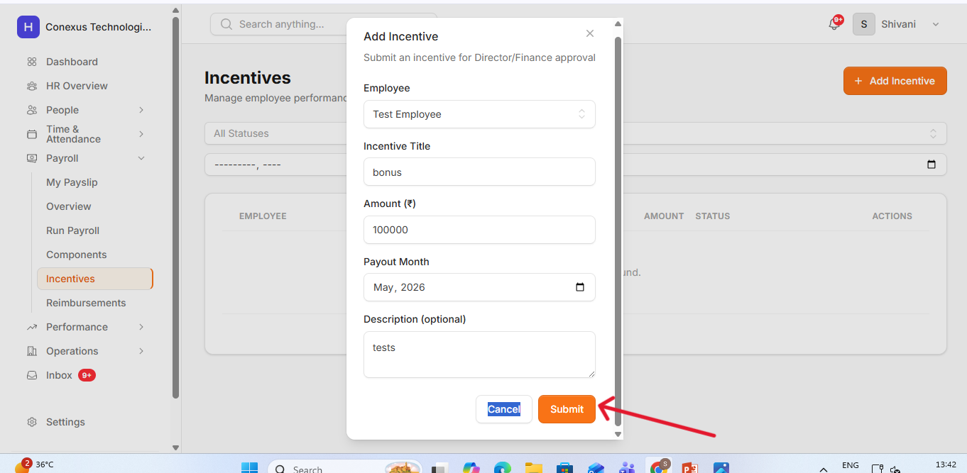
Issue 27: Reimbursement Form Submit Button Is Not Working
Module: HR Module
Navigation Path: HR → Payroll → Reimbursement → Submit
Current Behavior (Issue):
The Reimbursement form in the HR module has the same issue as the Incentive form — the Submit button does not function when clicked. No data is saved and no feedback is provided to the user.
Expected Behavior:
The Submit button on the Reimbursement form must be fully functional. Upon clicking, the system should validate the form, persist the reimbursement record, and display a success confirmation. This issue must be resolved consistently alongside the Incentive and Expense Claim form submit button fixes.
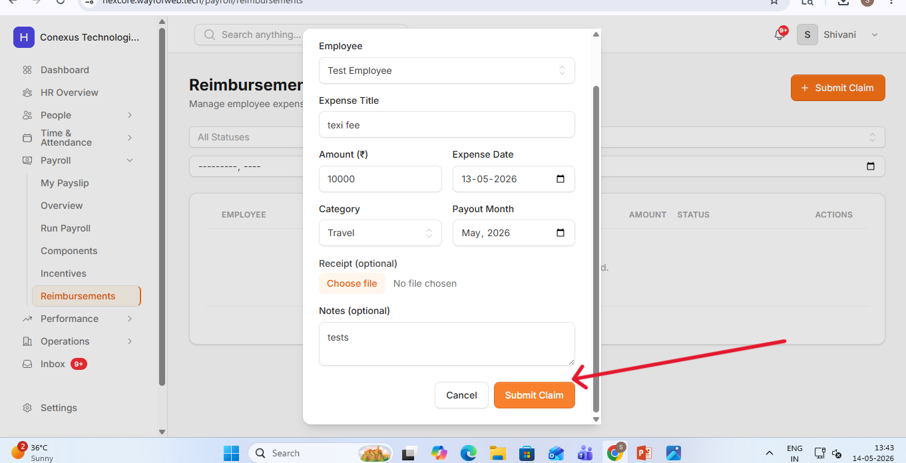
Issue 28: 500 Internal Server Error When Editing and Saving Employee Information
Module: Super Admin / HR Module
Navigation Path: Super Admin / HR → People → Manage Employees → Edit Employee → Save
Current Behavior (Issue):
When a Super Admin or HR user navigates to the Edit Employee page, modifies any input field, and clicks Save, a 500 Internal Server Error is returned. The change is not saved, and the error is displayed to the user. This indicates a server-side failure in the employee update API endpoint.
Expected Behavior:
The Edit Employee functionality must work without errors. After editing any field and clicking Save, the system should validate the input, send the update to the backend, and successfully persist the change. A success notification should then be shown, and the updated information should be reflected immediately on the employee profile page.
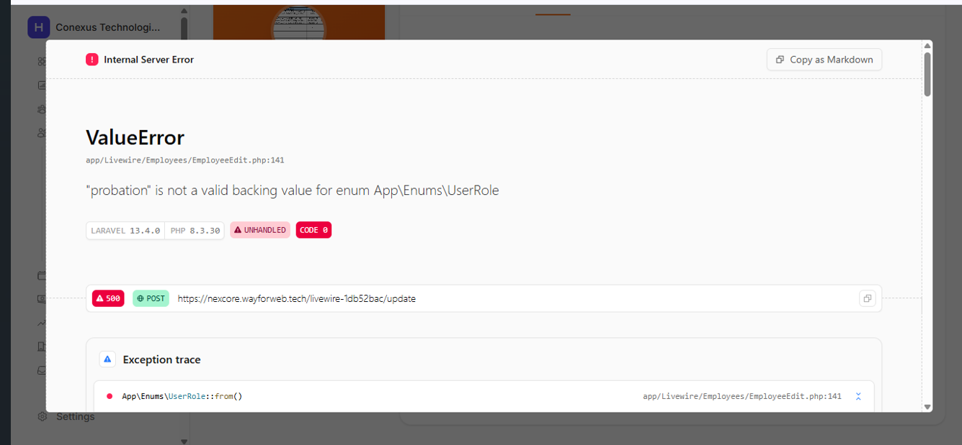
Issue 29: Regularization Request Submission Does Not Appear in User Inbox or Notifications
Module: Employee Module / Super Admin / HR
Navigation Path: Employee → Submit Regularization Request → Inbox / Notifications
Current Behavior (Issue):
When an employee submits a regularization request, no information about the submitted request is shown in the employee's inbox or notifications panel. Only after the request has been accepted does any trace of it appear in the inbox. Pending regularization requests are completely invisible to the submitting employee.
Expected Behavior:
Upon submission of a regularization request, the system must immediately create a record entry in the user's inbox or notifications panel showing the submitted request details, including date, type, and current status (Pending). This allows the employee to track the status of their submission in real time without having to search for it manually.
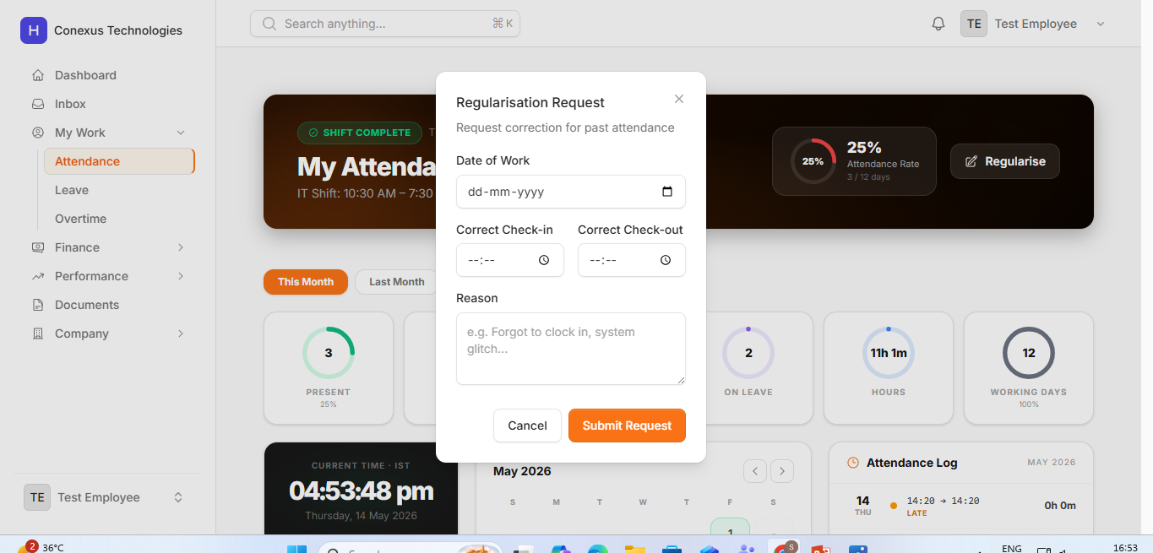
Issue 30: 500 Internal Server Error When Super Admin or HR Approves or Rejects Regularization Request
Module: Super Admin / HR Module
Navigation Path: Super Admin / HR → Regularization Requests → Approve or Reject
Current Behavior (Issue):
When the Super Admin or HR user attempts to approve or reject a regularization request, a 500 Internal Server Error is returned. The action does not complete, and the request status remains unchanged. This makes regularization management completely non-functional for both user roles.
Expected Behavior:
The approval and rejection actions for regularization requests must execute successfully. Upon approval or rejection, the system should update the request status in the database, notify the employee of the decision, and reflect the updated status in the relevant management views. The 500 error must be investigated and resolved at the backend API level.
Issue 31: Unnecessary "Close" Button Present in the Salary Breakup View
Module: Employee Module
Navigation Path: Employee → My Payslip → Salary Timeline → View Salary Breakup
Current Behavior (Issue):
In the Salary Breakup view accessed via Employee → My Payslip → Salary Timeline → View Salary Breakup, there is an unnecessary or redundant "Close" button displayed in the UI. This button adds clutter and may confuse users.
Expected Behavior:
The unnecessary Close button must be removed from the Salary Breakup view. If a close action is required (e.g., for a modal or popup), only one close mechanism should exist — either a dedicated close icon or the button — but not both. Duplicate or non-functional UI elements should be cleaned up.
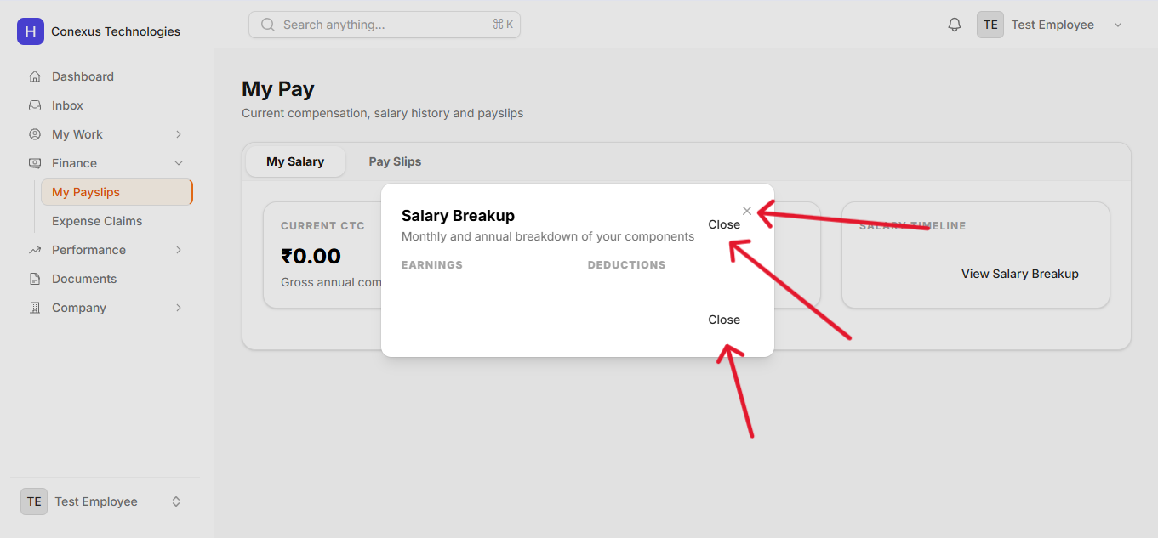
Issue 32: Late Timer Should Display in Hours Format, Not Raw Minutes or Other Units
Module: Employee Module / HR / Super Admin
Navigation Path: Attendance / Time Tracking → Late Timer Display
Current Behavior (Issue):
The "Late Timer" field or indicator in the attendance/time tracking module is not displaying the late duration in a human-readable hours format. It may be showing the value in minutes or another format that is not immediately intuitive to users.
Expected Behavior:
The Late Timer must display the duration of lateness in hours (and minutes if applicable), formatted clearly (e.g., "1 hour 30 minutes" or "01:30 hrs"). This makes the information easier to read and understand for both employees and managers reviewing attendance records.
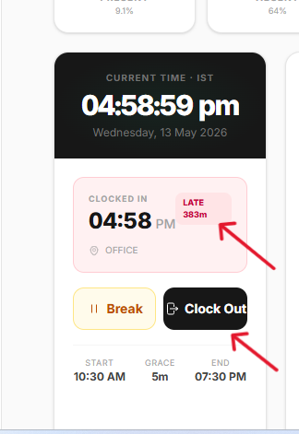
Issue 33: No Warning or Confirmation Prompt Displayed When Clicking the Clock-Out Button
Module: Employee Module
Navigation Path: Employee Module → Attendance → Clock-Out Button
Current Behavior (Issue):
When an employee clicks the Clock-Out button, the action is performed immediately without displaying any warning or confirmation prompt. There is no opportunity for the employee to confirm that they intend to clock out, which may lead to accidental clock-outs.
Expected Behavior:
A warning or confirmation dialog must be displayed when an employee clicks the Clock-Out button. The prompt should ask the employee to confirm their intention (e.g., "Are you sure you want to clock out?") before the action is processed. This helps prevent accidental clock-outs and ensures intentional user action.
Issue 34: Text Color Is Not Visible Due to Camouflage with Background Color
Module: General UI
Navigation Path: Multiple Screens — Text Elements on Various Pages
Current Behavior (Issue):
On certain screens throughout the HRMS application, text content is not visible because the text color is the same as or very similar to the background color, causing it to blend in (camouflage effect). Users cannot read the affected text, making those areas of the UI inaccessible.
Expected Behavior:
All text elements across the application must have sufficient color contrast against their background to meet readability standards. The text color and background color combinations must be reviewed and corrected wherever the camouflage issue exists. Standard WCAG contrast ratio guidelines (minimum 4.5:1 for normal text) should be followed.
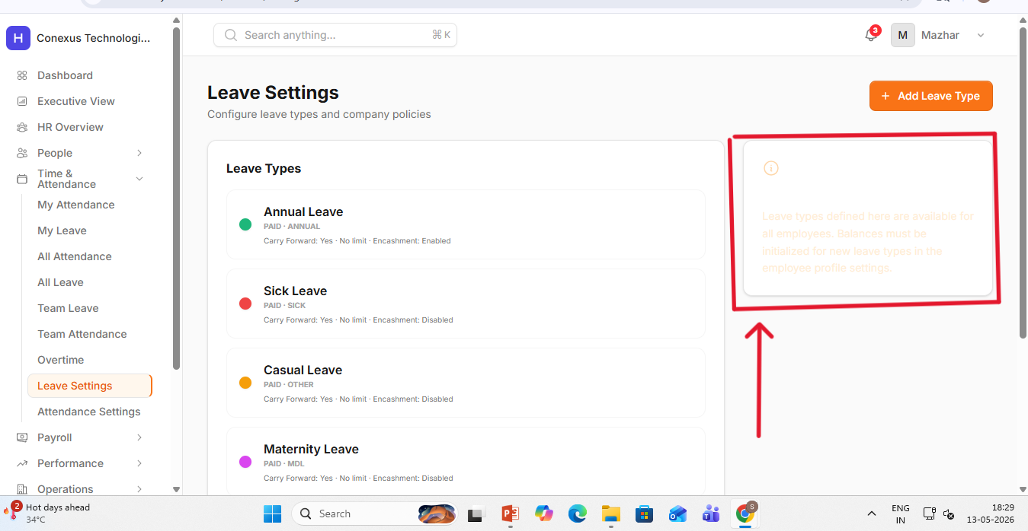
Issue 35: Clicking Gmail Icon Redirects to Another Page Instead of Opening Gmail Options
Module: General UI
Navigation Path: Multiple Screens — Gmail / Email Icon Integration
Current Behavior (Issue):
When a user clicks on the Gmail icon within the HRMS application, instead of opening a Gmail-related options panel or linking to Gmail in a controlled way, the user is redirected to an entirely different page within the application or an unintended external URL.
Expected Behavior:
Clicking the Gmail icon should open the intended Gmail integration options — such as a compose window, link to Gmail inbox, or OAuth-based email action relevant to the context. The redirect must be corrected so that the icon performs the intended email-related action without navigating the user away from the current context in an unintended manner.
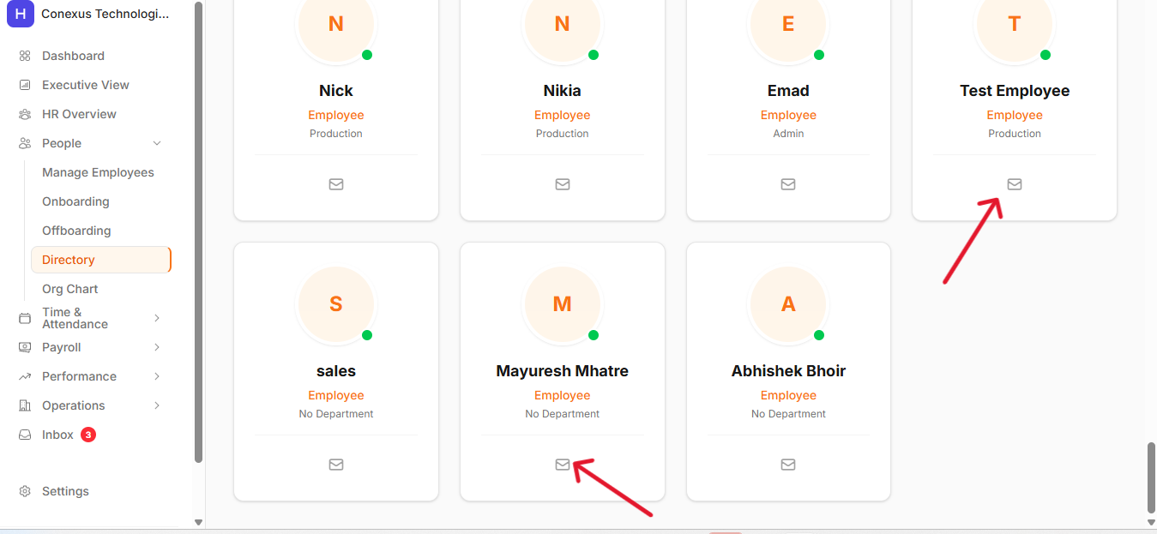
Issue 36: Quick Action Dropdown Menu Has Width and Alignment Issues
Module: Super Admin / HR Module
Navigation Path: People → Manage Employees → Edit → Quick Action Menu
Current Behavior (Issue):
The Quick Action menu dropdown that appears in the Manage Employees edit section has a width and alignment issue. The menu items are not properly aligned, the dropdown container width is incorrect, and the overall layout appears broken or misaligned compared to its expected position.
Expected Behavior:
The Quick Action dropdown menu must be correctly sized and aligned. The menu width should be sufficient to display all action labels without truncation, and the dropdown should appear in the correct position relative to its trigger element. All menu items should be evenly spaced and properly aligned within the dropdown container.
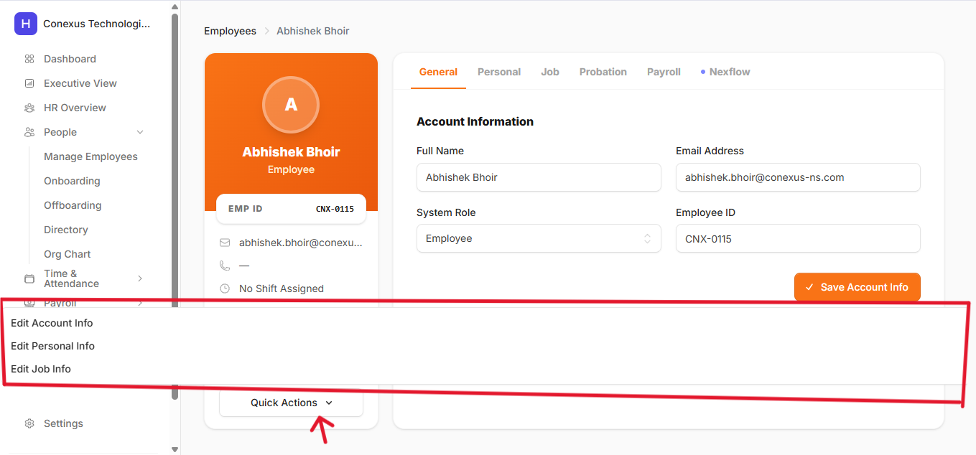
Issue 37: Team Invitation Request Not Delivered to Invited Member's Inbox or Notifications
Module: All Modules
Navigation Path: Profile → Team → Create Team → Invite Team Members
Current Behavior (Issue):
When a user creates a team (e.g., "IT Team") and sends an invitation to a member to join the team, the invited member does not receive any notification or inbox message about the team invitation. The invitation is sent without any delivery confirmation or notification mechanism in place.
Expected Behavior:
When a team invitation is sent to a member, the invited member must receive a notification in their inbox or notification panel informing them of the invitation. The notification should include the team name, the sender's name, and a direct link or action button to accept or decline the invitation.
Issue 38: Data Validation Is Not Implemented in Input Fields
Module: All Modules — Form Fields
Navigation Path: All Modules → Any Input Field
Current Behavior (Issue):
Input fields across various forms and modules in the HRMS system do not have proper data validation implemented. Users can enter invalid data types, leave required fields empty, or submit forms with incorrect formatting without receiving any error or warning messages.
Expected Behavior:
Data validation must be implemented on all input fields across all modules. Validation should include required field checks, correct data type enforcement (e.g., numbers only for phone fields, valid date format for date fields), maximum/minimum length restrictions where applicable, and real-time or on-submit validation error messages that clearly explain what needs to be corrected.
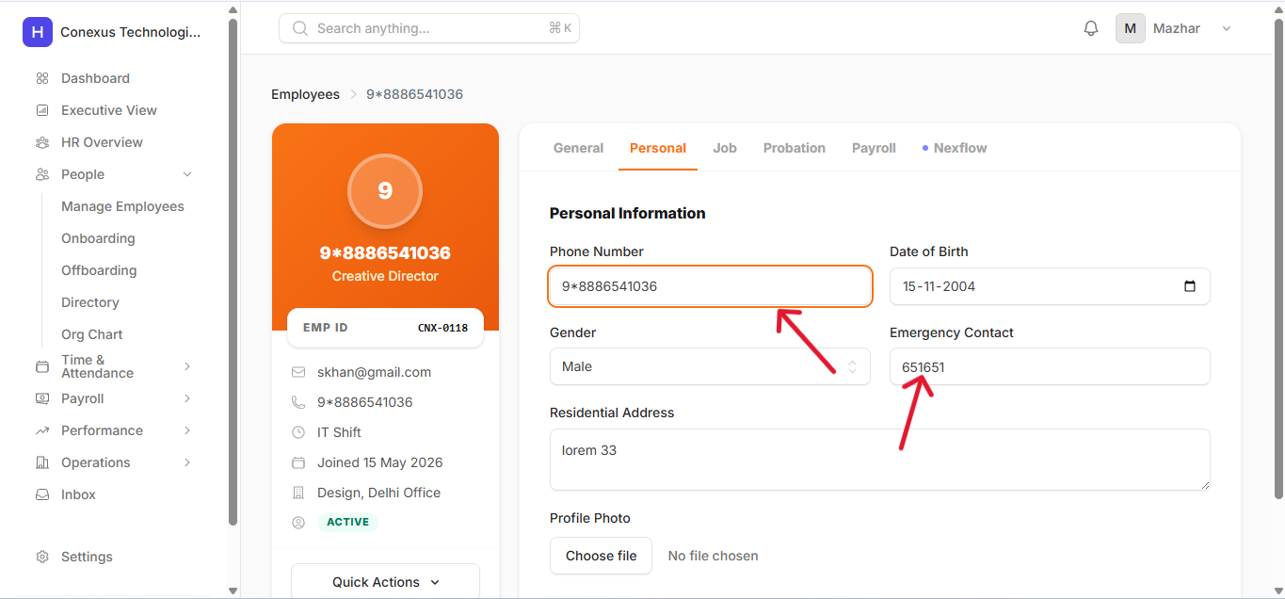
Issue 39: Employee Does Not Receive Exit Details After HR Saves Offboarding Information
Module: HR / Super Admin Module
Navigation Path: Offboard Management → Employee Exit Details → Save
Current Behavior (Issue):
When the HR or Super Admin fills in an employee's exit details on the Offboard Management page and saves the record, the exit detail information is not sent or communicated to the employee in any form. The employee has no visibility into their offboarding details.
Expected Behavior:
After the HR or Super Admin saves an employee's exit details on the Offboard Management page, the system must automatically send the exit details to the relevant employee. This could be via an in-app notification, an inbox message, or an email notification containing the exit date, reason, and any relevant offboarding information. The employee must be informed and have access to their offboarding details.
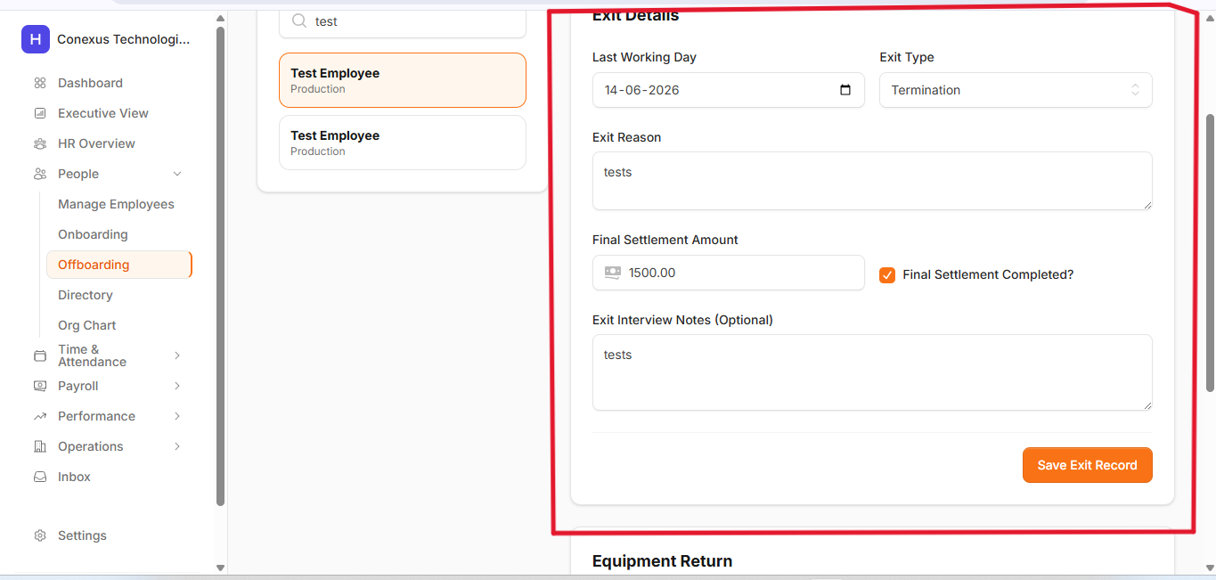
Issue 40: Offboard Checklist Is Displaying Onboarding Page Content Instead of Offboarding Details
Module: HR / Super Admin Module
Navigation Path: Offboard Management → Offboard Checklist
Current Behavior (Issue):
When the HR or Super Admin views the Offboard Checklist for an employee, the page displays content from the Onboarding page instead of the correct Offboarding Checklist details. This appears to be a routing or component rendering error where the wrong component or data source is being loaded for the Offboard Checklist view.
Expected Behavior:
The Offboard Checklist page must display the correct offboarding checklist items specific to the selected employee's offboarding process. The page must not render any onboarding-related content. The routing and component assignment for the Offboard Checklist must be reviewed and corrected so that the appropriate data and UI are displayed.
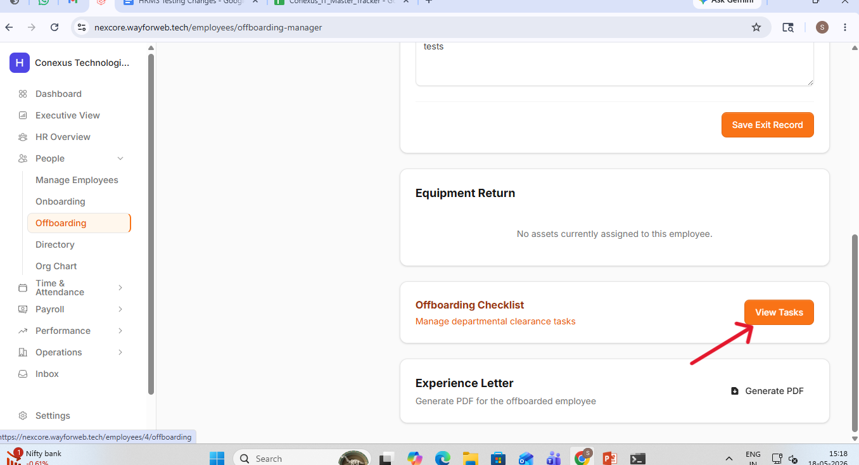
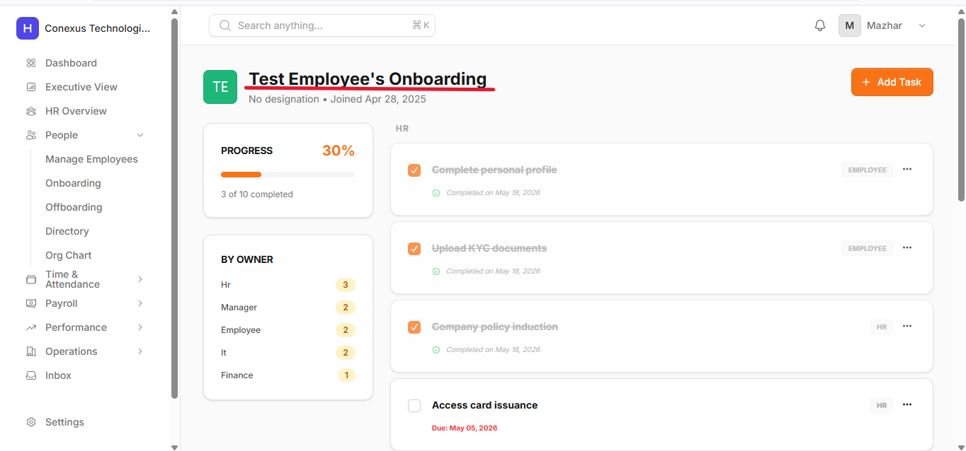

End of HRMS Testing Change Requirements Document
All issues listed above require investigation, testing, and resolution. Each item includes the navigation path, current broken behavior, and expected correct behavior to enable precise implementation.

