CSD-310 | Module 6 Assignment
MySQL Database Queries via Python
Zachary White
Instructor: Sue Sampson
April 26th, 2026

github

1. Assignment Overview
This assignment demonstrates how to query a MySQL database through both the terminal window and a Python script. The movies database contains three tables: film, genre, and studio. Four queries were written to retrieve and display data from these tables in a formatted output.

Table Name | Description
studio | Stores film studio records (ID and name)
genre | Stores genre records (ID and name)
film | Stores film records including name, runtime, and director

2. Database Connection
The Python script connects to MySQL using the mysql-connector library and a .env file for secure credential storage. The .env file contains the following keys:

USER=User
PASSWORD=xxxxxx
HOST=Localhost
DATABASE=movies

The connection configuration in Python:

secrets = dotenv_values(".env")
config = {
"user": secrets["USER"],
"password": secrets["PASSWORD"],
"host": secrets["HOST"],
"database": secrets["DATABASE"],
"raise_on_warnings": True
}
db = mysql.connector.connect(**config)

3. Python Queries

Query 1 Studio Records
Selects all fields from the studio table and displays each studio's ID and name.

cursor.execute("SELECT studio_id, studio_name FROM studio")

Expected Output:
-- DISPLAYING Studio RECORDS --
Studio ID: 1
Studio Name: 20th Century Fox

Studio ID: 2
Studio Name: Blumhouse Productions

Studio ID: 3
Studio Name: Universal Pictures

Query 2 Genre Records
Selects all fields from the genre table and displays each genre's ID and name.

cursor.execute("SELECT genre_id, genre_name FROM genre")

Expected Output:
-- DISPLAYING Genre RECORDS --
Genre ID: 1
Genre Name: Horror

Genre ID: 2
Genre Name: SciFi

Genre ID: 3
Genre Name: Drama

Query 3 Short Film Records (Runtime < 2 Hours)
Selects films with a runtime under 120 minutes (less than 2 hours).

cursor.execute("SELECT film_name, film_runtime FROM film WHERE film_runtime < 120")

Expected Output:
-- DISPLAYING Short Film RECORDS --
Film Name: Alien
Runtime: 117

Film Name: Get Out
Runtime: 104

Query 4 Director Records (Ordered by Director)
Selects film names and directors from the film table, ordered alphabetically by director name.

cursor.execute("SELECT film_name, film_director FROM film ORDER BY film_director")

Expected Output:
-- DISPLAYING Director RECORDS in Order --
Film Name: Get Out
Director: Jordan Peele

Film Name: Gladiator
Director: Ridley Scott

Film Name: Alien
Director: Ridley Scott

4. Complete Python Script
Below is the complete movies_queries.py script:

""" import statements """
import mysql.connector # to connect
from mysql.connector import errorcode

import dotenv # to use .env file
from dotenv import dotenv_values

# load .env file
secrets = dotenv_values(".env")

# database config
config = {
"user": secrets["USER"],
"password": secrets["PASSWORD"],
"host": secrets["HOST"],
"database": secrets["DATABASE"],
"raise_on_warnings": True
}

try:
db = mysql.connector.connect(**config)

print("\nDatabase user {} connected to MySQL on host {} with database {}".format(
config["user"], config["host"], config["database"]
))

input("\nPress any key to continue...")

except mysql.connector.Error as err:
if err.errno == errorcode.ER_ACCESS_DENIED_ERROR:
print("The supplied username or password are invalid")
elif err.errno == errorcode.ER_BAD_DB_ERROR:
print("The specified database does not exist")
else:
print(err)

try:
db = mysql.connector.connect(**config)

print("\nDatabase user {} connected to MySQL on host {} with database {}".format(
config["user"], config["host"], config["database"]
))

input("\nPress any key to continue...")

# -------------------------------------------
# -- Query 1: Display all Studio records
# -------------------------------------------
print("\n-- DISPLAYING Studio RECORDS --")

cursor = db.cursor()
cursor.execute("SELECT studio_id, studio_name FROM studio")
studios = cursor.fetchall()

for studio in studios:
print("Studio ID: {}".format(studio[0]))
print("Studio Name: {}\n".format(studio[1]))

# -------------------------------------------
# -- Query 2: Display all Genre records
# -------------------------------------------
print("\n-- DISPLAYING Genre RECORDS --")

cursor.execute("SELECT genre_id, genre_name FROM genre")
genres = cursor.fetchall()

for genre in genres:
print("Genre ID: {}".format(genre[0]))
print("Genre Name: {}\n".format(genre[1]))

# -------------------------------------------
# -- Query 3: Display films with runtime < 2 hours (120 minutes)
# -------------------------------------------
print("\n-- DISPLAYING Short Film RECORDS --")

cursor.execute("SELECT film_name, film_runtime FROM film WHERE film_runtime < 120")
short_films = cursor.fetchall()

for film in short_films:
print("Film Name: {}".format(film[0]))
print("Runtime: {}\n".format(film[1]))

# -------------------------------------------
# -- Query 4: Display film names and directors, grouped by director
# -------------------------------------------
print("\n-- DISPLAYING Director RECORDS in Order --")

cursor.execute("SELECT film_name, film_director FROM film ORDER BY film_director")
directors = cursor.fetchall()

for film in directors:
print("Film Name: {}".format(film[0]))
print("Director: {}\n".format(film[1]))

except mysql.connector.Error as err:
if err.errno == errorcode.ER_ACCESS_DENIED_ERROR:
print("The supplied username or password are invalid")
elif err.errno == errorcode.ER_BAD_DB_ERROR:
print("The specified database does not exist")
else:
print(err)

finally:
db.close()

5. Script Execution Results
The script was successfully executed from the command line using the following command:

cd c:\CSD\CSD310\module-6
python movies_queries.py

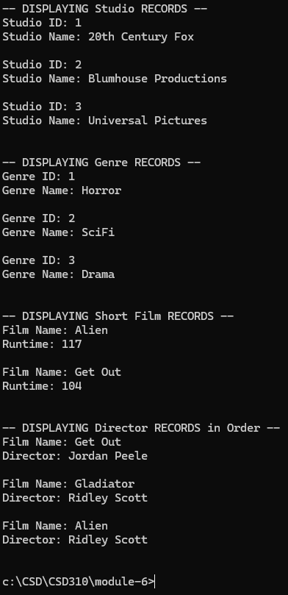
The script connected successfully to the MySQL movies database returned a pause waiting for the user to progress the application, once progressed, returned the expected output for all four queries. The screenshot below shows the terminal output matching the expected results exactly.

Terminal output confirmed:

Query | Result
Studio Records | 3 records returned (20th Century Fox, Blumhouse Productions, Universal Pictures)
Genre Records | 3 records returned (Horror, SciFi, Drama)
Short Films (< 2 hrs) | 2 records returned (Alien: 117 min, Get Out: 104 min)
Director Records | 3 records returned, ordered by director name

CSD-310 | Module 6 | MySQL Queries Assignment

