CSD-310 | Module 7 Assignment
Movies: Update & Delete
Zachary White
Instructor: Sue Sampson
05/01/2026

1. Assignment Overview
This assignment demonstrates how to update and delete records from a MySQL database using Python. The script connects to the movies database and performs the following operations:

Step | Action
1 | Display all films (initial state)
2 | INSERT: Add The Matrix (Lana Wachowski, SciFi, 20th Century Fox)
3 | UPDATE: Change Alien genre from SciFi to Horror
4 | DELETE: Remove Gladiator from the film table

2. Script Execution Output
The following output was produced by running the script from the command line:

Initial Display Before Any Changes
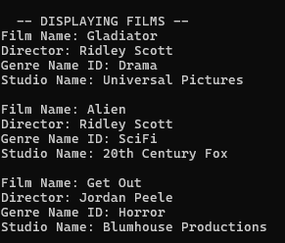

After INSERT The Matrix Added
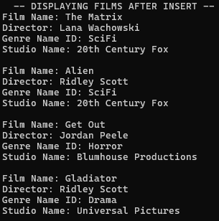

After UPDATE Alien Changed to Horror
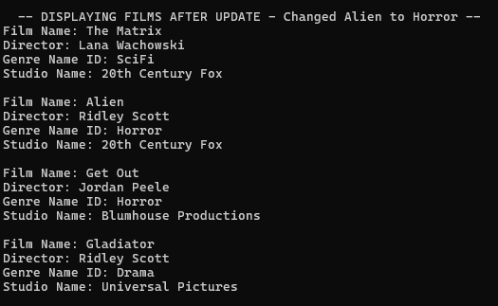

After DELETE Gladiator Removed
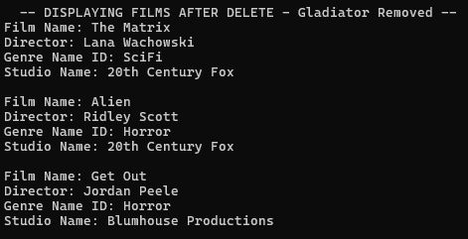

3. GitHub Repository
The complete project including all module files is available at the GitHub repository link below.
https://github.com/DevZWhite/CSD310-306J-Database-Development-and-Use

