Name: Zachary White
Instructor: Sue Sampson
Class: CSD 310
Date: 3/29/2026
Module 1 – Assignment 1.2: Git & GitHub Setup

In this assignment, I demonstrated the foundational workflow for version control using Git and GitHub as part of the CSD 310 – Database Development and Use course. Beginning in my local CSD directory, I created a new subdirectory named module-1 using the mkdir command, then verified its creation with the dir command on Windows. I documented this process by capturing a screenshot of the directory listing, which was embedded into this Word document and saved as Zwhite-Assignment1_2.docx within the module-1 folder. Next, I confirmed the status of my local Git repository, staged all new files using git add --all, committed the changes with a descriptive message, and pushed the updated repository to GitHub using git push origin main. This process reinforced how Git tracks changes at the file and directory level, how staging allows selective control before a commit, and how pushing synchronizes local work with a remote repository -skills that are necessary for collaborative and organized software and database development.
Deliverable 1: GitHub Repository Link
Repository URL: https://github.com/DevZWhite/CSD310-306J-Database-Development-and-Use/tree/main/module-1
Deliverable 2: Screenshot of GitHub Repository
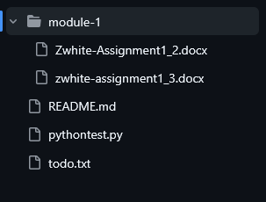
Deliverable 3: Screenshot of Local Directory
