Zachary White
Instructor: Sue Sampson
Date: 04/02/2026
Class: CSD 310

Assignment 2.3
Entity Relationship Diagram (ERD)
An Entity Relationship Diagram, or ERD, is a visual tool used to model the structure of a database by showing the entities involved, the attributes that describe them, and the relationships between them. In this assignment, I identified three core relationships from the given business rules: a USER having many ROLES, a USER having one BIRTHDATE, and a USER having many DEPENDENTS.
Each of these relationships was translated into a corresponding entity with a primary key, relevant attributes, and a foreign key linking back to the USER table. The cardinality notation on each relationship line indicates whether the connection is one-to-one or one-to-many, which is our primary rulings for this example this ensures the database is structured correctly and avoids data redundancy. Creating this diagram helped me understand how to move from written business requirements to a formal data model before any actual database is built. Although I had much practice in a prior class doing this, just not with paradigm.
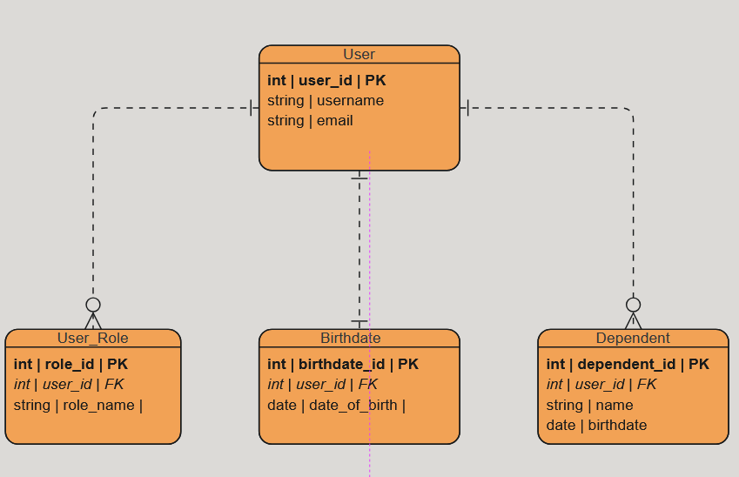
Figure 1: An ERD showcasing various relationships

NoSQL Data Structure
A NoSQL database stores data in a document-oriented format rather than using the rigid table-and-row structure of a relational database. The key difference is that instead of spreading related data across multiple linked tables, a NoSQL document embeds that data directly into a single record. To convert my ERD into a NoSQL structure, I collapsed all three relationships into one user document. The BIRTHDATE, which had a one-to-one relationship with USER, became a simple scalar field. (Bielefeldt 2014)
The ROLES and DEPENDENTS, which both had one-to-many relationships, became embedded arrays within the same document. This approach eliminates the need for joins when querying a user’s complete information, since everything is retrieved in a single read. Working through this conversion reinforced the idea that NoSQL design is driven by how data will be accessed rather than how it relates in the abstract, which is a fundamentally different mindset from relational modeling.

// Collection: users
{
"_id": "user_001",
"username": "jdoe",
"email": "jdoe@example.com",
// Embedded - one birthdate per user
"birthdate": "1990-04-15",
// Embedded array - many roles per user
"roles": [
"admin",
"editor"
],
// Embedded array - many dependents per user
"dependents": [
{
"name": "Jane Doe",
"birthdate": "2015-08-22"
},
{
"name": "Jake Doe",
"birthdate": "2018-03-10"
}
]
}

Reference
Bielefeldt, K. (2014, May 6). What does it mean when data is scalar? Software Engineering Stack Exchange. https://softwareengineering.stackexchange.com/questions/238033/what-does-it-mean-when-data-is-scalar

