Zachary White
Sue Sampson
April 19, 2026
CSD 310
MySQL Installation and Database Functions

Part 1: MySQL Installation and Initial Connection
MySQL 8.0 was successfully installed on a Windows machine. The installation process required setting a root password, which is necessary for all future database connections. Once the installation was complete, the MySQL Command Line Client was launched from the Windows Start menu. Upon entering the root password, the MySQL monitor was started, confirming a successful connection to the local database server. The connection was assigned ID 21, and the server version was confirmed as MySQL 8.0.45 Community Server GPL.
Figure 1: Initial MySQL Connection
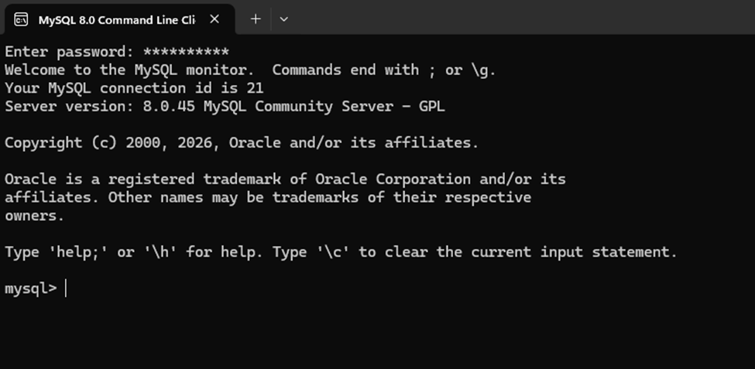

Part 2: Creating the Movies Database
After establishing a connection to the MySQL server, the next step was to create a new database named “movies.” This was accomplished using the standard MySQL CREATE DATABASE statement. Once the command was executed, MySQL confirmed success with the message “Query OK, 1 row affected.” To verify that the database was created correctly, the SHOW DATABASES command was then run, which displays a complete list of all databases currently on the server.
The commands used were:
CREATE DATABASE Movies;
SHOW DATABASES;
As shown in the screenshot below, the output from SHOW DATABASES confirms that the “movies” database now appears alongside the other default system databases (information_schema, mysql, performance_schema, sakila, sys, and world), totaling 7 databases in the set.

Figure 2: SHOW DATABASES Output Confirming Movies Database Creation
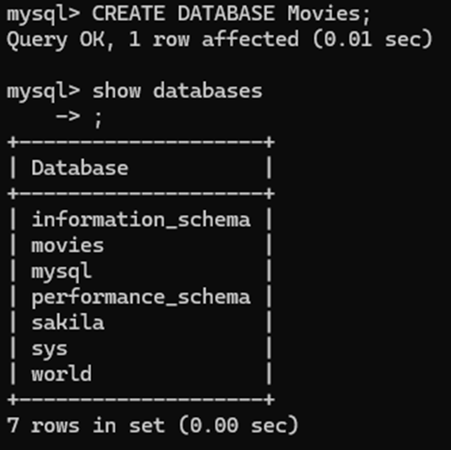

Part 3: MySQL Functions Exploration
The following section explores three MySQL functions sourced from W3Schools. For each function, a description of its use case, an alias for the column header, and the corresponding SQL statement are provided.

Function 1: UPPER()
Use Case: The UPPER() function converts all characters in a string to uppercase. This is useful when standardizing data for display or comparison purposes, for example, when displaying customer names or column values in a consistent, uppercase format regardless of how they were originally entered.
Column Alias: UppercaseName
SQL Statement:
SELECT UPPER(first_name) AS UppercaseName FROM sakila.customer LIMIT 5;
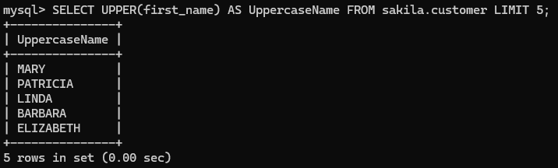

Function 2: LENGTH()
Use Case: The LENGTH() function returns the number of characters (or bytes) in a string. This is particularly useful for validating input data such as checking that a phone number or zip code field meets a required length or for filtering records where string length is a meaningful condition, like finding unusually short or long descriptions.
Column Alias: TitleLength
SQL Statement:
SELECT title, LENGTH(title) AS TitleLength FROM sakila.film LIMIT 5; 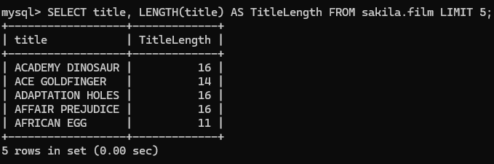

Function 3: NOW()
Use Case: The NOW() function returns the current date and time at the moment the query is executed. This is commonly used for timestamping record for instance, automatically recording when a row was inserted or updated or for calculating time differences, such as how many days have passed since an order was placed.
Column Alias: CurrentDateTime
SQL Statement:
SELECT NOW() AS CurrentDateTime; 