Zachary White
Sue Sampson
April 19, 2026
CSD 310

Entity Relationship Diagram | Movies Database

Assignment Overview
The following Entity Relationship Diagram (ERD) was created based on the business rules provided for the Movies database. An ERD is a visual representation of the data structure of a database, showing the entities (tables), their attributes (fields), and the relationships between them. This diagram serves as the blueprint for the database tables that will be created in the next module.

Business Rules
The ERD was designed to satisfy the following two business rules:
1. One STUDIO can produce many FILMs: This establishes a one-to-many (1:M) relationship between the STUDIO and FILM entities. A single studio may be responsible for producing multiple films. The studio_id foreign key in the FILM table links each film back to its producing studio.
2. One FILM can be described by one GENRE: This establishes a one-to-one (1:1) relationship between the FILM and GENRE entities. Each film is assigned exactly one genre. The genre_id foreign key in the FILM table links each film to its corresponding genre.

Entity Relationship Diagram
The diagram below illustrates the three entities (STUDIO, FILM, and GENRE), all of their respective fields, primary keys (PK), foreign keys (FK), and the cardinality of the relationships between them.
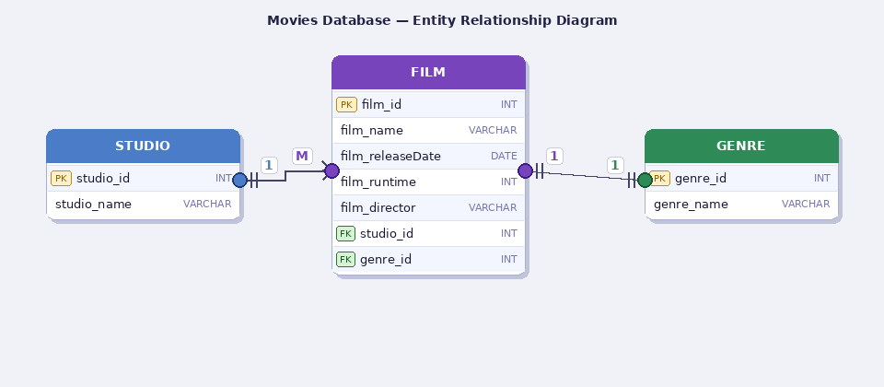
Figure 1: Movies Database Entity Relationship Diagram

Entity Descriptions

STUDIO
The STUDIO entity stores information about the production studios responsible for creating films. It contains two fields: studio_id (INT, Primary Key), which is a unique identifier for each studio, and studio_name (VARCHAR), which stores the name of the studio. The STUDIO entity is the “one” side of a one-to-many relationship with FILM.

GENRE
The GENRE entity stores the categories used to classify films. It contains two fields: genre_id (INT, Primary Key), a unique identifier for each genre, and genre_name (VARCHAR), the name of the genre. The GENRE entity is the “one” side of a one-to-one relationship with FILM.

FILM
The FILM entity is the central table in the database and stores detailed information about each movie. Its fields include: film_id (INT, Primary Key), film_name (VARCHAR), film_releaseDate (DATE), film_runtime (INT), film_director (VARCHAR), studio_id (INT, Foreign Key) referencing the STUDIO table, and genre_id (INT, Foreign Key) referencing the GENRE table. The two foreign keys enforce the relationships defined in the business rules.

