MySQL Database Initialization and Python Connector
Zachary White
Sue Sampson
April 19, 2026
CSD – 310

Assignment Overview
This assignment covers the initialization of the Movies database using a provided SQL script, verification of the resulting database tables, and the setup and testing of a Python connector to the MySQL database. Each step is documented with screenshots of the terminal output below.

Part 1: Running the SQL Initialization Script
After logging into the MySQL Command Line Client and switching to the movies database using USE movies;, the db_init_2022.sql script was run using the SOURCE command. The script created the necessary tables and populated them with initial data. The output shown below confirms that all queries executed successfully, with each line reporting “Query OK” along with the number of rows affected and execution time. The warnings shown are expected and do not indicate errors.
Figure 1: SQL Script Execution Output
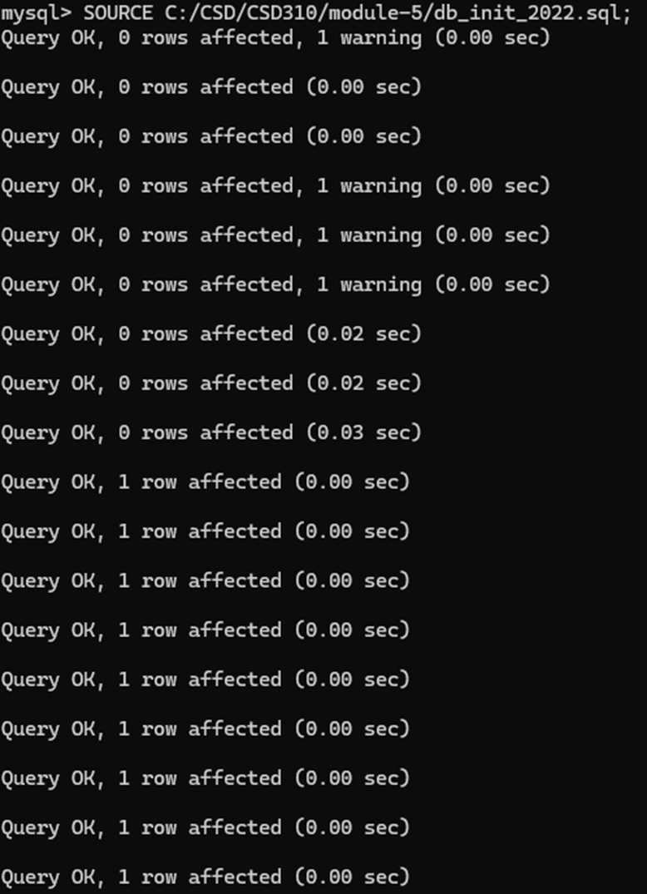

Part 2: Verifying Database Tables
Following the successful execution of the initialization script, the SHOW TABLES; command was run to confirm that the expected tables were created in the movies database. The output confirms that three tables exist: film, genre, and studio. These correspond directly to the entities defined in the ERD created in the previous module.
Figure 2: SHOW TABLES Output
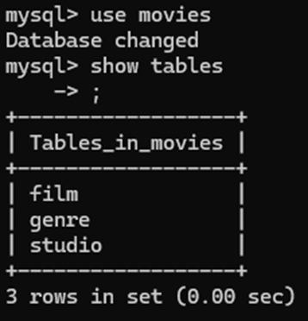

Part 3: Python MySQL Connector Test
To enable Python to communicate with the MySQL database, the mysql-connector-python and python-dotenv packages were installed using pip. A .env file was created in the module-5 directory containing the database credentials (user, password, host, and database name), keeping sensitive login information out of the source code.
The mysql_test.py script was then written and executed. It reads the credentials from the .env file, attempts a connection to the movies database, and prints a confirmation message if successful. As shown in the screenshot below, the script connected successfully, confirming that the movies_user account, password, and database configuration are all correct.
Figure 3: Python MySQL Connector Test Output
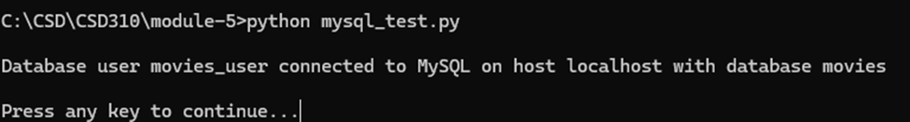

GitHub Repository
All files for this assignment, including the mysql_test.py script, the .env configuration file (excluded from tracking via .gitignore), and this Word document, have been staged, committed, and pushed to the GitHub repository for CSD-310. The repository link is included below.
GitHub Repository: [Insert GitHub repository link here]

