DATABASE MANAGEMENT
Milestone 3

Willson Financial
Reports
GOLD TEAM
Kobe Alexander | Samuel Dirr | Sebastian Siqueiros | Zachary White
Professor Sue Sampson | Spring 2026

Report 1 | Monthly Client Growth
Business Question:
How many clients have been added for each of the past six months?
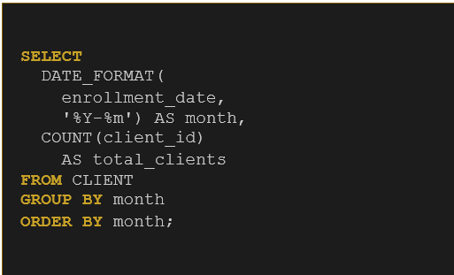
Result:
One client enrolled per month, steady growth trend across all six months (Jan–Jun 2024).

Report 2 | Average Client Assets

Business Question:

What is the average amount of assets (in currency) for the entire client list?

Result:

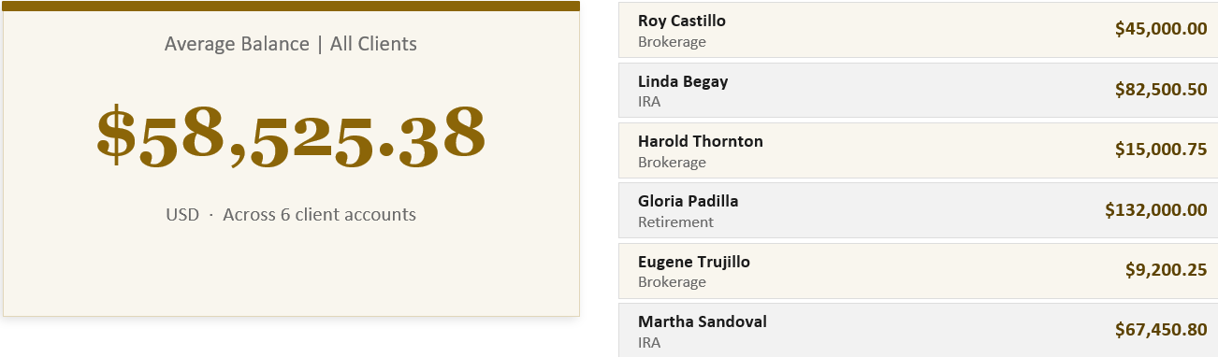

Report 3 | High Transaction Clients

Business Question:

How many clients have more than 10 transactions in a single month?
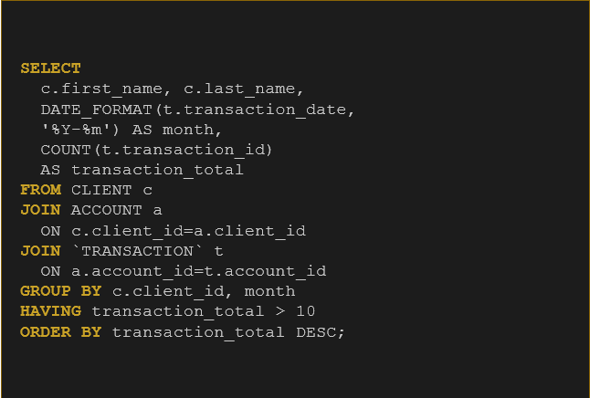
Results:
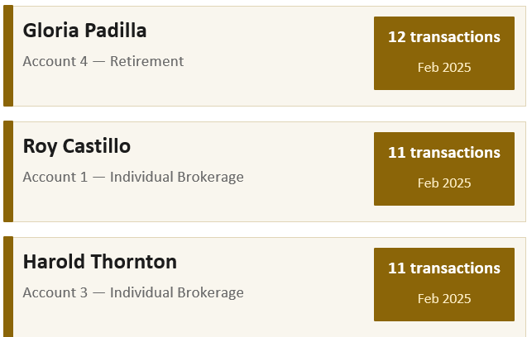

Report 1-3 Terminal Output

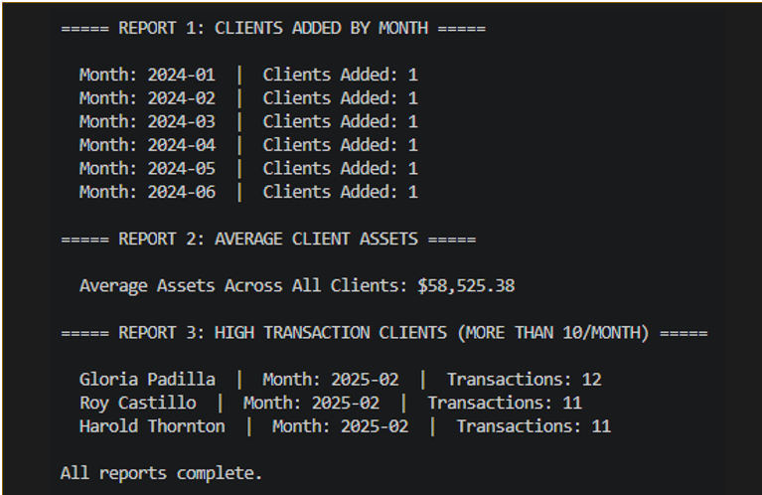

Github Links |  | Kobe: https://github.com/Kobea77/csd-310  Sebastian: https://github.com/sebsiqueiros/csd-310  Zach: https://github.com/DevZWhite/CSD310-306J-Database-Development-and-Use  Sam: https://github.com/samdirr/csd-310

