Name: Zachary White
Instructor: Darrell Payne
Date: April 4, 2026
Class: CSD 325
Module 2 - Debugging Assignment
Program Overview
For this assignment I used a program I wrote earlier in the year for our Python course. The program converts a user-entered distance in miles to kilometers using a fixed conversion rate of 1.60934. It includes a defined function, a validation loop, and error handling - making it a strong candidate for demonstrating debugging tools in VS Code.
Section 1 - Program Flowchart
The flowchart below models the complete logic of the miles-to-kilometers converter. The program begins by defining the miles_to_kilometers() function, then enters main() which runs a while True loop. Each iteration prompts the user for input, validates it against two conditions (non-numeric and negative values), performs the conversion by calling the function, and finally prints the results before breaking out of the loop. Both error paths loop back to the top of the while block so the user can re-enter a valid value.

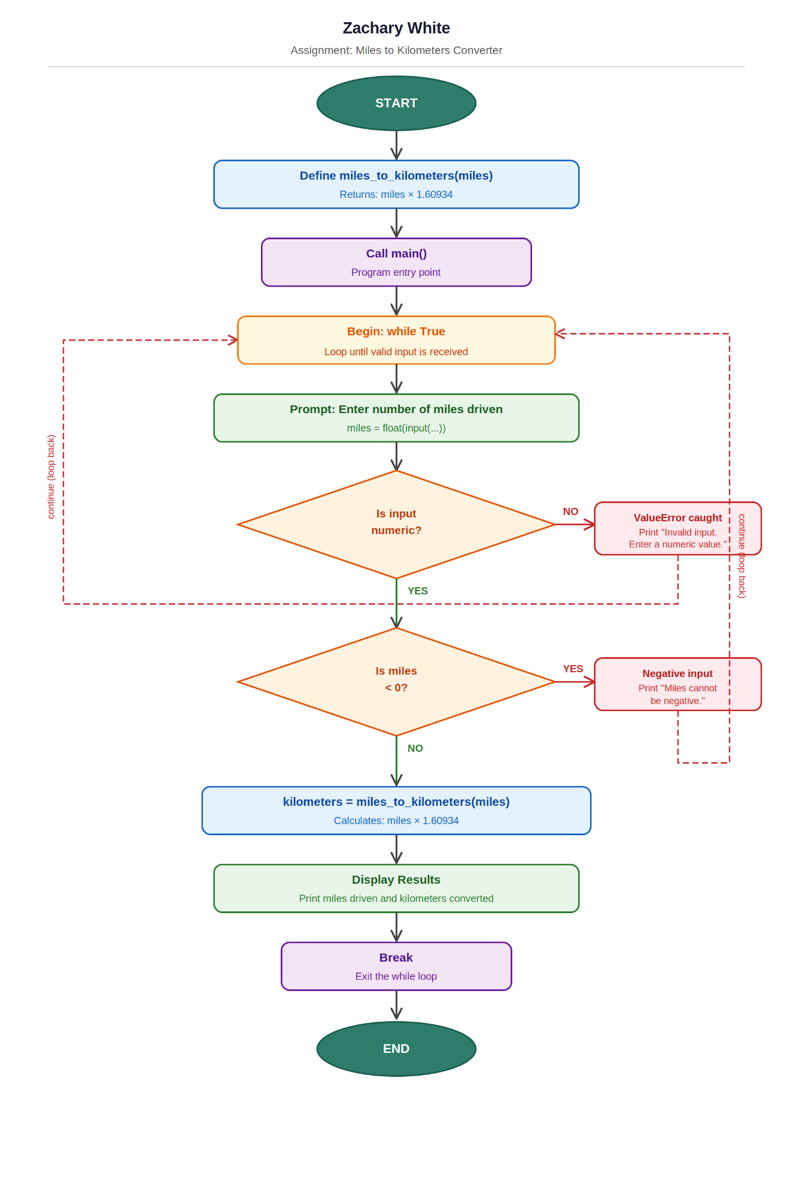
Figure 1 - Flowchart: Miles to Kilometers Converter

Section 2 - Debugging with VS Code
The following screenshots document the debugging session conducted in VS Code using the built-in Python debugger (Debugpy). A breakpoint was set, the program was stepped through line by line, and variable values were observed at each stage to verify the program behaves as expected.

Screenshot 1 - Breakpoint Set at Input Line
A breakpoint was placed on line 33 - the miles = float(input(...)) statement - which is the first line inside the while True loop where execution pauses and waits for user input. The yellow arrow on the left gutter indicates the debugger is paused at this exact line, confirming the breakpoint was hit successfully. At this point the loop has begun but no value has been assigned to the miles variable yet.
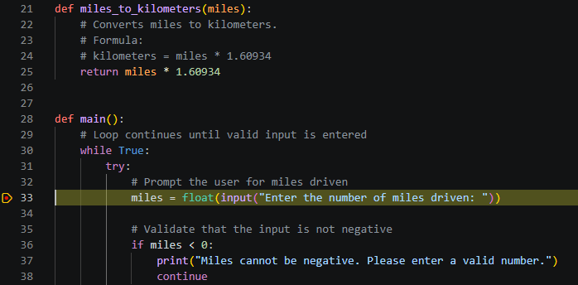
Figure 2 - Debugger paused at breakpoint on line 33 (input prompt)

Screenshot 2 - Stepping Into the Function / Evaluating the Condition
After entering a value of 20 at the terminal prompt, the debugger advanced to line 36 - the if miles < 0 conditional. The yellow highlight shows the debugger is now evaluating whether the entered value is negative. Because 20 is a valid positive number, this condition evaluates to False and the negative-input branch is skipped. The terminal panel at the bottom confirms the session, showing the program was launched and "Enter the number of miles driven: 20" was received.
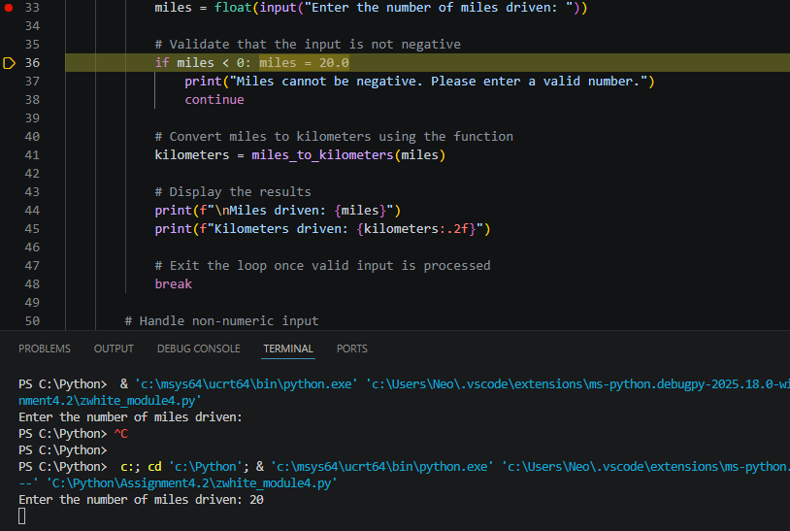
Figure 3 - Debugger stepped to line 36; evaluating the miles < 0 condition with input value 20

Screenshot 3 - Variable Values Observed After Conversion
Continuing to step through the program, the debugger reaches line 45 - the second print statement which outputs the converted kilometers value. At this point both variables are fully resolved and visible in the inline debug annotations: miles = 20.0 and kilometers = 32.1868. This confirms that the miles_to_kilometers() function executed correctly, returning 20 * 1.60934 = 32.1868. The program then exits the loop via the break statement on line 48, completing execution.

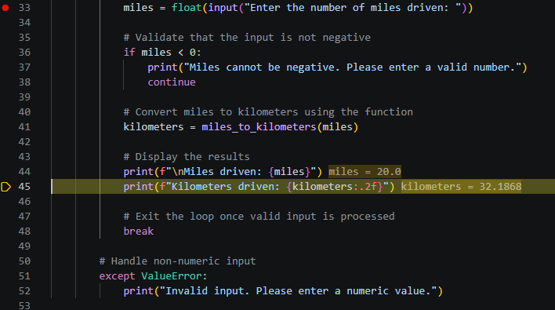
Figure 4 - Variable values confirmed: miles = 20.0, kilometers = 32.1868

Summary
This debugging session demonstrated three core debugging techniques in VS Code: setting a breakpoint to pause execution at a specific line, stepping through the program to observe control flow at each decision point, and inspecting live variable values directly in the editor to verify program state. The miles-to-kilometers converter performed as designed - correctly accepting a positive numeric input, skipping the error branches, invoking the conversion function, and displaying the expected output before cleanly exiting the loop.

References:
Lucid Software Inc. (n.d.). Lucidchart: Diagramming powered by intelligence. https://www.lucidchart.com
Abiola, O. (2017, July 10). Debugging in Python. Codementor. https://www.codementor.io/@gbozee/debugging-in-python-9ia7lof3

