CSD 325 – Module 4 Assignment

Student: Zachary White | Instructor: Darrell Payne
Date: April 17, 2026 | Class: CSD 325

Part 1 - Flowchart: Original sitka_highs.py
The flowchart below models the flow of execution in the original program provided for this module.

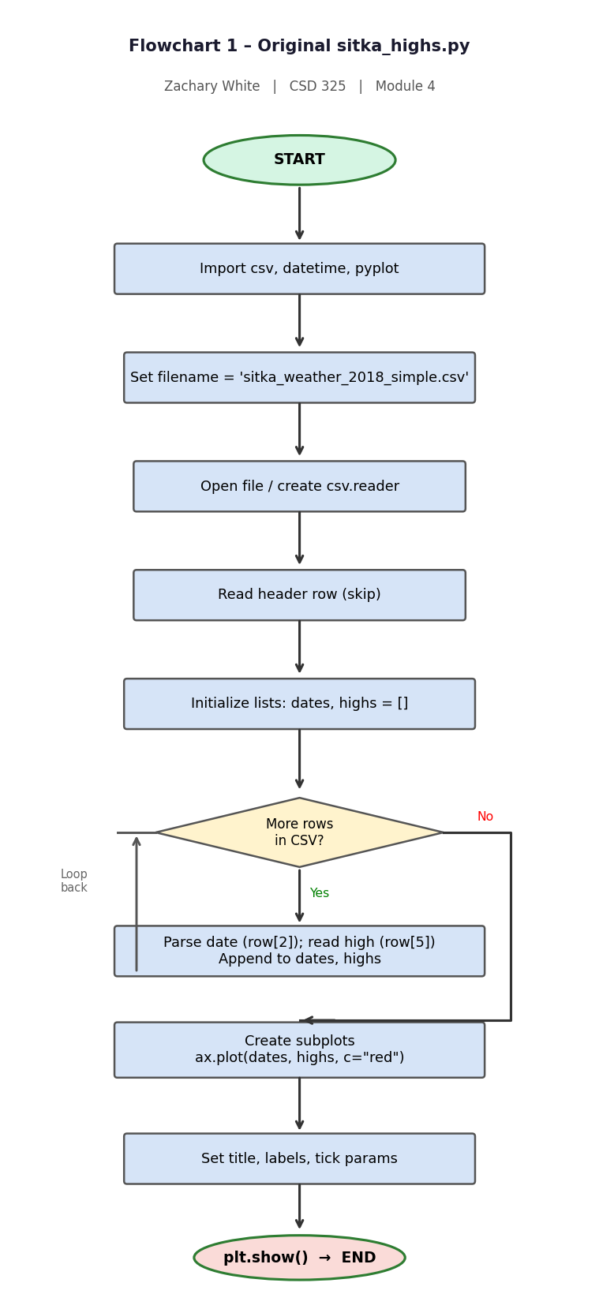

Part 2 - Revised Program: sitka_high_low_zw.py

Changes Made
The following changes were made to the original sitka_highs.py:

- Added import sys for a clean program exit via sys.exit().
- Wrapped the program in a while True loop so the menu repeats after each graph.
- Added a welcome banner printed once when the program starts.
- Added a menu each iteration: H = Highs, L = Lows, E = Exit.
- "Lows" option plots TMIN (row[6]) in blue with its own title.
- "Exit" option prints a goodbye message then calls sys.exit(0).
- Input validation: unrecognised entries print a helpful message and loop back.

Program Source Code
"""
sitka_high_low_zw.py
Student : Zachary White
Instructor: Darrell Payne
Class : CSD 325
Date : 04/17/2026
"""

import csv
import sys
from datetime import datetime
from matplotlib import pyplot as plt

FILENAME = "sitka_weather_2018_simple.csv"

print("=" * 50)
print(" Sitka, AK Weather Viewer - 2018")
print("=" * 50)

while True:
print(" Please select an option:")
print(" H - Highs : View daily HIGH temperatures")
print(" L - Lows : View daily LOW temperatures")
print(" E - Exit : Quit the program")

choice = input(" Enter your choice (H / L / E): ").strip().upper()

if choice == "E":
print(" Thank you for using the Sitka Weather Viewer. Goodbye! ")
sys.exit(0)

elif choice in ("H", "L"):
dates, values = [], []
with open(FILENAME) as f:
reader = csv.reader(f)
next(reader)
for row in reader:
dates.append(datetime.strptime(row[2], "%Y-%m-%d"))
values.append(int(row[5] if choice == "H" else row[6]))

fig, ax = plt.subplots()
if choice == "H":
ax.plot(dates, values, c="red")
plt.title("Daily High Temperatures - Sitka 2018", fontsize=24)
else:
ax.plot(dates, values, c="blue")
plt.title("Daily Low Temperatures - Sitka 2018", fontsize=24)

plt.xlabel("", fontsize=16)
fig.autofmt_xdate()
plt.ylabel("Temperature (F)", fontsize=16)
plt.tick_params(axis="both", which="major", labelsize=16)
plt.show()

else:
print(f" '{choice}' is not valid. Please enter H, L, or E.")

Part 3 - Revised Flowchart: sitka_high_low_zw.py
The flowchart below reflects all changes: the menu loop, Highs vs. Lows branches, and the Exit path with sys.exit().
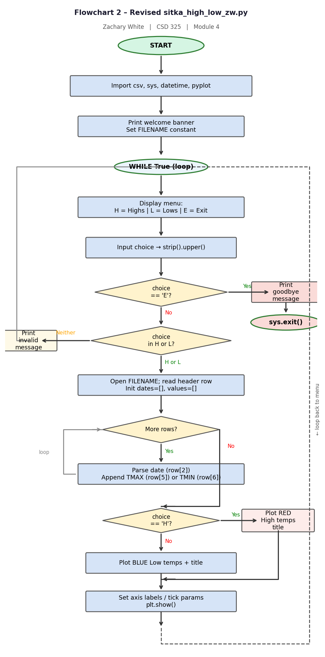

End of Module 4 Assignment | Zachary White | CSD 325

