Student Name: Zachary White
Assignment: Module 10 - Tkinter GUI To-Do List
Instructor: Darrell Payne
Course: CSD-325

Part 1: Listing 2.2 - Scrolling To-Do App (Baseline)
The following is the baseline Tkinter To-Do List program from Listing 2.2 of the Tkinter By Example tutorial. The program was run and a couple of tasks were added to verify it works correctly.

Listing 2.2 Code
import tkinter as tk
import tkinter as tk
import tkinter.messagebox as msg
class Todo(tk.Tk):
def __init__(self, tasks=None):
super().__init__()
# Initialize task list
if not tasks:
self.tasks = []
else:
self.tasks = tasks

# Create widgets
self.tasks_canvas = tk.Canvas(self)
self.tasks_frame = tk.Frame(self.tasks_canvas)
self.text_frame = tk.Frame(self)

self.scrollbar = tk.Scrollbar(
self.tasks_canvas,
orient="vertical",
command=self.tasks_canvas.yview
)

self.tasks_canvas.configure(yscrollcommand=self.scrollbar.set)

# Window settings
self.title("To-Do App v2")
self.geometry("300x400")

# Text box for entering tasks
self.task_create = tk.Text(
self.text_frame,
height=3,
bg="white",
fg="black"
)
# Layout
self.tasks_canvas.pack(side=tk.TOP, fill=tk.BOTH, expand=1)
self.scrollbar.pack(side=tk.RIGHT, fill=tk.Y)

self.canvas_frame = self.tasks_canvas.create_window(
(0, 0),
window=self.tasks_frame,
anchor="n"
)
self.task_create.pack(side=tk.BOTTOM, fill=tk.X)
self.text_frame.pack(side=tk.BOTTOM, fill=tk.X)
self.task_create.focus_set()

# Default placeholder item
todo1 = tk.Label(
self.tasks_frame,
text="--- Add Items Here ---",
bg="lightgrey",
fg="black",
pady=10
)
todo1.bind("<Button-1>", self.remove_task)

self.tasks.append(todo1)

for task in self.tasks:
task.pack(side=tk.TOP, fill=tk.X)

# Event bindings
self.bind("<Return>", self.add_task)
self.bind("<Configure>", self.on_frame_configure)
self.bind_all("<MouseWheel>", self.mouse_scroll) # Windows/macOS
self.bind_all("<Button-4>", self.mouse_scroll) # Linux scroll up
self.bind_all("<Button-5>", self.mouse_scroll) # Linux scroll down
self.tasks_canvas.bind("<Configure>", self.task_width)

# Alternating color schemes
self.colour_schemes = [
{"bg": "lightgrey", "fg": "black"},
{"bg": "grey", "fg": "white"}
]
def add_task(self, event=None):
task_text = self.task_create.get(1.0, tk.END).strip()
if len(task_text) > 0:
new_task = tk.Label(
self.tasks_frame,
text=task_text,
pady=10
)
self.set_task_colour(len(self.tasks), new_task)
new_task.bind("<Button-1>", self.remove_task)
new_task.pack(side=tk.TOP, fill=tk.X)
self.tasks.append(new_task)
self.task_create.delete(1.0, tk.END)
def remove_task(self, event):
task = event.widget

if msg.askyesno(
"Really Delete?",
"Delete " + task.cget("text") + "?"
):
self.tasks.remove(task)
task.destroy()
self.recolour_tasks()
def recolour_tasks(self):
for index, task in enumerate(self.tasks):
self.set_task_colour(index, task)
def set_task_colour(self, position, task):
_, task_style_choice = divmod(position, 2)
my_scheme_choice = self.colour_schemes[task_style_choice]
task.configure(bg=my_scheme_choice["bg"])
task.configure(fg=my_scheme_choice["fg"])
def on_frame_configure(self, event=None):
self.tasks_canvas.configure(
scrollregion=self.tasks_canvas.bbox("all")
)

def task_width(self, event):
canvas_width = event.width
self.tasks_canvas.itemconfig(
self.canvas_frame,
width=canvas_width
)
def mouse_scroll(self, event):
if event.delta:
self.tasks_canvas.yview_scroll(
int(-1 * (event.delta / 120)),
"units"
)
else:
if event.num == 5:
move = 1
else:
move = -1
self.tasks_canvas.yview_scroll(move, "units")
if __name__ == "__main__":
todo = Todo()
todo.mainloop()
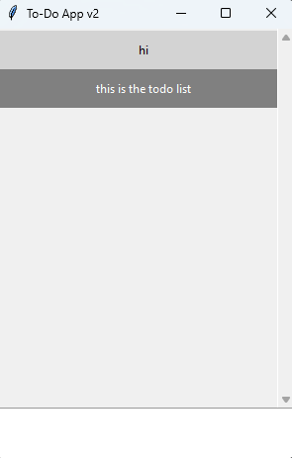

Part 2: Modified To-Do App
The following modifications were made to the baseline program to meet the assignment requirements:
1. Window Title: Changed from 'To-Do App' to 'Sampson-ToDo' using self.title('Sampson-ToDo').
2. Complementary Colors: Applied purple (#9B59B6) and gold/yellow (#F1C40F) as the two complementary colors for menu items, the header label, and alternating task rows.
3. Right-Click to Delete: Changed the delete binding from <Button-1> (left click) to <Button-3> (right click).
4. Delete Instructions in Label: Updated the header label text to read: "Items Added --- ** Right Click Item to Delete **" so users know how to delete tasks.
5. File > Exit Menu: Added a File menu to the menu bar with an Exit option. When clicked, it calls self.quit() to terminate the program cleanly.

Modified Program Code (todo_app.py)
import tkinter as tk
class ToDoApp(tk.Tk):
def __init__(self):
super().__init__()
self.title('Sampson-ToDo') # Modified title
self.geometry('400x500')
self.task_list = []
self._build_menu() # New: File > Exit menu
self._build_ui()

def _build_menu(self):
# Purple and gold complementary color scheme
menu_bar = tk.Menu(self, bg='#9B59B6', fg='white',
activebackground='#6C3483', activeforeground='white')
file_menu = tk.Menu(menu_bar, tearoff=0, bg='#9B59B6', fg='white',
activebackground='#6C3483', activeforeground='white')
file_menu.add_command(label='Exit', command=self.quit)
menu_bar.add_cascade(label='File', menu=file_menu)
self.config(menu=menu_bar)
def _build_ui(self):
# Label with delete instructions
self.task_label = tk.Label(
self,
text='Items Added --- ** Right Click Item to Delete **',
bg='#9B59B6', fg='white', font=('Arial', 10, 'bold'), pady=6)
self.task_label.pack(fill=tk.X)
entry_frame = tk.Frame(self)
entry_frame.pack(fill=tk.X, padx=10, pady=(10, 0))
self.task_entry = tk.Entry(entry_frame, font=('Arial', 12))
self.task_entry.pack(side=tk.LEFT, fill=tk.X, expand=True)
self.task_entry.bind('<Return>', lambda e: self.add_task())
add_btn = tk.Button(entry_frame, text='Add Task',
bg='#F1C40F', fg='black', font=('Arial', 10, 'bold'),
command=self.add_task)
add_btn.pack(side=tk.LEFT, padx=(6, 0))
list_frame = tk.Frame(self)
list_frame.pack(fill=tk.BOTH, expand=True, padx=10, pady=10)
scrollbar = tk.Scrollbar(list_frame)
scrollbar.pack(side=tk.RIGHT, fill=tk.Y)
self.task_listbox = tk.Listbox(
list_frame, yscrollcommand=scrollbar.set,
font=('Arial', 12), selectbackground='#9B59B6',
activestyle='none', bg='white', fg='black', height=15)
self.task_listbox.pack(fill=tk.BOTH, expand=True)
scrollbar.config(command=self.task_listbox.yview)
# Right mouse button (Button-3) to delete
self.task_listbox.bind('<Button-3>', self.delete_task)
def add_task(self):
task = self.task_entry.get().strip()
if task:
self.task_list.append(task)
self.task_listbox.insert(tk.END, task)
idx = self.task_listbox.size() - 1
# Alternate gold and purple row colors
if idx % 2 == 0:
self.task_listbox.itemconfig(idx, bg='#F1C40F', fg='black')
else:
self.task_listbox.itemconfig(idx, bg='#9B59B6', fg='white')
self.task_entry.delete(0, tk.END)
def delete_task(self, event):
try:
index = self.task_listbox.nearest(event.y)
self.task_listbox.delete(index)
del self.task_list[index]
# Re-color remaining items after deletion
for i in range(self.task_listbox.size()):
if i % 2 == 0:
self.task_listbox.itemconfig(i, bg='#F1C40F', fg='black')
else:
self.task_listbox.itemconfig(i, bg='#9B59B6', fg='white')
except Exception:
pass
if __name__ == '__main__':
app = ToDoApp()
app.mainloop()

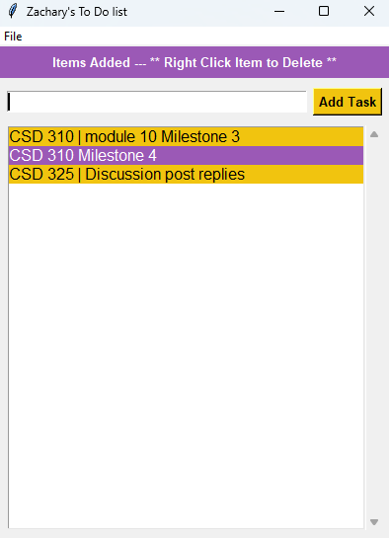
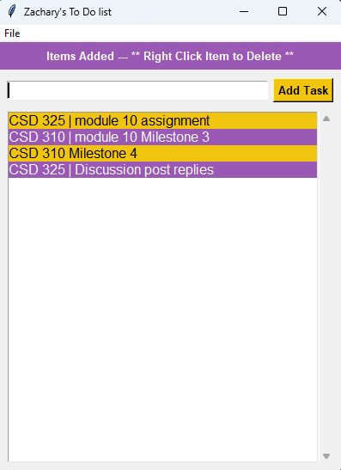

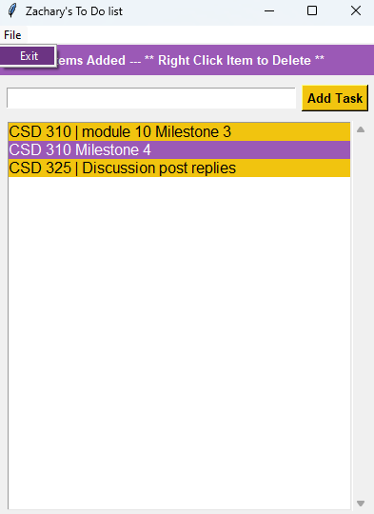
Summary of Changes
All five required modifications were implemented successfully. The program was tested by adding multiple tasks and verifying that right-clicking a task removed it from the list. The File > Exit menu item was confirmed to close the application cleanly. The purple and gold color scheme matches the example screenshot provided in the assignment as-well.

