Module 11: Django Tutorial
Learn Django in 20 Minutes | Assignment Submission
Student: | Zachary White
Course: | CSD 325
Instructor: | Professor Darrell Payne
Date: | May 24, 2026
Assignment: | Module 11 | Django Tutorial

Assignment Overview
This assignment required following the "Learn Django in 20 Minutes" tutorial to create and run a local Django web application. The steps included setting up a Django project, verifying the project structure, launching the development server, and customizing the HTTP response to display a personalized greeting.

Step 1: Project Directory Verification
After creating the Django project, the working directory was confirmed to contain manage.py — the file required to run Django management commands. The directory listing below shows the demo folder and manage.py file at C:\csd\csd325\module-11\demo.

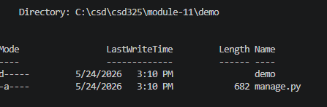
Figure 1 | PowerShell directory listing confirming manage.py is present in the demo project folder.

Step 2: Django Development Server | Welcome Page
With the server running via python manage.py runserver, the browser was directed to http://127.0.0.1:8000/. The Django welcome page confirms the installation was successful and the development server is active.

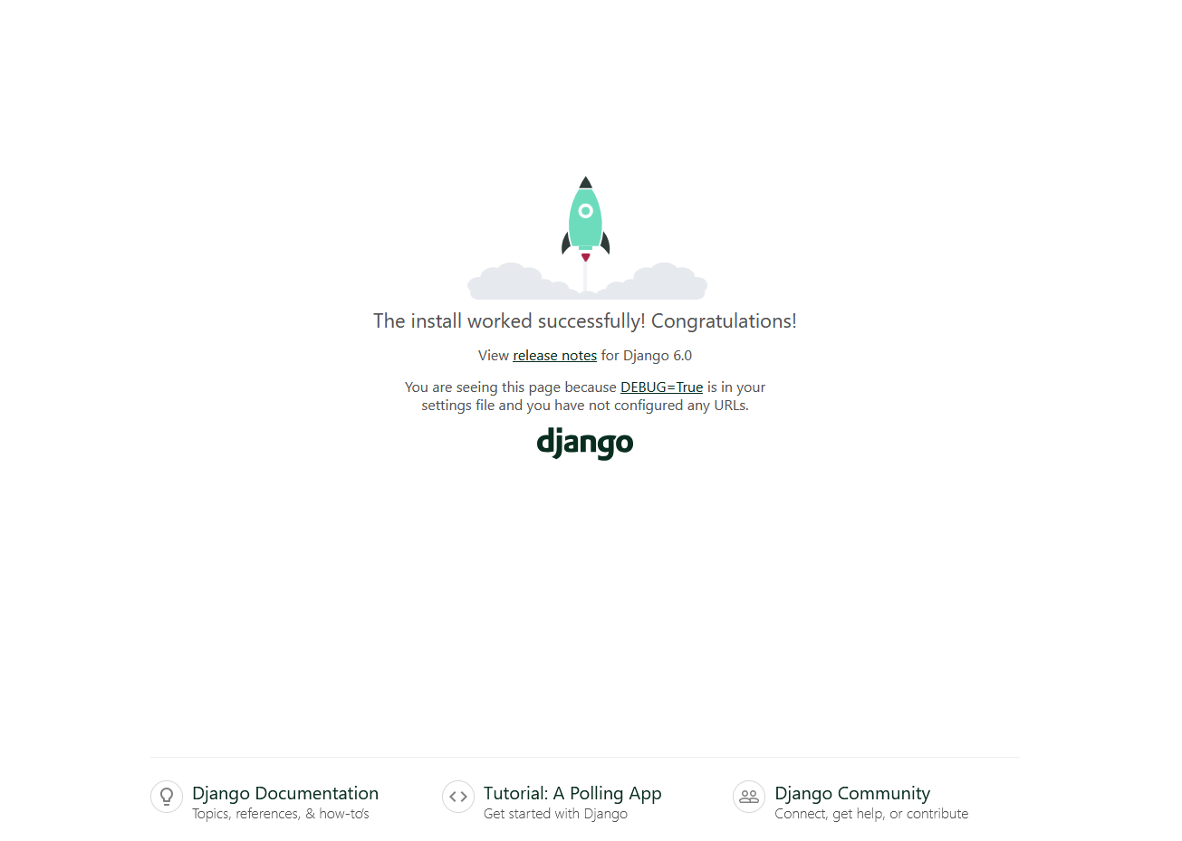
Figure 2 | Django default welcome page displayed at 127.0.0.1:8000, confirming the server is running correctly.

Step 3: Customized HTTP Response
The views.py file was modified to return a personalized HttpResponse. The string "Hello World" was replaced with "White says Hello!" as required by the assignment instructions. The screenshot below confirms the change is reflected in the browser.
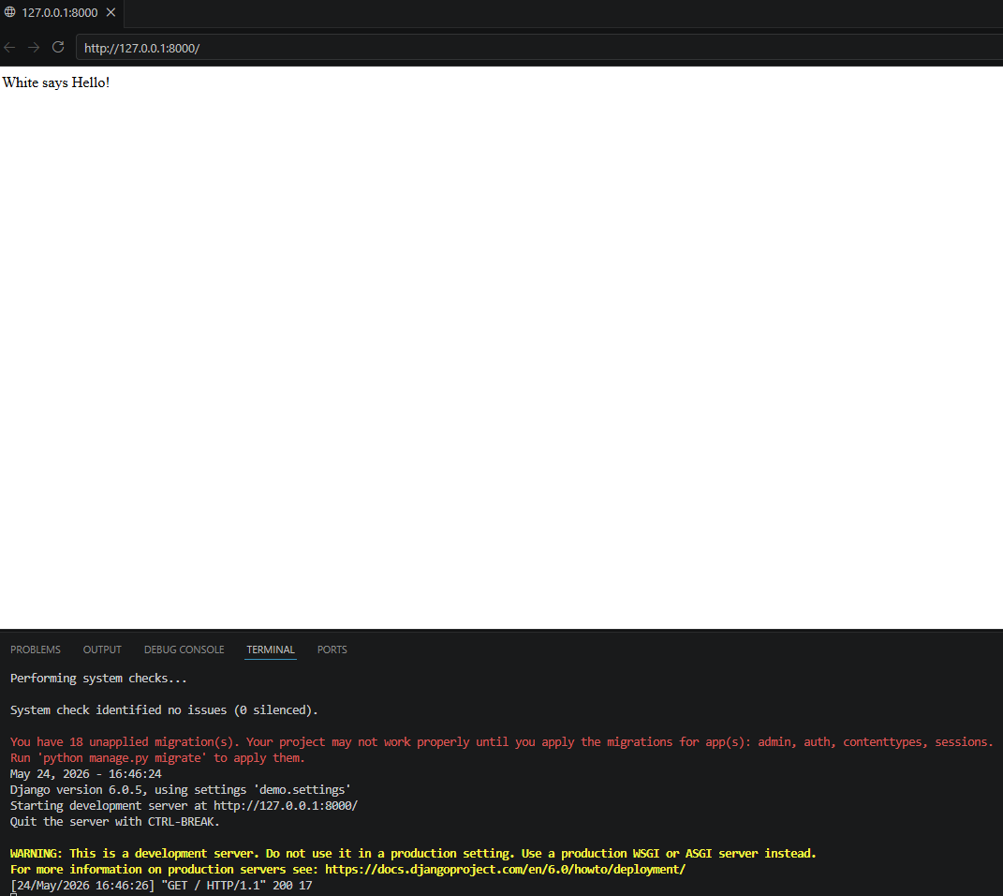
Figure 3 | Browser displaying "White says Hello!" at 127.0.0.1:8000, confirming successful views.py modification.

Summary
All three required steps of the Module 11 assignment were completed successfully: the project directory was verified, the Django development server was launched and confirmed operational, and the HTTP response was customized with the required personalized greeting.

