CSD-325 | Module 7 Assignment
City Functions & Unit Testing
Zachary White
Instructor: Darrell Payne
05/01/2026

1. Assignment Overview
This assignment covers two tasks: writing a Python program with a city_country() function that builds formatted location strings, and writing unit tests using Python's unittest module to verify the function works correctly through a series of deliberate modifications.
The assignment follows a test-driven development pattern the function is intentionally broken at each step by adding required parameters, causing tests to fail, then restored by making those parameters optional, causing tests to pass again.
File | Purpose
zwhite_assignment7.py | Contains the city_country() function and sample calls
zwhite_unittest_7.py | Contains unittest test cases for the city_country() function

2. city_country() Function
The final version of the city_country() function accepts four parameters: city and country (required), and population and language (optional). It returns a formatted string combining all provided values.
def city_country(city, country, population=None, language=None):
"""Return a formatted string of city, country with optional population and language."""
result = '{}, {}'.format(city.title(), country.title())
if population:
result += ' - population {}'.format(population)
if language:
result += ', {}'.format(language.title())
return result
The function was built up in stages first with just city and country, then population was added as required then made optional, then language was added as required then made optional. This mirrors the test-driven development cycle shown in the screenshots below

3. Step-by-Step Execution Results

Step 1 Initial city_functions.py Execution
The initial version of the function accepts only city and country. Three sample calls are made demonstrating the basic output format. The function correctly formats each city and country with title casing.
Screenshot city_functions.py output (3 sample calls):
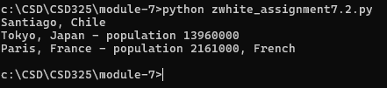

Step 2 Unit Tests Pass (Initial)
The test file zwhite_unittest_7.py is run for the first time. The test_city_country() method verifies that calling city_country('santiago', 'chile') returns 'Santiago, Chile'. All 3 tests pass successfully as shown by the OK result.
Screenshot All 3 tests passing:
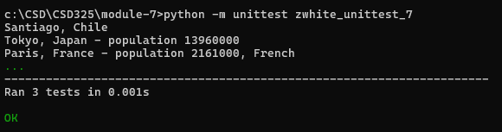

Step 3 Tests FAIL (population Made Required)
The city_country() function is modified to require population as a non-optional parameter (removing the default value). When the unit tests are run, they fail with a TypeError because the existing test calls don't pass a population argument. This is the expected failure that demonstrates the value of unit testing.
Screenshot Tests FAIL after population made required:
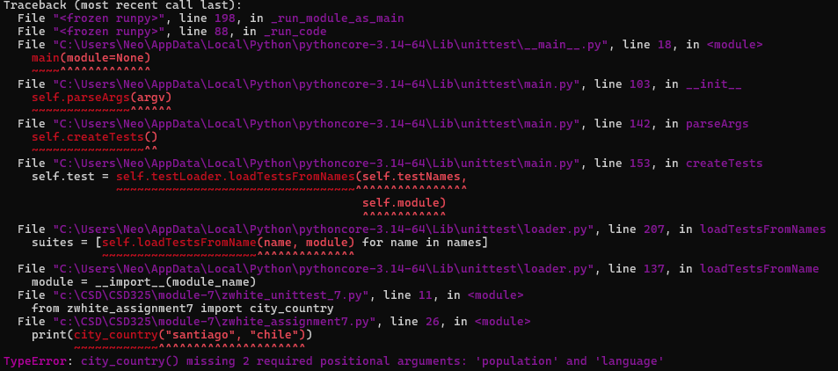

Step 4 Tests Pass Again (population=None Restored)
The population parameter is made optional again by restoring its default value to None. The unit tests are run again and all 3 pass, confirming the function is backward compatible with calls that don't include population.
Screenshot Tests passing after population=None restored:
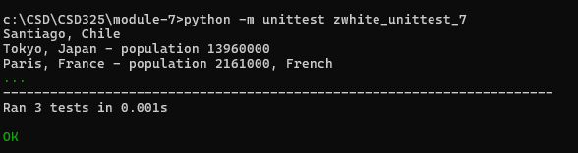

Step 5 Tests FAIL (language Made Required)
The city_country() function is modified again to require language as a non-optional parameter. Python raises a SyntaxError because a parameter without a default value cannot follow one that has a default this demonstrates an important Python rule about parameter ordering. The tests fail as expected.
Screenshot Tests FAIL after language made required:
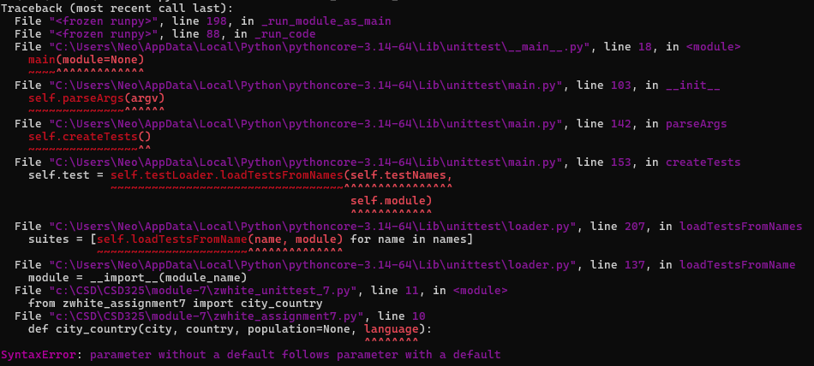

Step 6 Final Passing Tests (language=None Restored)
The language parameter is made optional by setting its default to None. All 3 unit tests pass successfully in the final run, confirming the complete function works correctly for all call patterns: city/country only, city/country/population, and city/country/population/language.
Screenshot All tests passing in final run:
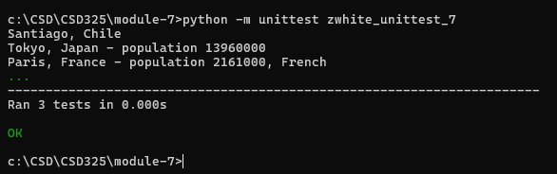

4. Final Test File
The final zwhite_unittest_7.py contains three test methods covering all parameter combinations:
import unittest
from zwhite_assignment7 import city_country
class TestCityCountry(unittest.TestCase):
def test_city_country(self):
"""Test city and country only."""
result = city_country('santiago', 'chile')
self.assertEqual(result, 'Santiago, Chile')
def test_city_country_population(self):
"""Test city, country, and population."""
result = city_country('tokyo', 'japan', population=13960000)
self.assertEqual(result, 'Tokyo, Japan - population 13960000')
def test_city_country_population_language(self):
"""Test city, country, population, and language."""
result = city_country('paris', 'france', population=2161000, language='french')
self.assertEqual(result, 'Paris, France - population 2161000, French')
if __name__ == '__main__':
unittest.main()

5. Summary
This assignment demonstrated the importance of unit testing in software development. By intentionally breaking the function and observing test failures, the process illustrated how unit tests catch regressions and enforce expected behavior. Key takeaways:

• The unittest module provides a structured way to verify function behavior automatically.
• Making parameters optional with default values (param=None) maintains backward compatibility.
• In Python, parameters with default values must always come after required parameters.
• Running tests after every change catches problems immediately rather than later.

