CSD-325 | Module 8 Assignment
Student JSON Read, Update & Write
Zachary White
Instructor: Darrell Payne
05/01/2026

1. Assignment Overview
This assignment demonstrates how to read, manipulate, and write JSON data using Python. The program loads a Student.json file into a Python list, displays the original records, appends a new student entry, displays the updated list, and writes the updated data back to the JSON file.
Step | Action
1 | Open Student.json and load with json.load()
2 | Print original student list using print_students()
3 | Append Zachary White to the list with append()
4 | Print updated student list using print_students()
5 | Write updated list back to Student.json using json.dump()

3. Python Script & flowchart zwhite_module8.py
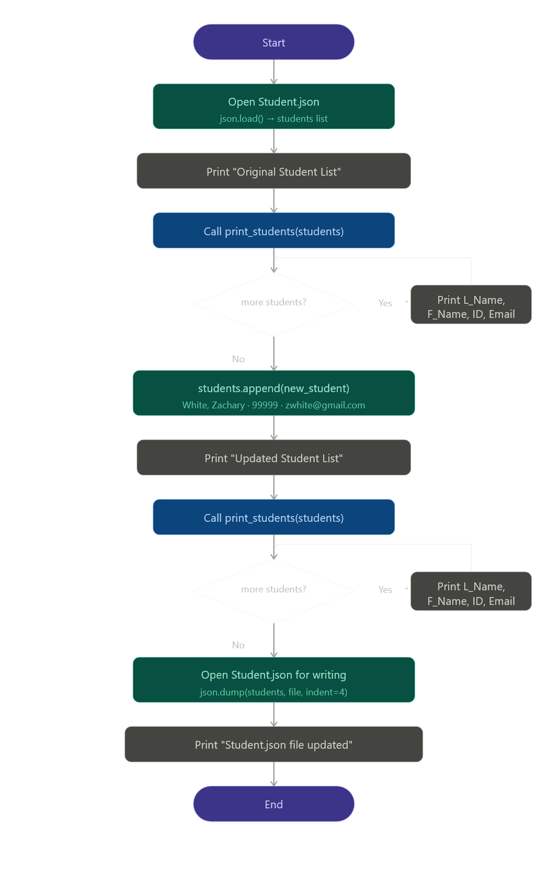
The complete program is shown below. It uses Python's built-in json module to handle reading and writing. The print_students() function is defined once and reused for both display calls.
"""
Author: Zachary White
Instructor: Darrell Payne
Date: 05/01/2026
Assignment: Module 8 - Student JSON
"""
import json
with open("Student.json", "r") as file:
students = json.load(file)
def print_students(student_list):
for student in student_list:
print("{}, {} : ID = {} , Email = {}".format(
student["L_Name"], student["F_Name"],
student["Student_ID"], student["Email"]
))
print("\n-- Original Student List --\n")
print_students(students)
new_student = {
"F_Name": "Zachary",
"L_Name": "White",
"Student_ID": 99999,
"Email": "zwhite@gmail.com"
}
students.append(new_student)
print("\n-- Updated Student List --\n")
print_students(students)
with open("Student.json", "w") as file:
json.dump(students, file, indent=4)
print("\n-- Student.json file has been updated --\n")

4. Program Output
The program was executed from the command line using:
cd c:\CSD\CSD325\module-8
python zwhite_module8.py
The output below shows the original list of four students, followed by the updated list with the new Zachary White entry appended, and finally the confirmation that the JSON file was written successfully.
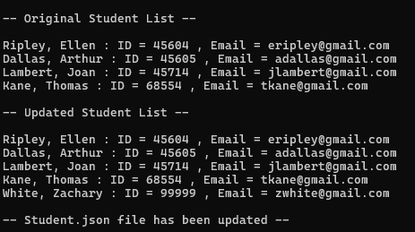

5. Updated Student.json Contents
After the program ran, the Student.json file was updated with the appended record. The full contents of the updated file are shown below:

[
{
"F_Name": "Ellen",
"L_Name": "Ripley",
"Student_ID": 45604,
"Email": "eripley@gmail.com"
},
{
"F_Name": "Arthur",
"L_Name": "Dallas",
"Student_ID": 45605,
"Email": "adallas@gmail.com"
},
{
"F_Name": "Joan",
"L_Name": "Lambert",
"Student_ID": 45714,
"Email": "jlambert@gmail.com"
},
{
"F_Name": "Thomas",
"L_Name": "Kane",
"Student_ID": 68554,
"Email": "tkane@gmail.com"
},
{
"F_Name": "Zachary",
"L_Name": "White",
"Student_ID": 99999,
"Email": "zwhite@gmail.com"
}
]

