CSD-325 | Module 9 Assignment
Student Name: Zachary White
Instructor: Darrell Payne
Assignment: Module 9 | Working with APIs in Python
Date: 05/09/2026

Part 1: API Tutorial (dataquest.io)

Step 1: Test the Connection (tutorial_api.py)
The following code tests the connection to google.com and prints the HTTP status code. A 200 response means the connection was successful.

import requests
response = requests.get('http://www.google.com')
print(response.status_code)

Step 2: Retrieve Current Astronauts in Space (tutorial_api.py)
This section calls the Open Notify API (http://api.open-notify.org/astros.json) to retrieve and display the names and spacecraft of all astronauts currently in space. The raw JSON is printed first, followed by formatted output.

astros_url = 'http://api.open-notify.org/astros.json'
response = requests.get(astros_url)
data = response.json()

print(f"Number of people in space: {data['number']}")
for person in data['people']:
print(f" Name: {person['name']}")
print(f" Craft: {person['craft']}")

Screenshot – tutorial_api.py output (connection test + astronauts):
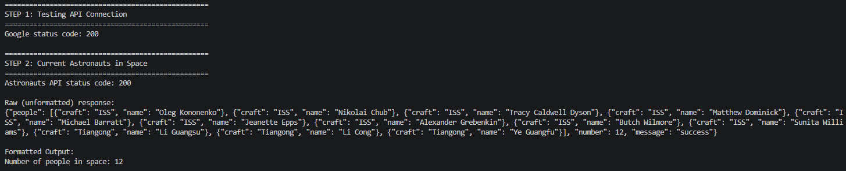

Part 2: Custom API Program (custom_api.py)

API Choice: Open Notify ISS Current Location
I chose the Open Notify ISS Location API (http://api.open-notify.org/iss-now.json) because it is free, requires no API key, and returns clean JSON with the real-time latitude and longitude of the International Space Station. The same server powers the astronaut API used in the tutorial, confirming it is reliable.

Step 1 Test the Connection
base_url = 'http://api.open-notify.org/iss-now.json'
test_response = requests.get(base_url)
print(f'Connection status code: {test_response.status_code}')

Step 2 Raw (Unformatted) Response
The raw JSON string is printed directly using response.text before any parsing is applied:
{"message": "success", "timestamp": 1778428890,
"iss_position": {"latitude": "49.7475", "longitude": "127.5564"}}

Step 3 Formatted Output
The JSON is parsed with response.json() and key fields are printed in a labeled, readable format. The Unix timestamp is also converted to a human-readable UTC date and time.
Status : success
Timestamp : 1778428890 (2026-05-10 16:01:30 UTC)
Latitude : 49.7475
Longitude : 127.5564
Track ISS : https://www.n2yo.com/passes/

Screenshot – custom_api.py full output:

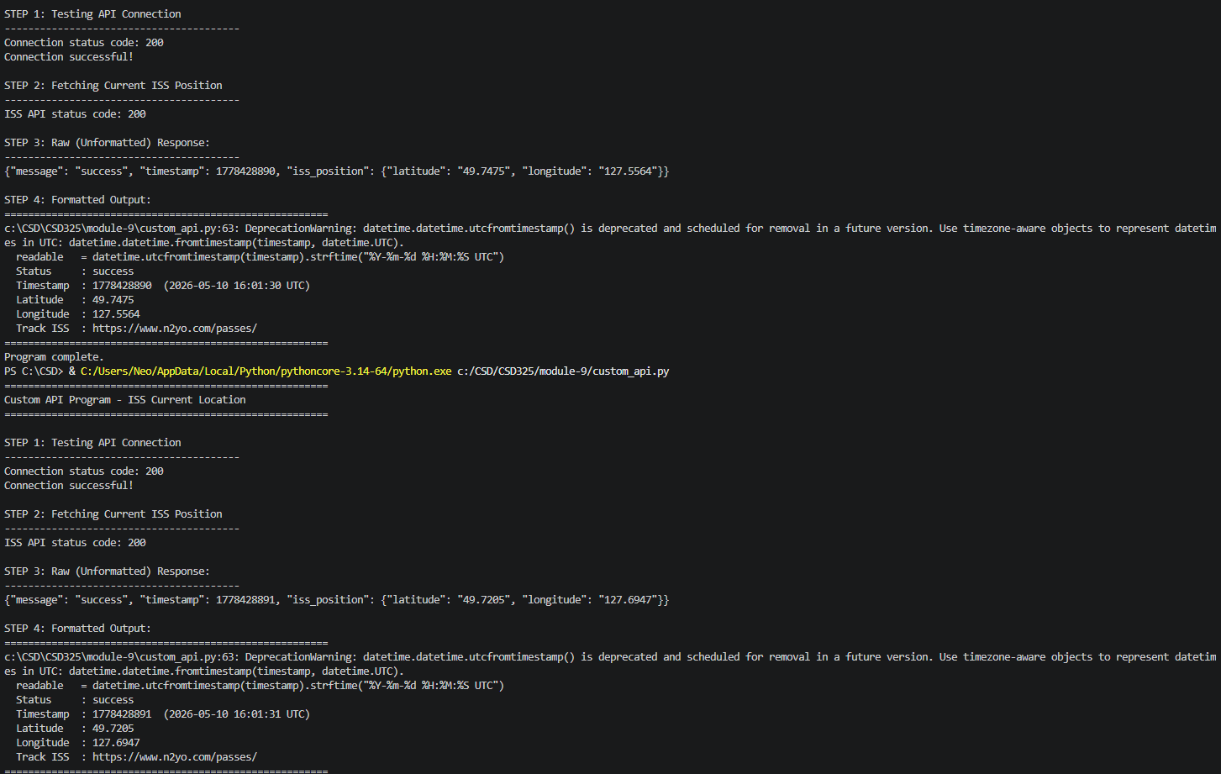

Summary
This assignment demonstrated how to interact with web APIs using Python's requests library. The key steps for any API program are:

1. Test the connection first check the HTTP status code (200 = OK).
2. Make the data request to the API endpoint.
3. Print the raw response (response.text) to see the unformatted JSON.
4. Parse with response.json() and format the output for readability.

Both APIs used in this assignment Open Notify Astronauts and Open Notify ISS Location are free, require no API key, and return well-structured JSON, making them ideal for learning the fundamentals of API programming in Python.

