Zachary White
November 8, 2026
Module 3 Assignment, CSD430
Professor: Darrell Payne
Job Application Form and JSP Results Page

Overview
This assignment is a job application form for my fictional company called Iron Soft. The form, application.html, gathers 13 pieces of information across four steps: personal info, position and availability, experience and skills, and a final review. When the applicant submits it, the data is posted to a separate JSP file, applicationresults.jsp, which cleans the data and displays it in an HTML table with field descriptions, a title, and an overall description.

Design Notes
The Java code is kept in scriptlets, and all HTML tags are placed outside of them. The results page stores the field names, descriptions, and group names in String arrays, so one loop can print every row of the table. Every answer is escaped before it is displayed so that typed text can never run as HTML. A JavaScript file validates each field as the user types, and an external CSS file provides the styling.

Requirements Summary
Requirement | Where it is met
Form with 3+ input types | Text, email, tel, url, drop-down, radio buttons, date, range slider, number, and checkbox inputs
5+ data entry points | 13 fields across four steps
Form submits to a separate JSP | application.html posts to applicationresults.jsp
Java in scriptlets | All data arrays, loops, and formatting are in scriptlets
HTML tags outside scriptlets | All markup is plain HTML; values are inserted with <%= %>
Results in an HTML table | Field, Description, and Your Response columns grouped under headings
Descriptions, title, overall description | Description column, table intro, page title, and confirmation card
Documentation | Header comments in all four files plus inline comments

Application Form Screenshots
  Figure 1: Step 1, Personal Info  Text, email, tel, and url inputs collect the applicant’s contact details. The progress bar and step list show where the applicant is. |   Figure 2: Step 2, Position and Availability  A drop-down, radio buttons, a date picker, and a salary slider collect the job details.
  Figure 3: Step 3, Experience and Skills  A number input, a drop-down, and clickable skill chips. Green check marks show valid fields. |   Figure 4: Step 4, Review and Submit  Every answer is summarized with Edit links. The applicant must confirm before Submit activates.

Results Page
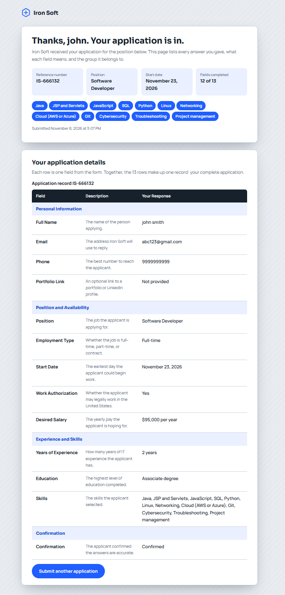
Figure 5: applicationresults.jsp displaying the submitted application
After submission, applicationresults.jsp shows a confirmation card with a reference number, the position, start date, number of completed fields, and the selected skills. The table lists each field with a description and the applicant’s response, grouped under headings.

Project Structure and Code
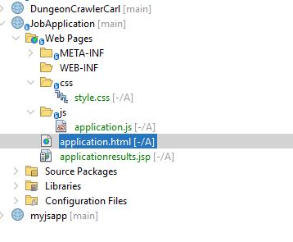  Figure 6: Project Structure in NetBeans  The JobApplication project holds the HTML form and JSP in Web Pages, with css and js folders. | 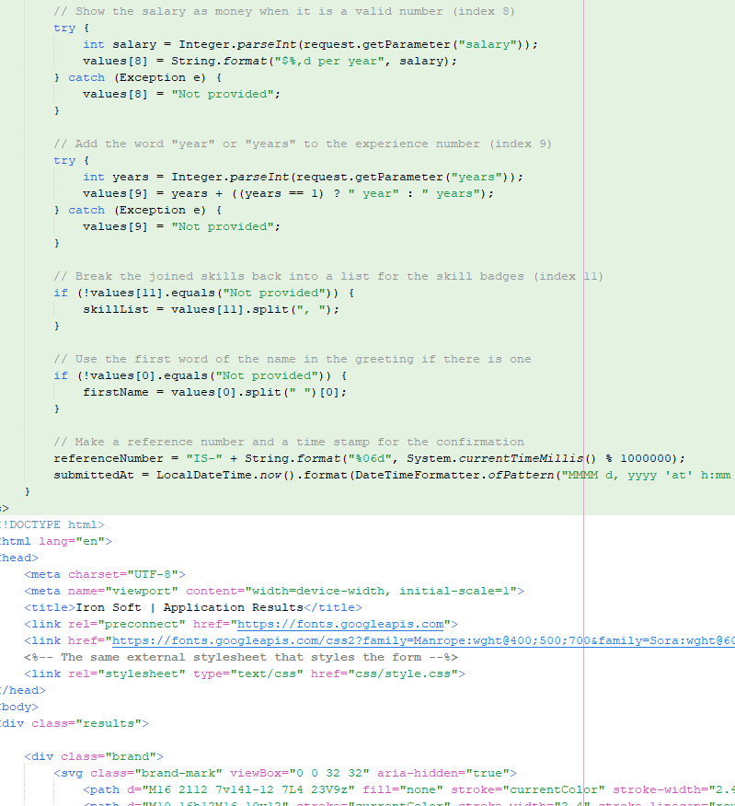  Figure 7: JSP Scriptlet Code  Part of the scriptlet that formats the salary, experience, and skills and builds the reference number.
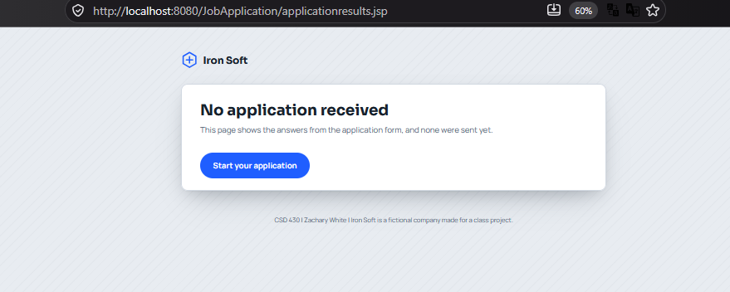
Figure 8: Direct visit to applicationresults.jsp without submitting the form
When the results page is opened without form data, the scriptlet detects that nothing was submitted and shows a friendly message with a link back to the form instead of an error.

