Zachary White
October 25, 2026
Module 1 Assignment, CSD430
Professor: Darrell Payne
Java, Apache Tomcat, and NetBeans Installation and First JSP
This paper shows that Java, Apache Tomcat, and the NetBeans IDE were installed and configured successfully, and that a first JSP file containing both Java code and HTML tags runs correctly on Tomcat.

Figure 1: Java Installation
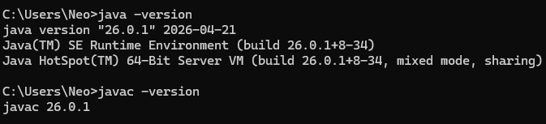
Figure 1: java -version and javac -version in Command Prompt
The Command Prompt shows that Java SE 26.0.1 is installed. Both the runtime (java -version) and the compiler (javac -version) report their versions, which confirms the JDK is installed and available on the system PATH.

Figure 2: Apache Tomcat Installation
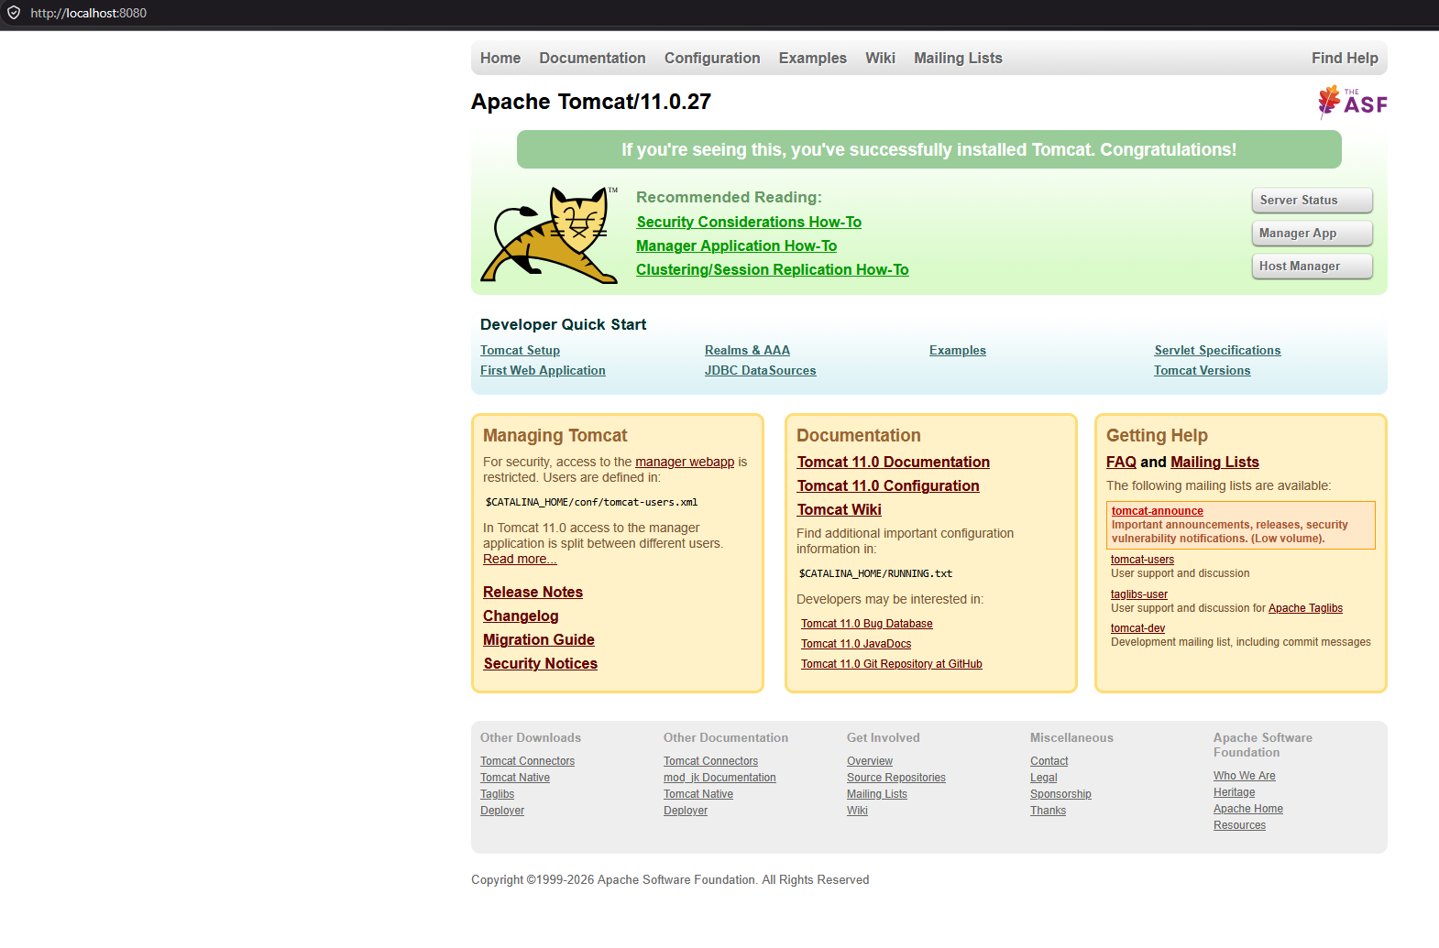
Figure 2: Apache Tomcat 11.0.27 welcome page at http://localhost:8080
After setting JAVA_HOME and starting Tomcat, the default welcome page loads at localhost:8080. The message confirming a successful installation, along with the version number Apache Tomcat/11.0.27, shows the server is running correctly.

Figure 3: NetBeans IDE Configuration
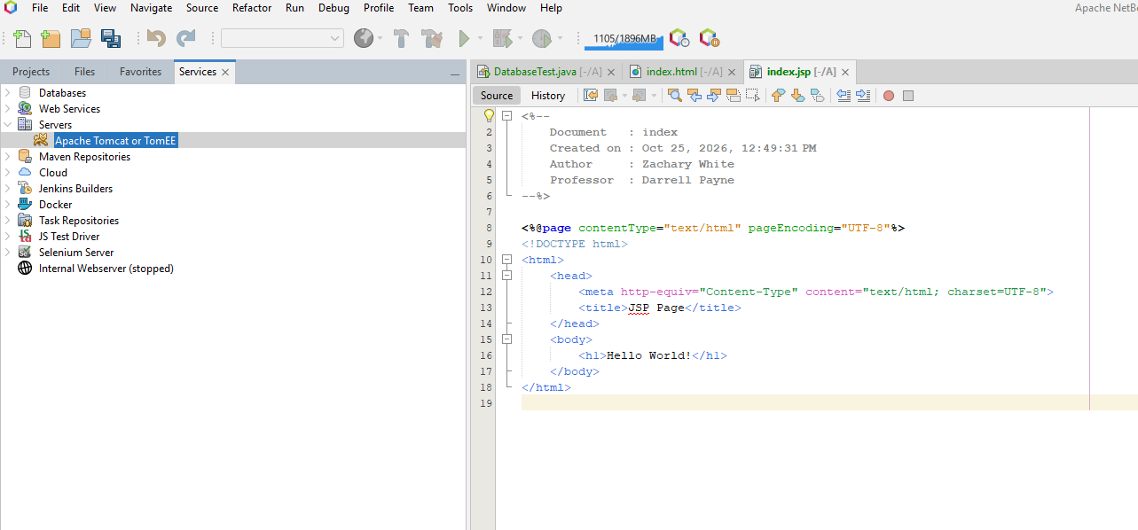
Figure 3: NetBeans with Apache Tomcat registered under Servers and index.jsp open
Apache NetBeans is installed, and the Services tab lists Apache Tomcat or TomEE under Servers, which shows the IDE is connected to the Tomcat installation. The editor on the right shows the JSP file for the project, including the header comment with my name and the professor’s name.

Figure 4: JSP Running in the Browser
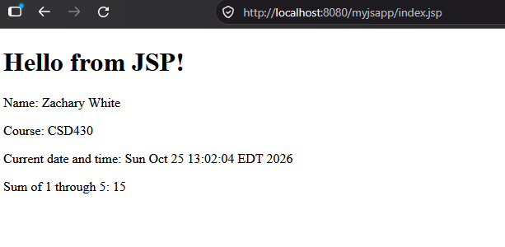
Figure 4: index.jsp running at http://localhost:8080/myjspapp/index.jsp
The JSP page was deployed to Tomcat from NetBeans and displays correctly in the browser. The heading and name come from HTML tags. The course name, current date and time, and the sum of 1 through 5 (15) are generated by Java code in the JSP, which confirms the page is being processed by the server.

JSP Source Code (index.jsp)
The file combines JSP directives and comments, standard HTML tags, and Java code in a scriptlet and expressions.
<%--
Document : index
Created on : Oct 25, 2026
Author : Zachary White
Professor : Darrell Payne
--%>
<%@page contentType="text/html" pageEncoding="UTF-8"%>
<!DOCTYPE html>
<html>
<head>
<meta http-equiv="Content-Type" content="text/html; charset=UTF-8">
<title>JSP Page</title>
</head>
<body>
<h1>Hello from JSP!</h1>
<p>Name: Zachary White</p>
<%
String course = "CSD430";
java.util.Date now = new java.util.Date();
int total = 0;
for (int i = 1; i <= 5; i++) {
total += i;
}
%>
<p>Course: <%= course %></p>
<p>Current date and time: <%= now %></p>
<p>Sum of 1 through 5: <%= total %></p>
</body>
</html>

