Zachary White
November 1, 2026
Module 2 Assignment, CSD430
Professor: Darrell Payne
Dynamic JSP Page with Scriptlets and External CSS

Overview
This assignment is a dynamic HTML page built with JSP scriptlets. The page presents information about the book series Dungeon Crawler Carl by Matt Dinniman, grouped into three categories: the books, the characters, and the floors and locations. The Java code is kept in scriptlets, all HTML tags are placed outside the scriptlets, and an external CSS file controls the styling of the page.

Design Choice
I chose to store the data in a two-dimensional String array system because it was the simplest way to organize each category without creating extra classes or methods. Each row is one record and each column is one field, so a single loop can display every record within its table or reference it by its index position.

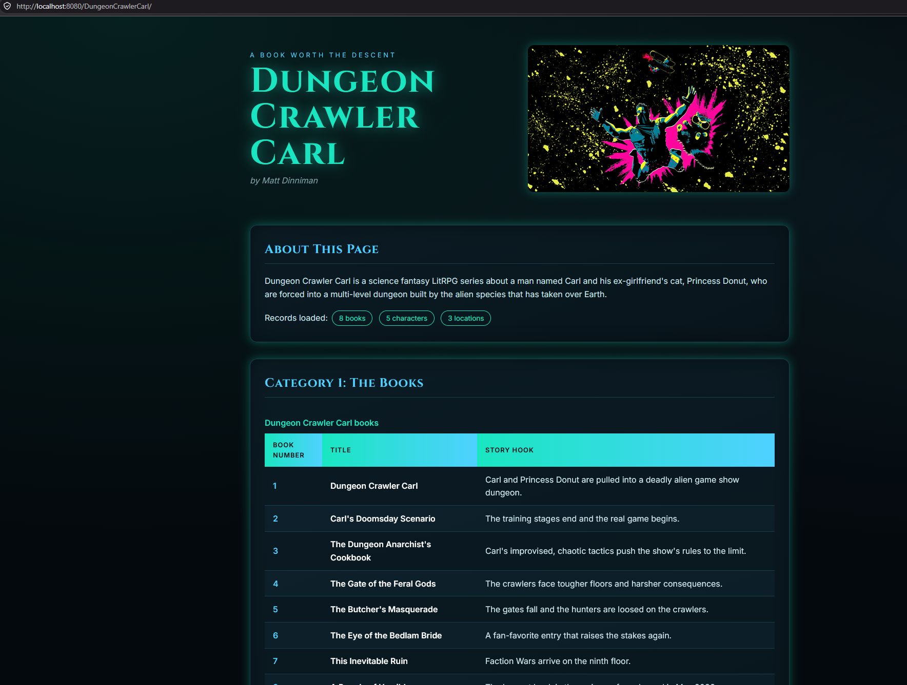
Figure 1: The page running on Tomcat at http://localhost:8080/DungeonCrawlerCarl/
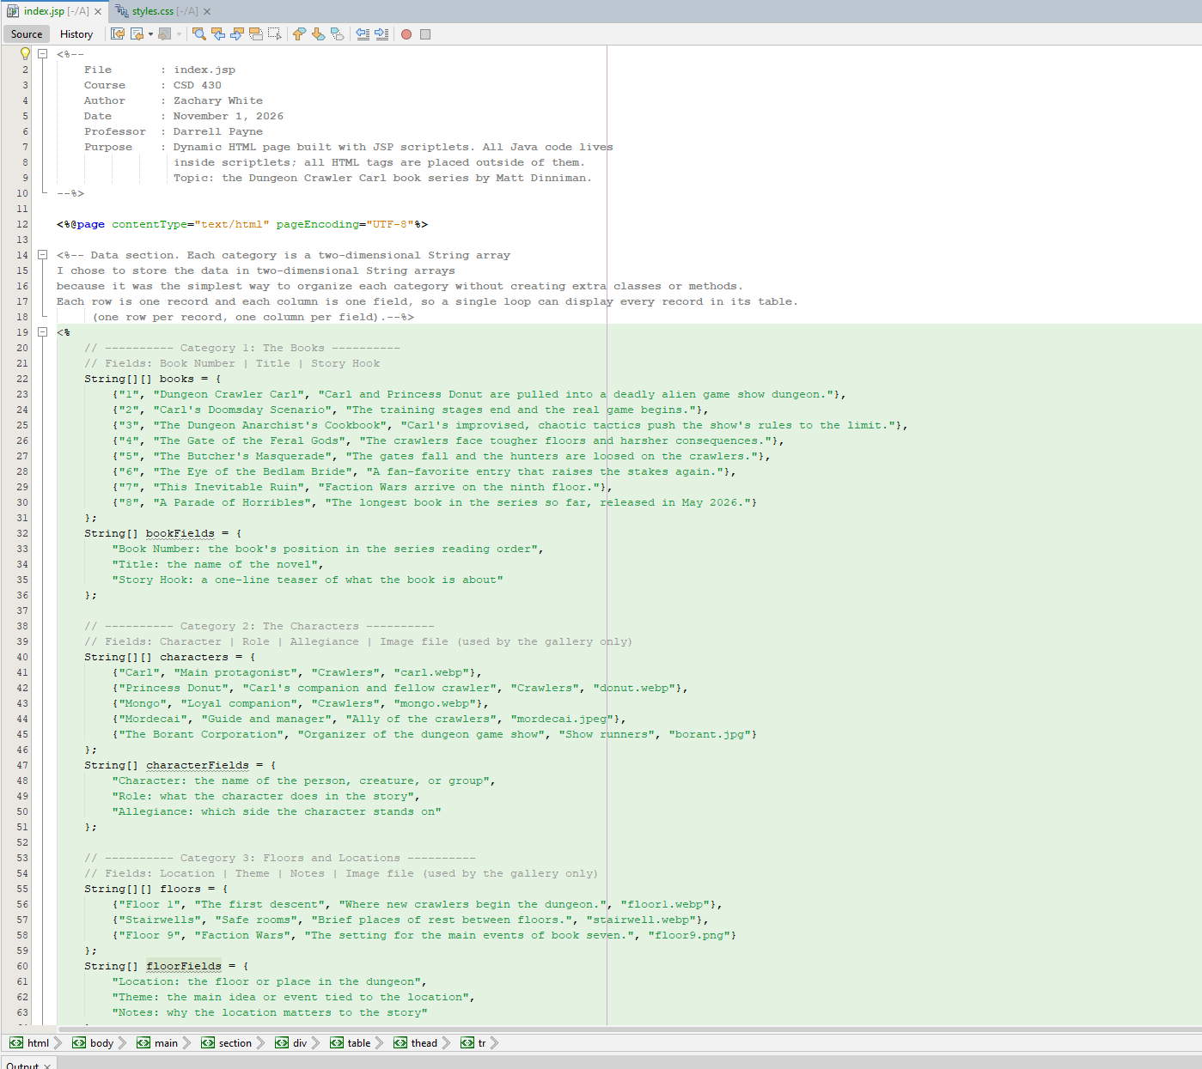
Figure 2: index.jsp showing the header comment, page directive, and scriptlet data arrays

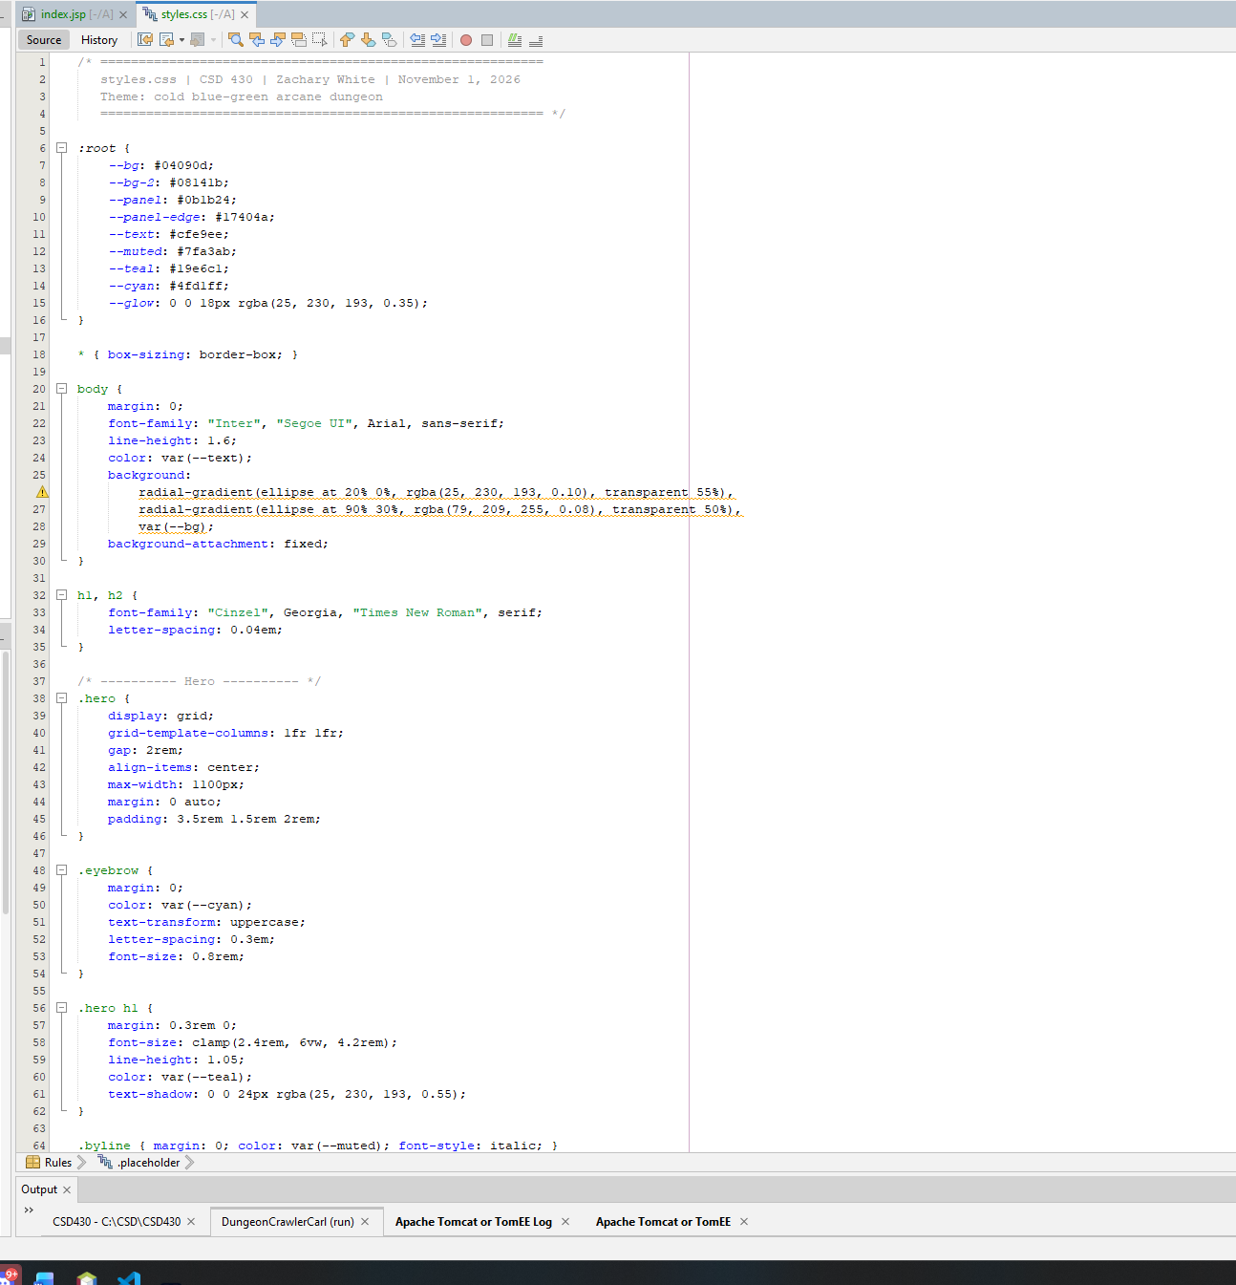
Figure 3: styles.css defining the color variables, fonts, and hero layout

