 | Blockchain-Backed Certificate Issuance & Verification Platform — CertiChain ERP
JAVA PROJECT  NOVEMBER 2026 | JAVA PROJECT REPORT SUBMITTED IN PARTIAL FULFILLMENT OF THE REQUIREMENTS FOR THE AWARD OF THE  DEGREE OF BACHELOR OF ENGINEERING  IN COMPUTER SCIENCE AND ENGINEERING IN SPECIALIZATION WITH ARTIFICIAL INTELLIGENCE AND MACHINE LEARNING  OF THE ANNA UNIVERSITY
 | Submitted by  DEVARANJAN J 722825148016
  PROJECT
  WORK
BATCH
2025 – 2029
Under the Guidance of

Mr.R.VIKKRAM M.Tech.,(Ph.D.)
Department of Computer Science And Engineering – Artificial Intelligence and Machine Learning

Sri Eshwar College of Engineering
(An Autonomous Institution – Affiliated to Anna University)
COIMBATORE – 641 202

Sri Eshwar College of Engineering
(An Autonomous Institution – Affiliated to Anna University)
COIMBATORE – 641 202

BONAFIDE CERTIFICATE

Certified that this Report titled “Blockchain-Backed Certificate Issuance & Verification Platform — CertiChain ERP ” is the bonafide work of

DEVARANJAN J | 722825148016
who carried out the project work under my supervision.

----------------------------------------- | -----------------------------------------
SIGNATURE | SIGNATURE
Dr.S.Sumathi M.E.,Ph.D.,  HEAD OF THE DEPARTMENT  CSE(AI&ML),  Sri Eshwar College of Engineering,  Coimbatore – 641 202. | Mr.R.Vikkram M.Tech.,(Ph.D.),  SUPERVISOR  Assistant Professor,  CSE(AI&ML),  Sri Eshwar College of Engineering,  Coimbatore – 641 202.

Submitted for the Autonomous Semester End Mini Project Viva-Voce held on

…………………..

_________________________  INTERNAL EXAMINER | _________________________  EXTERNAL EXAMINER

DECLARATION

DEVARANJAN J [722825148016]

To declare that the project entitled “Blockchain-Backed Certificate Issuance & Verification Platform – CertiChain ERP ” submitted in partial fulfilment to the University as the project work of Bachelor of Engineering in Computer Science and Engineering (Artificial Intelligence and Machine Learning) Degree, is a record of original work done by us under the supervision and guidance of Mr.R.VIKKRAM, M.Tech., (PhD), Assistant Professor, Department of Computer Science and Engineering (Artificial Intelligence and Machine Learning), Sri Eshwar College of Engineering, Coimbatore.

Place: Coimbatore

Date:
DEVARANJAN J

Project Guided by,

Mr.R.Vikkram AP,CSE(AI&ML)

ACKNOWLEDGEMENT

The success of a work depends on a team and cooperation. I take this opportunity to express my gratitude and thanks to everyone who helped me in my project. I would like to thank the management for the constant support provided by them to complete this project.
It is indeed our great honor bounded duty to thank our beloved Chairman Mr. R. Mohanram, for his academic interest shown towards the students.
We are indebted to our Director Mr. R. Rajaram, for motivating and providing us with all facilities.
I wish to express my sincere regards and deep sense of gratitude to Dr. Sudha Mohanram, M.E, Ph.D. Principal, for the excellent facilities and encouragement provided during the course of the study and project.
We are indebted to Dr.S.Sumathi, M.E., Ph.D. Head of Computer Science And Engineering (Artificial Intelligence and Machine Learning) Department for having permitted us to carry out this project and giving the complete freedom to utilize the resources of the department.
I express my sincere thanks to my mini project Coordinator Mr.R.Vikkram, M.Tech.,(Ph.D.) Assistant Professor of Computer Science and Engineering (Artificial Intelligence and Machine Learning) Department for the valuable guidance and encouragement given, to us for this project.
I solemnly express our thanks to all the teaching and nonteaching staff of the Computer Science and Engineering (Artificial Intelligence and Machine Learning) Department, family and friends for their valuable support which inspired us to work on this project.

TABLE OF CONTENT

CONTENT | PAGE NO
ABSTRACT | 6
- INTRODUCTION  - OBJECTIVE | 7
- SYSTEM REQUIREMENTS & SPECIFICATION  - EXSISTING SCENARIO  - PROBLEM STATEMENT | 8  9
- LOW-LEVEL DESIGN (LLD)  3.1. SYSTEM ARCHITECTURE AND MODULE DESIGN  3.2. LOW-LEVEL MODULE AND DATA FLOW DESIGN | 10  12
- MODELING (UML DIAGRAMS)  - USE CASE DIAGRAM  - CLASS DIAGRAM | 15  16
- DATABASE DESIGN  - DATABASE STRUCTURE  - DATABASE SCHEMA  - FLOWCHART | 17  18  19
- IMPLEMENTATION AND TESTING  - IMPLEMENTATION  - TESTING  - CODE AND OUTPUT | 20  20  21-36
- CONCLUSION AND FUTURE SCOPE  - CONCLUSION | 37
- APPENDICES AND REFERENCES  - REFERENCES  - APENDIX A  - APENDIX B | 38  39  40

ABSTRACT

This project presents the design and implementation of CertiChain ERP, a Blockchain-Backed Certificate Issuance and Verification Platform developed to provide secure, tamper-resistant, and efficient management of academic credentials. The system enables accredited institutions to digitally issue certificates, generate unique SHA-256 cryptographic hashes, and anchor certificate records on a blockchain to provide an additional layer of integrity and authenticity. Employers and authorized verification agencies can instantly verify certificates by using the generated certificate hash and obtain the verification status without requiring manual document validation.
The application is developed using Java Spring Boot for the backend, React with TypeScript for the frontend, and MySQL for persistent data management. Solidity and Hardhat are used to implement and test the blockchain component, while secure authentication and role-based access control are implemented using Spring Security and JWT. The platform supports multiple roles, including Administrator, Accountant, and Verifier, with controlled access to certificate management, verification services, financial transactions, and reporting functions.
In addition to certificate issuance and verification, CertiChain ERP integrates enterprise resource planning features such as customer and vendor management, sales orders, invoices, payments, purchase orders, vendor bills, chart of accounts, double-entry accounting, budgets, and financial reports. Audit logging is incorporated to maintain traceability of important system activities. By combining cryptographic verification, blockchain-based integrity, centralized database management, and financial administration in a single platform, the proposed system provides a reliable and scalable solution for managing the complete lifecycle of academic certificate issuance, verification, and related institutional operations.

INTRODUCTION

1.1 OBJECTIVE

The primary objective of CertiChain ERP is to develop a secure and reliable web-based platform for issuing, managing, and verifying academic certificates using SHA-256 cryptographic hashing and blockchain technology. The system aims to generate unique digital fingerprints for certificates and securely record their verification information on a blockchain, thereby enabling fast and tamper-resistant credential verification.
The platform provides secure authentication and role-based access control for administrators, accountants, and verification agencies. It enables institutions to manage certificate records, issue and revoke credentials, and allows authorized verifiers to perform instant certificate verification using the certificate hash.
Another objective is to integrate certificate management with essential ERP and financial management functions, including customer and vendor management, sales orders, invoices, payments, purchase orders, vendor bills, chart of accounts, double-entry accounting, budgeting, and financial reporting. The system maintains audit logs for important activities and uses Spring Boot, React, MySQL, Solidity, and Hardhat to provide a structured, scalable, and maintainable solution for academic credential management and institutional operations.

SYSTEM REQUIREMENTS & SPECIFICATION

2.1 EXISTING SCENARIO

In the existing academic credential management process, certificates are generally issued and maintained through institution-controlled databases, printed documents, or centralized digital systems. Certificate verification often requires students or graduates to provide copies of their credentials, while employers and background verification agencies manually contact the issuing institution or use separate verification portals to confirm the authenticity of the certificate. This process can require significant time and administrative effort, particularly when a large number of credentials need to be verified.
Traditional digital certificate systems mainly depend on centralized databases and document records. If certificate information is modified, duplicated, or incorrectly represented, identifying the original record may require additional administrative verification. Physical certificates can also be damaged, lost, or subjected to unauthorized alteration. Furthermore, certificate verification and institutional financial activities are commonly handled through separate systems, making it difficult to maintain a unified record of certificate issuance, verification transactions, invoices, payments, and operational expenses.Existing verification services may also require separate mechanisms for managing verification requests and charging agencies for API-based verification services. Financial activities such as customer invoicing, vendor payments, revenue tracking, budgeting, and accounting may not be directly connected with the certificate management workflow.
Therefore, the existing scenario involves manual verification procedures, dependence on centralized records, separate financial management processes, and limited integration between credential verification and institutional enterprise operations. These limitations create the need for an integrated platform that can provide secure certificate issuance, cryptographic verification, blockchain-based integrity, automated verification services, and financial management within a single system.

PROBLEM STATEMENT

The increasing use of digital academic credentials has created a need for a secure and reliable mechanism to issue, store, and verify certificates. Traditional certificate verification methods depend heavily on physical documents, centralized institutional records, and manual communication between employers, verification agencies, and educational institutions. These approaches can result in delays, increased administrative effort, and difficulties in detecting unauthorized modification or duplication of certificate information.
The absence of a cryptographically verifiable certificate identifier also makes it difficult to establish the integrity of a digital credential independently. A verification agency may need to contact the issuing institution or access a separate verification system for every credential, which can reduce the efficiency of large-scale verification operations. Certificate revocation and maintaining an auditable history of credential-related activities can also become difficult when records are distributed across different systems.
In addition, certificate verification services and the associated financial activities are often managed separately. Customer invoices, verification service revenue, vendor bills, infrastructure expenses, payments, budgets, and accounting records may not be directly connected to the certificate lifecycle. This creates difficulties in maintaining a unified view of both credential operations and their financial performance.
Therefore, there is a need for an integrated platform that can securely issue academic certificates, generate SHA-256 cryptographic hashes, maintain tamper-resistant verification records using blockchain technology, support instant certificate verification and revocation, and integrate these operations with sales, purchase, accounting, budgeting, and financial reporting. The proposed CertiChain ERP addresses these requirements by providing a centralized application with secure role-based access, audit logging, blockchain-backed credential integrity, and integrated enterprise financial management.

LOW-LEVEL DESIGN (LLD)
3.1 SYSTEM ARCHITECTURE AND MODULE DESIGN
The CertiChain ERP system follows a layered architecture that separates the user interface, business logic, data management, blockchain operations, and security components. This structure improves maintainability, scalability, security, and communication between different modules of the application.
The frontend is developed using React with TypeScript and Vite. It provides the user interface for authentication, certificate management, verification, ERP transactions, accounting, budgeting, and reporting. The frontend communicates with the backend through REST APIs.
The backend is implemented using Java Spring Boot. It contains the business logic and provides RESTful APIs for certificate management, verification, master data, financial transactions, accounting, budgeting, reporting, and authentication.
The MySQL database stores structured application data such as users, institutions, certificates, verification requests, customers, vendors, products, invoices, payments, accounting records, budgets, and audit logs.
The blockchain layer is implemented using Solidity and Hardhat. Certificate hashes are recorded through a smart contract to provide tamper-resistant verification information. Sensitive student information is not stored directly on the blockchain; only the required cryptographic reference and blockchain transaction information are maintained.
Major Modules
- Authentication and Authorization Module
Provides secure login using Spring Security and JWT authentication. Role-based access control restricts system operations according to user permissions.
- Institution Management Module
Maintains accredited institution information and supports creation and management of institutional records.
- Certificate Management Module
Handles certificate creation, issuance, SHA-256 hash generation, certificate status management, and revocation.
- Blockchain Module
Communicates with the smart contract and records certificate hash information on the local blockchain network.
- Verification Module
Allows employers and verification agencies to verify certificates using their cryptographic hash and receive the corresponding verification status.
- Customer and Vendor Management Module
Maintains verification agencies, customers, and infrastructure vendors required for ERP operations.
- Sales and Billing Module
Manages verification service packages, sales orders, customer invoices, and customer payments.
- Purchase Management Module
Handles infrastructure purchase orders, vendor bills, and vendor payments.
- Accounting Module
Implements the Chart of Accounts, journals, journal entries, general ledger, and double-entry accounting.
- Budget Management Module
Maintains analytic accounts, planned budgets, actual revenue, actual expenses, and budget utilization.
- Reporting Module
Generates financial reports such as Profit and Loss, Balance Sheet, Trial Balance, and Budget Reports.

3.2 LOW-LEVEL MODULE AND DATA FLOW DESIGN

The low-level design defines how individual components communicate and process information inside the CertiChain ERP system.
A. Certificate Issuance Process
- The authorized user logs into the application.
- Spring Security authenticates the user and verifies the assigned role.
- The user enters student and certificate information.
- The backend validates the submitted information.
- A canonical certificate string is generated from the required certificate fields.
- The Java MessageDigest mechanism generates the SHA-256 hash.
- The certificate record and generated hash are stored in MySQL.
- The certificate hash is submitted to the blockchain smart contract.
- The blockchain transaction is recorded and its transaction information is stored in MySQL.
- The certificate status is set to ACTIVE.
- The system returns the issued certificate information to the frontend.

B. Certificate Verification Process
- The verifier enters the certificate hash.
- The frontend sends the hash to the Spring Boot verification API.
- The backend validates the hash format.
- The certificate hash is searched in MySQL.
- If no matching record exists, the system returns NOT_FOUND.
- If the certificate exists, its current status is checked.
- If the certificate is revoked, the system returns REVOKED.
- If the certificate is active, the stored hash is compared with the blockchain record.
- If the blockchain record does not match, the system returns BLOCKCHAIN_MISMATCH.
- If the records match, the certificate is returned as VALID.
- The verification request is recorded in the audit log.

C. Certificate Revocation Process
Administrator
↓
Select Certificate
↓
Enter Revocation Reason
↓
Backend Validation
↓
Update MySQL Status
↓
Update Blockchain Status
↓
Create Audit Log
↓
Certificate Status = REVOKED
Once a certificate is revoked, subsequent verification requests identify the certificate as revoked rather than returning it as a valid credential.

D. Financial Transaction Process
The ERP financial subsystem follows a double-entry accounting approach.
For a verification service invoice:
Customer Invoice
↓
Debit: Accounts Receivable
↓
Credit: Verification API Revenue
↓
Customer Payment
↓
Debit: Bank
↓
Credit: Accounts Receivable
For infrastructure expenses:
Vendor Bill
↓
Debit: Cloud Infrastructure Expense
↓
Credit: Accounts Payable
↓
Vendor Payment
↓
Debit: Accounts Payable
↓
Credit: Bank
Every accounting transaction must maintain the fundamental rule:
Total Debit = Total Credit

MODELING (UML DIAGRAMS)

4.1 USE CASE DIAGRAM

The Use Case Diagram represents the interaction between users and the CertiChain ERP system.
Actors:
- Administrator – Manages institutions, certificates, users, and revocation.
- Accountant – Manages sales, purchases, payments, accounting, and budgets.
- Verifier – Verifies certificates using the certificate hash.
- System – Generates SHA-256 hashes, communicates with blockchain, and maintains audit logs.
Main Use Cases:
- Login and Authentication
- Manage Institutions
- Issue Certificate
- Verify Certificate
- Revoke Certificate
- Manage Customers and Vendors
- Manage Sales and Purchases
- Manage Accounting and Budgets
- Generate Reports
- Maintain Audit Logs

4.2 CLASS DIAGRAM

The Class Diagram represents the major entities and their relationships in CertiChain ERP.
Main Classes:
- User
- Institution
- Certificate
- BlockchainTransaction
- VerificationRequest
- Customer
- Vendor
- Product
- Invoice
- Payment
- ChartOfAccount
- JournalEntry
- Budget
- AuditLog
Important Relationships:
User → Institution
User → Certificate
Institution → Certificate
Certificate → BlockchainTransaction
Certificate → VerificationRequest
Customer → Invoice → Payment
Vendor → Bill → Payment
JournalEntry → ChartOfAccount
User → AuditLog

DATABASE DESIGN

5.1 DATABASE STRUCTURE

CertiChain ERP uses MySQL to store certificate, user, institution, verification, financial, and audit data.
Main Tables:
- Users and Roles
- Institutions
- Certificates
- Blockchain Transactions
- Verification Requests
- Customers and Vendors
- Products
- Invoices and Payments
- Journal Entries
- Budgets
- Audit Logs
Primary keys uniquely identify records, while foreign keys maintain relationships between tables.

5.2 DATABASE SCHEMA

The database follows a relational structure with connected tables.
Users
↓
Institutions → Certificates → Blockchain Transactions
↓
Verification Requests

Customers → Invoices → Payments
Vendors → Bills → Payments

Chart of Accounts → Journal Entries
↓
Budgets

Users → Audit Logs
The database maintains data integrity, relationships, and secure transaction records for the complete CertiChain ERP system.

5.3 FLOWCHART
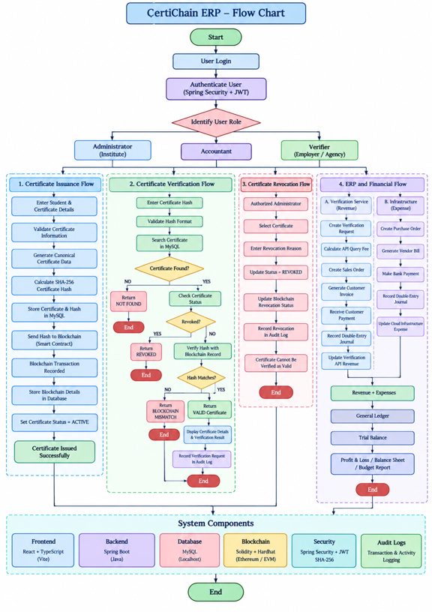

IMPLEMENTATION

6.1 IMPLEMENTATION

CertiChain ERP is implemented using React TypeScript for the frontend, Java Spring Boot for the backend, and MySQL for database management. SHA-256 is used for certificate hashing, while Solidity and Hardhat are used for blockchain integration.
The system implements certificate issuance, verification, revocation, user authentication, financial transactions, accounting, budgeting, and reporting.

6.2 TESTING

The system is tested to verify that all major functions work correctly.

Test Case | Expected Result
User Login | User authenticated
Certificate Issuance | Certificate created with SHA-256 hash
Certificate Verification | Correct status displayed
Certificate Revocation | Certificate marked revoked
Hash Verification | Matching hash validated
Invoice Creation | Invoice generated correctly
Payment Entry | Payment recorded
Report Generation | Correct financial report displayed

Testing confirms the basic functionality and integration of the CertiChain ERP modules.

6.3 CODE

CONTROLLER (AuthController.java)

package com.certichain.backend.auth;

import com.certichain.backend.security.JwtUtils;
import org.springframework.beans.factory.annotation.Autowired;
import org.springframework.http.ResponseEntity;
import org.springframework.security.authentication.AuthenticationManager;
import org.springframework.security.authentication.UsernamePasswordAuthenticationToken;
import org.springframework.security.core.Authentication;
import org.springframework.security.core.context.SecurityContextHolder;
import org.springframework.security.crypto.password.PasswordEncoder;
import org.springframework.web.bind.annotation.*;

import java.util.HashMap;
import java.util.HashSet;
import java.util.Map;
import java.util.Set;

@RestController
@RequestMapping("/api/auth")
public class AuthController {

@Autowired
private AuthenticationManager authenticationManager;

@Autowired
private UserRepository userRepository;

@Autowired
private PasswordEncoder passwordEncoder;

@Autowired
private JwtUtils jwtUtils;

@PostMapping("/login")
public ResponseEntity<?> authenticateUser(@RequestBody Map<String, String> loginRequest) {
Authentication authentication = authenticationManager.authenticate(
new UsernamePasswordAuthenticationToken(loginRequest.get("username"), loginRequest.get("password")));

SecurityContextHolder.getContext().setAuthentication(authentication);
String jwt = jwtUtils.generateJwtToken(authentication);

User user = userRepository.findByUsername(loginRequest.get("username")).get();

Map<String, Object> response = new HashMap<>();
response.put("success", true);
response.put("token", jwt);

Map<String, Object> userMap = new HashMap<>();
userMap.put("id", user.getId());
userMap.put("username", user.getUsername());
userMap.put("email", user.getEmail());
userMap.put("roles", user.getRoles());

response.put("user", userMap);
return ResponseEntity.ok(response);
}

@PostMapping("/register")
public ResponseEntity<?> registerUser(@RequestBody Map<String, Object> signUpRequest) {
if (userRepository.existsByUsername((String) signUpRequest.get("username"))) {
return ResponseEntity.badRequest().body("Error: Username is already taken!");
}

if (userRepository.existsByEmail((String) signUpRequest.get("email"))) {
return ResponseEntity.badRequest().body("Error: Email is already in use!");
}

User user = new User();
user.setUsername((String) signUpRequest.get("username"));
user.setEmail((String) signUpRequest.get("email"));
user.setPassword(passwordEncoder.encode((String) signUpRequest.get("password")));
user.setFullName((String) signUpRequest.get("fullName"));

Set<Role> roles = new HashSet<>();
roles.add(Role.ADMIN); // Default for demo, should be controlled based on logic
user.setRoles(roles);

userRepository.save(user);

return ResponseEntity.ok("User registered successfully!");
}

@GetMapping("/me")
public ResponseEntity<?> me(Authentication authentication) {
if (authentication == null) return ResponseEntity.status(401).build();
User user = userRepository.findByUsername(authentication.getName()).orElse(null);
if (user == null) return ResponseEntity.status(404).build();

Map<String, Object> userMap = new HashMap<>();
userMap.put("id", user.getId());
userMap.put("username", user.getUsername());
userMap.put("email", user.getEmail());
userMap.put("roles", user.getRoles());
return ResponseEntity.ok(userMap);
}
}

Institution.java

package com.certichain.backend.institution;

import jakarta.persistence.*;
import java.time.LocalDateTime;

@Entity
@Table(name = "institutions")
public class Institution {

@Id
@GeneratedValue(strategy = GenerationType.IDENTITY)
private Long id;

@Column(unique = true, nullable = false)
private String institutionCode;

@Column(nullable = false)
private String name;

@Column(unique = true, nullable = false)
private String registrationNumber;

private String email;
private String phone;
private String address;
private String city;
private String state;
private String country;

@Enumerated(EnumType.STRING)
private InstitutionStatus status;

@Column(updatable = false)
private LocalDateTime createdAt;

private LocalDateTime updatedAt;

@PrePersist
protected void onCreate() {
createdAt = LocalDateTime.now();
updatedAt = LocalDateTime.now();
if (status == null) status = InstitutionStatus.ACTIVE;
}

@PreUpdate
protected void onUpdate() {
updatedAt = LocalDateTime.now();
}

// Getters and Setters
public Long getId() { return id; }
public void setId(Long id) { this.id = id; }

public String getInstitutionCode() { return institutionCode; }
public void setInstitutionCode(String institutionCode) { this.institutionCode = institutionCode; }

public String getName() { return name; }
public void setName(String name) { this.name = name; }

public String getRegistrationNumber() { return registrationNumber; }
public void setRegistrationNumber(String registrationNumber) { this.registrationNumber = registrationNumber; }

public String getEmail() { return email; }
public void setEmail(String email) { this.email = email; }

public String getPhone() { return phone; }
public void setPhone(String phone) { this.phone = phone; }

public String getAddress() { return address; }
public void setAddress(String address) { this.address = address; }

public String getCity() { return city; }
public void setCity(String city) { this.city = city; }

public String getState() { return state; }
public void setState(String state) { this.state = state; }

public String getCountry() { return country; }
public void setCountry(String country) { this.country = country; }

public InstitutionStatus getStatus() { return status; }
public void setStatus(InstitutionStatus status) { this.status = status; }

public LocalDateTime getCreatedAt() { return createdAt; }
public void setCreatedAt(LocalDateTime createdAt) { this.createdAt = createdAt; }

public LocalDateTime getUpdatedAt() { return updatedAt; }
public void setUpdatedAt(LocalDateTime updatedAt) { this.updatedAt = updatedAt; }
}

enum InstitutionStatus {
ACTIVE,
INACTIVE,
SUSPENDED
}

Dashboard.tsx
import React, { useEffect, useState } from 'react';
import apiClient from '../api/apiClient';
import {
Building2, Plus, LogOut, Users, Award,
Activity, Hexagon, Search, Bell, Settings,
ArrowUpRight, ArrowDownRight, MoreHorizontal, Wallet
} from 'lucide-react';
import { useNavigate } from 'react-router-dom';
import { AreaChart, Area, XAxis, YAxis, CartesianGrid, Tooltip, ResponsiveContainer } from 'recharts';

const data = [
{ name: 'Mon', active: 400, pending: 240 },
{ name: 'Tue', active: 300, pending: 139 },
{ name: 'Wed', active: 200, pending: 980 },
{ name: 'Thu', active: 278, pending: 390 },
{ name: 'Fri', active: 189, pending: 480 },
{ name: 'Sat', active: 239, pending: 380 },
{ name: 'Sun', active: 349, pending: 430 },
];

export default function Dashboard() {
const [institutions, setInstitutions] = useState([]);
const [name, setName] = useState('');
const [code, setCode] = useState('');
const [regNum, setRegNum] = useState('');
const [loading, setLoading] = useState(false);
const navigate = useNavigate();

useEffect(() => {
loadInstitutions();
}, []);

const loadInstitutions = async () => {
try {
const res = await apiClient.get('/institutions');
setInstitutions(res.data);
} catch (err) {
console.error("Failed to load institutions", err);
}
};

const handleCreate = async (e: React.FormEvent) => {
e.preventDefault();
setLoading(true);
try {
await apiClient.post('/institutions', {
name,
institutionCode: code,
registrationNumber: regNum,
status: 'ACTIVE'
});
setName('');
setCode('');
setRegNum('');
await loadInstitutions();
} catch (err) {
alert("Error creating institution");
} finally {
setLoading(false);
}
};

return (
<div className="min-h-screen bg-[#f8fafc] text-slate-800 flex font-sans selection:bg-indigo-500/30">

{/* Sidebar (Sleek SaaS Style) */}
<div className="w-[280px] bg-white border-r border-slate-200/60 flex flex-col z-20">
<div className="h-20 px-8 flex items-center gap-3 border-b border-slate-100">
<div className="bg-indigo-600 p-2.5 rounded-xl shadow-lg shadow-indigo-500/20">
<Hexagon size={24} className="text-white" strokeWidth={2.5} />
</div>
<h2 className="text-xl font-bold text-slate-900 tracking-tight">CertiChain</h2>
</div>

<div className="p-5 flex-1 overflow-y-auto">
<p className="text-[11px] font-bold text-slate-400 uppercase tracking-wider mb-4 px-3">Overview</p>
<nav className="space-y-1.5 mb-8">
<a href="#" className="flex items-center gap-3 px-4 py-3 bg-indigo-50 text-indigo-700 rounded-xl font-semibold transition-all">
<Activity size={20} strokeWidth={2.5} /> Dashboard
</a>
<a href="#" className="flex items-center gap-3 px-4 py-3 text-slate-500 hover:text-slate-900 hover:bg-slate-50 rounded-xl font-medium transition-all">
<Building2 size={20} /> Institutions
</a>
<a href="#" className="flex items-center gap-3 px-4 py-3 text-slate-500 hover:text-slate-900 hover:bg-slate-50 rounded-xl font-medium transition-all">
<Users size={20} /> Customers
</a>
</nav>

<p className="text-[11px] font-bold text-slate-400 uppercase tracking-wider mb-4 px-3">Blockchain</p>
<nav className="space-y-1.5">
<a href="#" className="flex items-center gap-3 px-4 py-3 text-slate-500 hover:text-slate-900 hover:bg-slate-50 rounded-xl font-medium transition-all">
<Award size={20} /> Certificates
</a>
<a href="#" className="flex items-center justify-between px-4 py-3 text-slate-500 hover:text-slate-900 hover:bg-slate-50 rounded-xl font-medium transition-all">
<div className="flex items-center gap-3">
<Wallet size={20} /> Smart Contracts
</div>
<span className="bg-emerald-100 text-emerald-700 py-0.5 px-2 rounded-md text-[10px] font-bold">LIVE</span>
</a>
</nav>
</div>

<div className="p-5 border-t border-slate-100">
<button onClick={() => { localStorage.clear(); navigate('/login') }} className="w-full flex items-center justify-center gap-2 p-3 text-slate-600 hover:text-red-600 hover:bg-red-50 rounded-xl transition-all font-semibold">
<LogOut size={18} /> Sign Out
</button>
</div>
</div>

{/* Main Workspace */}
<div className="flex-1 flex flex-col h-screen overflow-hidden">

{/* Navbar */}
<header className="bg-white/80 backdrop-blur-md h-20 px-10 flex justify-between items-center border-b border-slate-200/60 z-10 sticky top-0">
<div className="flex items-center gap-3 bg-slate-100/80 rounded-full px-5 py-2.5 w-[400px] border border-slate-200/50 focus-within:bg-white focus-within:border-indigo-500 focus-within:ring-4 focus-within:ring-indigo-500/10 transition-all">
<Search size={18} className="text-slate-400" />
<input type="text" placeholder="Search institutions, transactions, IDs..." className="bg-transparent outline-none text-sm text-slate-700 w-full font-medium placeholder-slate-400" />
</div>
<div className="flex items-center gap-6">
<button className="text-slate-400 hover:text-slate-600 transition-colors relative">
<Bell size={22} />
<span className="absolute top-0 right-0 w-2 h-2 bg-indigo-500 rounded-full"></span>
</button>
<button className="text-slate-400 hover:text-slate-600 transition-colors">
<Settings size={22} />
</button>
<div className="h-9 w-9 bg-gradient-to-tr from-indigo-600 to-purple-500 rounded-full ring-2 ring-white shadow-md cursor-pointer"></div>
</div>
</header>

{/* Dashboard Scroll Area */}
<div className="flex-1 overflow-y-auto p-10 pb-20 relative">

<div className="flex justify-between items-end mb-8">
<div>
<h1 className="text-3xl font-bold text-slate-900 tracking-tight">Overview</h1>
<p className="text-slate-500 mt-1">Monitor your blockchain network and ERP operations.</p>
</div>
<button className="bg-indigo-600 hover:bg-indigo-700 text-white px-5 py-2.5 rounded-lg font-semibold shadow-sm shadow-indigo-600/20 transition-all flex items-center gap-2">
Generate Report
</button>
</div>

{/* Top KPI Metrics */}
<div className="grid grid-cols-1 md:grid-cols-3 gap-6 mb-8">
{/* KPI 1 */}
<div className="bg-white p-6 rounded-2xl border border-slate-200/60 shadow-sm hover:shadow-md transition-shadow">
<div className="flex justify-between items-start mb-4">
<p className="text-sm font-semibold text-slate-500 uppercase tracking-wide">Network Nodes</p>
<span className="flex items-center gap-1 text-emerald-600 text-xs font-bold bg-emerald-50 px-2.5 py-1 rounded-md border border-emerald-100">
<ArrowUpRight size={14} /> 12%
</span>
</div>
<h3 className="text-4xl font-black text-slate-900 tracking-tight mb-2">{institutions.length}</h3>
<p className="text-sm font-medium text-slate-500 flex items-center gap-2">
<span className="w-2 h-2 rounded-full bg-emerald-500"></span> Live Institutions
</p>
</div>

{/* KPI 2 */}
<div className="bg-white p-6 rounded-2xl border border-slate-200/60 shadow-sm hover:shadow-md transition-shadow">
<div className="flex justify-between items-start mb-4">
<p className="text-sm font-semibold text-slate-500 uppercase tracking-wide">Certificates Minted</p>
<span className="flex items-center gap-1 text-emerald-600 text-xs font-bold bg-emerald-50 px-2.5 py-1 rounded-md border border-emerald-100">
<ArrowUpRight size={14} /> 4.2%
</span>
</div>
<h3 className="text-4xl font-black text-slate-900 tracking-tight mb-2">1,204</h3>
<p className="text-sm font-medium text-slate-500 flex items-center gap-2">
<span className="w-2 h-2 rounded-full bg-indigo-500"></span> Verified on Blockchain
</p>
</div>

{/* KPI 3 */}
<div className="bg-white p-6 rounded-2xl border border-slate-200/60 shadow-sm hover:shadow-md transition-shadow">
<div className="flex justify-between items-start mb-4">
<p className="text-sm font-semibold text-slate-500 uppercase tracking-wide">Pending Tasks</p>
<span className="flex items-center gap-1 text-rose-600 text-xs font-bold bg-rose-50 px-2.5 py-1 rounded-md border border-rose-100">
<ArrowDownRight size={14} /> 2.1%
</span>
</div>
<h3 className="text-4xl font-black text-slate-900 tracking-tight mb-2">4</h3>
<p className="text-sm font-medium text-slate-500 flex items-center gap-2">
<span className="w-2 h-2 rounded-full bg-rose-500"></span> Requires Attention
</p>
</div>
</div>

{/* Chart & Form Row */}
<div className="grid grid-cols-1 lg:grid-cols-3 gap-6 mb-8">

{/* Chart Area */}
<div className="bg-white p-6 rounded-2xl border border-slate-200/60 shadow-sm lg:col-span-2">
<div className="flex justify-between items-center mb-6">
<div>
<h3 className="text-lg font-bold text-slate-900">Network Activity</h3>
<p className="text-sm text-slate-500">Daily active nodes and transactions</p>
</div>
<select className="bg-slate-50 border border-slate-200 text-sm font-medium text-slate-700 rounded-lg px-3 py-1.5 outline-none">
<option>This Week</option>
<option>This Month</option>
</select>
</div>
<div className="h-[280px] w-full">
<ResponsiveContainer width="100%" height="100%">
<AreaChart data={data} margin={{ top: 10, right: 10, left: -20, bottom: 0 }}>
<defs>
<linearGradient id="colorActive" x1="0" y1="0" x2="0" y2="1">
<stop offset="5%" stopColor="#4f46e5" stopOpacity={0.3}/>
<stop offset="95%" stopColor="#4f46e5" stopOpacity={0}/>
</linearGradient>
</defs>
<CartesianGrid strokeDasharray="3 3" vertical={false} stroke="#e2e8f0" />
<XAxis dataKey="name" axisLine={false} tickLine={false} tick={{fill: '#64748b', fontSize: 12}} dy={10} />
<YAxis axisLine={false} tickLine={false} tick={{fill: '#64748b', fontSize: 12}} />
<Tooltip
contentStyle={{ borderRadius: '12px', border: 'none', boxShadow: '0 4px 6px -1px rgb(0 0 0 / 0.1)' }}
cursor={{ stroke: '#cbd5e1', strokeWidth: 1, strokeDasharray: '4 4' }}
/>
<Area type="monotone" dataKey="active" stroke="#4f46e5" strokeWidth={3} fillOpacity={1} fill="url(#colorActive)" />
</AreaChart>
</ResponsiveContainer>
</div>
</div>

{/* Registration Form Widget */}
<div className="bg-white p-6 rounded-2xl border border-slate-200/60 shadow-sm flex flex-col">
<h3 className="text-lg font-bold text-slate-900 mb-1">Quick Add</h3>
<p className="text-sm text-slate-500 mb-6">Register a new institution node.</p>

<form onSubmit={handleCreate} className="flex-1 flex flex-col gap-4">
<div>
<label className="block text-[11px] font-bold text-slate-500 uppercase tracking-wider mb-1.5">Institution Name</label>
<input value={name} onChange={e => setName(e.target.value)} required className="w-full p-2.5 bg-slate-50 rounded-lg border border-slate-200 focus:bg-white focus:border-indigo-500 focus:ring-4 focus:ring-indigo-500/10 outline-none transition-all text-sm font-medium text-slate-800 placeholder-slate-400" placeholder="e.g. Stanford University" />
</div>
<div>
<label className="block text-[11px] font-bold text-slate-500 uppercase tracking-wider mb-1.5">Network Code</label>
<input value={code} onChange={e => setCode(e.target.value)} required className="w-full p-2.5 bg-slate-50 rounded-lg border border-slate-200 focus:bg-white focus:border-indigo-500 focus:ring-4 focus:ring-indigo-500/10 outline-none transition-all text-sm font-medium text-slate-800 placeholder-slate-400" placeholder="e.g. STAN-01" />
</div>
<div>
<label className="block text-[11px] font-bold text-slate-500 uppercase tracking-wider mb-1.5">Gov Reg Number</label>
<input value={regNum} onChange={e => setRegNum(e.target.value)} required className="w-full p-2.5 bg-slate-50 rounded-lg border border-slate-200 focus:bg-white focus:border-indigo-500 focus:ring-4 focus:ring-indigo-500/10 outline-none transition-all text-sm font-medium text-slate-800 placeholder-slate-400" placeholder="e.g. 998877" />
</div>
<button type="submit" disabled={loading} className="mt-auto bg-indigo-600 hover:bg-indigo-700 text-white p-3 rounded-xl font-bold flex items-center justify-center gap-2 shadow-sm shadow-indigo-600/20 transform hover:-translate-y-0.5 transition-all w-full text-sm">
{loading ? 'Processing...' : <><Plus size={18} /> Register Entity</>}
</button>
</form>
</div>
</div>

{/* Data Table */}
<div className="bg-white rounded-2xl border border-slate-200/60 overflow-hidden shadow-sm">
<div className="p-6 border-b border-slate-200/60 flex justify-between items-center bg-white">
<div>
<h3 className="font-bold text-lg text-slate-900">Institution Directory</h3>
<p className="text-sm text-slate-500 mt-1">All verified nodes currently registered on the CertiChain network.</p>
</div>
<button className="text-slate-400 hover:text-slate-600 bg-slate-50 p-2 rounded-lg border border-slate-200 transition-colors">
<MoreHorizontal size={20} />
</button>
</div>
<div className="overflow-x-auto">
<table className="w-full text-left border-collapse">
<thead className="bg-slate-50 border-b border-slate-200 text-slate-500 text-[11px] font-bold uppercase tracking-wider">
<tr>
<th className="py-4 px-6">Node ID</th>
<th className="py-4 px-6">Entity Name</th>
<th className="py-4 px-6">Network Code</th>
<th className="py-4 px-6">Registration #</th>
<th className="py-4 px-6 text-right">Status</th>
</tr>
</thead>
<tbody className="divide-y divide-slate-100 bg-white">
{institutions.length === 0 ? (
<tr>
<td colSpan={5} className="p-12 text-center">
<div className="inline-flex justify-center items-center w-12 h-12 rounded-full bg-slate-50 mb-3">
<Building2 className="text-slate-400" size={24} />
</div>
<p className="text-slate-600 font-medium">No institutions found</p>
<p className="text-slate-400 text-sm mt-1">Use the quick add widget to register your first node.</p>
</td>
</tr>
) : institutions.map((inst: any) => (
<tr key={inst.id} className="hover:bg-slate-50/80 transition-colors group">
<td className="py-4 px-6 font-mono text-sm text-slate-400 font-medium group-hover:text-indigo-500 transition-colors">#{inst.id.toString().padStart(4, '0')}</td>
<td className="py-4 px-6 font-bold text-slate-800">{inst.name}</td>
<td className="py-4 px-6"><span className="px-2.5 py-1 bg-slate-100 text-slate-600 rounded-md text-xs font-bold font-mono border border-slate-200">{inst.institutionCode}</span></td>
<td className="py-4 px-6 text-slate-500 font-medium text-sm">{inst.registrationNumber}</td>
<td className="py-4 px-6 text-right">
<span className="inline-flex items-center gap-1.5 bg-emerald-50 text-emerald-700 px-2.5 py-1 rounded-md text-[11px] font-bold border border-emerald-200">
<span className="w-1.5 h-1.5 rounded-full bg-emerald-500 animate-pulse"></span>
{inst.status}
</span>
</td>
</tr>
))}
</tbody>
</table>
</div>
</div>
</div>
</div>
</div>
);
}

OUTPUT

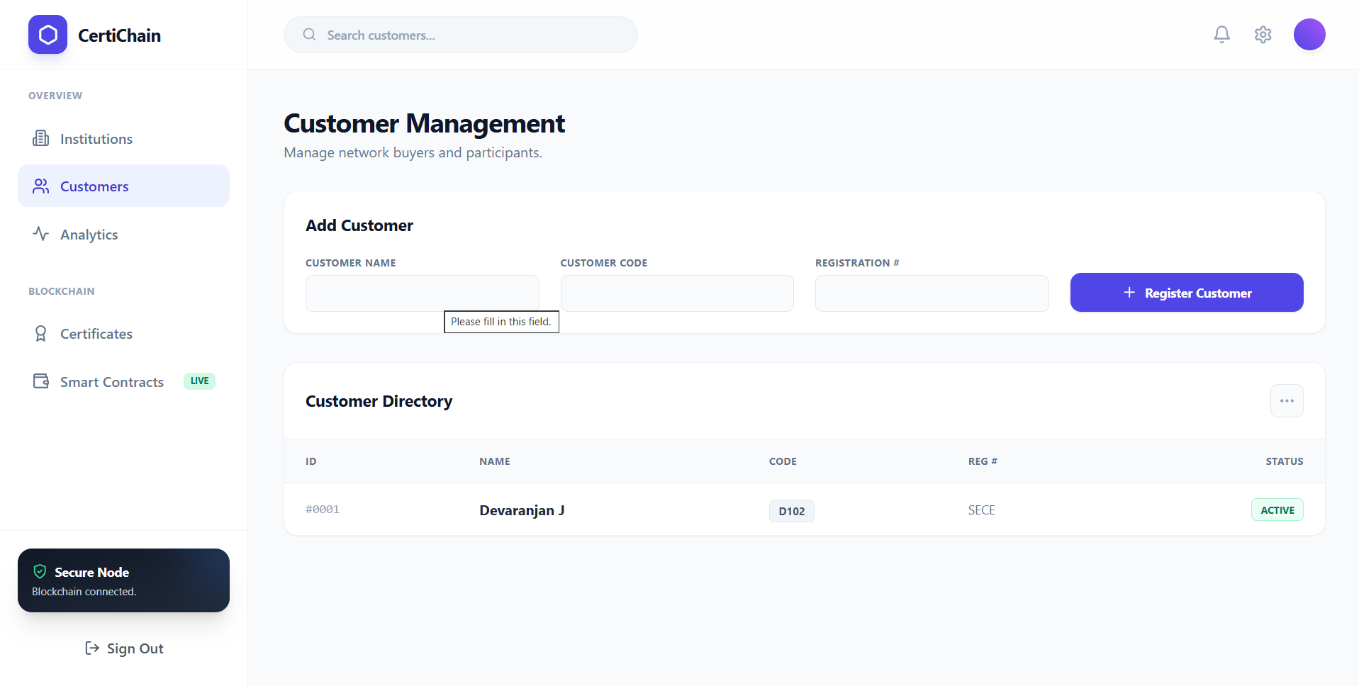
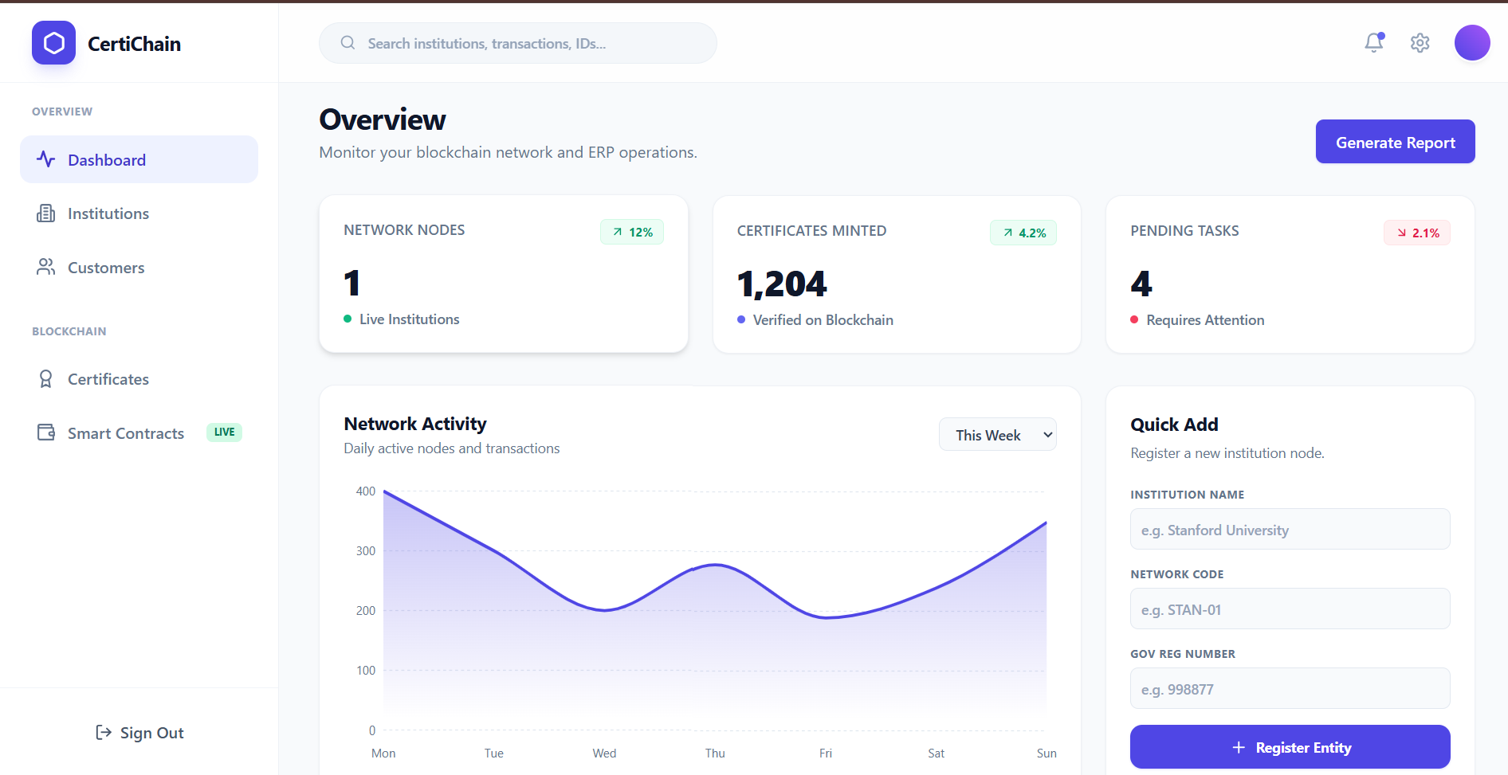

CONCLUSION

The CertiChain ERP project provides a secure and integrated solution for the issuance, management, and verification of academic certificates using SHA-256 cryptographic hashing and blockchain technology. The system addresses the limitations of conventional certificate verification by generating a unique cryptographic identity for each certificate and maintaining blockchain-backed records that can be used to verify the integrity of the credential.
The application is developed using Java Spring Boot, React with TypeScript, MySQL, Solidity, and Hardhat. Secure authentication and role-based access control provide controlled access to the system for administrators, accountants, and verification agencies. The certificate management module supports certificate issuance, hash generation, verification, and revocation, while the blockchain component provides an additional layer of tamper resistance and traceability.
In addition to certificate management, the system integrates important ERP and financial operations such as customer and vendor management, verification service billing, sales orders, invoices, payments, purchase orders, vendor bills, chart of accounts, double-entry accounting, budgeting, and financial reporting. Audit logging further improves the traceability of important certificate and financial operations.
The proposed platform demonstrates how blockchain and enterprise software can be combined to create a reliable academic credential ecosystem. By reducing dependence on manual verification and integrating credential management with financial operations, CertiChain ERP provides a structured foundation that can be extended for large-scale institutional and verification requirements.

REFERENCE

- Spring Team. (2024). Spring Boot Reference Documentation. Retrieved from https://docs.spring.io/spring-boot/docs/current/reference/html/
- Spring Team. (2024). Spring Security Reference. Retrieved from https://docs.spring.io/spring-security/reference/
- Spring Data Team. (2024). Spring Data JPA - Reference Documentation. Retrieved from https://docs.spring.io/spring-data/jpa/docs/current/reference/html/
- Oracle. (2024). MySQL Connector/J Developer Guide. Retrieved from https://dev.mysql.com/doc/connector-j/en/
- Baeldung. (2024). Spring Boot Tutorial. Retrieved from https://www.baeldung.com/spring-boot

PROJECT TITLE | Blockchain-Backed Certificate Issuance & Verification Platform — CertiChain ERP
PROGRAM | B.E CSE(AIML)
PROJECT BATCH NUMBER
BATCH MEMBERS | DEVARANJAN J | 722825148016
NAME OF THE SUPERVISOR | Mr.R.VIKKRAM M.Tech.,(PhD)
NAME OF THE SDG GOALS MAPPED
  Quality Education
  Industry, Innovation and Infrastructure
  Peace, Justice and Strong Institutions
MENTION THE SDG GOALS NUMBER | SDG 4,9,16
NAME OF THE TRL LEVEL | Technology Readiness Level 5 – Technology validated in a relevant environment
MENTION THE TRL LEVEL | TRL 5

POs & PSOs Mapping (Put a tick mark in the mapped PO’s & PSO’s):
Program Outcomes |  |  |  |  |  |  |  |  |  |  | Program Specific Outcomes
PO1 | PO 2 | PO 3 | PO 4 | PO 5 | PO 6 | PO 7 | PO 8 | PO 9 | PO 10 | PO 11 | PSO 1 | PSO 2 | PSO 3

Signature of the Supervisor
Mr.R.VIKKRAM M.Tech.,(PhD)
VENUE AND EXPENDITURE STATEMENT FOR THE PROJECT WORK
Laboratory details where the project is carried out | GEN AI LAB,AIML
Software / Hardware details | Java, Spring Boot , MySQL , React.js,node.js , Postman,JavaScript,Git,GitHub

Signature of the student Signature of the Supervisor
Devaranjan J Mr.R.Vikkram M.Tech.,(PhD)

