**SMART WATER MANAGEMENT**

|  |  |
| --- | --- |
| **Date** | **10-10-2023** |
| **Team ID** | **666** |
| **Team Name** | **Proj_223434_Team_2** |
| **Project Name** | **Smart Water Management** |

**Table of Contents**

|  |  |
| --- | --- |
| 1 | Introduction |
| 2 | Problem Statement |
| 3 | Design and Innovation Strategies |
| 3.1 | IOT Integration |
| 3.2 | Energy Efficiency |
| 3.3 | Interactive Features |
| 3.4 | Environmental sustainability |
| 3.5 | Maintenance and Monitoring |
| 3.6 | Public Awareness |
| 3.7 | Scalability |
| 3.8 | Community Involvement |
| 4 | Conclusion |

**1.Introduction**

Water supply is the most important thing in daily home activity. We commonly supply the water by pumping the groundwater to fill a water tank. However, the utilization of non-automated switch used to turn on and turn off a pumping machine sometimes causes either the water spills or a wasteful electrical consumption. In this work, an automated water tank filling system will be proposed. By applying an ultrasonic sensor, an ultrasonic transmitter is mounted on the top of the tank and transmits an ultrasonic pulse down into the tank. The transmitter is programmed to automatically determine the liquid level and switch the pumping machine. The dynamics of water flow and liquid level during filling and draining the water tank will be reported. We hope to this system, people will enjoy supplying water without their worries related to water spills and a wasteful electrical consumption.

**2.Problem Statement**

"Design a comprehensive water management system which ensures overflowing water tanks contribute to the majority of wastage of water in residences. Most of the time, it is due to human error that tanks are allowed to overflow. So, by automating the process and by removing the human error, we can reduce the wastage of water by quite a bit. Another reason for wastage of water is due to leaks that occur in pipes. These leaks might not be detected immediately, and by the time the leak is detected, a lot of water will already be wasted. Sometimes the leak might not be detected until after a long time-wasting a lot of water in the process. By placing sensors in the pipes, we can detect the flow of the water in pipes and immediately detect any leaks in the pipe and immediately notify the user. By using electrically controlled valves, we can cut off the water supply to minimize the wastage of water. The utilization of water can be minimized by reducing the flow of water from the tank itself”.

**3. Design and Innovation Strategies**

**3.1.** **IoT Integration:**

Innovation- Incorporate Internet of Things (IoT) technology to enable water overflow detection involves connecting sensors and communication mediums.

Design- Implement water level sensors at critical locations where overflow is a concern such as tank.

- Sensors capable of accurately measuring water levels and reduces the risk of water wastage through alerting.

**3.2 Energy Efficiency:**

Innovation - Choose energy-efficient sensors for water level monitoring.

Design - Low power sensors can operate for extended periods without consuming excessive energy.

- IoT can also monitor energy consumption in the water overflow detection system itself, helping identify areas where energy efficiency can be improved.

**3.3. Interactive Features:**

Innovation - Create interactive Display that shows real-time water level data using LCD Display.

Design - Allow users to set their own threshold levels for alerts.

**3.4. Environmental Sustainability:**

Innovation - The project helps conserve water resources by preventing overflow and reducing wastage, contributing to the sustainable use of a precious resource.

Design - Through IoT integration, the project can optimize energy usage, reducing the carbon footprint associated with water management operations.

**3.5. Maintenance and Monitoring:**

Innovation - Implement a predictive maintenance system that uses data from sensors to identify and address issues before they become major problems.

Design - Set up remote monitoring and diagnostics capabilities to reduce downtime and maintenance costs.

**3.6. Public Awareness:**

Innovation - The project's interactive features can raise public awareness about water conservation, promoting responsible water usage.

**3.7. Scalability:**

Innovation - It can be scaled to accommodate growing water management needs, making it adaptable to changing circumstances.

**3.8. Community Involvement:**

Innovation - Involving the community in water conservation efforts through interactive features fosters a sense of ownership and sustainability.

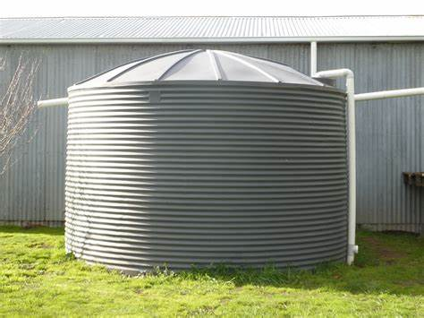

LCD

Pump

Arduino

Microcontroller

Ultrasonic Sensor Sensor

Relay module

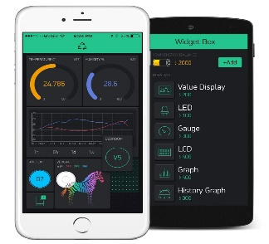 

App

**4. Conclusion**

In conclusion, moreover this project involved designing and development of automatic water level control system had exposed to the better way of software and hardware architecture that blends together for the interfacing purposes. The system employs the use of advance sensing technology to detect the water level.

* This system is very beneficial in rural as well as urban areas.
* It helps in the efficient utilization of available water sources.
* If used on a large scale, it can provide a major contribution in the conservation of water for us and the future generations.