\*\*\*>>>1..

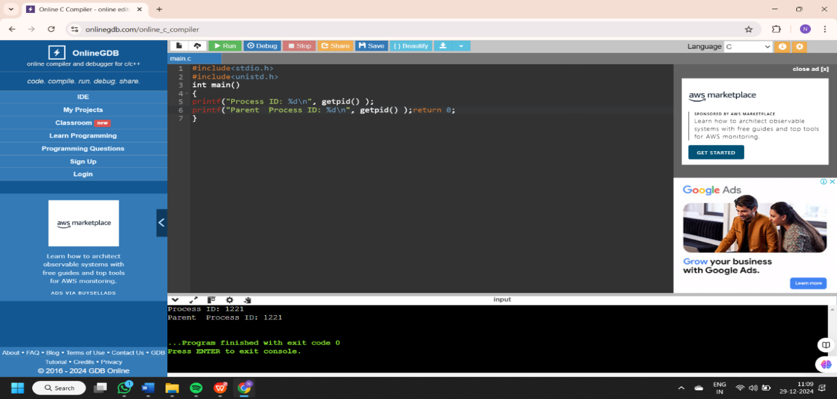

\*\*\*>>2

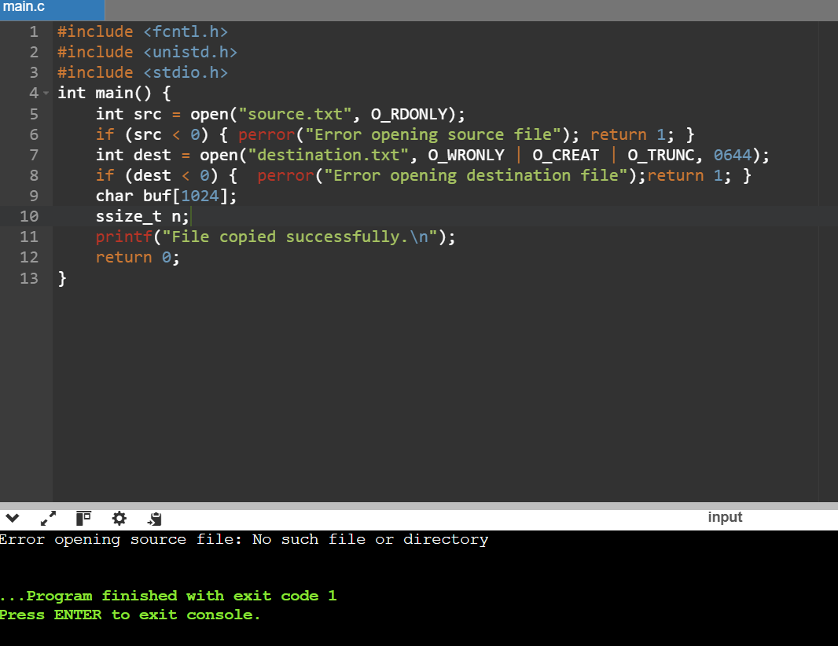

\*\*\*>>> 3===8(3 to 8) 3 – 8

3….,4,7,8

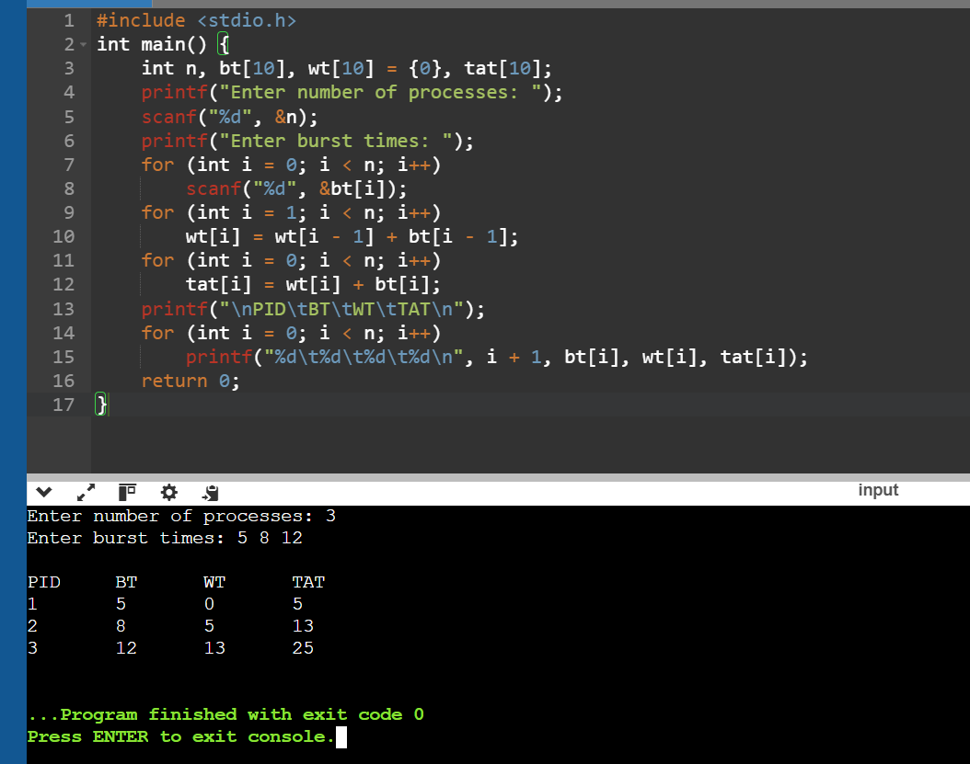

\*\*\*>5,6

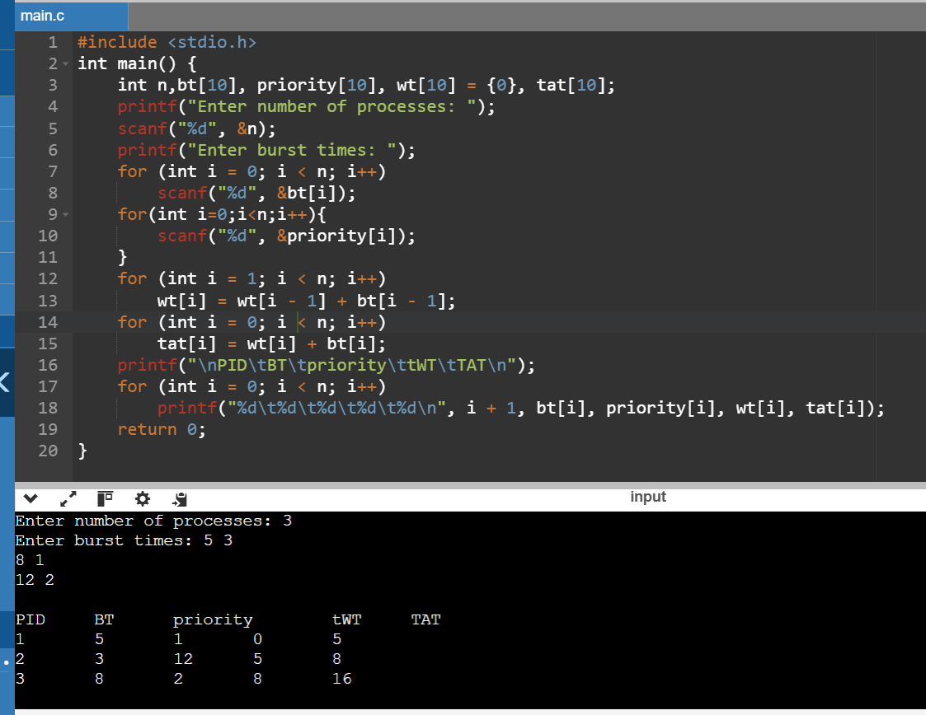

\*\*\*>>>9 and 10th

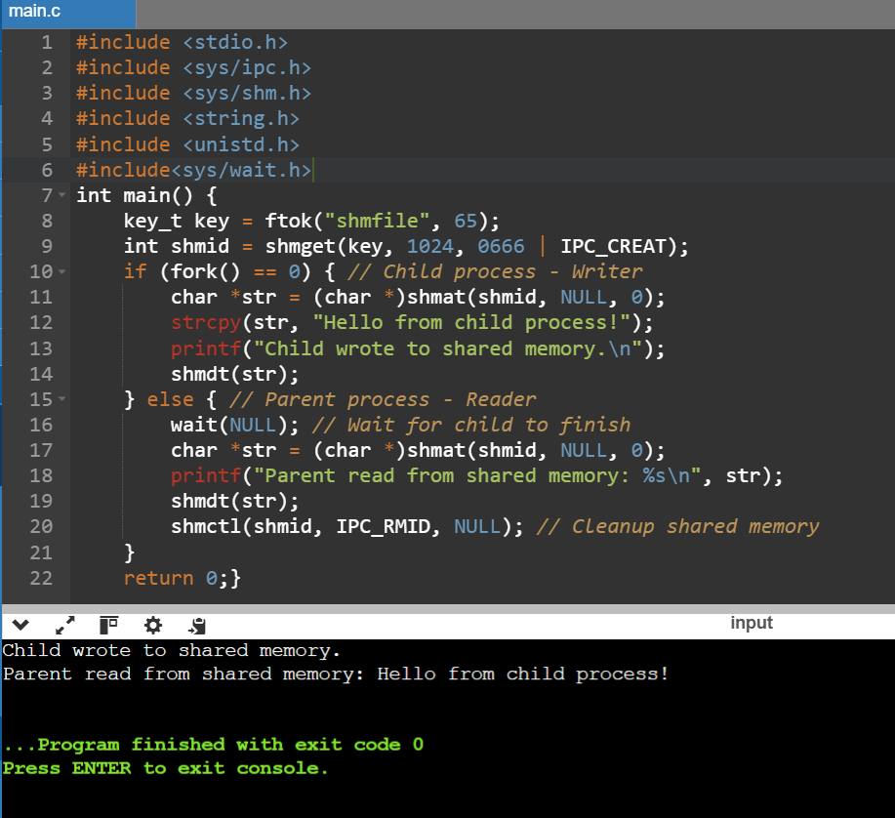

\*\*\*\*>>>11th

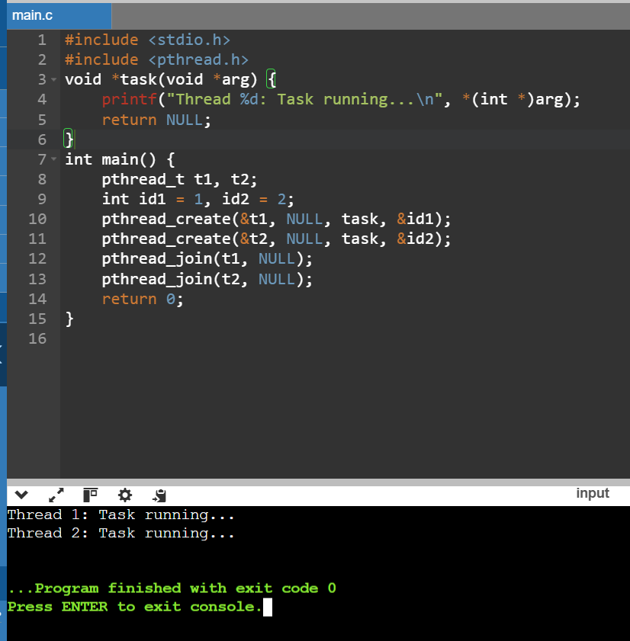

14, 15>>>

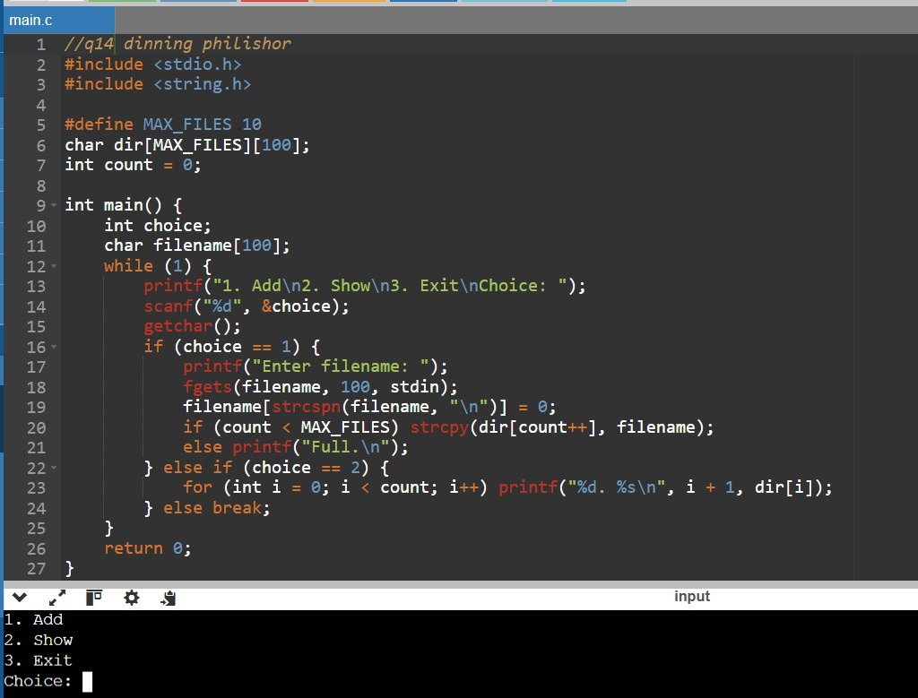

\*\*\*\*>>>16th

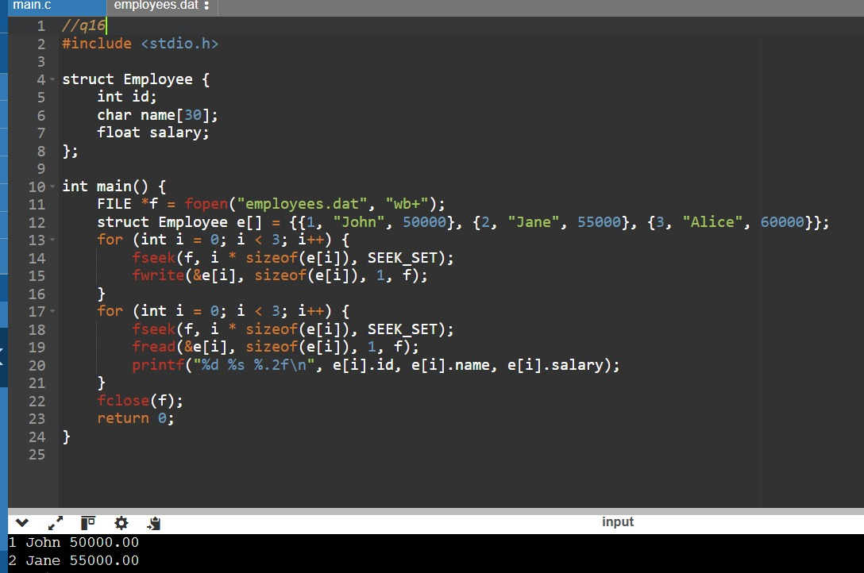

\*\*\*>>37 ,38 ,39 disk scheduling algorthims, fcfs,c-scan,scan

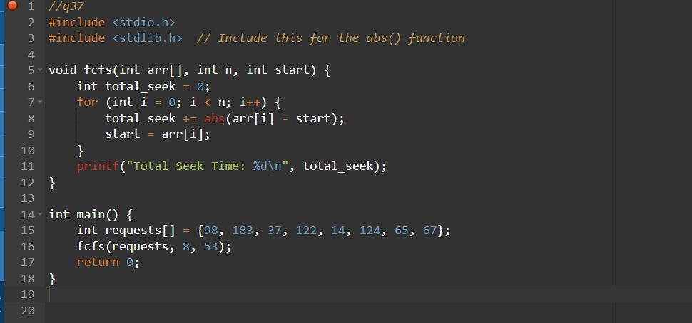

\*\*\*>>>21, 22, 23(ff, bf, wf algorthims)[wf>=, ff<, bf>)

