Ideation Phase
Brainstorm & Idea Prioritization Template

Date | DECEMBER, 2025
Team ID | LTVIP2026TMIDS80000
Project Name | Online Payments Fraud Detection using ML
Maximum Marks | 4 Marks
Team Members
1.Gurramkonda Reddy Charan(22BFA05294)

2.Deva Raju Valathuru(22BFA05339)

3.Polipakala Girivaraprasad(22BFA05321)

4.Peripaidi Harsha(22BFA05319)

5.Kancherla Madhukar Reddy(22BFA05297)

Brainstorm & Idea Prioritization:

Brainstorming provides a free and open environment that encourages everyone within a team to participate in the creative thinking process that leads to problem solving. Prioritizing volume over value, out-of-the-box ideas are welcome and built upon, and all participants are encouraged to collaborate, helping each other develop a rich amount of creative solutions.

Mural Link (Brainstorming) https://app.mural.co/t/atgsworkspace2758/m/atgsworkspace2758/1697613685502/8d94fdae546f3e85faa57 e0e0eb2532a7b52d5a8?sender=u6662b8c63e5c4dfa94ac8405

Step-1: Team Gathering, Collaboration and Select the Problem Statement
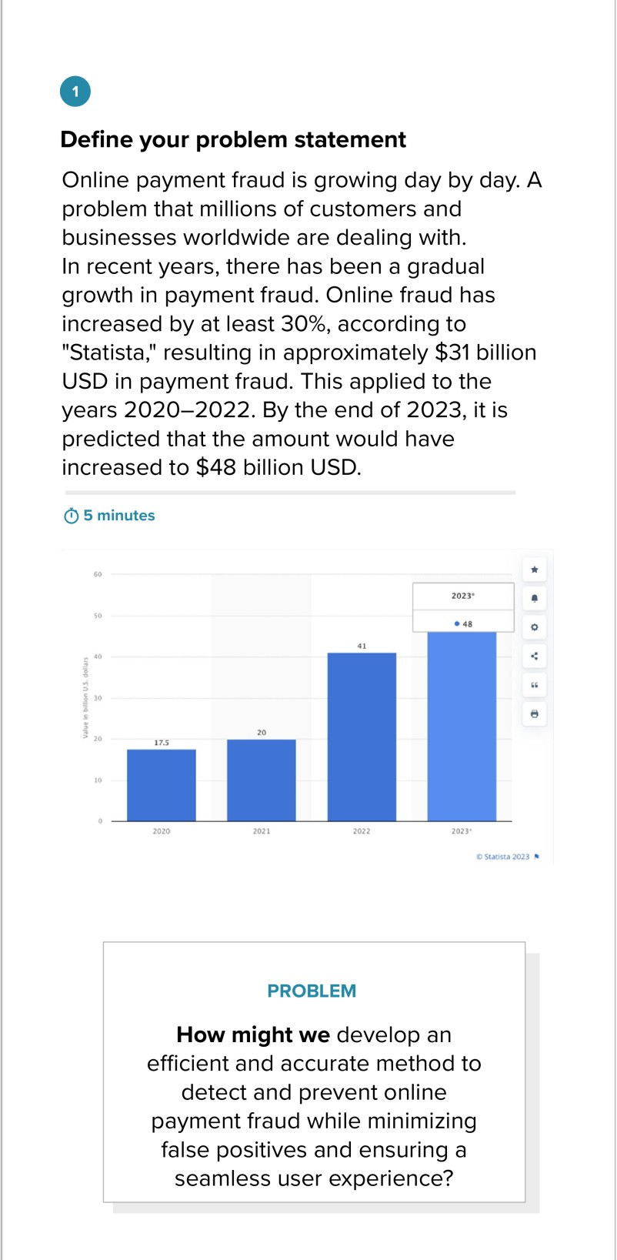

Step-2: Brainstorm, Idea Listing and Grouping
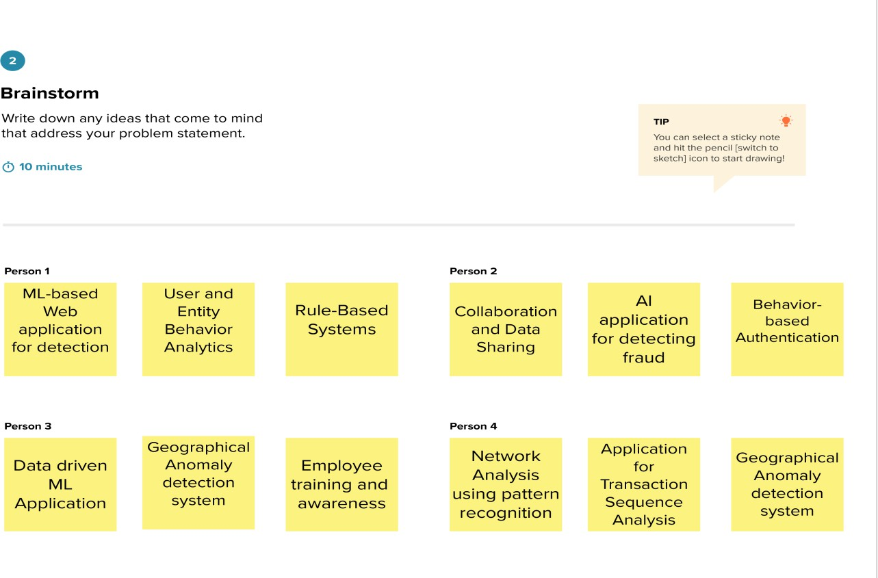

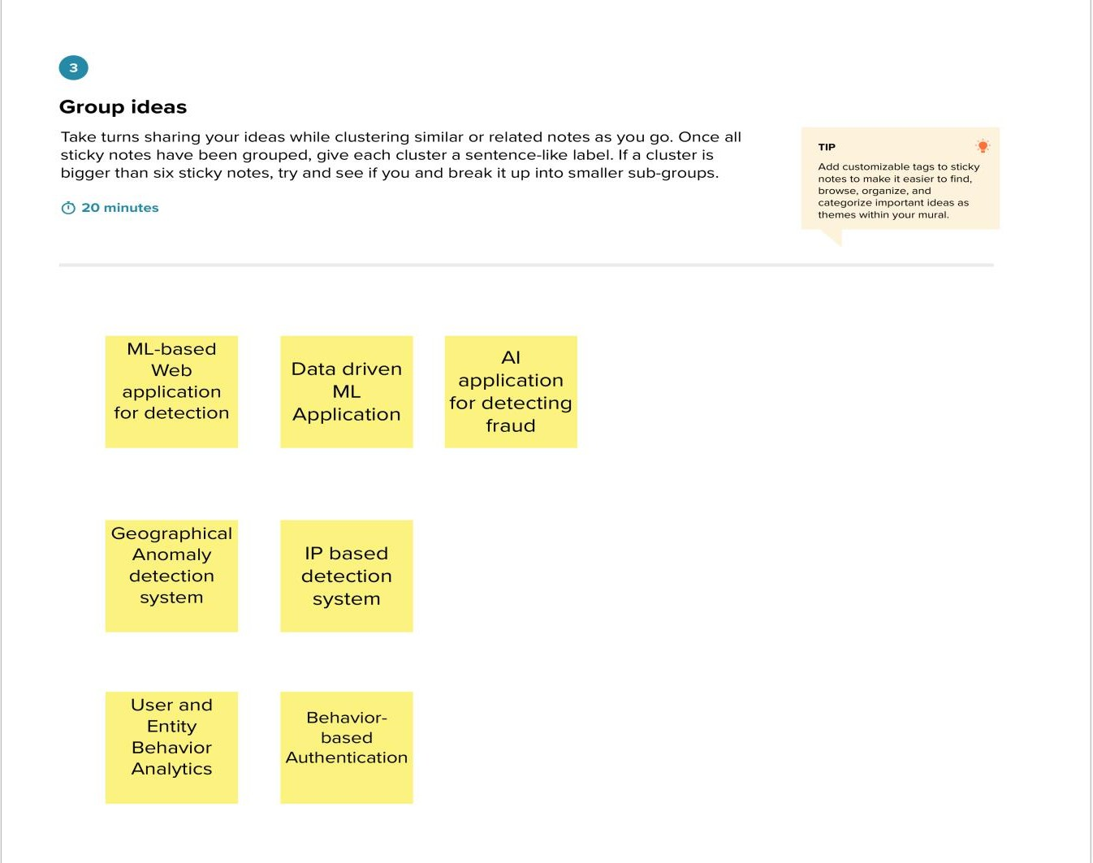

Step-3: Idea Prioritization

