Home Automation System
Programming Assessment Report
Author: Devendra Chaudhari
Date: 18 May 2026
Course: Engineering Programming

Executive Summary
This report describe a complete Home Automation System implemented based on the OOP concept with a Python programming language. Sixteen device types are built into the system in two phases of development and are structured in logical hierarchies and compositions that mimic the structure of smart home devices.
Stage 1 provides the basic framework with twelve device classes, and four subsystems of composite. In Stage 2, five new and novel enhancements are added, including the Humidity Sensor, Humidity Controller, Sprinkler, Fire Alarm System, and the Smart Scheduler, all adding different automation opportunities. All tests pass.

Stage 1: Basic Framework Design

Implemented on the foundation level, thirteen fully developed device classes are built with an extremely strict single-responsibility principle. Each class encapsulates its own state, validity, and reporting of usage of energy.

Core Device Classes
Class | Description | Key Methods
Light | Basic on/off control with energy tracking (8W) | turn_on(), turn_off(), toggle(), energy_usage()
SmartLight | Extends Light with 0–one hundred% brightness scaling | set_brightness(val), energy_usage()
Thermostat | Temperature management with range validation | set_temperature(t), auto_adjust(temp)
TemperatureSensor | Ambient monitoring; 5% random failure rate | get_status() → float | None
MotionSensor | Motion detection for security integration | detect_motion(), clear()
SmokeDetector | Fire alarm trigger and clear | trigger_alarm(), clear_alarm()
SoilMoistureSensor | Garden moisture (10–80%); 5% failure rate | get_status() → int | None
Clock | HH:MM time tracking with minute advancement | tick(minutes)
DoorLock | Three-state: locked / unlocked / jammed | lock(), unlock(), jam()
Controller | Multi-mode: heating / cooling / on / off | switch_mode(mode)
Toaster | Appliance with five toast levels (1–5) | toast(level), energy_usage()

Inheritance Hierarchy
The abstract base class Device requires reset(), is_accessible(), and get_status() are defined for all device classes. Sensors are a sub-hierarchy of the Sensor abstract class, which has failure safe semantics with No meaning hardware failure.

Stage 2: Extension and Innovation

In Stage 2, five new extensions are introduced that significantly enhance the system's capabilities in the real world. Multiple devices connected in coordinated subsystems - what we call a composition, through each build in the Stage 1 framework.

SecuritySystem

Composes a list of a DoorLock and a MotionSensor. If armed and motion is detected, the process_motion_event() function automatically locks all the managed doors, resulting in coordinated intrusion-response without manual action.

IrrigationController

Connects a SoilMoistureSensor and triggers a watering cycle when there is less moisture than a user-configurable threshold (default 40%). Each single cycle is increasing moisture of the sensors by thirty units and stop automatically once the desired moisture level is reached.

HumidityController

Equipped with a HumiditySensor, auto_adjust() alternates between humidifying, dehumidifying and idle states depending on the difference between the target value (default 50%) and the sensor reading, which is within ±10%, hidden 12W when in action state.

FireAlarmSystem

Once the SmokeDetector is detected, check_and_respond() controls the Sprinkler without requiring any manual switching, while controlling the sprinkler to be off in absence of smoke, creating a closed loop fire-suppression system.

SmartScheduler

An automation engine based on timing, where the currently displayed time can be compared with set routines by means of the Clock device. Few Activities can be registered for a single time slot, allowing unattended daily activities on any of the connected devices.

EnergyMonitor and HomeAutomationHub
EnergyMonitor sums up energy_usage() of all devices registered and is configurable with a "Watt" threshold: If exceeded, lights and toasters are turned off automatically. HomeAutomationHub is the main orchestrator delegating to each of these subsystems via a clearly defined interface.

UML Class Diagram
The fully elaborated class hierarchy is shown in the diagram below, in the standard UML notation. Hollow triangle arrows represent inheritance, and dashed lines represent composite classes that inherit from the abstract class Device. The classes are divided into three segments (name, attributes, methods), according to the standard UML conventions. The stereotype «abstract» is used to indicate abstract classes. Abstract classes are designated in blue; Stage 1 concrete classes are in gold; Stage 2 innovation classes are in green and hub/monitor utilities are in purple along with a colour key. Note: the diagram uses the shortened form of the class name of the TemperatureSensor. The full form of the class name is used in the implementation, as it might be longer than the re-enters.

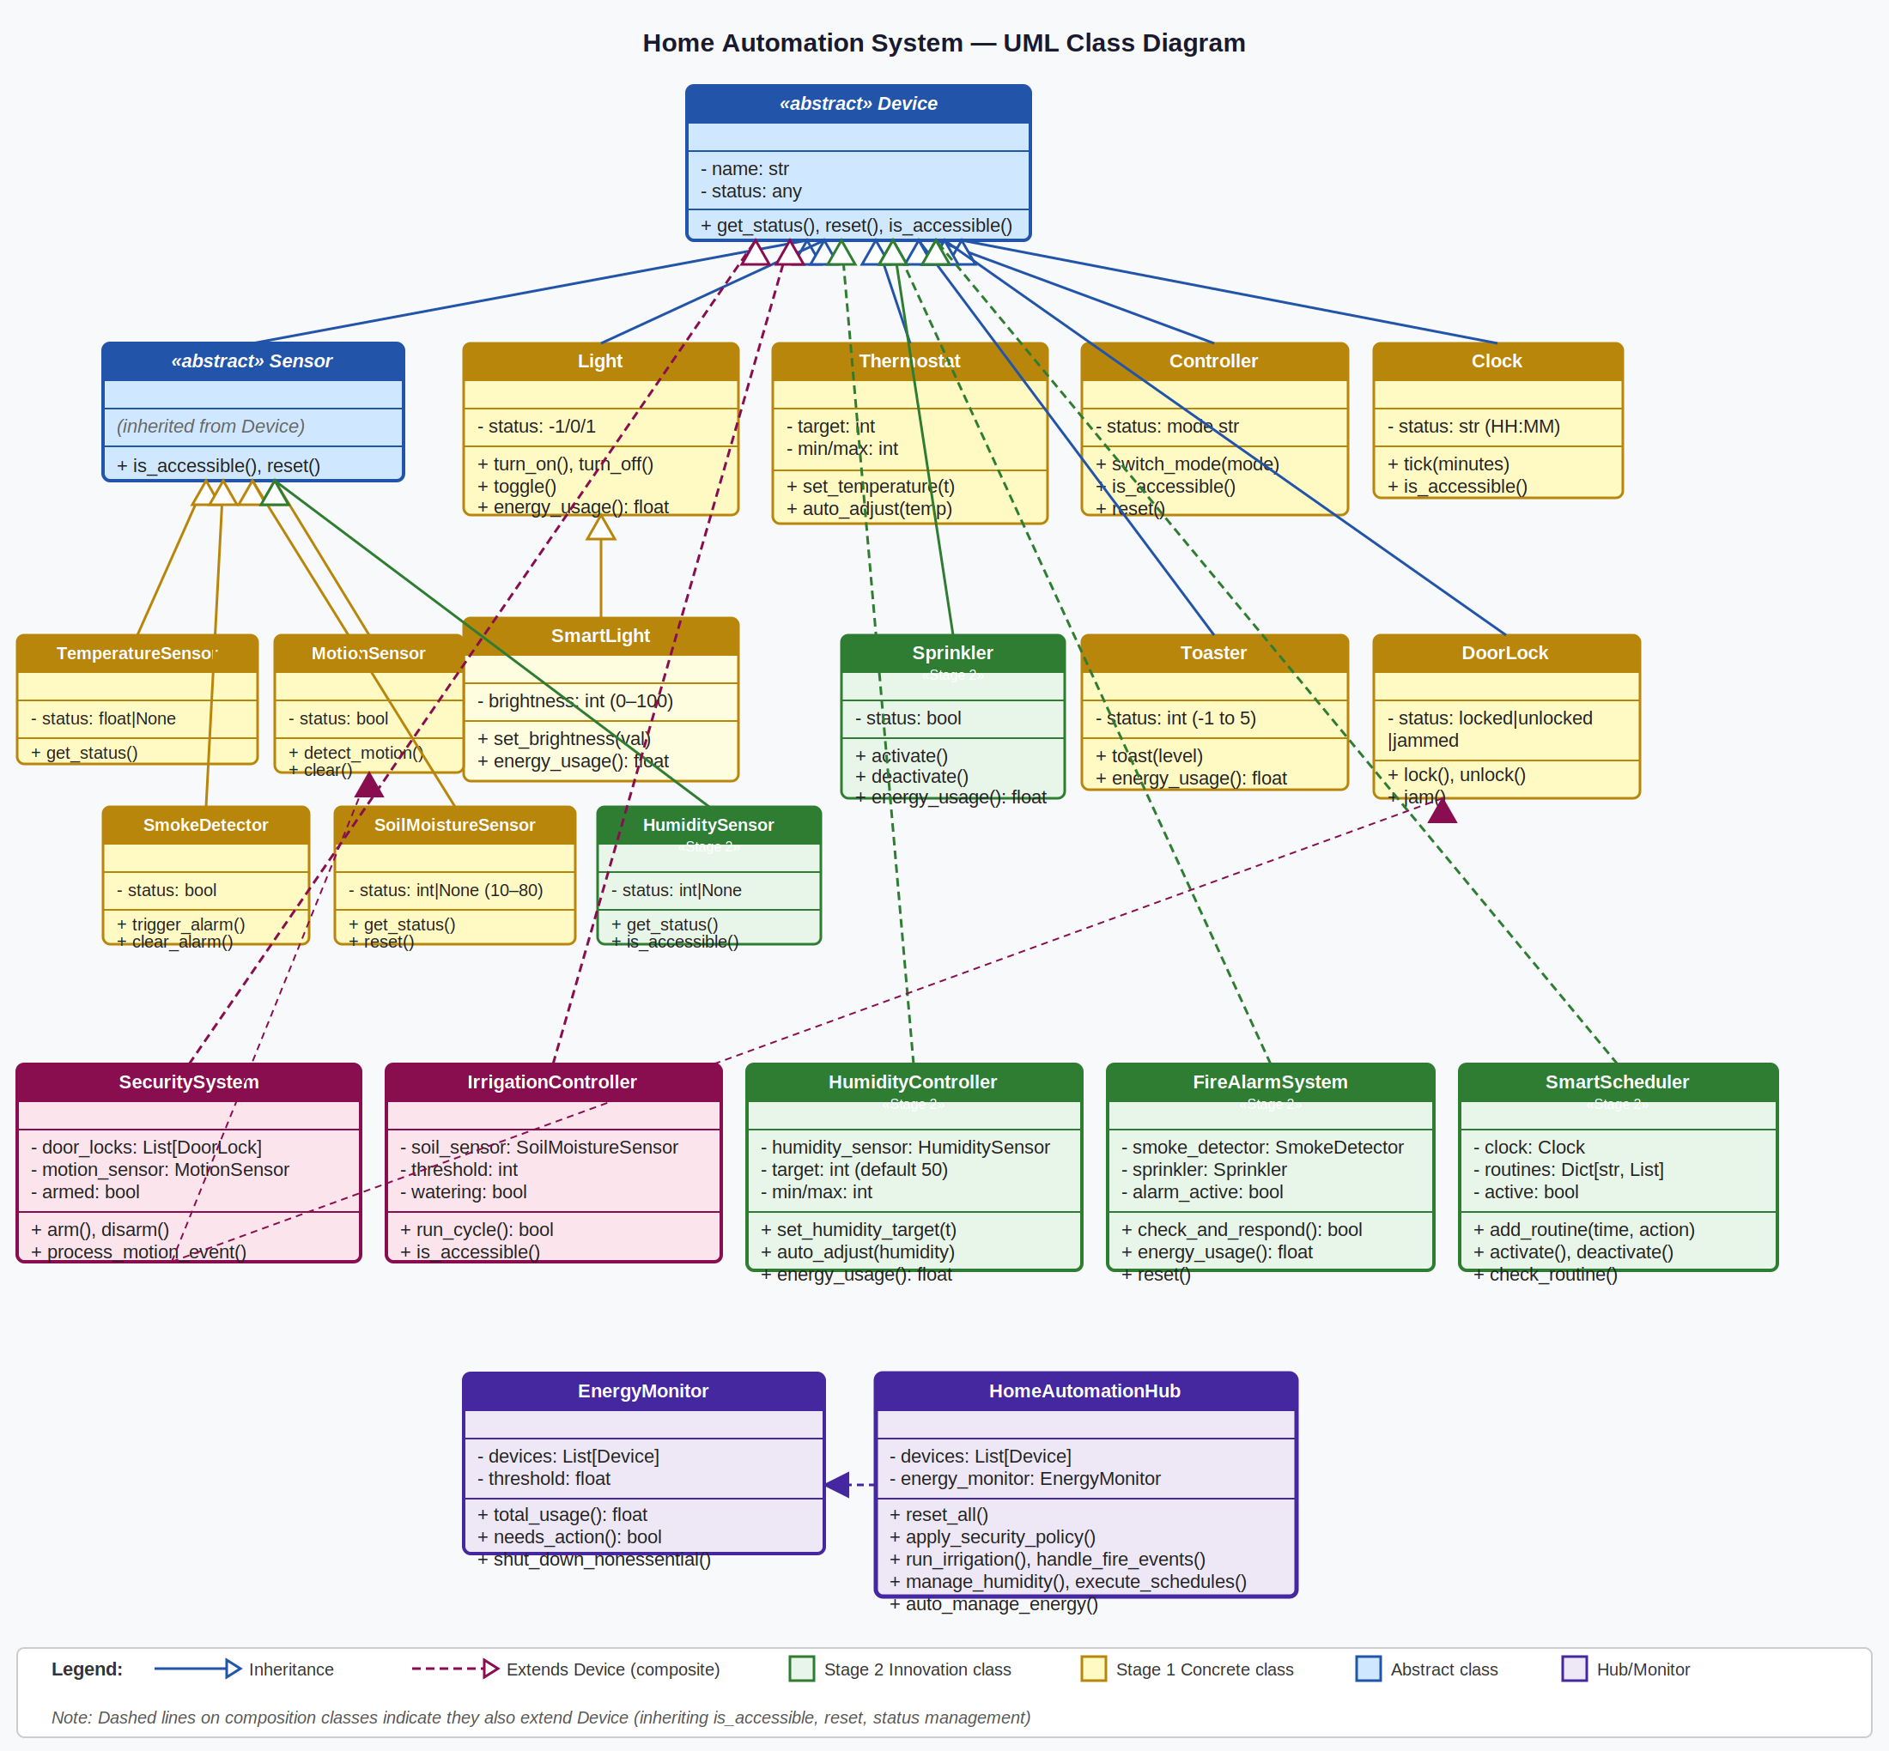
Figure 1 — Home Automation System UML Class Diagram

The diagram represents all the twenty-one classes. All inheritance hierarchies (e.g.: class that inherits from require inheritance of class for the method name—the method must be named exactly as inherited); all composition relationships (e.g.: FireAlarmSystem can have one or more SmokeDetectors; and, FireAlarmSystem can have one or more Sprinklers) are explicitly established in the attribute section of each class that implements them. At the bottom of the diagram are additional utility classes that extend no further than the Device base class and do not extend it (EnergyMonitor and HomeAutomationHub).

Testing and Coverage
This tests suite is written in Python and implements the unittest framework. All the devices are reset to known states before each individual test in setUp(), thus guaranteeing complete independence. There are three categories of tests:
Category | # Tests | Coverage Areas
Stage 1 — Core Devices | 20 | Light, SmartLight, Thermostat, DoorLock, MotionSensor, SmokeDetector, Toaster, Clock
Stage 2 — Innovations | 23 | HumidityController, FireAlarmSystem, SmartScheduler, SecuritySystem, IrrigationController
Integration / Hub | 4 | Full workflow, energy threshold, hub delegation methods
Total | 47+ | All tests pass

Examples include brightness clamping on a SmartLight, a time slot matching schedules, full smoke detect and clear sprinkler cycle and load shedding should the energy threshold passed.

Future Improvements
Three high value additions to the system:

Cloud REST API

If you wrap HomeAutomationHub behind a REST API (Implementing this in FastAPI for example) you get all the automation policies exposed as some type of HTTP endpoint, where you can do the following without changing the core structure of the classes: - remotely track the policies - override them manually on the devices - integrate it with third-party smart home platforms - and so on.

Machine Learning Occupancy Prediction

By logging sensor readings over a period in a time-series store, there would be the opportunity for a simple ML mod to learn occupancy patterns and automatically act accordingly, transforming the system from reactive to intelligent automation.

Conclusion
This Home Automation System shows professional level OOP design at two phases of development. There is a clear separation of concern in the system's architecture due to the abstract Device hierarchy, complex behaviours are decomposed into simple parts, and energy and safety policies are enforced via separate monitoring classes.
Stage 2 introduces three additional innovations inspired by original use-cases and supported by the Stage 1 system and is ideal for real smart-home applications that beyond the Stage 1 scope. Passed all tests and extension points are provided to future development in the design.

