Bug Report

PROJECT NAME: - AP RERA
TESING TEAM: DEV, LASYA, RAKESH
MODULE NAME: Complaint registration

Actual Result:
The district field was not manually selected by the user in the form. However, the system allowed navigation to the next page without showing any validation error. On the summary page, the district is automatically displayed as “West Godavari” even though the user did not select it.

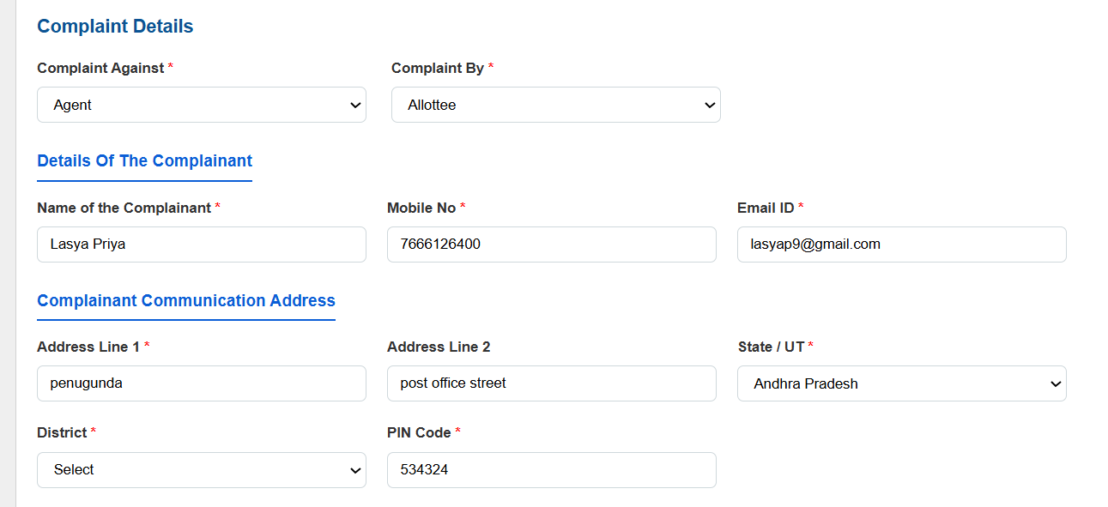

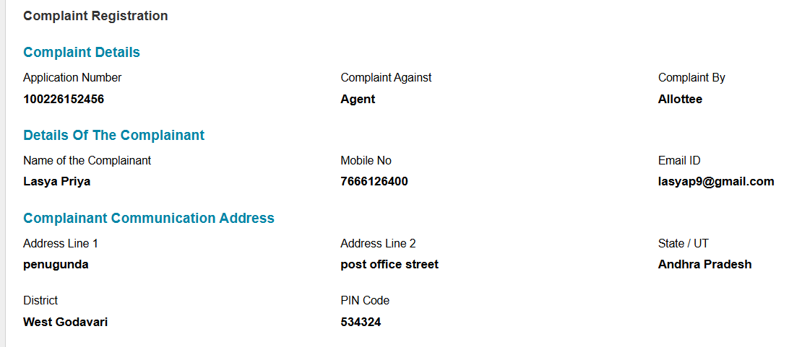

Expected Result:
If the district field is mandatory and not selected by the user, the system should display a validation message such as “Please select District” and should not allow navigation to the next page. The district value should only appear on the summary page if it has been explicitly selected by the user. The system must not auto-assign or assume a default district without user selection.

Actual Result:
The district dropdown is not functioning properly and does not allow the user to select a district. Even though the district remains unselected in the form, the system allows navigation to the next page without showing any validation error. On the summary page, the district is displayed as “West Godavari” automatically, even though the user did not select it.

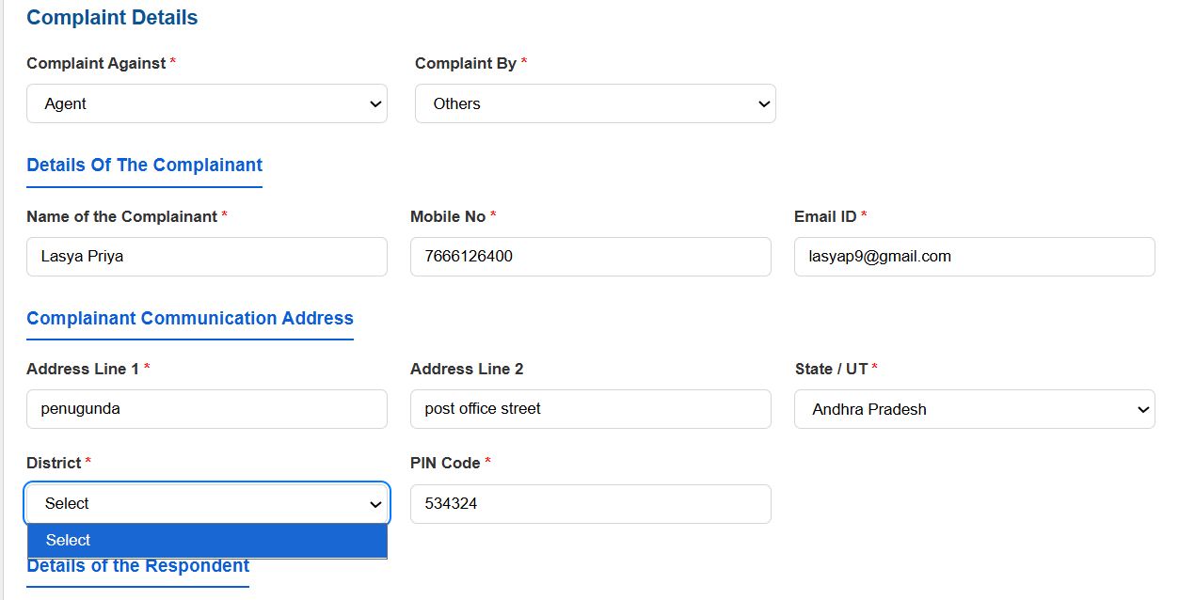

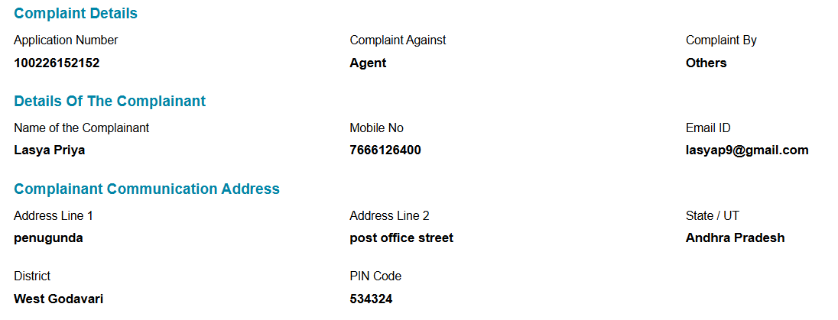

Expected Result:
The district dropdown should function properly and allow the user to select a district from the available list based on the selected State/UT. If the district is not selected, the system should display a validation message and prevent navigation to the next page. The summary page should display only the district explicitly selected by the user and must not auto-populate or assume a default value without user input.

Actual Result:
The district dropdown in the Respondent Communication Address section is not functioning properly and does not allow the user to select a district. Even though the district remains unselected in the form, the system allows the user to proceed to the next page without showing any validation error. On the summary page, the district is automatically displayed as “West Godavari” even though it was not selected by the user.

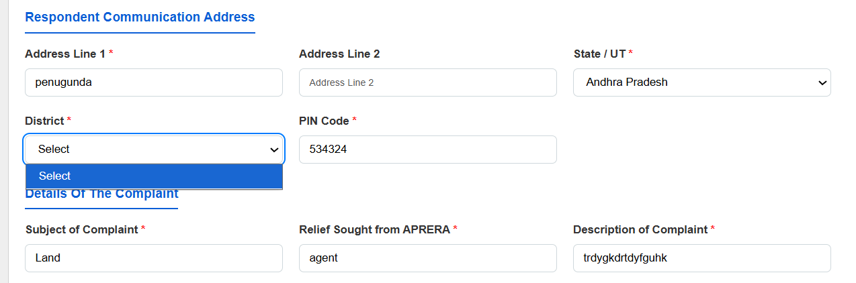

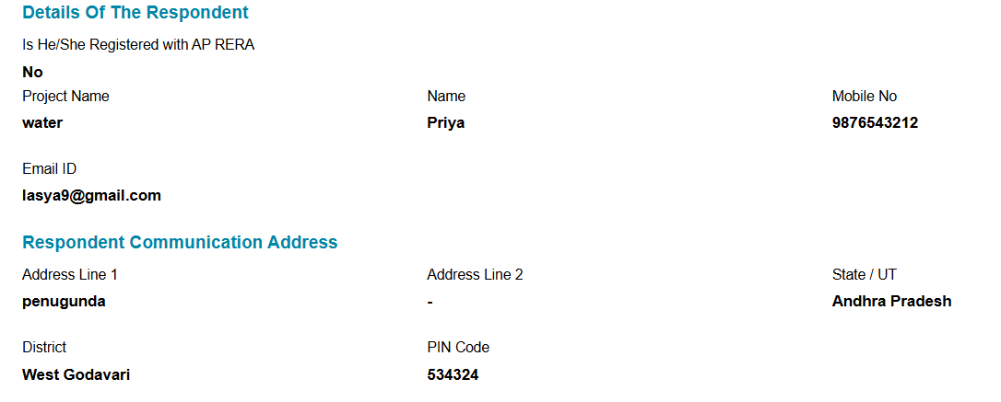
Expected Result:
The district dropdown should work correctly and allow the user to select a district based on the selected State/UT. If the district is not selected, the system should display a validation message and prevent navigation to the next page. The summary page should display only the district explicitly selected by the user and should not auto-populate or assume a default district value.
Actual Result:
After adding documents, the uploaded document details are displayed in a plain list format without proper table structure. The alignment of columns such as S.No, Document Description, Uploaded Document, and Action does not appear in a clear tabular format, making the layout look unstructured and not visually organized.

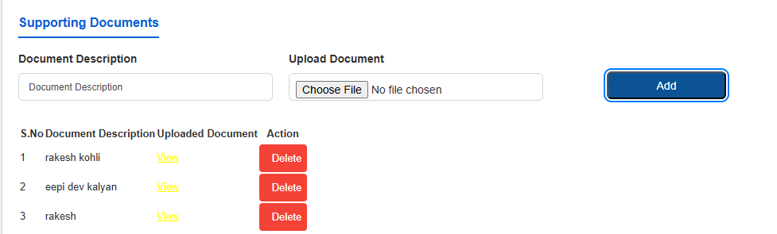

Expected Result:
After adding documents, the uploaded entries should be displayed in a properly formatted table with clear column headers such as S.No, Document Description, Uploaded Document, and Action. The table should have proper alignment, borders, and consistent spacing to ensure readability and a professional appearance.

Actual Result:
The Upload Fee Receipt field is marked as mandatory, but the system allows the user to proceed to the next page without uploading any file. No validation message is shown, and the page redirects successfully even though the required document is missing.

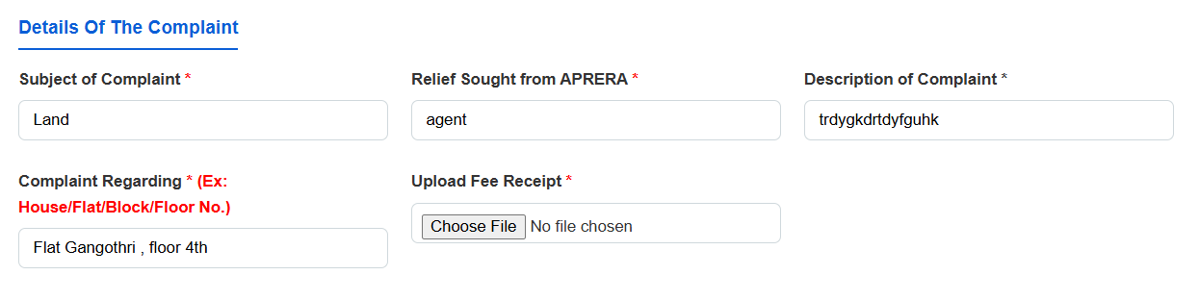

Expected Result:
The system should enforce mandatory validation for the Upload Fee Receipt field. If no file is uploaded, a validation message such as “Please upload fee receipt” should be displayed, and the user should not be allowed to proceed to the next page until a valid file is uploaded.

Actual Result:
The Interim Order field provides Yes and No radio button options. However, the system allows navigation to the next page without properly validating the selection. On the summary page, the Interim Order field appears as blank or “-”, even though it is marked as mandatory in the form

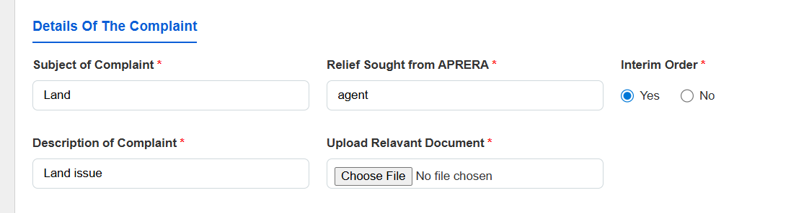

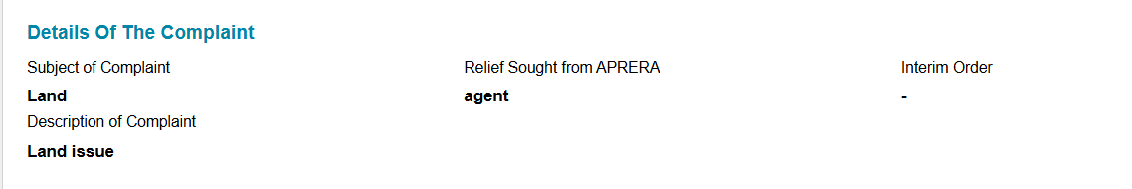

Expected Result:
The system should require the user to explicitly select either Yes or No for the Interim Order field before allowing navigation to the next page. If no option is selected, a validation message such as “Please select Interim Order option” should be displayed, and the user should not be allowed to proceed. The selected value (Yes or No) should be accurately reflected on the summary page.

Actual Result:
The system allows the user to proceed without entering the Document Description and without uploading a document file. Even though the fields are empty, the page redirects to the next page and displays a document entry in the list, such as “INTERIM ORDER,” without proper validation.

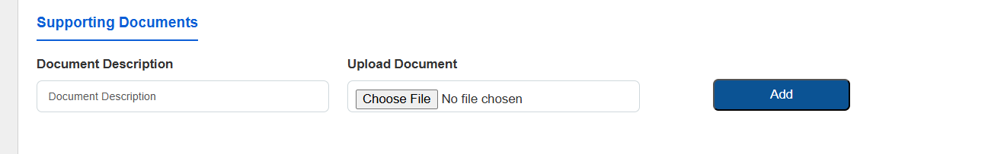

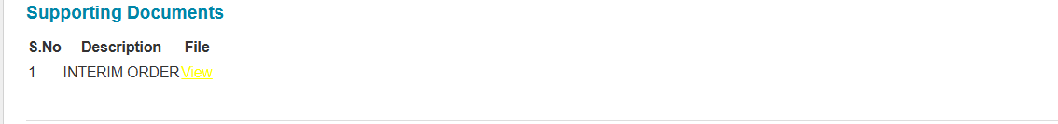

Expected Result:
The system should validate that both Document Description and Upload Document fields are filled before allowing the user to proceed. If either field is left empty, a validation message should be displayed and the user should not be redirected to the next page. Only properly added and validated documents should appear in the document list.

