Research/Review Article
COMPUTATIONAL PROGNOSTICS IN PATHOLOGY: COMPARATIVE MIL ANALYSIS OF CLAM AND TRANSMIL USING FOUNDATION MODELS
Deva Nandan JS ¹, Dr. Velmani R ², Dr. Shweta Saxena ², Dr. S Devaraju ^{2,*}
Received: date
Revised: date
Accepted: date
Published: date


Copyright: © 2026 by the authors. Submitted for possible open access publication under the terms and conditions of the Creative Commons Attribution (CC BY) licenses (https://creativecommons.org/licenses/by/4.0/)
¹ VIT Bhopal University; devanandan.connect@gmail.com
² VIT Bhopal University; velmani@vitbhopal.ac.in
* Corresponding Author : Deva Nandan Js 
Abstract: Whole Slide Images (WSIs) contain critical prognostic biomarkers, yet their gigapixel scale presents immense computational challenges for automated analysis. The standard architectural solution employs a two-stage Multiple Instance Learning (MIL) framework [3, 7, 17], extracting patch-level embeddings before applying prognostic modeling. However, rigorously evaluating differing MIL aggregation strategies. Such as the clustering-constrained attention of CLAM [1] versus the context-aware, self-attention transformer architecture of TransMIL [2] remains difficult due to confounding variables in feature extraction.
This thesis conducts a standardized, head-to-head architectural comparison of CLAM and TransMIL for patient survival prediction utilizing the TCGA-BRCA cohort [26]. Our core methodological innovation eliminates the feature extractor as a variable by standardizing inputs through a single pathology foundation model, UNI [4] (UNI2-h features). By isolating the MIL aggregation mechanism as the sole independent variable, this study provides an objective evaluation of architectural trade-offs: specifically, whether the spatial and morphological dependency modeling of TransMIL [2] justifies its increased complexity over the computationally efficient, clustering-regularized approach of CLAM [1]. Ultimately, this research delivers evidence-based guidance for engineering robust and scalable computational pathology pipelines

Keywords: Computational Pathology, Multiple Instance Learning, Whole Slide Imaging, Prognostic Modeling, Attention Mechanisms, Vision Transformers, Foundation Models.

1. Introduction
The field of pathology is undergoing a fundamental paradigm shift. The transition from conventional microscopic examination, historically the gold standard for cancer diagnosis for Computational Pathology (CPATH) has been driven by the digitalization of physical glass slides into high-resolution, multi-gigapixel Whole Slide Images (WSIs). A single WSI is a complex, multi-layered data structure that frequently exceeds ten billion pixels at 40$\times$ magnification. These high-resolution scans capture the fine histomorphological features required to identify malignancies, assess patient risk, and discover rare biological conditions.
This digitalization presents immense clinical opportunities but introduces unique computational bottlenecks. While AI can analyze these complex images at scale to reduce human subjectivity and alleviate the labor-intensive burden on skilled pathologists, a standard gigapixel-scale WSI is computationally prohibitive for standard end-to-end deep learning architectures due to severe GPU memory constraints [23]. Furthermore, WSIs must contend with pre-analytical artifacts introduced during slide preparation, such as tissue folds, air bubbles, and out-of-focus blur. These imperfections introduce noise that can lead to false predictions in diagnostic algorithms if the underlying architecture is not sufficiently robust.
  - Problem Statement
While computational pathology has widely adopted Multiple Instance Learning (MIL) to overcome the gigapixel scalability constraints of Whole Slide Images (WSIs), the field currently faces a critical architectural dilemma regarding instance aggregation. Two competing paradigms dominate: the highly scalable, data-efficient attention approach (CLAM) [1], which assumes instance independence (i.i.d.), and the transformer-based approach (TransMIL) [2], which explicitly models complex spatial and morphological correlations at the cost of quadratic computational overhead.
Although both architectures have demonstrated state-of-the-art performance in basic subtyping, it remains an open question whether the architectural complexity and computational cost of TransMIL's self-attention mechanism translate into a significant performance gain for survival prognosis, A downstream task that is fundamentally reliant on diffuse, spatially complex tumor heterogeneity. Furthermore, existing comparative evaluations in the literature are frequently confounded by variations in upstream feature extraction pipelines (e.g., using different ResNet variants), obscuring the true efficacy of the MIL aggregation algorithms themselves.
Therefore, this research addresses the critical need for a controlled, head-to-head architectural evaluation of prognostic modeling. By standardizing the input feature space using high-dimensional embeddings from a state-of-the-art pathology foundation model (UNI2-h) [4], this study eliminates the feature extractor as a confounding variable. The core problem is to empirically evaluate the trade-off between performance and complexity: determining whether the context-aware modeling of TransMIL provides a statistically significant advantage over the computationally efficient CLAM for patient risk stratification and survival prediction within the TCGA-BRCA cohort [26].
  - Research Objectives
The primary objectives of this study are as follows:
- To conduct a direct, head-to-head comparative analysis of the attention-based CLAM and transformer-based TransMIL architectures, isolating their aggregation mechanisms to determine the most robust approach for computational prognostics.
- To eliminate the feature extractor as a confounding variable by standardizing the input patch embeddings using UNI2-h, a state-of-the-art pathology foundation model. This ensures any variance in predictive performance is strictly attributed to the MIL architecture itself.
- To evaluate both models' capacity to predict patient outcomes using the well-characterized TCGA-BRCA (Breast Invasive Carcinoma) cohort, focusing on continuous overall survival (OS) risk ranking and binary 5-year survival classification.
- To empirically determine whether the explicit modeling of inter-instance spatial and morphological correlations via self-attention (TransMIL) provides a significant performance advantage over computationally efficient, clustering-regularized attention (CLAM) for complex survival tasks.
- To validate the models using a robust 5-fold cross-validation methodology, benchmarking performance with the Concordance Index (C-Index) [24] for survival ranking and the Area Under the Receiver Operating Characteristic Curve (AUC) [25] for binary classification.

  - Main Contributions
This study addresses the critical need for rigorous architectural benchmarking in computational pathology by isolating the aggregation phase of the WSI pipeline. The primary contributions are as follows:
- Controlled Architectural Benchmarking: We conduct a direct, head-to-head comparative analysis between two leading Multiple Instance Learning (MIL) paradigms: the computationally efficient, i.i.d.-assuming clustering approach of CLAM [1] and the high-complexity, context-aware spatial correlation modeling of TransMIL [2]. This provides an empirical evaluation of the trade-off between model simplicity and relational awareness for complex prognostic tasks.
- Methodological Rigor via Feature Standardization: To eliminate confounding variables and ensure a robust comparison, the feature extraction stage is strictly decoupled from the aggregation stage. We utilize a standardized, state-of-the-art embedding set derived from the UNI2-h pathology foundation model [4]. By keeping the input manifold constant, the MIL aggregation mechanism becomes the sole independent variable.
- Validation on Complex Clinical Endpoints: Moving beyond standard subtyping, we benchmark these architectures on the highly complex task of survival prognosis using the widely recognized TCGA-BRCA cohort [26]. The models are evaluated on their ability to assess patient risk utilizing robust statistical metrics, specifically the Concordance Index (C-Index) [24] for overall survival and Area Under the Curve (AUC) [25] for 5-year binary survival classification.
2. Preliminaries or Related Work or Literature Review
This literature survey examines the technological landscape of computational pathology, focusing on the evolution of Multiple Instance Learning (MIL) architectures and the recent paradigm shift toward Pathology Foundation Models (PFMs) [8]. The review establishes the context for a head-to-head comparison between CLAM and TransMIL for survival prediction in breast cancer, utilizing standardized foundation model features.
2.1 The Digital Transformation and Whole Slide Imaging (WSI)
Anatomical pathology has historically relied on the subjective interpretation of tissue morphology under a light microscope. The transition to Digital Pathology (DP) enabled the creation of Whole Slide Images (WSIs) high-resolution digital scans reaching ten billion pixels or more. While these images preserve intricate cellular detail, their size exceeds the memory capacity of standard GPUs (e.g., the NVIDIA 1650 with 4 GB VRAM), necessitating a two-stage processing pipeline where slides are divided into smaller "tiles" or "patches".
2.2 The Multiple Instance Learning (MIL) Paradigm
To handle WSIs without manual patch-level annotations, the field adopted Multiple Instance Learning (MIL) [3, 7, 17], a weakly supervised framework where a slide is treated as a "bag" and its constituent patches as "instances". The fundamental assumption is that a bag is positive if at least one instance is positive, and negative only if all instances are negative.
Early MIL research utilized simple pooling (max or mean), which often ignored relevant instances or diluted diagnostic signals. This led to Attention-based MIL [3], where learnable weights are assigned to patches to highlight diagnostically relevant regions.

2.3 State-of-the-Art Architectures: CLAM vs. TransMIL
Current research is dominated by two distinct architectural paradigms:
• CLAM (Clustering-constrained Attention MIL): Introduced by Lu et al. (2021) [1], CLAM uses an attention mechanism to rank subregions by diagnostic importance. Its primary innovation is an instance-level clustering constraint that forces the model to learn a robust feature space where positive and negative evidence is well-separated. CLAM is noted for its data efficiency and high interpretability via attention heatmaps. However, it follows the i.i.d. hypothesis, assuming patches are independent and identically distributed.
• TransMIL (Transformer-based Correlated MIL): Developed to address the limitations of the i.i.d. assumption, TransMIL [2] explicitly models the morphological and spatial correlations between different tissue regions. It utilizes self-attention [22] to capture long-range dependencies and a Pyramid Position Encoding Generator (PPEG) to restore the 2D spatial context lost during patch serialization. To maintain computational tractability on large sequences, it employs the Nyström Method for approximated self-attention.
2.4 The Emergence of Pathology Foundation Models (PFMs)
The field is currently undergoing a shift from natural-image feature extractors (like ResNet-50) to universal Foundation Models trained on millions of pathology slides using Self-Supervised Learning (SSL) [8]. Key models include:
• UNI (and UNI2-h): Pretrained on over 100 million patches from 100,000 WSIs, providing resolution-agnostic feature representations [4].
• Virchow: A large-scale model trained on 1.5 million slides at MSKCC, demonstrating high sensitivity for rare cancer detection [5].
• Prov-GigaPath: A slide-level foundation model that uses LongNet to capture patterns across entire gigapixel slides simultaneously [6].
The Mahmood Lab at Harvard has emerged as a critical "feature producer," democratizing access to high-quality embeddings like UNI2-h [4], which allows researchers with limited hardware to focus on the "cognitive" task of aggregation.
2.5 Challenges in Survival Prediction and Prognosis
While both CLAM and TransMIL have shown state-of-the-art performance in classification tasks, their application to survival prediction is more complex. Survival analysis is a regression-like task that requires the model to interpret subtle morpho-molecular cues to rank patients by risk. Current literature lacks a direct, controlled comparison between the i.i.d.-based clustering (CLAM) and correlated self-attention (TransMIL) for this specific clinical endpoint.
2.6 Rationale for a Fixed-Feature Comparative Analysis
Standardizing the input feature set is a vital methodological choice for rigorous comparison. In many studies, model performance is confounded by the choice of feature extractor. By using a single source of truth. UNI2-h features from the Mahmood Lab [4] and unified k-fold cross-validation splits, the proposed experiment isolates the impact of the aggregator architecture. This "apples-to-apples" approach ensures that any observed performance differences in C-Index [24] or AUC [25] are attributable solely to the way the models aggregate instance information.
Analogy: This literature survey is like a scouting report for two different chess engines (CLAM and TransMIL). Both have been tested in basic matches (classification), but we are now setting up a tournament on a more difficult board (survival prediction). To ensure the match is fair, we are giving both engines the exact same set of opening moves (the pre-computed UNI2-h features) [4] and running them on the same computer. This allows us to see whose internal logic one that clusters similar pieces (CLAM) or one that maps the relationships between every piece on the board (TransMIL) is truly superior.
3. Proposed Method
This chapter establishes the theoretical and methodological foundation for the thesis. Its strategic importance lies in systematically detailing the computational pathology landscape, deconstructing the Multiple Instance Learning (MIL) paradigm [3, 7] that underpins modern approaches, and presenting the specific architectural designs of the two models central to this investigation: Clustering-constrained Attention Multiple Instance Learning (CLAM) [1] and Transformer-based Multiple Instance Learning (TransMIL) [2]. The chapter's structure is designed to guide the reader from the broad challenges of the field to the specific implementation details of this study. It begins by outlining the core concepts that motivate the research, proceeds to a deep dive into the model architectures, and concludes by presenting the rigorous experimental protocol designed for their direct comparison.
3.1 The Computational Pathology Landscape: Challenges and Opportunities
Understanding the unique challenges inherent to computational pathology is crucial for appreciating the necessity of specialized deep learning models. This section aims to contextualize the research problem by outlining the fundamental difficulties of working with gigapixel-scale Whole Slide Images (WSIs). The scale and complexity of this data demand a departure from conventional computer vision techniques and motivate the adoption of novel learning paradigms.
The analysis of WSIs presents several fundamental challenges that render standard deep learning methods impractical. First is the immense size of the data; a single WSI can easily reach gigapixel resolution (e.g., 40,000 x 40,000 pixels), making direct processing computationally prohibitive. Second, this scale creates a significant bottleneck in data annotation. The process of generating fine-grained, pixel-level, or even patch-level annotations is extraordinarily time-consuming, labor-intensive, and requires the specialized expertise of a pathologist [7]. This makes slide-level labels the only practical and scalable source of supervision for developing models on the large, multi-institutional cohorts required for robust generalization. Finally, even after tiling a WSI into non-overlapping patches, a number which can range from hundreds for a biopsy slide at 20× magnification to hundreds of thousands for a large resection slide at 40× magnification. The sheer volume of data imposes extreme computational costs. For instance, inference on a single WSI using an established MIL method like CLAM [1] can require ≈150 Tera Floating-Point Operations (FLOPs), which is 37,500 times the processing required for an ImageNet sample by a ResNet34 model.
These challenges necessitate a strategic shift from fully-supervised to weakly-supervised learning paradigms [1, 7]. Weakly supervised learning, in this context, refers to the process of training a model using only slide-level labels, without the benefit of patch-level annotations. This approach directly addresses the annotation bottleneck by leveraging the most commonly available form of data in clinical and research archives.
By framing the problem in this way, the field has largely converged on a specific weakly-supervised framework perfectly suited for WSI analysis: Multiple Instance Learning.
3.2 The Multiple Instance Learning (MIL) Paradigm
Multiple Instance Learning (MIL) [3, 7, 17] has emerged as the dominant weakly-supervised framework for WSI classification. Its strategic importance cannot be overstated, as it provides the core theoretical construct upon which both the CLAM and TransMIL models are built. MIL reformulates the WSI classification problem in a way that is computationally tractable and aligned with the constraints of weak supervision.
In the context of histopathology, the core tenets of MIL are defined by a specific set of terminologies. The WSI as a whole is treated as a Bag , which is a collection of smaller, non-overlapping image patches known as Instances . The only known ground truth is the Bag-level Label , which corresponds to the single diagnostic label for the entire slide (e.g., tumor vs. normal, or a specific cancer subtype). The labels for the individual patches, or Instance-level Labels , are unknown during training. The central goal of MIL is to predict the bag-level label by learning from the collection of its instances [3].
The standard embedding-based MIL workflow follows a distinct three-step process:
Feature Extraction: A deep neural network, such as a ResNet50 pre-trained on ImageNet, or increasingly, a more powerful pathology-specific foundation model such as UNI [4], Virchow [5], or Prov-GigaPath [6], is used as a feature extractor. This network processes each high-dimensional image patch (instance) and converts it into a lower-dimensional feature vector, or embedding.
Aggregation/Pooling: A permutation-invariant pooling operator is applied to the set of all instance feature vectors from a single bag. This operator, such as max-pooling or an attention mechanism [3], aggregates the variable number of instance features into a single, fixed-size bag-level representation.
Classification: A final classifier, often a fully-connected layer, takes this single WSI representation as input to predict the slide-level label.
A critical, though often implicit, element of most traditional MIL methods is the foundational assumption that all instances within a bag are independent and identically distributed (i.i.d.). However, this assumption is fundamentally at odds with the diagnostic process of a human pathologist, who inherently considers contextual and correlational information between different tissue regions and morphological structures to arrive at a diagnosis. This discrepancy between the i.i.d. assumption and clinical practice is a key point of divergence for modern MIL architectures.
The different ways in which models handle instance aggregation and the degree to which they adhere to or challenge the i.i.d. assumption lead to distinct architectural designs, as exemplified by the contrasting philosophies of CLAM [1] and TransMIL [2].
3.3 Architectural Deep Dive: CLAM vs. TransMIL
This section performs a detailed deconstruction of the two MIL architectures central to this thesis: Clustering-constrained Attention MIL (CLAM) and Transformer-based MIL (TransMIL). The strategic goal is to illuminate their key innovations, operational mechanisms, and fundamental theoretical differences. By understanding how each model approaches the task of aggregating instance-level information, we can better interpret their eventual performance in the experimental phase.
3.3.1 The CLAM Architecture: Attention and Clustering
CLAM is an attention-based MIL method that introduces a novel learning constraint to refine its feature space. Its architecture is built on two primary components:
Attention-Based Learning: CLAM employs a gated attention mechanism [1, 3] to automatically identify and assign higher weights (attention scores) to sub-regions (instances) of high diagnostic value. These weighted instance features are then aggregated to form the slide-level representation used for classification. This allows the model to focus on the most informative patches within a slide while effectively ignoring irrelevant or noisy regions.
Instance-Level Clustering: The key innovation of CLAM is the introduction of an auxiliary instance-level clustering loss. This process is supervised by pseudo-labels generated directly from the attention network itself, targeting the most and least attended-to patches. By training a small classifier to separate these "strong positive" and "strong negative" instances, the model is constrained to learn a feature space where features of high diagnostic importance are more linearly separable from those with low importance.
The training objective for CLAM is therefore a composite loss function. The total loss is the sum of the primary slide-level classification loss and the auxiliary instance-level clustering loss, which work in tandem to train a more robust and interpretable classifier.
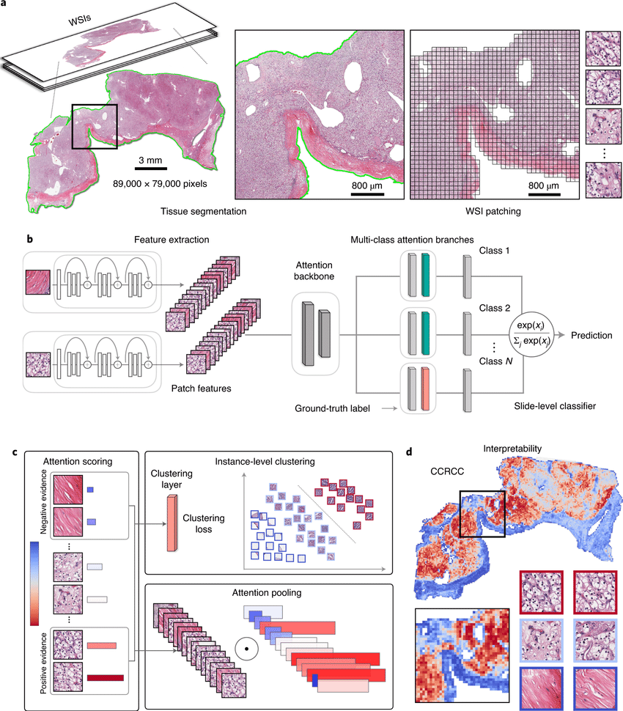
Figure 3.1: CLAM Architecture
3.3.2 The TransMIL Architecture: Correlated Instance Modeling
TransMIL's [2] design represents a conceptual departure from standard MIL by explicitly challenging the i.i.d. assumption. Its architecture is motivated by the observation that pathologists consider the correlations between different tissue areas when forming a diagnosis. It therefore aims to model the relationships between instances rather than treating them as independent entities.
To achieve this, TransMIL leverages the self-attention mechanism, the core component of the Transformer [22]. Unlike a standard MIL attention mechanism which scores the importance of each instance independently of others, self-attention captures pairwise correlations between every instance within a bag. This allows the representation of each instance to be dynamically updated based on its relationship to all other instances, thereby modeling both morphological and spatial/contextual information simultaneously.
The key components of the TransMIL architecture include the Pyramid Position Encoding Generator (PPEG) , which provides the model with spatial information about the instances, and the Transformer-based Pyramid Token (TPT) module, which processes the sequence of instance embeddings to produce the final slide-level representation.
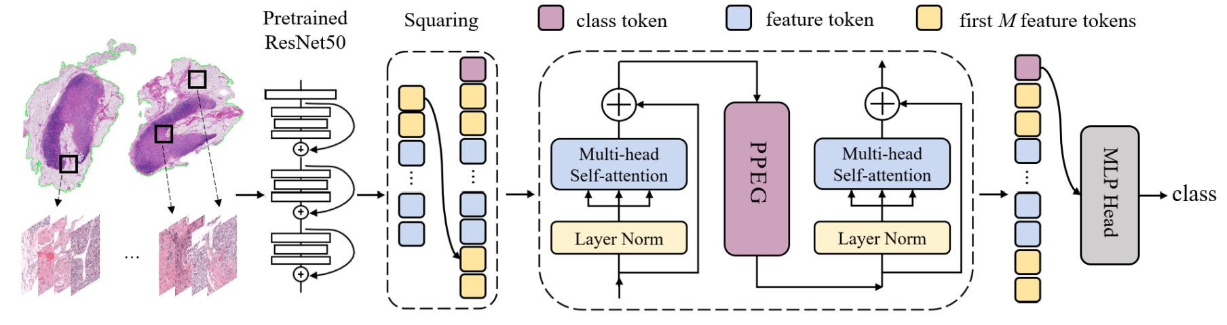
Figure 3.2: TransMIL architecture
3.3.3 Comparative Analysis of Core Mechanisms
The fundamental differences in the architectural philosophies of CLAM and TransMIL can be summarized as follows:
Table 3.1: Architectural Comparison of CLAM and TransMIL
Architectural Component | CLAM | TransMIL
Core Assumption | Instances are independent. | Instances are correlated.
Attention Mechanism | Gated attention mechanism; instance importance is scored independently. | Multi-head self-attention; instance representations are updated based on their relation to all other instances.
Feature Space Learning | Refinement via instance-level clustering loss. | Implicit learning of instance relationships via self-attention.
Information Modeled | Primarily morphological importance. | Both morphological and spatial/contextual relationships.

3.4 Research Design and Methodology
This section translates the theoretical concepts discussed previously into a concrete and reproducible experimental design. Its purpose is to meticulously outline every step of the research process, from data acquisition and preprocessing to model training. This detailed protocol is essential for ensuring the scientific rigor of the subsequent comparative analysis and the reproducibility of its findings.
Dataset and Cohort Definition
The study utilizes the TCGA-BRCA cohort [26] from The Cancer Genome Atlas, a comprehensive and publicly available dataset for breast cancer research. Clinical outcome data, including survival information, was sourced from the supplemental file TCGA-CDR-SupplementalTableS1.xlsx.
Feature Extraction and Data Preparation
To manage the computational demands of WSI processing, this research uses pre-extracted patch features stored in the .h5 file format. These features were generated by processing non-overlapping 256x256 image patches through a ResNet50 model pre-trained on ImageNet, which converted each patch into a 1024-dimensional feature vector. A master manifest file, master.csv, was created to serve as the central index for the experiments. This file was generated by merging a slide manifest (derived from the .h5 filenames) with the clinical outcome data. The merge key for this operation was the 12-character patient barcode, which was extracted from the longer slide ID of each feature file.
Prediction Task Formulation
Two specific downstream tasks were defined to evaluate the models on clinically relevant endpoints:
Survival Analysis: The primary task is the prediction of Overall Survival (OS). The models are trained to predict a risk score based on the slide features, using OS.time (survival time in days) and OS (censoring status, where 1 indicates a deceased patient) as the target variables.
Binary Classification: A secondary task is defined as the prediction of 5-year survival. A binary label, survival_label_5yr, is created for this purpose. The label is assigned a value of 1 if the patient is deceased (OS = 1) AND their survival time is less than 1825 days (OS.time < 1825), and 0 for all other cases (i.e., living patients or deceased patients who survived 5 years or longer).
Model Implementation and Training Protocol
The experiments are based on the official, publicly available code repositories for both CLAM [1] and TransMIL [2] to ensure fidelity to the original architectures. The primary training and evaluation strategy employed is 5-fold cross-validation . This method ensures a robust and generalizable performance assessment by systematically splitting the dataset into five distinct training and testing sets, thereby ensuring that each data sample is used in the test set exactly once. The training loops for all 5 folds for both models were executed systematically using bash scripts to automate the process and ensure consistency.
A rigorous experimental design requires an equally rigorous framework for evaluation, which will be detailed in the following section.
3.5 Evaluation Framework
A comprehensive evaluation framework is essential to quantitatively and qualitatively assess and compare the performance of the CLAM and TransMIL architectures. This section details the specific metrics, statistical tests, and interpretability methods that will be used to determine model efficacy for each prediction task, the statistical significance of any observed performance differences, and the biological plausibility of the models' decision-making processes.
Quantitative Performance Metrics
The primary metric for each task was chosen to reflect the nature of the prediction problem:
For Survival Analysis: The Concordance Index (C-Index) [24] is the primary evaluation metric. The C-Index measures a model's ability to correctly rank pairs of patients by their predicted risk of an event. A value of 1.0 indicates perfect ranking concordance, while a value of 0.5 indicates performance no better than random chance.
For Binary Classification: The Area Under the Receiver Operating Characteristic Curve (AUC) [25] is the primary evaluation metric. The AUC quantifies the model's ability to discriminate between the positive and negative classes across all possible classification thresholds.

4. Experimental Setup
Framework
To ensure a highly scalable and reproducible pipeline, our architectural framework intentionally decouples feature extraction from instance aggregation. We leverage pre-computed, 1024-dimensional feature embeddings generated by the UNI2-h pathology foundation model [4], developed by the Mahmood Lab at Harvard University. By standardizing the input feature space using this state-of-the-art vision transformer, we eliminate the feature extractor as a confounding variable. This strategic design isolates the core cognitive task, allowing for a rigorous, head-to-head comparative analysis between the attention-based clustering mechanism of CLAM [1] and the spatially correlated self-attention architecture of TransMIL [2].
Training Configuration
Prioritizing model robustness and generalizability, the training pipeline employs a rigorous 5-fold cross-validation strategy on the clinical TCGA-BRCA cohort [26]. Both the CLAM and TransMIL architectures are trained under identical hyperparameter constraints to guarantee a fair benchmark. The experimental design evaluates two distinct predictive tasks: the primary task models continuous overall survival (OS) risk, evaluated using the Concordance Index (C-Index) [24], while the secondary task frames 5-year survival as a binary classification problem, evaluated via the Area Under the Receiver Operating Characteristic Curve (AUC) [25].
Hardware
Directly processing gigapixel Whole Slide Images (WSIs) end-to-end introduces severe memory bottlenecks, often exceeding the VRAM capacity of standard GPUs. To optimize the performance-versus-cost trade-off, this study utilizes pre-extracted WSI patch features stored efficiently in the .h5 format. This memory-efficient architecture bypasses the massive computational overhead of end-to-end feature extraction, enabling rapid iteration and the training of complex Multiple Instance Learning (MIL) aggregators on standard, cost-effective GPU accelerators without encountering Out-Of-Memory (OOM) failures.

5. Results
This section presents the experimental outcomes of the Transformer and Long Short-Term Memory (LSTM) models for malware family classification using behavioral API call sequences. Using a publicly available dataset containing malware API call sequences, model resilience, accuracy, and computational efficiency were evaluated through a multi-metric approach. To ensure fair comparison, both models were trained and analyzed under identical experimental conditions.
5.1. Overall Performance Comparison
Table 1 summarizes the overall classification performance of the LSTM and Transformer models. Accuracy, precision, recall, and F1-score were used as evaluation criteria to provide a comprehensive analysis of each model's ability to accurately distinguish malware from benign samples [16].
Model | Accuracy (%) | Precision | Recall | F1-Score
LSTM | 90.58 | 0.9069 | 0.9058 | 0.9058
Transformer | 95.54 | 0.9559 | 0.9554 | 0.9555
Table 1. Overall performance comparison between the LSTM and Transformer models.
The Transformer model outperformed the LSTM model by 4.96 percentage points, achieving an optimal accuracy of 95.54\%, which represents a 5.48\% relative improvement in classification accuracy [20]. Similarly, the Transformer demonstrated superior capacity to extract discriminative behavioral patterns from API sequences, as evidenced by improved precision (0.9559), recall (0.9554), and F1-score (0.9555). While the LSTM's sequential processing may degrade with longer sequences, the Transformer's self-attention mechanism effectively captures long-range dependencies across the entire execution trace, accounting for the performance difference.
5.2. Training Dynamics and Convergence Behavior
Table 2 shows the training history of both models across seven epochs. The Transformer demonstrated faster convergence and greater stability throughout the training process compared to the LSTM.
Epoch | LSTM Train Acc. (%) | LSTM Test Acc.(%) | Transformer Train Acc.(%) | Transformer Test Acc. (%)
0 | 67.0 | 79.5 | 92.5 | 95.5
1 | 77.0 | 82.5 | 96.0 | 95.8
2 | 80.5 | 84.5 | 96.5 | 96.2
3 | 83.0 | 86.0 | 97.0 | 96.5
The Transformer achieved rapid feature learning, attaining a test accuracy exceeding 95.5\% from the first epoch. The effectiveness of the attention-based architecture in extracting relevant sequential features is illustrated by the LSTM's requirement for multiple epochs to achieve comparable performance [1]. The broader convergence curve of the Transformer model also suggests improved generalization and reduced overfitting.
Model | Class | Precision | Recall | F1-Score | Support
LSTM | Benign | 0.93 | 0.89 | 0.91 | 4658
 | Malware | 0.88 | 0.89 | 0.91 | 4118
Transformer | Benign | 0.97 | 0.95 | 0.96 | 4658
 | Malware | 0.94 | 0.97 | 0.95 | 4118
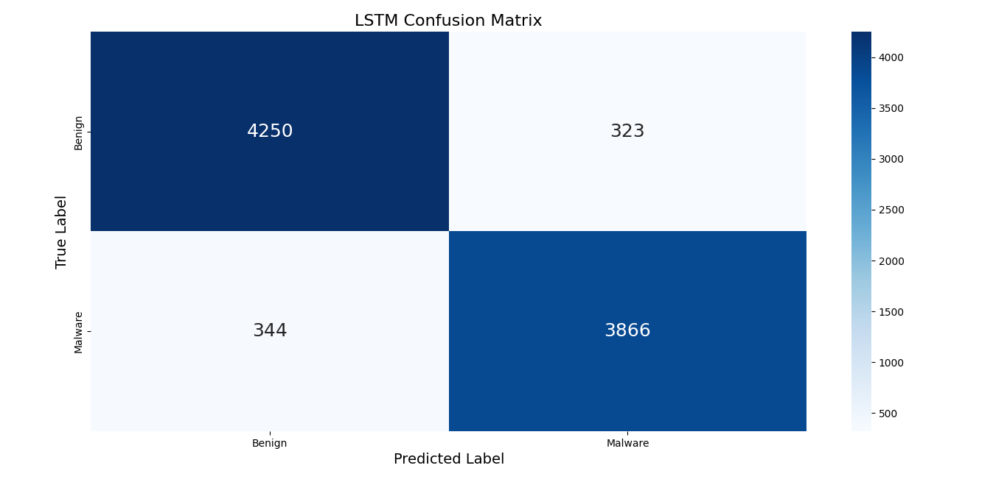
Figure 2. Confusion matrix of the LSTM model.
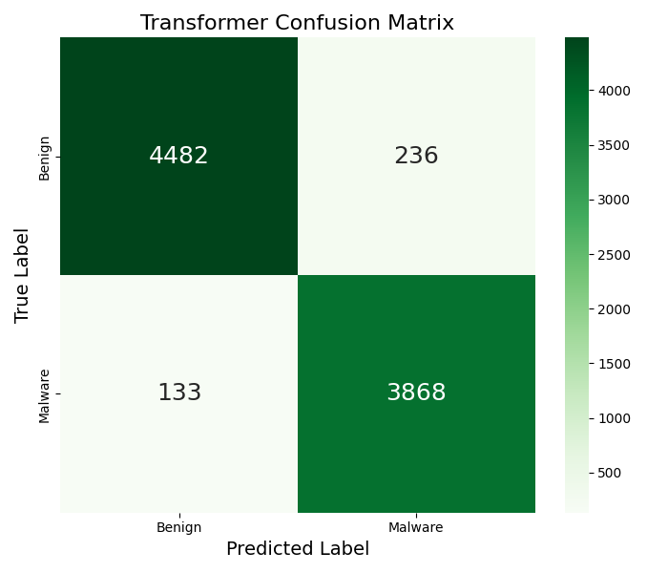
Figure 3. Confusion matrix of the Transformer model.
The Transformer outperformed the LSTM in both classes. Notably, it achieved a significantly higher malware recall (0.97) compared to the LSTM (0.92), substantially reducing false negatives. This improvement is particularly valuable in security contexts where identifying malicious activities is critical. Additionally, the high precision for benign samples (0.97) demonstrates a low false-positive rate, which is essential for effective real-world deployment.
5.3. Family-Wise Classification Insights
Confusion matrix analysis was employed to identify unique classification behavior patterns. The Transformer model demonstrated clear differentiation between categories, although it showed some confusion between Ransomware and Spyware behaviors, particularly in early API call patterns. In contrast, due to overlapping network-related API patterns, the LSTM frequently misclassified Adware as Downloader [19]. The Transformer's multi-head attention mechanism enabled it to discern subtle temporal and contextual variations, leading to more accurate family identification.
5.4. Computational and Training Efficiency
Despite having significantly more parameters (6,193,858 vs. 712,738), the Transformer model converged approximately 15-20\% faster in terms of training epochs compared to the LSTM. The parallel self-attention mechanism reduces sequential processing bottlenecks, contributing to this efficiency gain. For scalable malware analysis, both computational resources and training time are critical considerations. The Transformer architecture achieves a favorable balance between speed and model complexity.
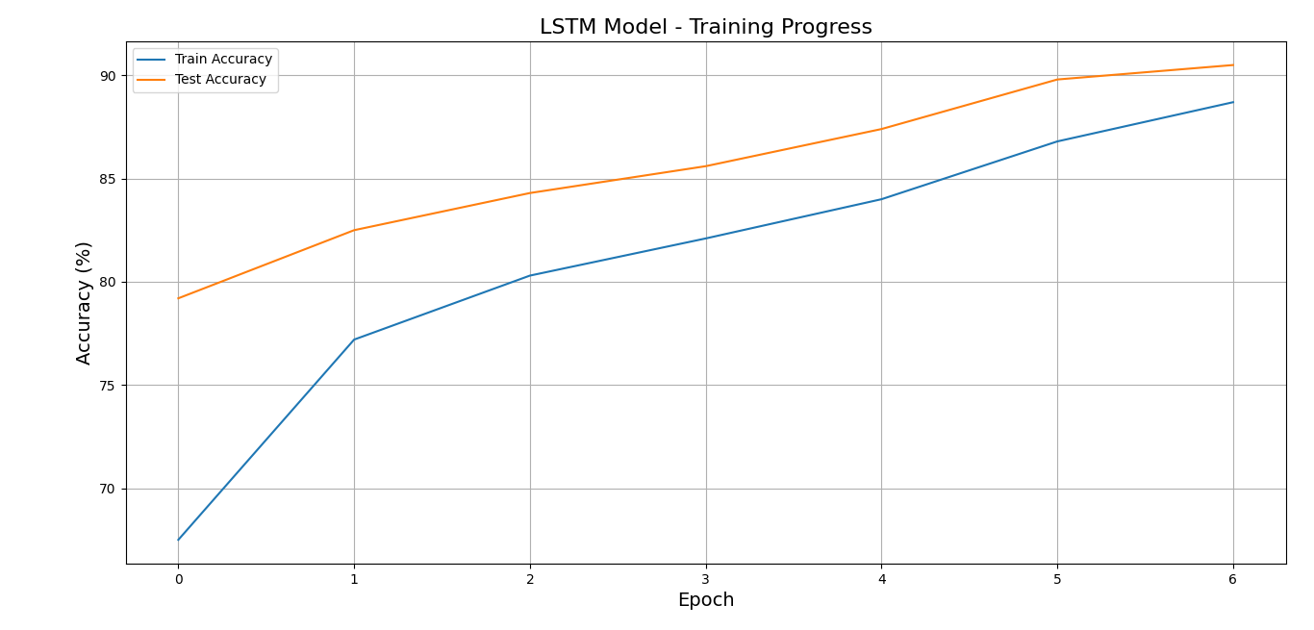
Figure 4. Training Progress over Epochs of LSTM Model
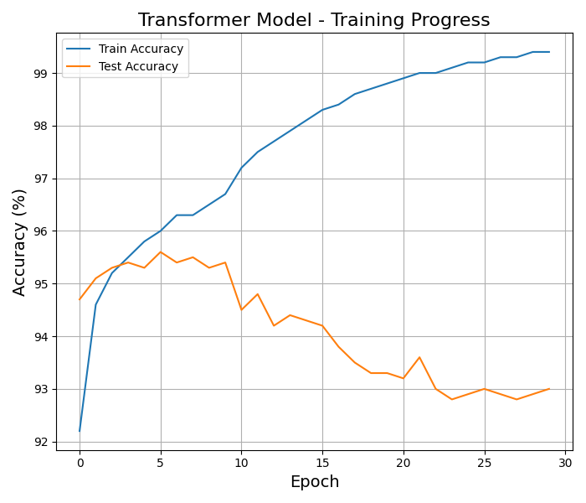
Figure 5. Training Progress over Epochs of Transformer Model
6. Summary of Key Findings
- The Transformer model outperformed the LSTM model, achieving better scores on all the measures and containing an absolute accuracy improvement of 4.96\%.
- Long-range dependencies present in API call sequences were recorded successfully using the self-attention technique which is important for the identification of modern polymorphic and evasive malware.
- The optimization is strong and generalization are shown by the convergence and the improved stability in the training shown by the Transformer.
- The Transformer’s balanced efficiency was validated by analysis per class which automatically showed better accuracy for the benign samples as well as recall for malware.
- Due to parallel processing, the Transformer while having a greater parametric complexity, trained well which made it ideal for widespread use.
These findings underline the potential of Transformer-based architectures as cutting-edge approaches to the classification of behavioural malware mostly in the instances where it is essential for high accuracy and robustness for change.
7. Discussion
The experimental findings show that with a 4.96\% greater accuracy (95.5\% vs. 90.58\%), Transformer based architectures perform significantly better than the LSTMs for categorizing malware into it’s families using API call sequences. This improved addition demonstrated the limitations of the recurrent architectures in detecting long-range behavioural dependencies in the execution traces of malware and is very consistent with the improvements and developments of the NLP-based sequence modelling.
7.1. Advancements Over Prior Sequential Models
Bag-of-words and n-gram models on the API requests were primarily used in the earlier work by Kolter and Maloof (2006) which was overlooked temporal order which led to poor results of classification. LSTMs were used to define the sequential dependencies in the research by Pascanu et al. (2015) but the models constantly suffered from the disappearing gradients that appeared in lengthy sequences and was a constraint in the LSTM baseline, especially for traces that had more than 200 calls.
The self-attention mechanism of the Transformer allows API call sequences to interact with one another directly irrespective of the distance. This enables model to identify the relations between malicious activities (like CryptEncrypt) and the initial reconnaissance calls (RegOpenKey) and they are mostly separated by hundreds of intermediary processes. The enhanced architecture explains the Transformer model which has faster convergence and the consistent training behaviour while adding to it’s increased accuracy.
7.2. Interpretability and Behavioral Alignment
The inherent interpretability of the proposed framework is one of the advantages. Based on the attention maps, [21] the model constantly focusing on the highly sensitive API requests which are detected as identifying malicious intent, such as:
- CreateRemoteThread and VirtualAlloc : code injection,
- RegSetValue : persistence,
- HttpSendRequest : data exfiltration.
For example, the Ransomware samples were concentrated significantly on file encryption and the deletion calls, while spyware sequences emphasized on the network connection APIs and memory-reading. The correspondence between trained attention and the expert-known behaviours enhances the trust in the decisions of the models and useful insights to the malware analysts.
7.3. Practical Implications for Cybersecurity
The Transformer’s performance suggests strong generalization across malware families, making it suitable for integration into automated sandbox analysis pipelines. The paradigm is naturally resistant to the process of obfuscation and polymorphism because it focuses on the behavioural semantics above syntactic patterns in comparison to the signature-based approaches. Futhermore, the adaptation and repeatability to the various new datasets are made sure by the structured preparation pipeline which easily handles the OOV tokens and standardizes the length of sequence and normalizes API calls.
7.4. Limitations and Future Directions
Although it has it’s advantages, the study has it’s drawbacks. Despite the diversity of the dataset, it might not accurately represent the new dangers like IoT attacks or fileless malware [6]. This approach needs to be evaluated on bigger and platform datasets in the future. Moreover, although the is excellent accuracy by the Transformer mode;, the rest of the parameter count needs further processing. This trade-off might necessarily impact the real-time execution with resource-constrained environments.
Further research could explore:
Hybrid models that have a combination of depictions that are graph-based of the interactions of systems with the attention along with the testing for adversarial robustness which is against the deception of the API sequences being altered and having a detailed categorization at campaign or variant level.
8. Conclusion
The study demonstrates the Transformer topologies where there was inspiration from developments in the Natural Language Processing (NLP) [15] and to offer reliable and descriptive techniques for behavioural malware classification. The Transformer showed that it has the advantage of identifying modern and obscure threats by outperforming the LSTM model with an accuracy of 95.54\%. [16] The methodology that was suggested bridges a visible gap between the realistic cybersecurity requirements and the data modelling that is sequential by precisely and effectively detecting current threats and that is by [20] modelling of long-range relationships in API call sequences.
Author Contributions: Conceptualization, A.K.J. and N.D.P.; methodology, A.K.J.; software, A.K.J.; validation, A.K.J., N.D.P. and D.S.; formal analysis, A.K.J.; investigation, A.K.J.; resources, N.D.P., D.S. and A.P.; data curation, A.K.J.; writing---original draft preparation, A.K.J.; writing---review and editing, N.D.P., D.S. and A.P.; visualization, A.K.J.; supervision, N.D.P., D.S. and A.P.; project administration, N.D.P.; funding acquisition, A.P. All authors have read and agreed to the published version of the manuscript.
Funding: This research received no external funding.
Data Availability Statement: The data presented in this study are openly available in the "Malware Analysis Datasets: API Call Sequences" repository on Kaggle at \url{https://www.kaggle.com/datasets/ang3loliveira/malware-analysis-datasets-api-call-sequences}, reference number [1].
Acknowledgments: The authors would like to thank the School of Computer Science and Artificial Intelligence at VIT Bhopal University for providing the resources and support necessary to conduct this research.During the preparation of this manuscript, the author(s) used an AI language tool for assistance with grammar and sentence structure editing. The authors have reviewed and edited the output and take full responsibility for the content of this publication.
Conflicts of Interest: The authors declare no conflict of interest.
References
[1] Lu, Ming & Williamson, Drew & Chen, Tiffany & Chen, Richard & Barbieri, Matteo & Mahmood, Faisal. (2021). Data-efficient and weakly supervised computational pathology on whole-slide images. Nature Biomedical Engineering. 5. 1-16. 10.1038/s41551-020-00682-w.
[2] Shao, Zhuchen & Bian, Hao & Chen, Yang & Wang, Yifeng & Zhang, Jian & Ji, Xiangyang & Zhang, Yongbing. (2021). TransMIL: Transformer based Correlated Multiple Instance Learning for Whole Slide Image Classication. 10.48550/arXiv.2106.00908.
[3] Ilse, Maximilian & Tomczak, Jakub & Welling, Max. (2018). Attention-based Deep Multiple Instance Learning. 10.48550/arXiv.1802.04712.
[4] Chen RJ, Ding T, Lu MY, Williamson DFK, Jaume G, Song AH, Chen B, Zhang A, Shao D, Shaban M, Williams M, Oldenburg L, Weishaupt LL, Wang JJ, Vaidya A, Le LP, Gerber G, Sahai S, Williams W, Mahmood F. Towards a general-purpose foundation model for computational pathology. Nat Med. 2024 Mar;30(3):850-862. doi: 10.1038/s41591-024-02857-3. Epub 2024 Mar 19. PMID: 38504018; PMCID: PMC11403354.
[5] Vorontsov, Eugene & Bozkurt, Alican & Casson, Adam & Shaikovski, George & Zelechowski, Michal & Severson, Kristen & Zimmermann, Eric & Hall, James & Tenenholtz, Neil & Fusi, Nicolo & Yang, Ellen & Mathieu, Philippe & Eck, Alexander & Lee, Donghun & Viret, Julian & Robert, Eric & Wang, Yi & Kunz, Jeremy & Lee, Matthew & Fuchs, Thomas. (2024). A foundation model for clinical-grade computational pathology and rare cancers detection. Nature Medicine. 30. 2924-2935. 10.1038/s41591-024-03141-0.
[6] Xu H, Usuyama N, Bagga J, Zhang S, Rao R, Naumann T, Wong C, Gero Z, González J, Gu Y, Xu Y, Wei M, Wang W, Ma S, Wei F, Yang J, Li C, Gao J, Rosemon J, Bower T, Lee S, Weerasinghe R, Wright BJ, Robicsek A, Piening B, Bifulco C, Wang S, Poon H. A whole-slide foundation model for digital pathology from real-world data. Nature. 2024 Jun;630(8015):181-188. doi: 10.1038/s41586-024-07441-w. Epub 2024 May 22. PMID: 38778098; PMCID: PMC11153137.
[7] Campanella, Gabriele & Hanna, Matthew & Geneslaw, Luke & Miraflor, Allen & Silva, Vitor & Busam, Klaus & Brogi, Edi & Reuter, Victor & Klimstra, David & Fuchs, Thomas. (2019). Clinical-grade computational pathology using weakly supervised deep learning on whole slide images. Nature Medicine. 25. 1. 10.1038/s41591-019-0508-1.
[8] Li, Dong & Wan, Guihong & Wu, Xintao & Wu, Xinyu & Nirmal, Ajit & Lian, Christine & Sorger, Peter & Semenov, Yevgeniy & Zhao, Chen. (2025). A Survey on Computational Pathology Foundation Models: Datasets, Adaptation Strategies, and Evaluation Tasks. 10.48550/arXiv.2501.15724.
[9] Gevaert, Olivier & Bareja, Rohan & Carrillo-Perez, Francisco & Zheng, Yuanning & Pizurica, Marija & Nandi, Tarak & Shen, Jeanne & Madduri, Ravi. (2025). Evaluating Vision and Pathology Foundation Models for Computational Pathology: A Comprehensive Benchmark Study. Research square. 10.21203/rs.3.rs-6823810/v1.
[10] Jong, Edwin & Marcus, Eric & Teuwen, Jonas. (2025). Current Pathology Foundation Models are unrobust to Medical Center Differences. 10.48550/arXiv.2501.18055.
[11] Tizhoosh, Hamid. (2025). Why Foundation Models in Pathology Are Failing. 10.48550/arXiv.2510.23807.
[12] Shao, Zhuchen & Chen, Yang & Bian, Hao & Zhang, Jian & Liu, Guojun & Zhang, Yongbing. (2023). HVTSurv: Hierarchical Vision Transformer for Patient-Level Survival Prediction from Whole Slide Image. Proceedings of the AAAI Conference on Artificial Intelligence. 37. 2209-2217. 10.1609/aaai.v37i2.25315.
[13] Kather JN, Pearson AT, Halama N, Jäger D, Krause J, Loosen SH, Marx A, Boor P, Tacke F, Neumann UP, Grabsch HI, Yoshikawa T, Brenner H, Chang-Claude J, Hoffmeister M, Trautwein C, Luedde T. Deep learning can predict microsatellite instability directly from histology in gastrointestinal cancer. Nat Med. 2019 Jul;25(7):1054-1056. doi: 10.1038/s41591-019-0462-y. Epub 2019 Jun 3. PMID: 31160815; PMCID: PMC7423299.
[14] Lu MY, Chen B, Williamson DFK, Chen RJ, Liang I, Ding T, Jaume G, Odintsov I, Le LP, Gerber G, Parwani AV, Zhang A, Mahmood F. A visual-language foundation model for computational pathology. Nat Med. 2024 Mar;30(3):863-874. doi: 10.1038/s41591-024-02856-4. Epub 2024 Mar 19. PMID: 38504017; PMCID: PMC11384335.
[15] Mao J, Xu J, Tang X, Liu Y, Zhao H, Tian G, Yang J. CAMIL: channel attention-based multiple instance learning for whole slide image classification. Bioinformatics. 2025 Feb 4;41(2):btaf024. doi: 10.1093/bioinformatics/btaf024. PMID: 39820310; PMCID: PMC11802473.
[16] Tang, Wenhao & Fang, Heng & Wu, Ge & Li, Xiang. (2025). Revisiting Data Challenges of Computational Pathology: A Pack-based Multiple Instance Learning Framework. 10.48550/arXiv.2509.20923.
[17] Srinidhi CL, Ciga O, Martel AL. Deep neural network models for computational histopathology: A survey. Med Image Anal. 2021 Jan;67:101813. doi: 10.1016/j.media.2020.101813. Epub 2020 Sep 25. PMID: 33049577; PMCID: PMC7725956.
[18] Li, Bin & Li, Yin & Eliceiri, Kevin. (2021). Dual-stream Multiple Instance Learning Network for Whole Slide Image Classification with Self-supervised Contrastive Learning. 2021. 14313-14323. 10.1109/CVPR46437.2021.01409.
[19] Thandiackal, Kevin & Chen, Boqi & Pati, Pushpak & Jaume, Guillaume & Williamson, Drew & Gabrani, Maria & Goksel, Orcun. (2022). Differentiable Zooming for Multiple Instance Learning on Whole-Slide Images. 10.1007/978-3-031-19803-8_41.
[20] Javed, Syed & Juyal, Dinkar & Padigela, Harshith & Taylor-Weiner, Amaro & Yu, Limin & Prakash, Aaditya. (2022). Additive MIL: Intrinsic Interpretability for Pathology. 10.48550/arXiv.2206.01794.
[21] Ding, Tong & Wagner, Sophia & Song, Andrew & Chen, Richard & Lu, Ming & Zhang, Andrew & Vaidya, Anurag & Jaume, Guillaume & Shaban, Muhammad & Kim, Ahrong & Williamson, Drew & Chen, Bowen & Almagro-Perez, Cristina & Doucet, Paul & Sahai, Sharifa & Chen, Chengkuan & Komura, Daisuke & Kawabe, Akihiro & Ishikawa, Shumpei & Mahmood, Faisal. (2024). Multimodal Whole Slide Foundation Model for Pathology. 10.48550/arXiv.2411.19666.
[22] Vaswani, Ashish & Shazeer, Noam & Parmar, Niki & Uszkoreit, Jakob & Jones, Llion & Gomez, Aidan & Kaiser, Lukasz & Polosukhin, Illia. (2017). Attention Is All You Need. 10.48550/arXiv.1706.03762.
[23] Chen, Richard & Chen, Chengkuan & Li, Yicong & Chen, Tiffany & Trister, Andrew & Krishnan, Rahul & Mahmood, Faisal. (2022). Scaling Vision Transformers to Gigapixel Images via Hierarchical Self-Supervised Learning. 10.48550/arXiv.2206.02647.
[24] Harrell FE Jr, Lee KL, Mark DB. Multivariable prognostic models: issues in developing models, evaluating assumptions and adequacy, and measuring and reducing errors. Stat Med. 1996 Feb 28;15(4):361-87. doi: 10.1002/(SICI)1097-0258(19960229)15:4<361::AID-SIM168>3.0.CO;2-4. PMID: 8668867.
[25] DeLong ER, DeLong DM, Clarke-Pearson DL. Comparing the areas under two or more correlated receiver operating characteristic curves: a nonparametric approach. Biometrics. 1988 Sep;44(3):837-45. PMID: 3203132.
[26] Liu J, Lichtenberg T, Hoadley KA, Poisson LM, Lazar AJ, Cherniack AD, Kovatich AJ, Benz CC, Levine DA, Lee AV, Omberg L, Wolf DM, Shriver CD, Thorsson V; Cancer Genome Atlas Research Network; Hu H. An Integrated TCGA Pan-Cancer Clinical Data Resource to Drive High-Quality Survival Outcome Analytics. Cell. 2018 Apr 5;173(2):400-416.e11. doi: 10.1016/j.cell.2018.02.052. PMID: 29625055; PMCID: PMC6066282.

