**SENTIMENT ANALYSIS ON AMAZON REVIEWS**

**AIM** : To train a ML model so as to predict the sentiment polarity for test data (every 5th element of given dataset of 400,000 Amazon reviews)

**MACHINE LEARNING CLASSIFIERS**

**So why SVM?**

Minimal requirement of a set of core points(i.e. the support vectors) so as to set the hyperplane as compared to Regression

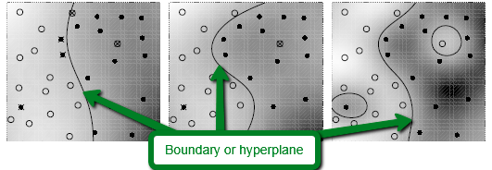

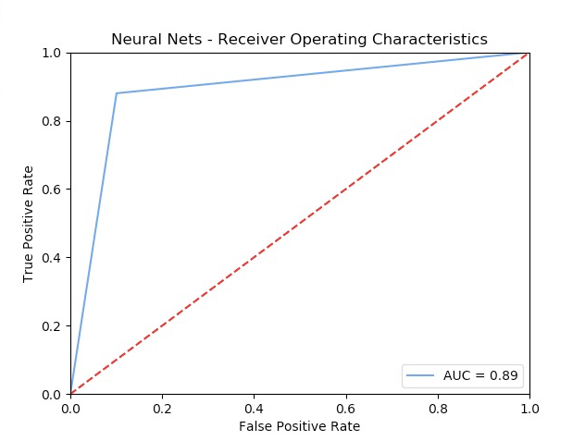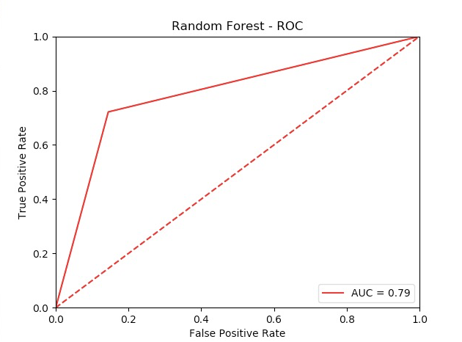

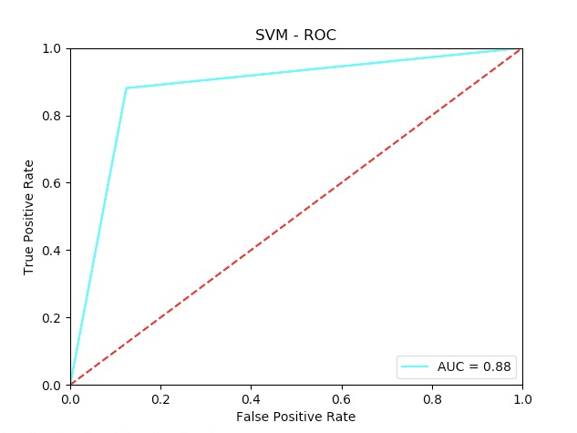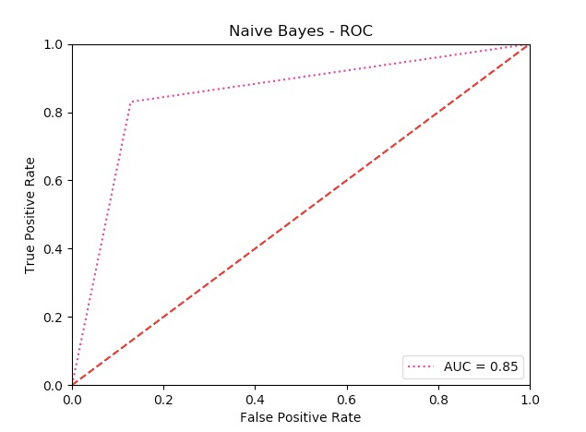

**Classifier Results’ Visualizations**

