**5. PUBLIC TRANSPORT OPTIMIZATION**

**PROGRAM:**

1. **DIAGRAM**

{

  "version": 1,

  "author": "SACS",

  "editor": "wokwi",

  "parts": [

    { "type": "wokwi-esp32-devkit-v1", "id": "esp", "top": -12.8, "left": 180.8, "attrs": {} },

    {

      "type": "wokwi-hc-sr04",

      "id": "ultrasonic1",

      "top": -31.94,

      "left": -1.1,

      "attrs": { "distance": "240" }

    },

    {

      "type": "wokwi-hc-sr04",

      "id": "ultrasonic2",

      "top": -32.14,

      "left": -184.37,

      "attrs": { "distance": "104" }

    },

    {

      "type": "wokwi-led",

      "id": "led1",

      "top": 196.6,

      "left": 95.24,

      "attrs": { "color": "red" }

    }

  ],

  "connections": [

    [ "esp:TX0", "$serialMonitor:RX", "", [] ],

    [ "esp:RX0", "$serialMonitor:TX", "", [] ],

    [ "ultrasonic1:VCC", "esp:VIN", "red", [ "v0" ] ],

    [ "ultrasonic1:GND", "esp:GND.2", "black", [ "v0" ] ],

    [ "ultrasonic1:TRIG", "esp:D13", "green", [ "v0" ] ],

    [ "ultrasonic1:ECHO", "esp:D12", "green", [ "v0" ] ],

    [ "ultrasonic2:GND", "esp:GND.2", "black", [ "v93.61", "h255.99", "v-19.13", "h1.42" ] ],

    [ "ultrasonic2:VCC", "esp:VIN", "red", [ "v111.32", "h288.11", "v-26.93" ] ],

    [ "ultrasonic2:ECHO", "esp:D14", "green", [ "v97.15", "h262.44", "v-53.14" ] ],

    [ "ultrasonic2:TRIG", "esp:D15", "green", [ "v102.11", "h397.16", "v-36.14" ] ],

    [ "led1:C", "esp:GND.1", "black", [ "v7.36", "h195.18", "v-106.29" ] ],

    [ "led1:A", "esp:D22", "green", [ "v0.98", "h178.81", "v-149.51" ] ]

  ],

  "dependencies": {}

}

1. **SKETCH**

#define BLYNK_TEMPLATE_ID "TMPL26V4fGv5q"

#define BLYNK_TEMPLATE_NAME "Test"

#define BLYNK_AUTH_TOKEN "XEHxNF_Ur1Nt2p7wB5B20dNI1ZUwj34P"

#include <WiFi.h>

#include <WiFiClient.h>

#include <BlynkSimpleEsp32.h>

int duration1 = 0;

int distance1 = 0;

int duration2 = 0;

int distance2 = 0;

int dis1 = 0;

int dis2 = 0;

int dis_new1 = 0;

int dis_new2 = 0;

int entered = 0;

int left = 0;

int inside = 0;

#define LED 2

#define PIN_TRIG1 15

#define PIN_ECHO1 14

#define PIN_TRIG2 13

#define PIN_ECHO2 12

BlynkTimer timer;

char auth[] = BLYNK_AUTH_TOKEN;

char ssid[] = "Wokwi-GUEST";   // your network SSID (name)

char pass[] = "";

#define BLYNK_PRINT **Serial**

long get_distance1() {

  // Start a new measurement:

  digitalWrite(PIN_TRIG1, HIGH);

  delayMicroseconds(10);

  digitalWrite(PIN_TRIG1, LOW);

  // Read the result:

  duration1 = pulseIn(PIN_ECHO1, HIGH);

  distance1 = duration1 / 58;

  return distance1;

}

long get_distance2() {

  // Start a new measurement:

  digitalWrite(PIN_TRIG2, HIGH);

  delayMicroseconds(10);

  digitalWrite(PIN_TRIG2, LOW);

  // Read the result:

  duration2 = pulseIn(PIN_ECHO2, HIGH);

  distance2 = duration2 / 58;

  return distance2;

}

void myTimer() {

**Serial**.println("100");

  dis_new1 = get_distance1();

  dis_new2 = get_distance2();

  if (dis1 != dis_new1 || dis2 != dis_new2){

**Serial**.println("200");

    if (dis1 < dis2){

**Serial**.println("Enter loop");

      entered = entered + 1;

      inside = inside + 1;

      digitalWrite(LED, HIGH);

      Blynk.virtualWrite(V0, entered);

      Blynk.virtualWrite(V2, inside);

      dis1 = dis_new1;

      delay(1000);

      digitalWrite(LED, LOW);

    }

    if (dis1 > dis2){

**Serial**.println("Leave loop");

      left = left + 1;

      inside = inside - 1;

      Blynk.virtualWrite(V1, left);

      Blynk.virtualWrite(V2, inside);

      dis2 = dis_new2;

      delay(1000);

    }

  }

}

 void setup() {

**Serial**.begin(115200);

  pinMode(LED, OUTPUT);

  pinMode(PIN_TRIG1, OUTPUT);

  pinMode(PIN_ECHO1, INPUT);

  pinMode(PIN_TRIG2, OUTPUT);

  pinMode(PIN_ECHO2, INPUT);

  Blynk.begin(auth, ssid, pass, "blynk.cloud", 8080);

  timer.setInterval(1000L, myTimer);

}

void loop() {

  Blynk.run();

  timer.run();

}

**STIMULATOR:**

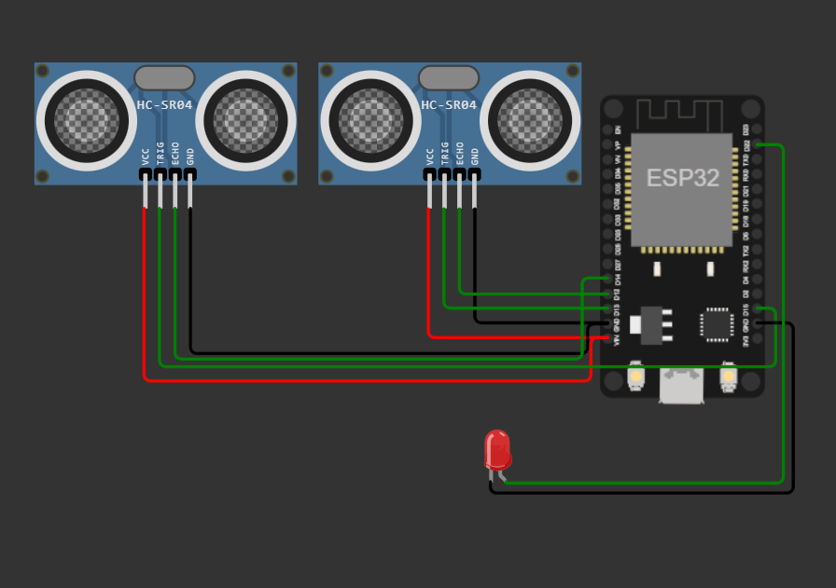

**STIMULATOR OUTPUT:**

load:0x3fff0030,len:1156

load:0x40078000,len:11456

ho 0 tail 12 room 4

load:0x40080400,len:2972

entry 0x400805dc

100

200

100

200

**OUTPUT IN WEBPAGE:**

