**LAB EXERCISE -1**

**Deva Vignan M**

**CH.EN.U4CSE22134**

**CSE-B**

**Aim:** To write program to count the number of characters, words, spaces, end of lines in a given input file.

**CODE:**

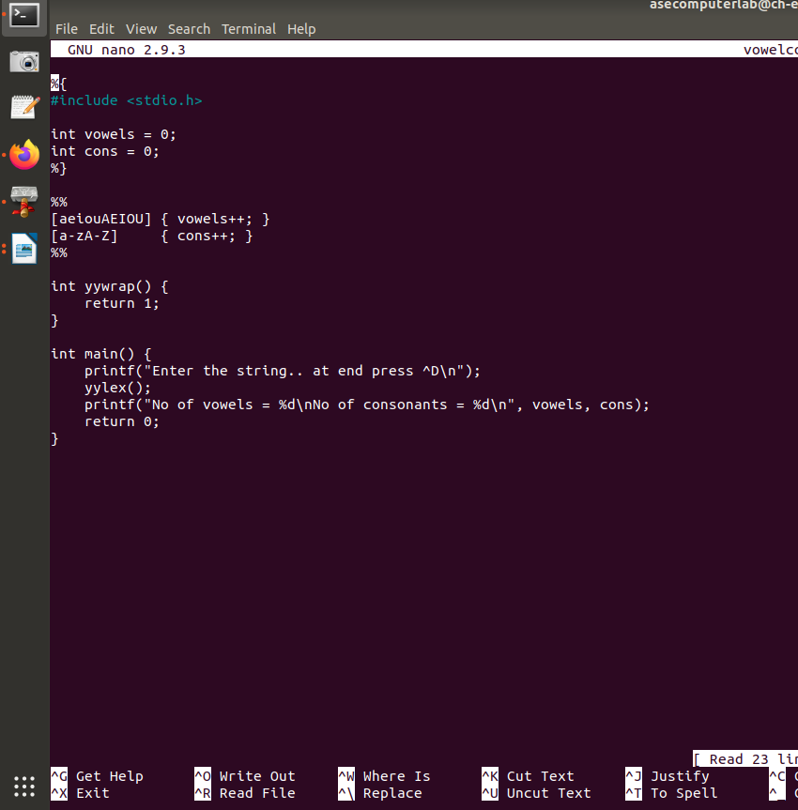

**Output:**

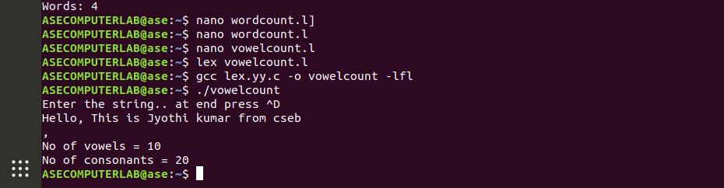

**2.Aim:**

Program to count the number of characters, words, spaces, end of lines in a given input file

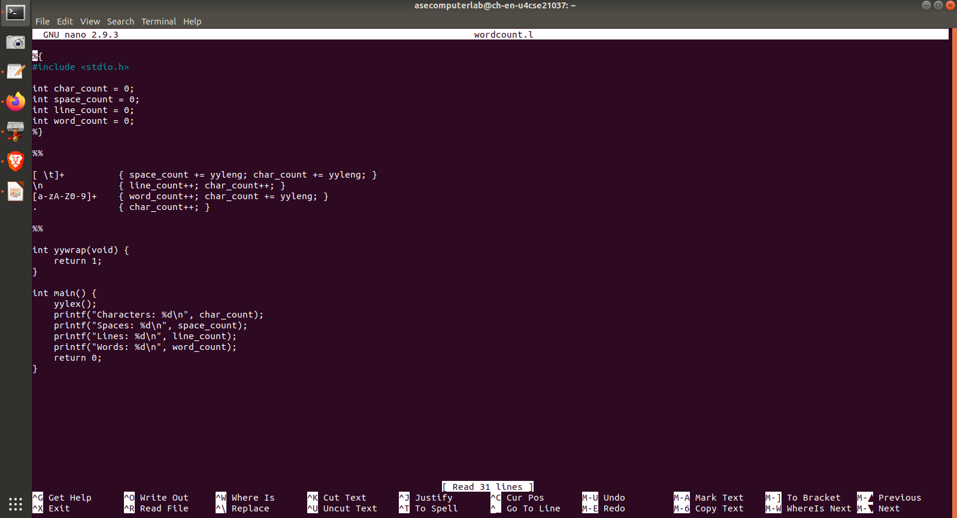**Code:**

**Output:**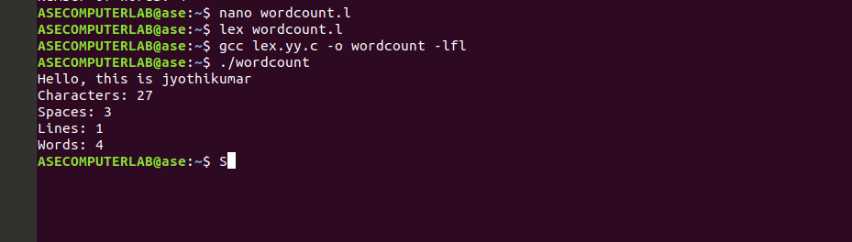

3**.Aim**: To write program to count no of: a) +ve and –ve integers b) +ve and –ve fractions

**Code:**

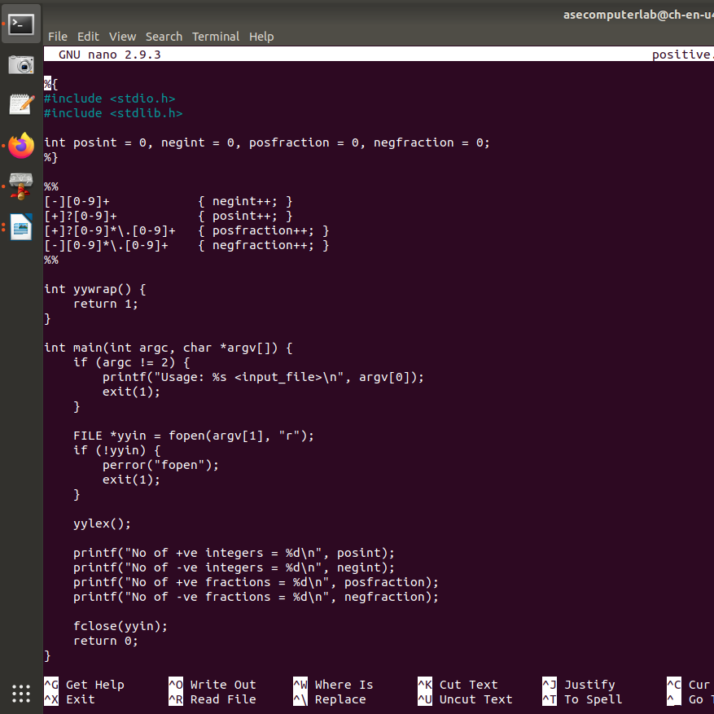

**Output:**

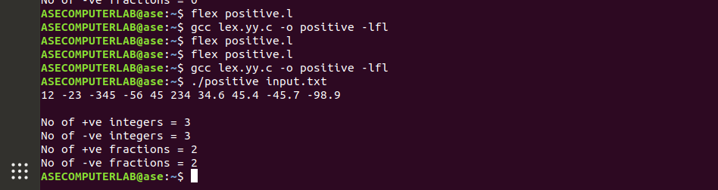

Result: The program successfully counts characters, words, spaces, lines, and distinguishes between positive/negative integers and fractions from the input file.  
All tasks executed correctly with accurate outputs based on the file content.