Polynomial Regression Report — Var 1
Student: Devaang Rastogi
Approach
For Var 1, I modeled the target variable y using polynomial regression with Elastic Net regularization. The six input features (x1 through x6) were expanded into polynomial features, and the resulting features were standardized before fitting the model.
Model selection
I evaluated polynomial degrees from 1 to 10. For each degree, I performed a grid search over L1 regularization strengths (lambda1) and L2 regularization strengths (lambda2), using the values 0, 4, 8, 12, 16, and 20 for each. Model selection used 5-fold cross-validation with shuffling and random_state=42. Within each fold, polynomial feature expansion and standardization were fitted only on the training split, then applied to the validation split to avoid information leakage.
The best configuration found for Var 1 was:
- Polynomial degree: 5
- Lambda1: 16.0
- Lambda2: 0.0
- 5-fold CV RMSE: 0.5633040143
Rationale
The degree-5 model achieved the lowest cross-validation RMSE among the configurations evaluated in the search. The degree and regularization parameters were selected based on validation performance rather than training error alone. The selected lambda2 value of zero means that the best configuration used L1 regularization without an L2 penalty in the tested grid. The positive lambda1 value applies an L1 penalty, which encourages a sparse coefficient vector.
Optimization and implementation
The model was fitted using FISTA (Fast Iterative Shrinkage-Thresholding Algorithm), implemented with PyTorch on a CUDA GPU. The smooth part of the objective included the squared-error loss and the L2 penalty; the L1 penalty was handled through the soft-thresholding proximal step. The intercept was handled separately by centering the training features and target, then recovering the intercept after optimization.
Final model and outputs
After selecting the hyperparameters, I refitted the degree-5 model on the full Var 1 training set using the selected regularization strengths. Polynomial expansion and standardization were fitted on the full training data for this final model. The final model, along with its polynomial transformer, scaler, selected hyperparameters, training RMSE, and training R², was saved in `polynomial_model_var1.pkl`. The script also generated a coefficient table (`polynomial_coefficients_var1.csv`), a hyperparameter comparison table (`var1_elasticnet_comparison.csv`), a regularization heatmap, and a plot comparing training and cross-validation MSE across polynomial degrees.

The reported CV RMSE is the model-selection estimate from 5-fold cross-validation. It is distinct from the training RMSE and training R² calculated after refitting on the complete training set.
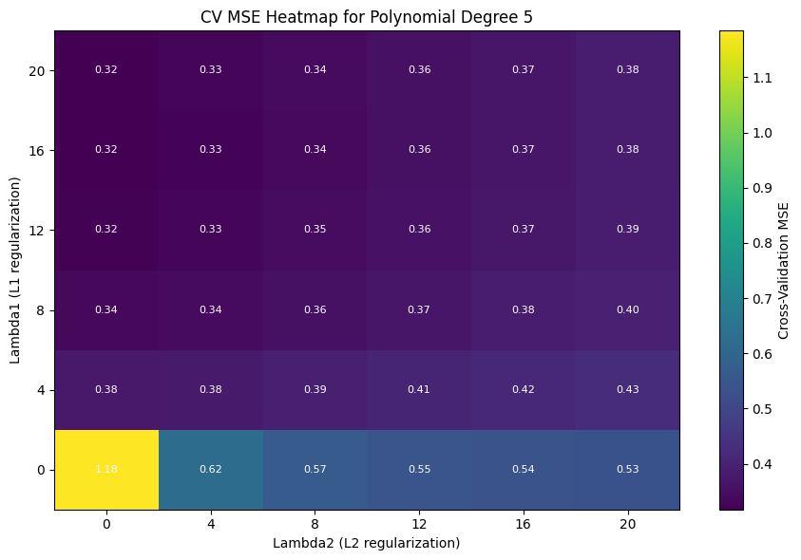

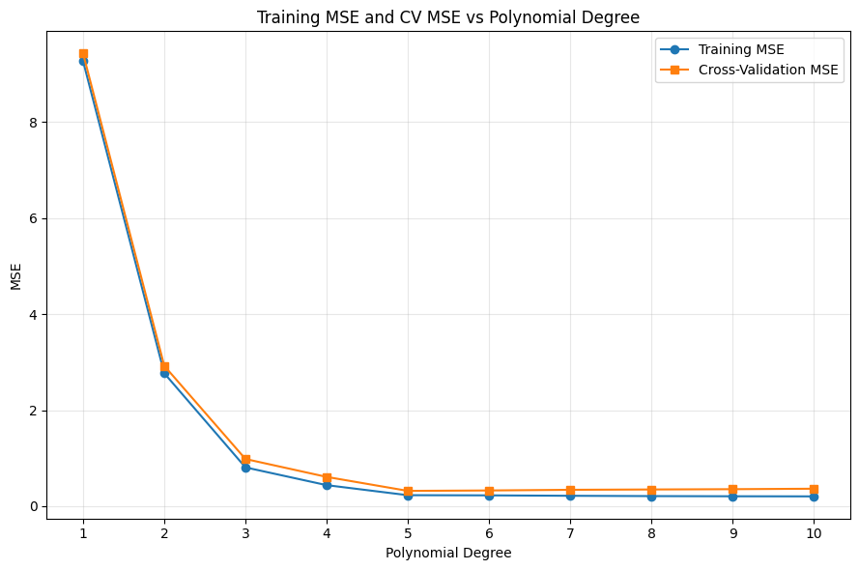
Polynomial Regression with Elastic Net — Var 2
Model Selection, Optimization, and Final Performance
Objective and Approach
The Var 2 dataset was modeled using polynomial regression with Elastic Net regularization. The predictors were x1, x2, and x3, and the response variable was y. PolynomialFeatures was used to generate polynomial terms without adding a constant bias column. The resulting features were standardized before fitting.
Model selection used shuffled 5-fold cross-validation with random_state=42. Polynomial degrees 1 through 20 were tested, along with lambda1 values {0.1, 0.15, 0.2, 0.25, 0.3, 0.4, 0.5} and lambda2 values {1.0, 1.25, 1.5, 1.75, 2.0, 2.5, 3.0}. Within each fold, the polynomial transformer and scaler were fitted using only the training partition, then applied to the validation partition. The selection metric was the square root of the mean fold MSE, reported as cross-validation RMSE.
Selected Configuration and Performance
Polynomial degree: 12
L1 regularization (lambda1): 0.25
L2 regularization (lambda2): 1.25
5-fold CV RMSE: 0.510412 (approximately 0.5104)
Final training RMSE: 0.419121 (approximately 0.4191)
Final training R-squared: 0.996784 (approximately 0.9968)
For degree 12, the lowest heatmap value occurs at lambda1=0.25 and lambda2=1.25. Several nearby settings give very similar errors, so the minimum is relatively shallow. This pair is the best among the tested grid combinations.
Rationale for Selecting Degree 12
The degree-versus-error plot shows a large decrease in training and cross-validation RMSE at lower polynomial degrees. The cross-validation curve then flattens around 0.5 from approximately degree 9 onward. Degree 12 achieves the lowest CV RMSE in the full search, so it was selected based on validation performance rather than training error alone. The training RMSE is lower than the CV RMSE, which is expected because the final model is fitted on all training observations.
Optimization and Final Fitting
Elastic Net was optimized using the Fast Iterative Shrinkage-Thresholding Algorithm (FISTA). The smooth part of the objective combines squared-error loss with the L2 penalty, while the proximal step applies soft-thresholding for the L1 penalty. The intercept was handled separately by centering the features and target, so it was not regularized.
The implementation used PyTorch operations on a CUDA GPU (Tesla T4). The spectral norm, Lipschitz constant, and step size were calculated once before the FISTA iteration loop for each model fit.
After selecting the hyperparameters, the polynomial transformer and scaler were refitted on the full Var 2 training set. The final model used degree 12, lambda1=0.25, and lambda2=1.25. Its training RMSE was 0.4191 and training R-squared was 0.9968, meaning it explains about 99.68% of the variation in the training targets. This is a training-set statistic, not an independent test-set score. The fitted transformations, weights, intercept, and selected hyperparameters were saved for subsequent prediction.
