PSV Orchestration Flow
Provider Screening & Verification | CVS Health | June 2026
────────────────────────────────────────────────────────────────────────────────
Executive Summary
The PSV Orchestration layer automates license-status verification for provider credentials across 188 state licensing boards. For each input row it (1) routes to the correct board(s), (2) executes up to 8 search strategies (the "ladder"), (3) disambiguates multi-record results, (4) retries using NPPES-derived alternate names when needed, and (5) falls back to an AI agent for hard cases. Every row exits through exactly one of four structured output channels. Evidence (screenshot + HTML) is captured per search attempt for audit.
End-to-End Flow Diagram
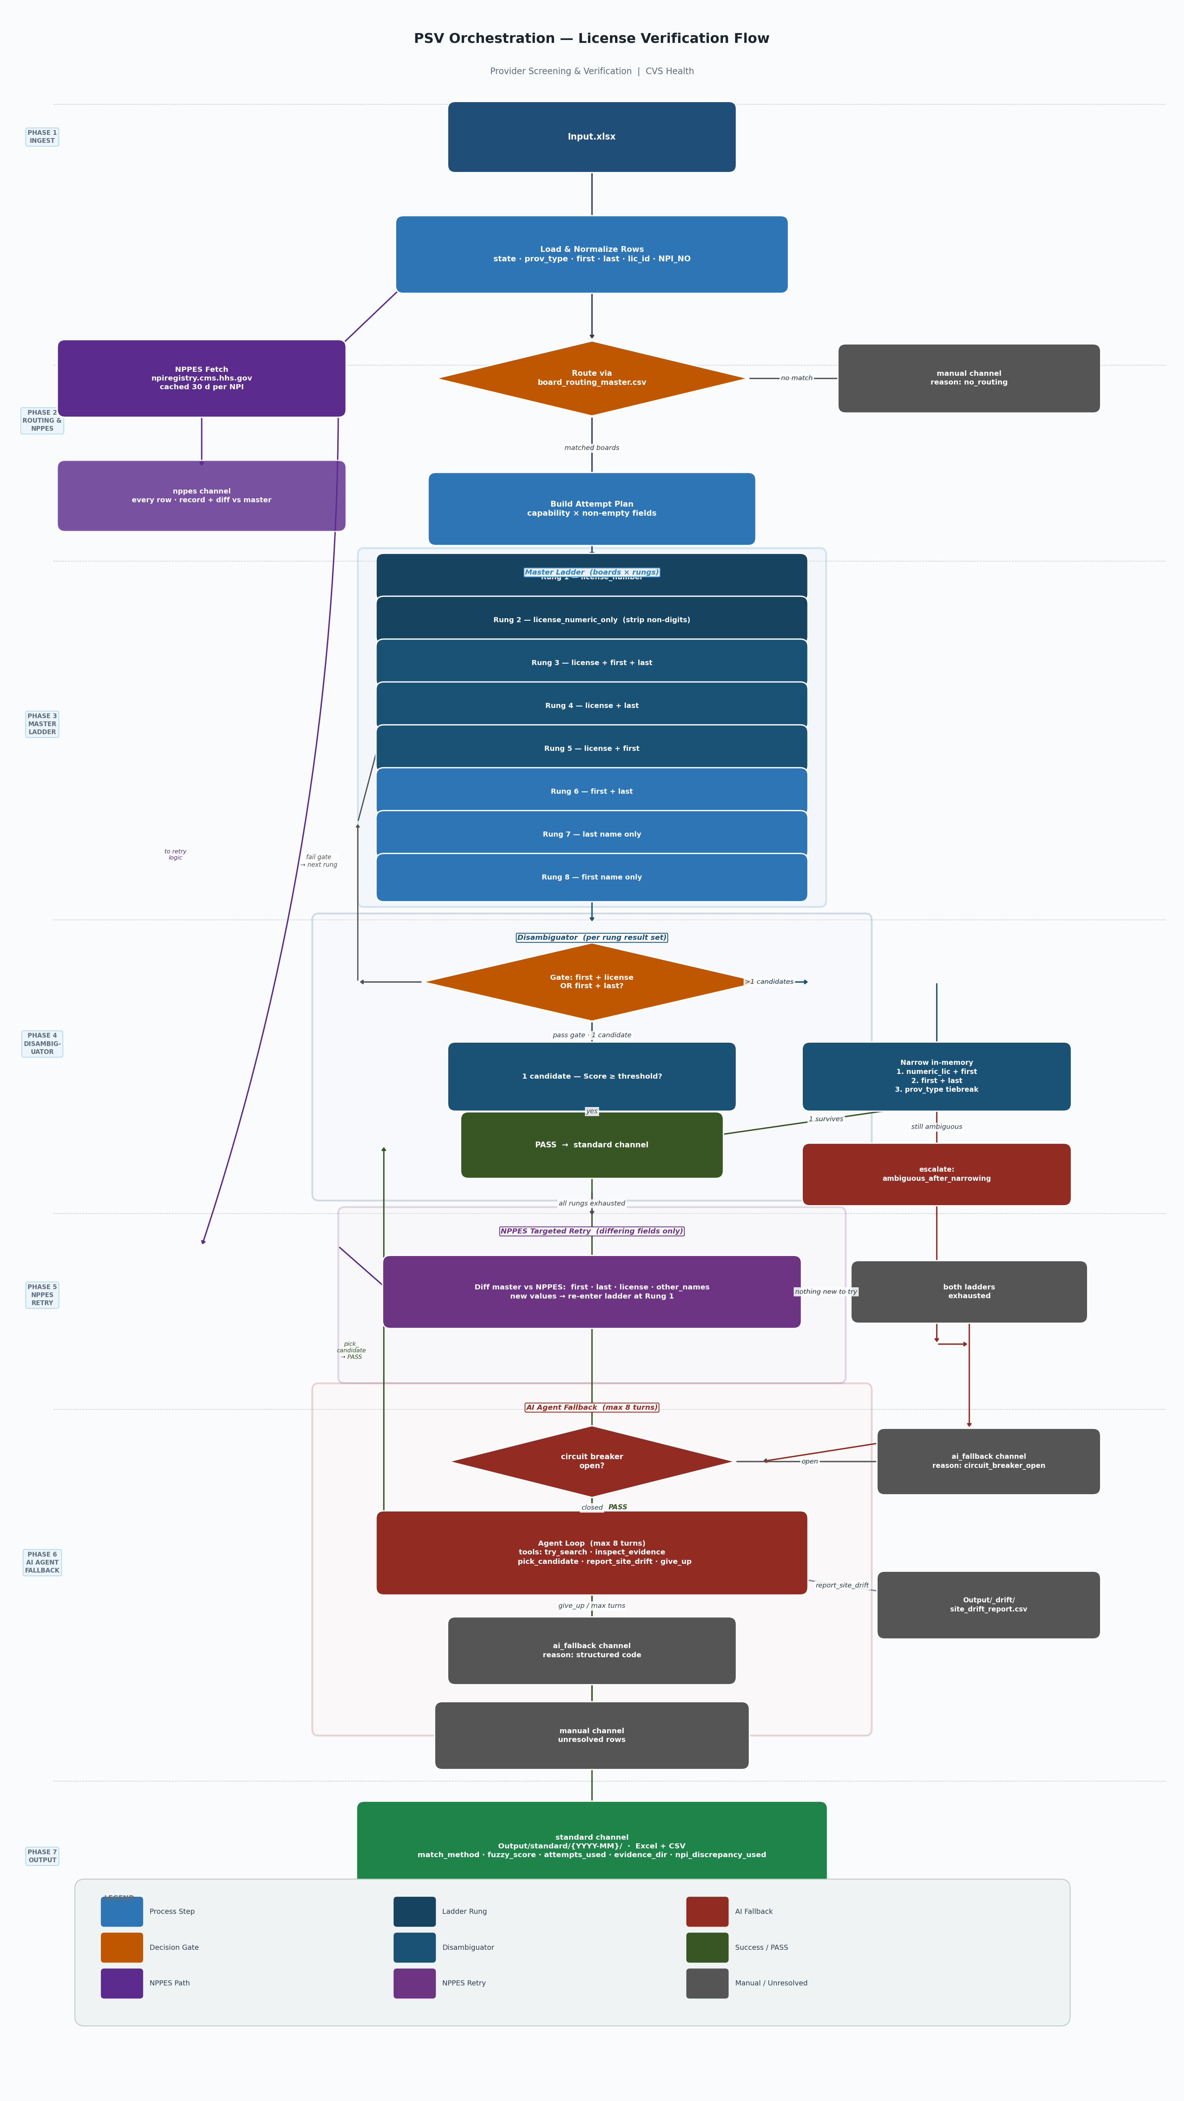
Figure 1 — PSV License Verification Orchestration Flow
Phase Descriptions
Phase 1 — Ingest
Input.xlsx is loaded and each row is normalized: state, provider type, first name, last name, license ID, and NPI number are extracted and standardized.
Phase 2 — Routing & NPPES Fetch
Two parallel tracks launch: (a) board_routing_master.csv maps (state, prov_type) to the set of applicable licensing boards; rows with no match exit immediately to the manual channel. (b) NPPES is queried for every row (cached 30 days per NPI) to obtain the official provider record for later cross-referencing.
Phase 3 — Master Ladder
For each matched board the engine attempts up to 8 search strategies in order of specificity — from exact license number down to first or last name alone. Each rung captures screenshot + HTML evidence. A deduplication signature (board, mode, normalized_query) prevents redundant searches.
Phase 4 — Disambiguator
Each rung's result set passes a gate (requires first + license OR first + last). A single passing candidate is scored; if the score meets threshold the row is committed as PASS. Multiple candidates are narrowed by numeric license, name match, and provider-type tiebreak. Persistent ambiguity escalates to the AI path.
Phase 5 — NPPES Targeted Retry
After all rungs are exhausted the engine diffs the master record against the NPPES record for alternate first/last names or license variants not yet tried. New values re-enter the ladder at Rung 1. If no new values exist the row proceeds to AI.
Phase 6 — AI Agent Fallback
An agentic loop (max 8 turns) drives a browser session guided by four tools: try_search, inspect_evidence, pick_candidate, report_site_drift, and give_up. The agent commits a result or records a structured failure reason. A circuit breaker prevents runaway calls when the AI endpoint is degraded.
Phase 7 — Output
Every row exits through exactly one channel. The standard channel (Excel + CSV) carries match provenance metadata. The nppes channel records every row's NPI record and diff. ai_fallback and manual channels carry structured failure reasons for downstream triage.
Output Channels
Channel | Path | Format | Contents
standard | Output/standard/{YYYY-MM}/ | Excel + CSV | Every matched row — canonical answer with match_method, fuzzy_score, attempts_used, evidence_dir, npi_discrepancy_used
nppes | Output/nppes/{YYYY-MM}/ | CSV | Every input row — full NPPES provider record + diff vs master fields
ai_fallback | Output/ai_fallback/{YYYY-MM}/ | CSV | Rows handled by the AI agent — outcome + structured reason code
manual | Output/manual/{YYYY-MM}/ | CSV | Unresolved rows — structured failure_reason for analyst triage
_drift | Output/_drift/ | CSV (append) | Site-drift reports filed by the AI agent — reviewed by engineering, not auto-applied

Structured Failure Reasons
Reason Code | Trigger Condition
no_routing | No board for (state, prov_type) in routing CSV
no_records | Every rung on every board returned zero records
name_mismatch | Records found but no candidate passed the name gate
license_mismatch | Name matched but license number disagreed
provider_type_mismatch | Name + license matched but prov_type misaligned
ambiguous_after_narrowing | Multiple candidates survived all narrowing steps
ai_circuit_breaker_open | AI endpoint repeatedly errored — row skipped
ai_max_turns_exceeded | Agent ran 8 turns without committing a result
ai_gave_up | Agent called give_up — structured reason appended

Per-Rung Evidence Capture
Every ladder rung writes a screenshot and raw HTML before any parsing. A deduplication signature (source_id, mode, normalized_query) ensures a rung is never run twice — even when the NPPES retry loop re-enters the ladder with new field values. Evidence paths are recorded in the standard output channel for traceability.
Evidence/{YYYY-MM}/{state}/{source_id}/{timestamp}_{query}/
search_results.html
search_results.png

Confidential — For internal review only | PSV Engineering | June 2026

