**SAVEETHA SCHOOL OF ENGINEERING**

**SAVEETHA INSTITUTE OF MEDICAL AND TECHNICAL SCIENCES**

**ITA 0443 - STATISTICS WITH R PROGRAMMING FOR REAL TIME PROBLEM**

**DAY 4– LAB MANUAL**

**Reg No:**

**Name:**

**LINEAR REGRESSION ANALYSIS IN R**

**Exercise**

1. Using linear regression analysis establish a relationship between height and weight of a person using the input vector given below.

# Values of height

151, 174, 138, 186, 128, 136, 179, 163, 152, 131

# Values of weight.

63, 81, 56, 91, 47, 57, 76, 72, 62, 48

Predict the weight of a person with height 170. Visualize the regression graphically.

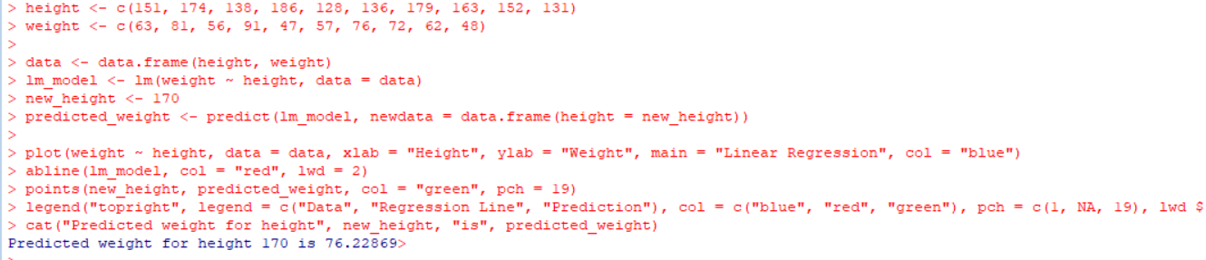

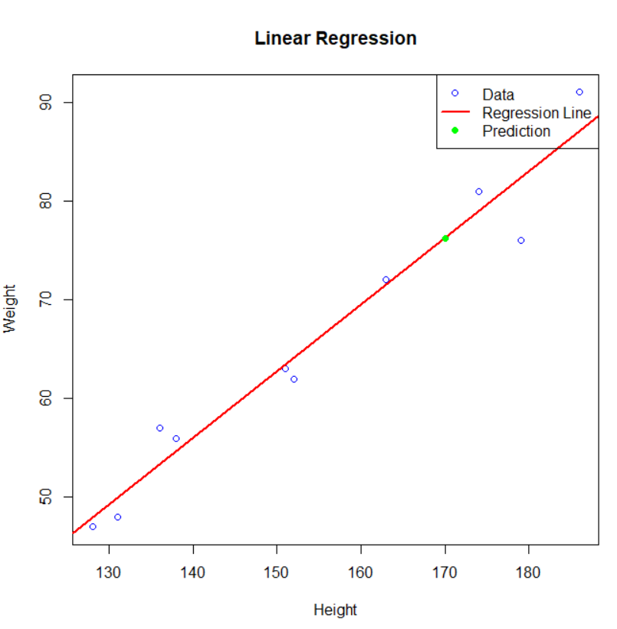

1. Download the Dataset "water" From Rdataset Link.Find out whether there is a linear relation between attributes"mortality" and"hardness" by plot function.Fit the Data into the Linear Regression model.Predict the mortality for the hardness=88

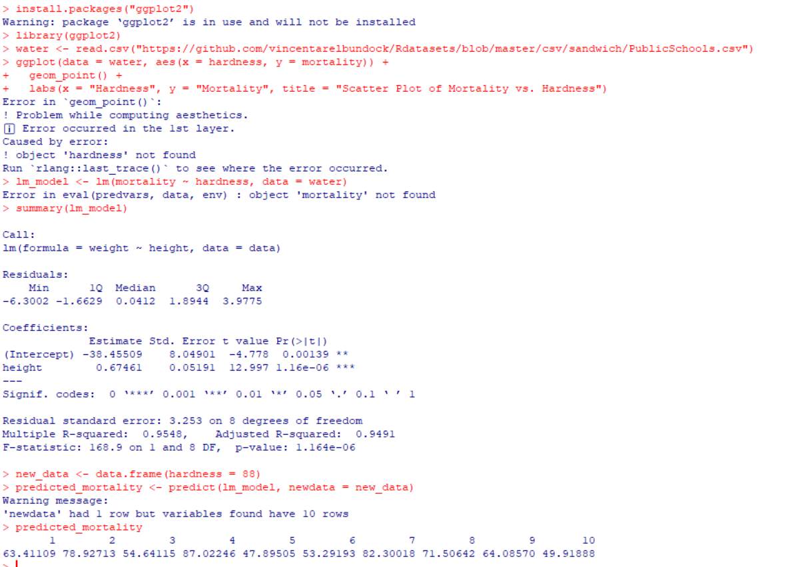

**MULTIPLE REGRESSION ANALYSIS IN R**

**Exercise:**

3.Generate a multiple regression model using the built in dataset mtcars.It gives a comparison between different car models in terms of mileage per gallon (mpg), cylinder displacement("disp"), horse power("hp"), weight of the car("wt") and some more parameters.

Establish the relationship between "mpg" as a response variable with "disp","hp" and "wt" as predictor variables. Predict the mileage of the car with dsp=221,hp=102 and wt=2.91.

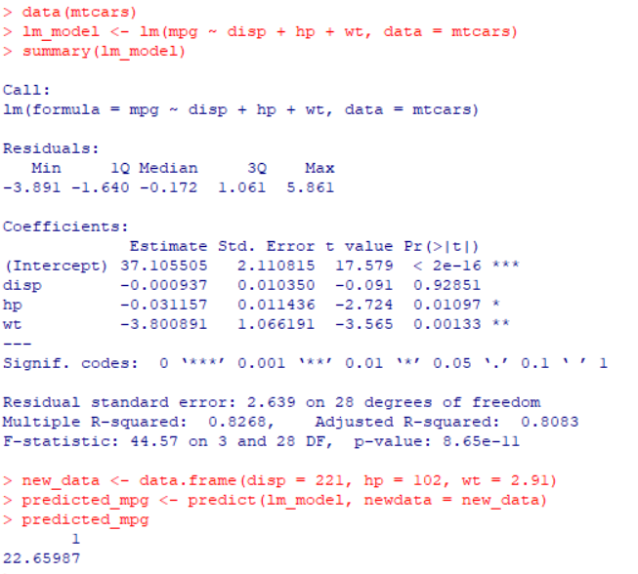

4. Consider the data set "delivery" available in the R environment. It gives a deliverytime (“delTime”)of production materials(number of productions “n.prod”) with the given distance(“distance”) to reach the destination place.

a)Create the model to establish the relationship between "delTime" as a response variable with "n.prod" and "distance" as predictor variables.

b)Predict the delTime for the given number of production(“n.prod”)=9 and distance(“distance”)=450

