**11th-May_Assignment:**

1)Create a shell script to print the HTTP error code of guvi.in & print, the success/failure message based on the error code response  
  
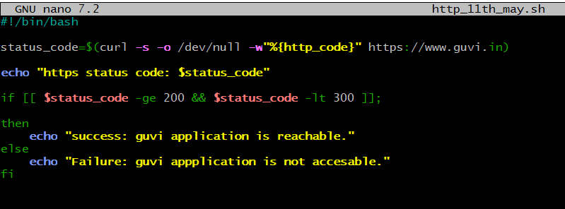

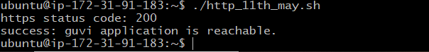

1. Given a file, replace all occurrence of the word "give" with "learning" from 5th line till the end in only those lines that contain the word "welcome"

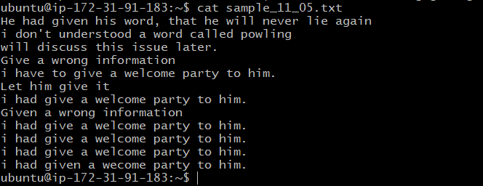

By using sed command we can replace the occurrence of “give” word with “learning” from the line 5 to end where lines having word “welcome”.

sed -i '5,${/welcome/s/give/learning/g}' sample_11_05.txt

