**27th_April_TASK:**

Get me the IP address of a particular domain (guvi.in)

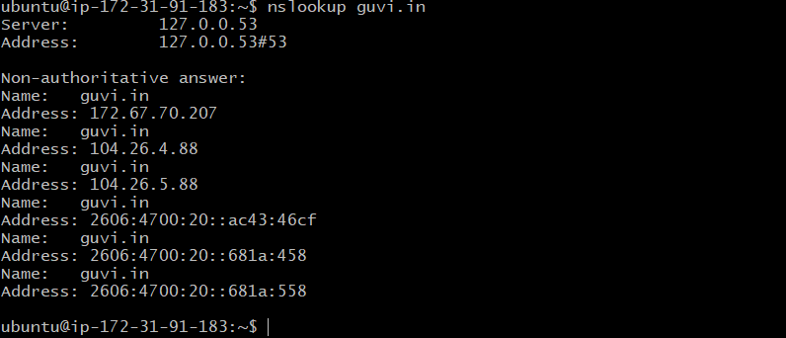  
  
  
How do I find my CPU/memory usage of my server?  
  
By using top command we can get the cpu and memory uasge  
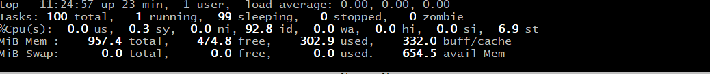

Test the connectivity between 2 nodes?

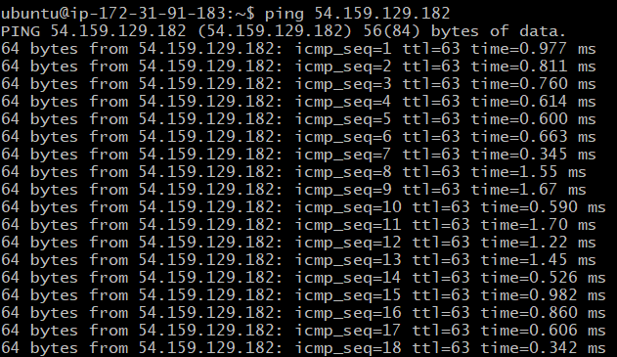

2.I have deployed an application in guvi.com:9000, and logs show my app is running, but I’m unable to view the page. Check whether my port is open or not ?

We can check the port number by running the telnet command, whether it’s running or not.

