Establish a new directory, populate it with script files, initiate an empty repository on GitHub, convert the local directory into a Git repository, and link it to GitHub for pushing the code into the repository.Perform merge, rebase, stash commands in following github repo.

Established a new directory:

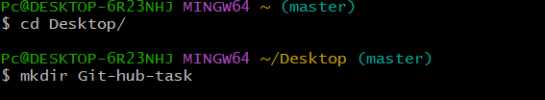

populated it with script files:

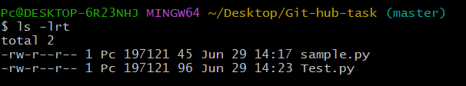

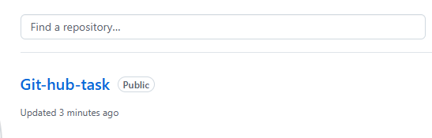





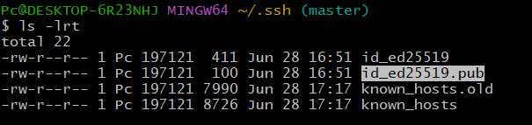

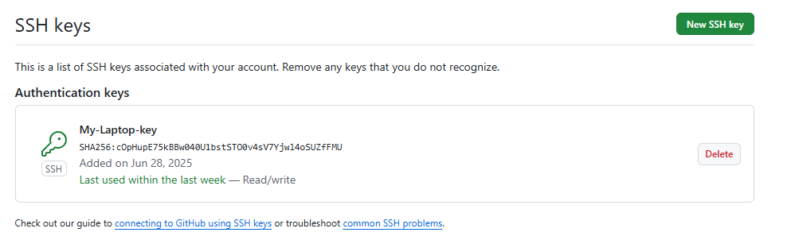

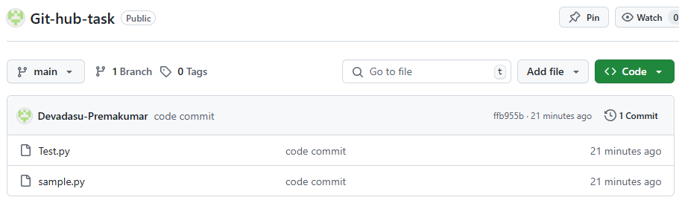

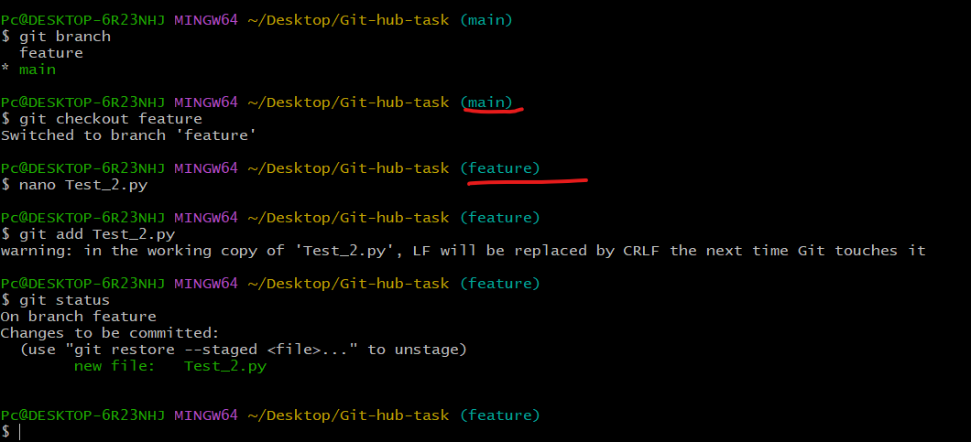

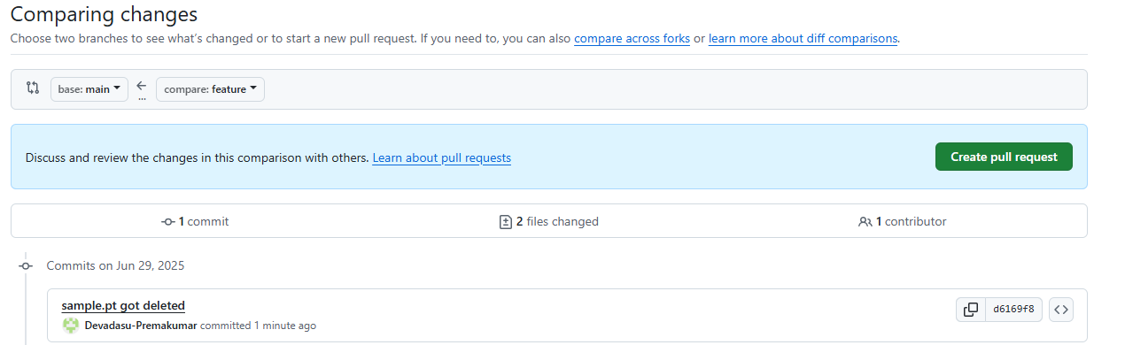

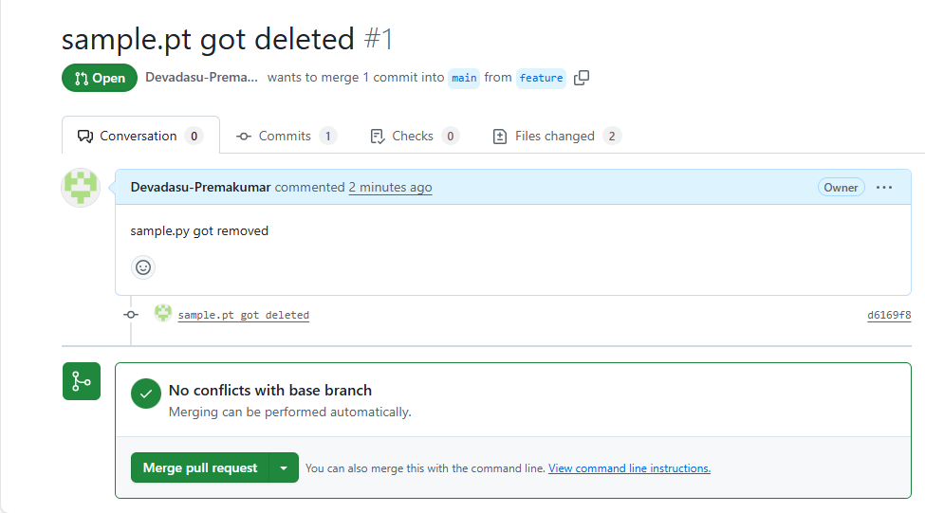

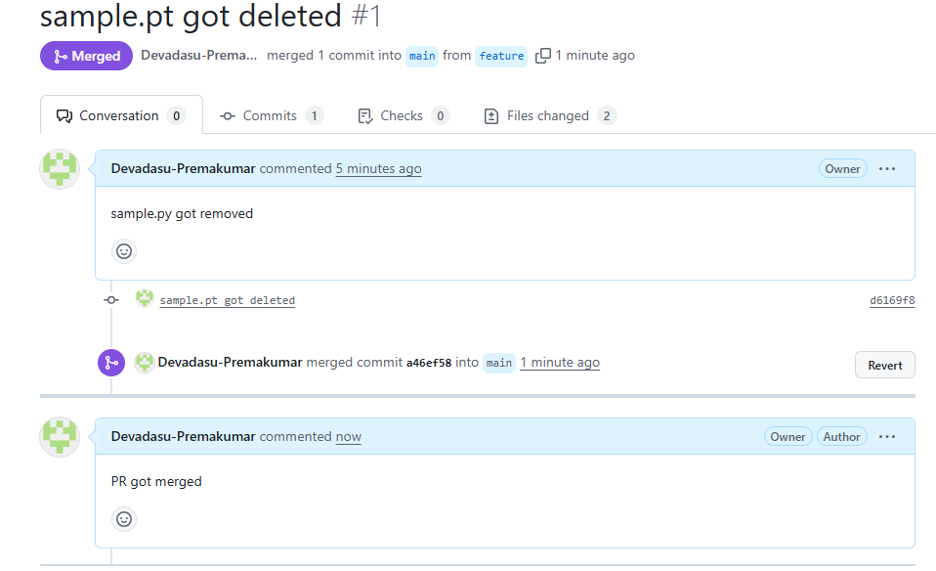

git merge

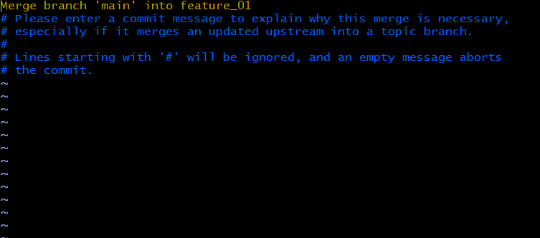

git rebase main

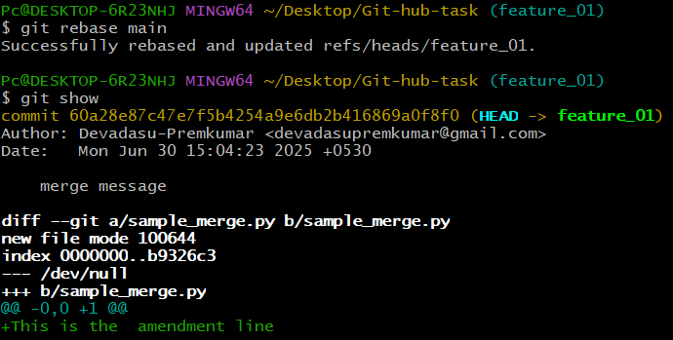

git stash

