**AWS_TASK -4:**

Launch an EC2 instance (Linux and Windows) along with a web server. Then, create an EBS volume of 5 GB, attach it to an EC2 machine (Linux and Windows), and take a snapshot. Finally, create an EBS volume using the taken snapshot.

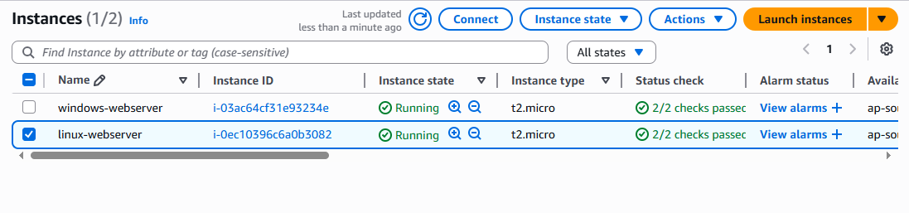

Ec2 server launched with web server

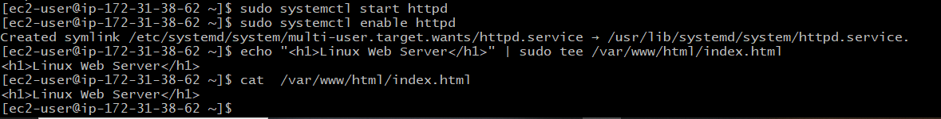

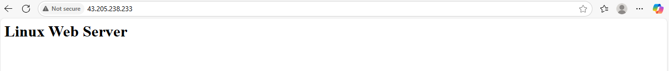

Windows server launched with web server

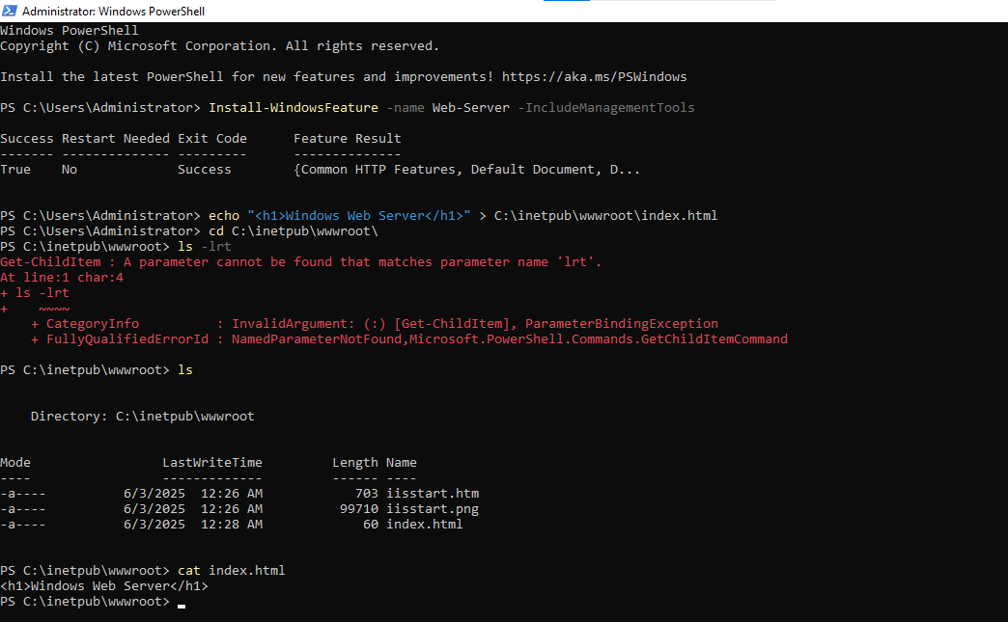

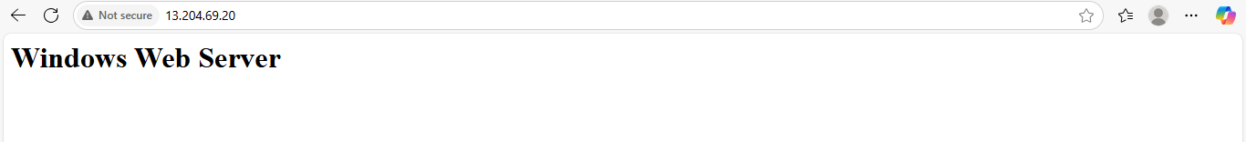

Created 5GB of EBS volume

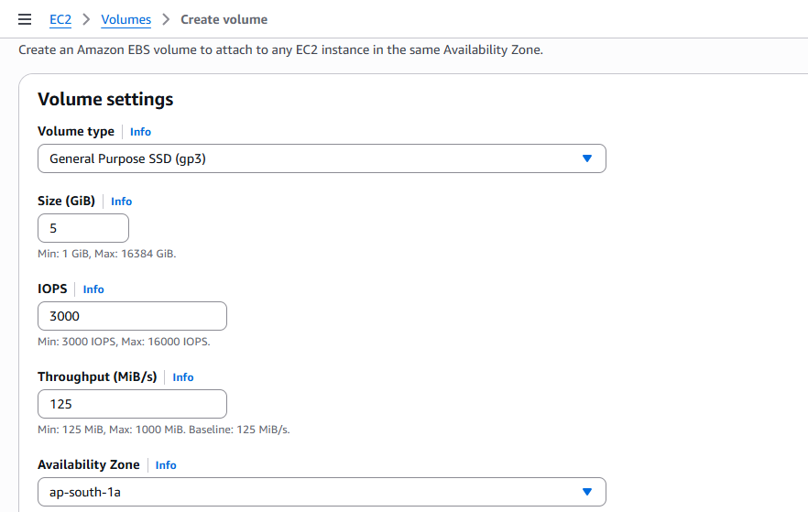

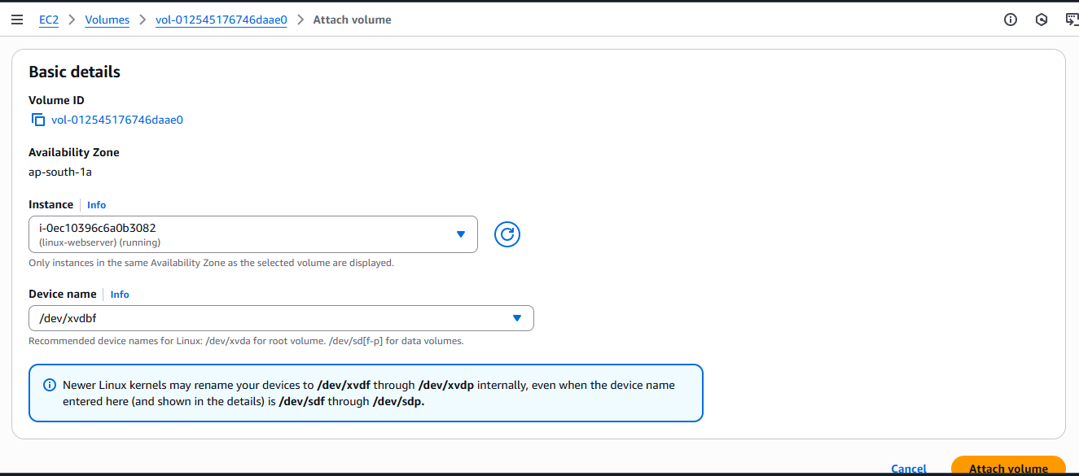

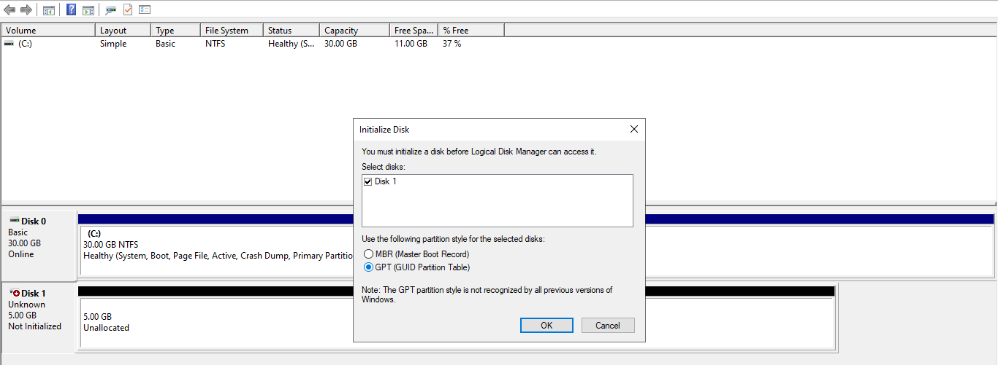

Mounted the 5gb of EBS volume in the windows server

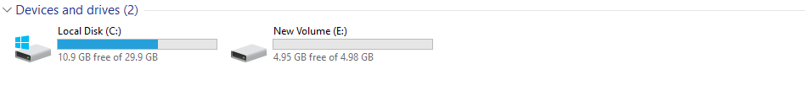

Mounted the 5gb of EBS volume in the linux server

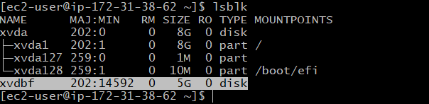

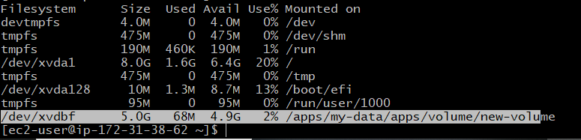

Created the snapshot

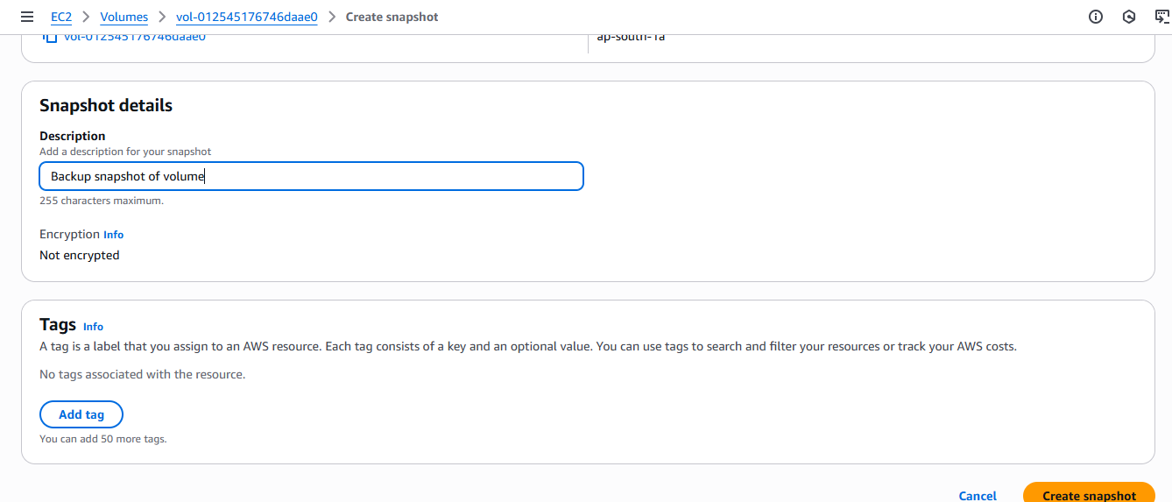

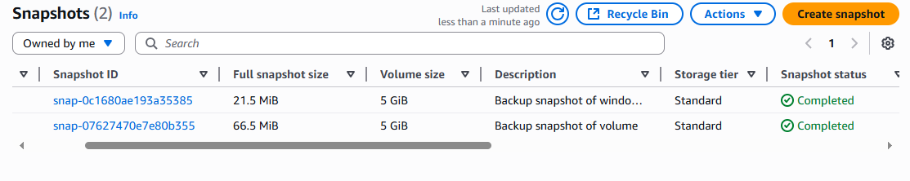

By using snapshot again added the EBS volume

