Create a windows Vm machine in AWS and connect with RDP open CMD in windows share the about system info.  
  
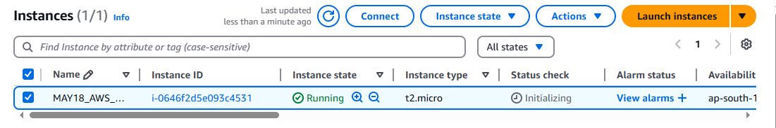

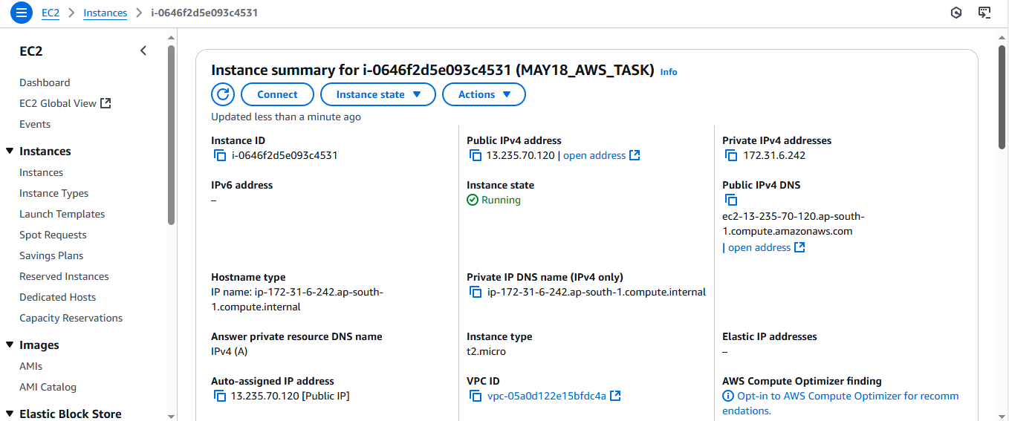  
  
  
Systeminfo  
