Deploy a simple web application using AWS code commit, code build and deploy & access via browser and automate via codepipeline.

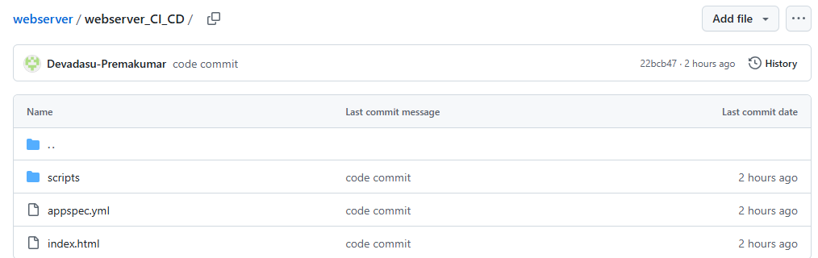

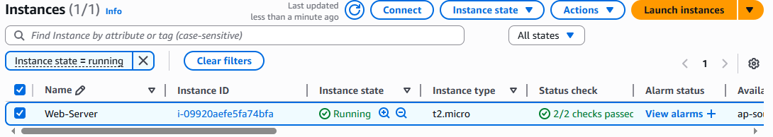

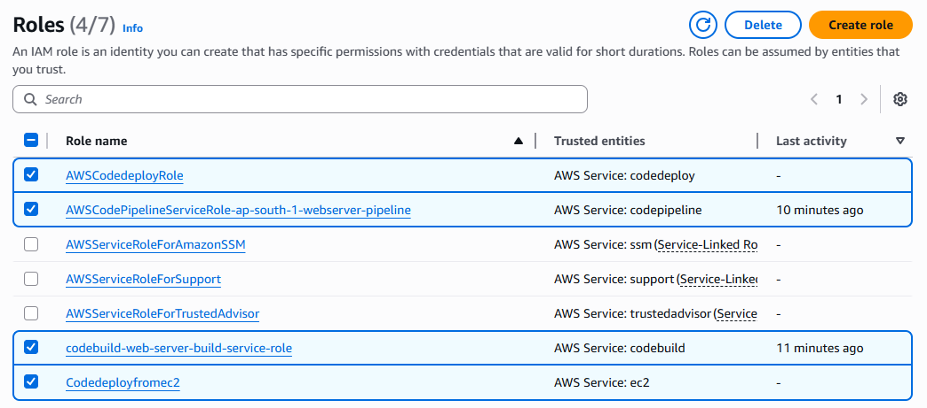

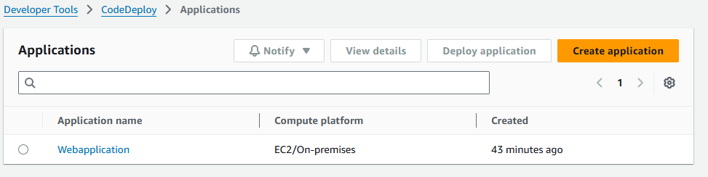

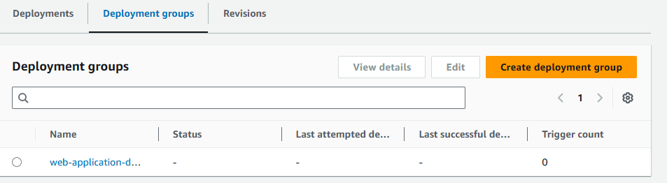

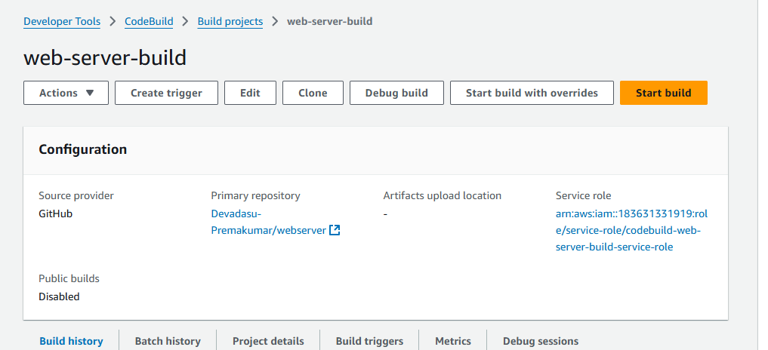

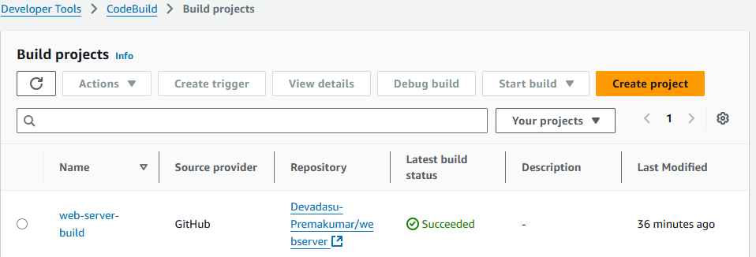

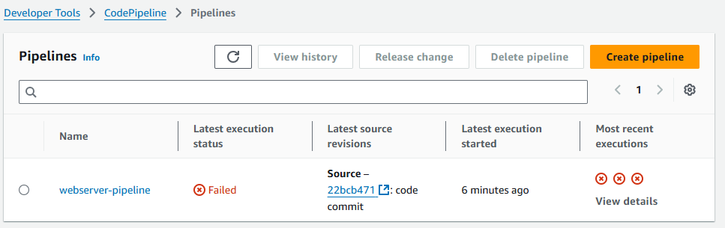

Deployment job getting failed, by thrown permission issue, but I had given the permission to the s3 and also added the inline policy. BUt still de[polyment getting failed.

