EEET2482/COSC2082

Software Engineering Design, Advanced Programming Techniques

**GROUP ACTIVITY No: 1**

Group Number/ Name: Beautifulcoders

Date: 15/03/2022

Members participating in this activity (*name – student ID*):

1. Le Duy Quang S3912105
2. Nguyen Tuong Khang S3927112
3. Do Phuong Linh S3926823
4. Nguyen Phan Duc Anh S3915181

Activity Result (take the screenshot and attached below):

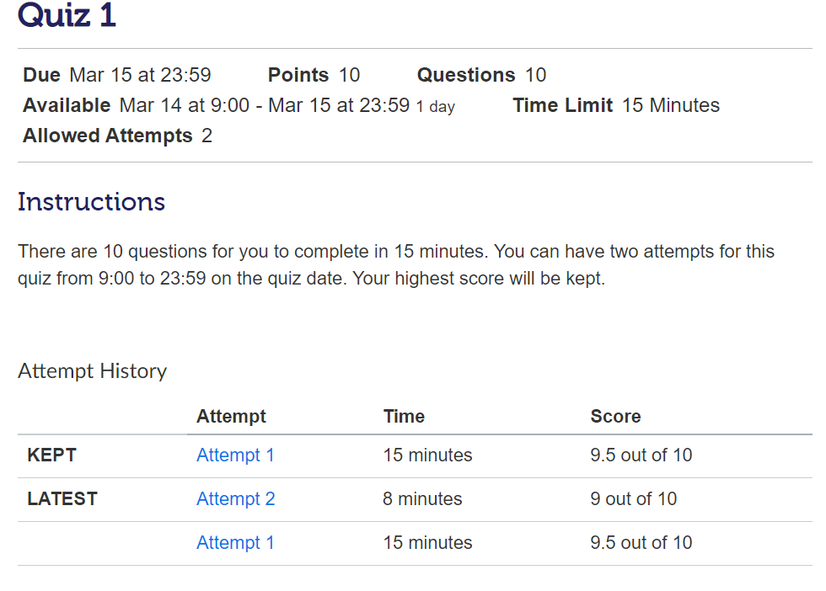

Link of recorded video (shared with the lecturer for access):

https://rmiteduau.sharepoint.com/:v:/r/sites/Recording471/Shared%20Documents/General/Recordings/Meeting%20in%20_General_-20220315_094627-Meeting%20Recording.mp4?csf=1&web=1&e=nLnJDY