|  |  |
| --- | --- |
| **Name** | **Devadharshini E** |
| **Reg. No.** | **621421106008** |
| **Department** | **ECE** |
| **Year** | **III** |
| **College Name** | **Maha Barathi Engineering College** |
| **Group** | **IOT – Smart Water Fountains** |

**Phase – 2**

**Innovation**

In this phase you need to put your design into innovation to solve the problem.

Explain in detail the complete steps that will be taken by you to put your design that you thought of in previous phase into transformation.

Create a document around it and share the same for assessment

**Smart water fountains**

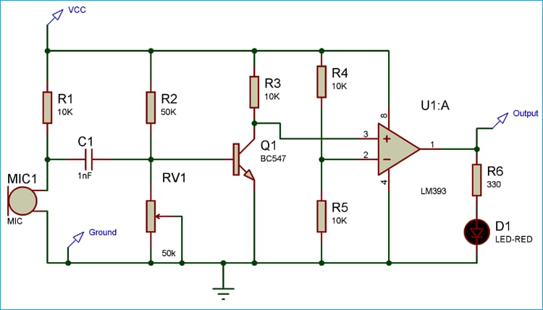

**Working**

IoT-based smart water fountains utilize sensors, connectivity, and data analysis to provide enhanced functionality and efficiency. Here is a general overview of how they work:

1. Sensors: Smart water fountains are equipped with various sensors such as motion sensors, proximity sensors, temperature sensors, and flow sensors. These sensors detect user presence, water temperature, water flow, and other relevant data.

2. Connectivity: The fountain is connected to the internet through Wi-Fi or other communication protocols. This enables the fountain to transmit and receive data in real-time.

3. Data collection: The sensors collect data on user interactions, water quality, temperature, flow rates, and other relevant parameters. This data is then sent to a cloud-based platform for storage and analysis.

4. Cloud-based platform: The collected data is stored and processed in a cloud-based platform. Advanced analytics algorithms can be applied to identify patterns, trends, and anomalies in the data.

5. User interface: The smart fountain may have a built-in display or be connected to a smartphone app. This interface allows users to interact with the fountain, access information, and customize settings.

6. Automation and control: Based on the data analysis and user preferences, the smart fountain can automatically adjust water temperature, activate bottle filling stations, and control other features. For example, if the fountain detects low water quality, it can trigger a filter replacement notification or shut off until maintenance is performed.

7. Remote monitoring and management: Facility managers or administrators can remotely monitor the status and performance of the smart fountains through the cloud-based platform. They can access real-time usage statistics, detect leaks or malfunctions, and schedule maintenance based on data insights.

8. Energy efficiency: IoT-based smart fountains often incorporate energy-saving features such as automatic shut-off when not in use or low-power components. These features help minimize electricity consumption.

By leveraging IoT technology, smart water fountains provide a seamless and connected experience for users while enabling efficient management and sustainability practices for facility owners.