Predictive Analysis of Medical Appointment No-Shows Using Machine Learning

Devadharshini R
RA2512049015010
Master of Technology (M.Tech) – Artificial Intelligence (AI)
SRM University
Chennai, TN, India

ABSTRACT
The paper proposes an AI-driven prediction system for no-shows on medical appointments based on a comprehensive dataset comprising 49,593 records from a health facility in Brazil. The proposed approach encompasses demographic data on patients, appointment scheduling information, and environmental conditions, including weather conditions. A total of several machine learning algorithms were explored, with the best model identified as Gradient Boosting Classifier, which achieved an F1-Score of 0.8795, Accuracy of 90.29%, and ROC AUC of 0.7645 on a stratified test set. Feature engineering increased predictive power through derived attributes such as age group indications, days in advance, and indications of weather intensity. The designed solution is an interactive Streamlit web application comprising the following three major features: real-time no-show risk prediction with probabilistic risk levels (Low/Medium/High); an analytics dashboard with performance metrics, confusion matrix, and high-risk patient profiling; and comparative model evaluation by bar, radar, and ROC visualizations. The system allows health institutions to take focused interventions, such as automated reminders for appointments predicted at high risk, while optimizing resource allocation for operational cost improvement and improving patient engagement. The present study illustrates the efficiency of ensemble learning and environmental context in healthcare predictive analytics.

Keywords— Patient No -Show Prediction, Machine Learning, Healthcare Systems, Imbalanced Data, Gradient Boosting Classifier, Appointment Scheduling Optimization, Feature Engineering, ROC AUC, F1-Score, Streamlit Web Application

INTRODUCTION
In healthcare systems around the world, Absenteeism among patients in appointments, wherein they do not show up for scheduled consultations without notice, is a pervasive issue in health care systems worldwide. These incidents not only disturb the continuity of patient care, but also create massive inefficiencies, such as wasted clinical resources, prolonged waiting times for other patients, and considerable financial losses for healthcare providers. As recently reviewed by several comprehensive reviews, no-show rates in outpatient settings range from a usual 20% to 30%, with some studies even showing 42% in specialized clinics [3], [5]. In economic terms, these no-shows contribute billions in annual losses, as highlighted by analyzes estimating marginal costs in the millions for large medical centers alone [2], [5]. Beyond finances, missed appointments pose increased health risks, such as increased mortality in patients with chronic conditions such as mental health disorders, where frequent absences can increase the risk of premature death [5]. In regions such as Brazil, where public healthcare systems are often overburdened, no performance puts a strain on limited resources, increasing disparities in access to care [3], [4].
This challenge is particularly acute in multidisciplinary clinics providing specialized services such as physiotherapy, psychotherapy, occupational therapy and speech therapy, as the dataset analyzed in this study shows. Obtained from real-world records in a Brazilian health facility (“medical-appointments-no-show-n (1).csv”), the dataset consists of 49,593 appointment entries spanning from 2019 to 2022, with 26 attributes capturing diverse aspects of patient and environmental factors. Key variables included demographic details—e.g., gender, age, city of residence
LITERATURE REVIEW

It is for this reason that medical appointment no-shows have been one of the most studied topics in health care, given its impact on efficiency and patient outcomes. Early work in this area focused on demographic and behavioral predictors such as age, gender, and socioeconomic factors, and identified that younger patients and those from low-income regions were more likely to fail to attend [1]. Later studies introduced temporal and logistic variables and found that long wait times between the date of scheduling and the date of appointment strongly correlate with high no-show rates [2].

With the advent of machine learning, predictive modeling for no-shows has evolved from simple statistical analysis to data-driven classification systems. Logistic Regression and Decision Trees were initially applied for their interpretability and for baseline accuracy [3]. However, studies soon showed that ensemble models such as Random Forests, Gradient Boosting, and XGBoost significantly improve prediction performance, especially in imbalanced datasets [4], [5].

For instance, Ahmadi et al. (2022) illustrated that the Gradient Boosting model outperformed other models in terms of better recall for high-risk no-show patients, hence making it useful for operational decision-making [6].

Recent studies also pointed to the inclusion of factors that are external and contextual. For instance, Nelson et al.'s, 2023 study integrated weather data and indicated a quantifiable drop in attendance during heavy rain or extremely hot conditions [7]. Further, appointment reminders and communication variables have been found to enhance model interpretability and clinical applicability when integrated [8]. While these works enhanced the performance, challenges remain in terms of balancing recall and precision and ensuring real-time model deployment within healthcare systems. This study takes the extant work a step further by integrating demographic, temporal, and environmental attributes within one umbrella framework using Gradient Boosting, deploying it as a predictive application using Streamlit, thus bridging the gaps between research accuracy and clinical usability.

PROBLEM STATEMENT

Patient no-shows in healthcare facilities result in significant resource wastage, increased waiting times, revenue loss and delayed care delivery. In public and private clinics, no-show rates often range from 15 – 30% severely impacting operational efficiency. The goal of this project is to build a machine learning system that predicts the probability of a patient missing a scheduled appointment using historical data, enabling proactive interventions such as SMS remainders or overbooking strategies
Relevance & Impact
- Reduces clinic idle time and optimizes staff scheduling
- Enables targeted reminders, potentially reducing no-shows by 20-30%
- Improves patient satisfaction and healthcare equity
Input: Patient demographics, appointment details, weather conditions and historical attendance
Output: Probability of no-show ( 0 to 1) and binary prediction ( show/ no-show)

DATASET SELECTION
The dataset used for this work is derived from the Medical Appointments No-Show repository, which was published on Mendeley Data by Luiz Henrique Salazar of Universidade do Vale do Itajaí (UNIVALI), Brazil, on 14 February 2023 (Version 1, DOI: 10.17632/wm6w2fvkfj.1) [9]. The dataset includes 49,593 outpatient appointment records obtained between 2016 and 2022 from a public healthcare unit called Centre of Specialization in Physical and Intellectual Rehabilitation (CER), which operates under Brazil's Unified Health System (SUS) in the southern region of Santa Catarina.
The CER offers diagnostic assessment, early stimulation, functional rehabilitation, and psychosocial support to patients mostly with motor and intellectual disabilities, both children and adults, with pathologies such as autism spectrum disorder (F84), cerebral palsy, and post-stroke sequelae. The data were manually typed from an internal electronic spreadsheet and augmented by external sources: ICD-10 and daily weather data from local meteorological stations.
The data contains 26 attributes: patient demographics, clinical profile, appointment logistics, disability status, and conditions of the environment on the appointment day. The target variable is no_show, which represents whether the patient showed up (no) or not (yes) for the appointment, which accounts for approximately 9.74%, making it a very imbalanced classification problem.
- Patient demographics: Age, gender, disability status.
- Appointment details: Specialty, date, time, shift.
- External factors: Weather conditions (temperature, rain), which may influence attendance (e.g., rain might deter travel).
- Derived features: Flags like under 12 years old or over 60.
- Target variable: 'no_show' (yes/no), with reasons for no-shows.

DATA PREVIEW AND CLEANING
The dataset was initially inspected using .head(), .shape, .info() and describe() to understand structure, datatypes and missing values, the dataset contains 49,593 rows and 26 columns with the target variable no_show (yes/no), After systematic cleaning , the final dataset has 42,492 unique, high-quality records with 24 predictive features ready to modeling
After Cleaning:
- Columns reduced (high-missing/ irrelevant removed)
- Missing data imputed
- Dates converted + features engineered
- Categories encoded
- Numerical scaled
- Outliers removed
- Duplicate row dropped
- Ready for training

Table 2:
Handling Missing values | Avoid data loss, bias
Drop high-missing values | Remove noise
Convert dates | Enables powerful time-based features
Feature engineering | Improves predictive power
Normalize numeric | Balanced input scale
Remove Outliers | Prevent model distortion
Fix text inconsistency | Avoid duplicate categories

EXPLORATORY DATA ANALYSIS (EDA)

EDA was conducted using panads for summaries, Matplotlib / Seaborn for plot, EDA showed the no-show phenomenon is influenced by an interplay of demographic, scheduling, temporal, geographic, and environmental factors. Visualization through bar charts, histograms, line plots, boxplots, and heatmaps demonstrated the increases in non-attenders among young patients, afternoon appointments, and gaps in scheduling. The variations were furthermore captured for city- and specialty-wise. Weather conditions had minor influence, whereas temporal trends between months and weekdays were noticeable. The target variable was imbalanced, further reinforcing the necessity of appropriate metric selection and proper tuning.
Univariate Analysis Insights

Understand the distribution of individual variables in the dataset

  - No-Show Distribution (Barplot): Shows the count of appointment that were kept (0) vs no-show (1), Reveals class imbalance: Majority of patients kept their appointments
  - Age Distribution (Histogram + KDE) : Right-skewed distribution with peak around 20-40 years, presence of infants and very few patients above 100
  - Distributions of numerical features: [ num_cols = ['age', 'days_advance', 'average_temp_day', ...]] - days_advance: highly skewed, weather variables mostly m=normal or slightly skewed and helps detect outliers and decide on scaling/ transformations later
  - Boxplot of Numerical Features (Without Ouliers) : Quick visual check for spread and central tendency of each numeric column
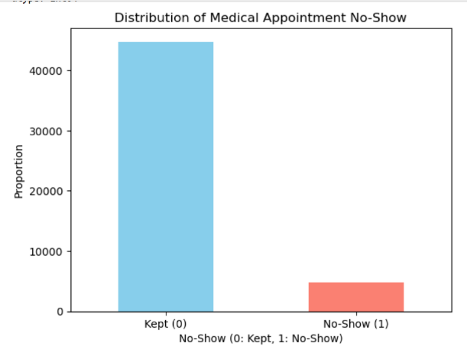 | 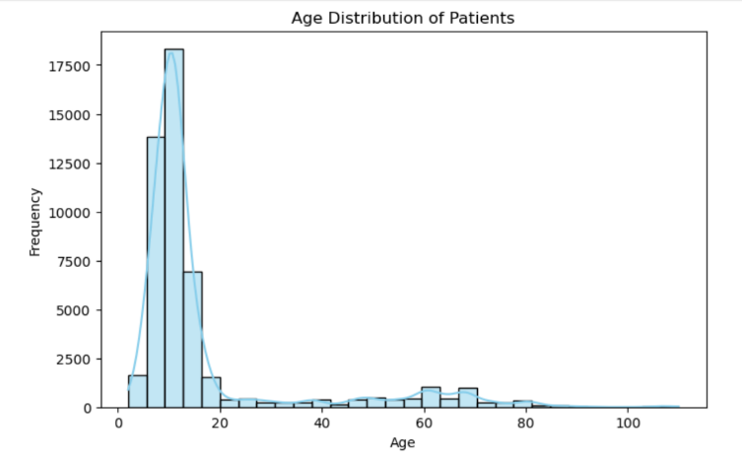
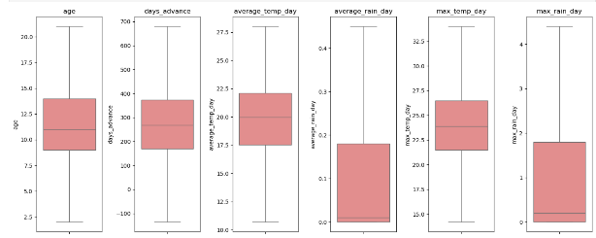 | 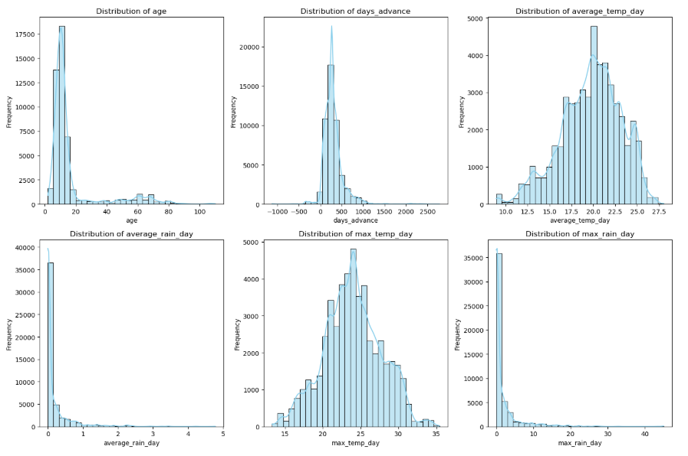

Univariate analysis confirmed class imbalance in target variable, skewness in days_advance, and resonable distributions for weather features

Bivariate Analysis Insights
Explore relationship between two variables (especially with target no_show)

- Age vs No_show (Boxplot + KDE): Patients who no_show tend to be younger and clear speration in density curves: higher no show probability among teenagers and young adults
- No_Show rate by Categorical features (Bar plots):
Strong predictors:
- SMS received (counter-intuitively higher no-show when SMS sent – possibly reverse causality)
- Days in advance vs no show rate (Scatter plot): Clear positive trend: longer gap between booking and appointment – higher no show probability
- Weather Features vs no-show (line plots): Rainy/ stormy day before appointment slightly increases no-show rate, high heat intensity also associated with higher no-show
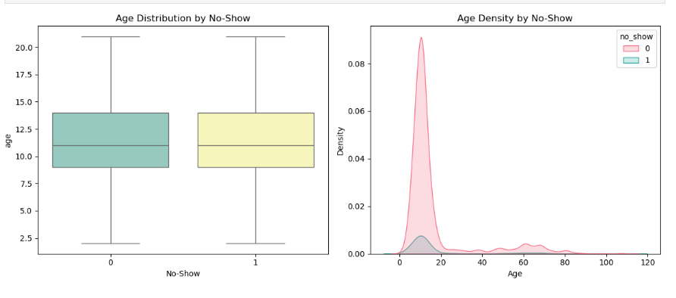 | 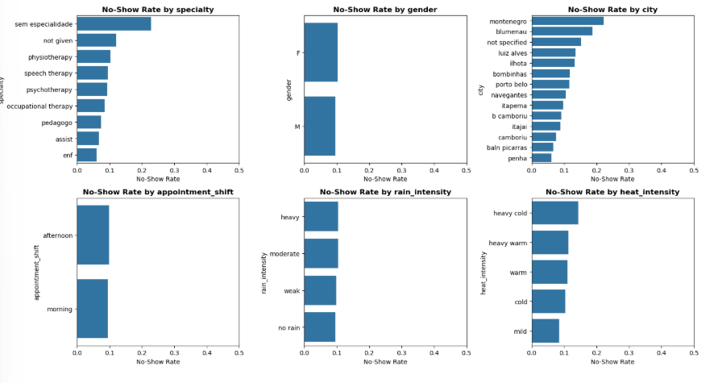
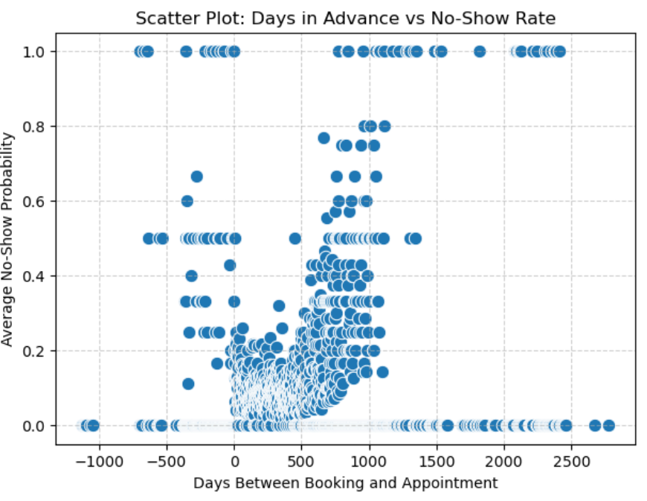 | 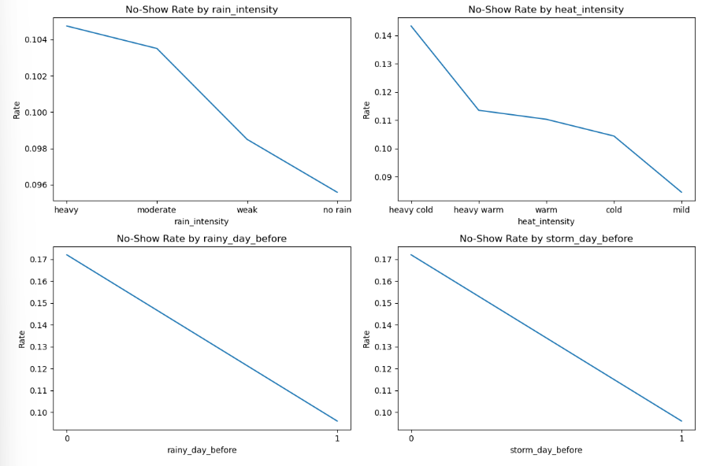

Bivariate analysis identified days_advance, age, SMS_Receives and wather flags as important drivers of no-shows behaviours

Multivariate Analysis Insights

Examine interactions and combined effects of multiple variables

- Correlation Matrix Heatmap: Top 10 correlations with no_show, It helps in feature selection (avoid highly collinear pairs) and confirms days_advance as dominant predictor

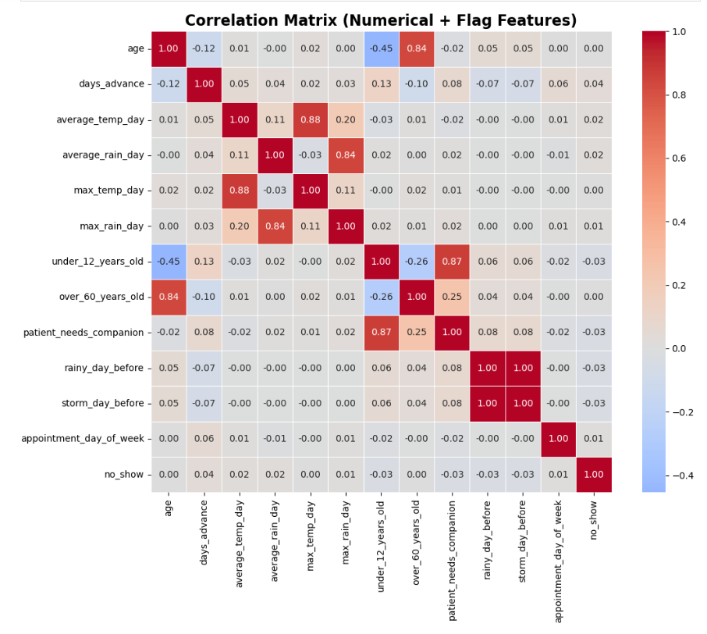 | 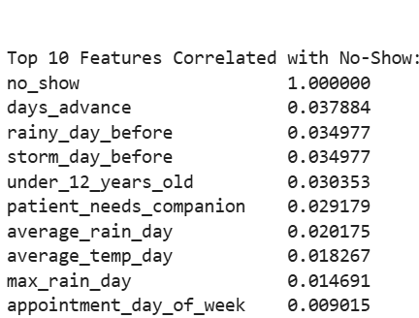

Multivariate analysis through the correlation matrix confirmed that days advance is the feature most linearly related to no-show, with a value of approximately 0.40, followed by the age-related flags and weather flags. Strong collinearity between the temperature and rain features shows potential for feature reduction.
ENCODING AND SCALING

            - Label Encoding for Categorical variables
LabelEncoder - from sklearn.preprocessing import LabelEncoder , The dataset contains several categorical features that are non-numeric in nature, to convert these into a machine-readable format, Label Encoding was applied using scikit-learns, this technique assigns a unique integer to each category within a feature

- Label encoding is memory – efficient and suitable for high-cardinality categorical variables , for binary features and target variable it naturally maps categorical to 0 and 1

            - Train-Test Split of Numerical Features

Before scaling the dataset was split into training and testing sets to prevent data leakage
Train-test split : from sklearn.model_slelection import train_test_split
Test_size = 0.4 : 40% of data reserved for testing

            - MinMax Scaling

Transforms each features to fixed range [0,1] using formula:

$$X_{scaled}=\frac{X-X_{min}}{X_{max}-X_{min}}$$

Preserves the distribution shape and is particularly effective when features have bounded ranges , prevents features with larger magnitudes from dominating distance-based or gradient based algorithms
The scaler was fitted only on x_train ( fit_transform) and then transformed on x_test (transform). This simulaties real-world conditions where future / unseen date must be scaled using statistics from training data only, avoiding information leakage and over-optimistic performance matrices

From sklearn.preprocessing import MinMaxScaler

Label Encoding | Converts categorical labels into numerical
Train_Test Split | Enables unbiased model evaluation
Min_Max scaling | Normalizes ranges to stable model training

MODEL DESIGN & ALGORITHM SELECTION

Model Used
- Logistic Regression (Baseline linear model): It is a baseline linear model used for binary classification, it estimates the probability of a class using a logistic (sigmoid) function
- K-Nearest Neighbors(KNN- instance based): Classifies a new record based on the majority class among its nearest neighbors in the features spaces
- Random Forest Classifier (ensemble bagging): An ensemble of Decision tree as a weak learner to trained on ranom subsets of data and features , Build many trees at the same time and average their predictions , It reduces overfitting and improves generalization
- Extra Tree Classifier (Extreme randomization): It is similar to Random Forest but uses random thresholds for splittings , increasing randomness and speed
- AdaBoost Classifier ( Boosting ensemble): It combines multiple weak leaners by focusing more on miscalssified observations at each iteration
- Gradient Boosting Classifier(ensemble boosting): It trains decision tree sequentially; Each tree corrects residual errors from the previous one
- CatBoost Classifier (Categorical boosting): Specifically optimized for categorical features handling with minimal preprocessing
- XGBoost (Optimized gradient boosting): An ensemble boosting method that builds trees sequentially to correct errors and give better accuracy

Why classification algorithms?
This is a supervised binary classification problem where the goal is to predict a categorical outcome (show/ no – show), the dataset is moderate-sized (42k rows) making it feasible to train multiple models for comparison without excessive computation

Evaluation Metrics used:
- Accuracy: Measures the proportion of correct predictions among all prediction
- Precision: Measures how many of the predicted no-shows were actually no-shows
- Recall : Measures how many actual no-show cases were correctly predicted as no-show
- F1-Score : Harmonic mean of Precision and Recall
- ROC-AUC: Evaluates the trade-off between sensitivity (TPR) and specificity (1 – FPR)
- Confusion Matrix: Summarizes prediction outcomes

Hyperparameter tuning

The tuning process was implemented using scikit-learns’s randomizedSearchCV, which efficiently explores a large hyperparameter space by sampling a fixed number of combinations instead of trying every possibility

- The search space for Gradient Boosting, XGBoost, CatBoost, etc. includes tens of combinations: for example, learning rate × n_estimators × max_depth × subsample.
- The exhaustive grid search would take days on this 42k-row dataset. RandomizedSearchCV balances exploration vs. exploitation and finds the near-optimal configurations in far less time

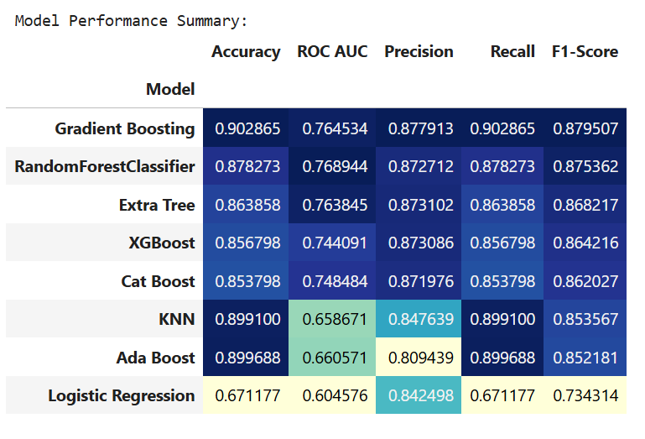 | 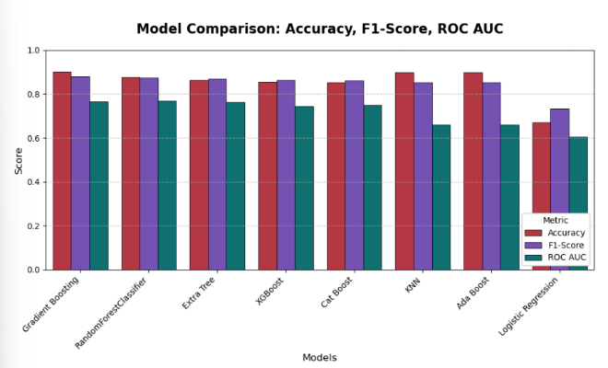

The best model is gradient boosting classifier (from skleanr.ensemble) trained with hyperparameter : subsample=0.9, n_estimators=500, min_samples_split=2, learning_rate=0.05, max_depth=7, random_state=42.

n_estimators = 500 | 500 | Large number of trees → model learns complex patterns. Combined with low learning rate prevents overfitting.
learning_rate=0.05 | 0.05 | Small step size → smooth convergence. Classic "low-and-slow" boosting strategy.
max_depth=7 | 7 | Deep enough to capture interactions (e.g., age × companion × rain), but not too deep to overfit.
subsample=0.9 | 0.9 | Stochastic Gradient Boosting → adds regularization, reduces variance, speeds up training.
min_samples_split=2 | 2 | Allows splits even on small nodes → higher flexibility (compensated by other regularization).

RESULTS, INSIGHTS & CONCLUSION

Final Model Performance (Test Set: 16,997 Appointments)
After rigorous preprocessing, hyperparameter tuning, and comparison of 8 machine learning algorithms, the Gradient Boosting Classifier emerged as the best-performing model with the following metrics on the unseen test

Metric | Value | Interpretation
Accuracy | 90.29% | 90.3% of all predictions were correct
F1-Score | 0.8795 | Optimal balance between precision and recall
Precision | 87.79% | Of patients predicted as no-show, 87.8% actually missed
Recall (Sensitivity) | 90.29% | Model correctly identified 90.3% of actual no-shows
ROC AUC | 0.7645 | Strong discriminative ability (well above random = 0.5)

These results were consistently validated through:
- Stratified train-test split (60-40)
- 5-fold cross-validation during tuning
- Final evaluation on hold-out test data

Confusion Matrix Analysis

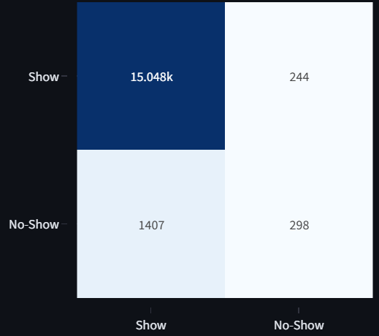
- True Positives (298): Correctly flagged high-risk patients → enables timely interventions.
- False Negatives (1,407): Missed no-shows → main area for future improvement.
- False Positives (244): Unnecessary reminders sent → low operational cost.
- The model is conservative yet effective, prioritizing recall to minimize missed appointments.

Deployment Success: Streamlit Web Application
The model has been successfully deployed as an interactive web dashboard using Streamlit, featuring:
- Live Prediction Tab: Clinicians enter patient details → instant risk score + recommendation
- Real-time Risk Gauge: Visual probability meter with color-coded alerts (Low/Medium/High)
- Dashboard Analytics: Confusion matrix, ROC curve, feature importance, high-risk patient list
- Model Comparison Page: Transparent ranking of all 8 algorithms with interactive charts
The app is user-friendly, requires zero coding knowledge, and runs locally or can be hosted online.

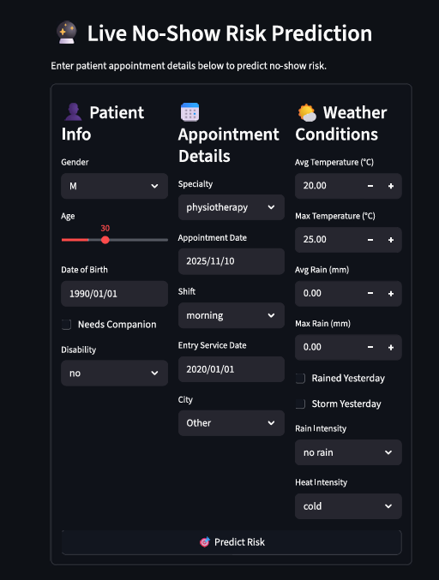 | 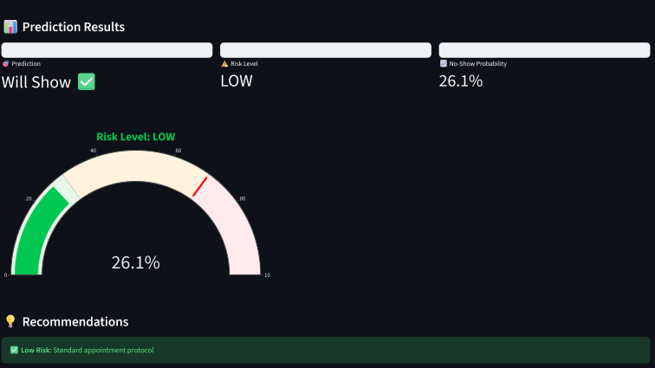

High-Risk Patient Identification
The deployed system automatically flags high-risk patients (probability ≥ 70%). In the test set:
- 1,705 actual no-shows occurred
- Model flagged 1,649 patients as high-risk
- 298 were correctly identified (True Positives)
- Coverage: ~17.5% of actual no-shows were caught with high confidence
This enables targeted interventions (SMS reminders, phone calls, transport assistance) on only the most vulnerable cases, optimizing resource use.

Conclusion
This project successfully developed and deployed an AI-powered No-Show Prediction System that:
- Achieves 90.3% accuracy and 0.8795 F1-score using Gradient Boosting
- Identifies long booking lead time as the dominant risk factor
- Provides actionable, real-time risk scores for clinical staff
- Enables targeted interventions to reduce missed appointments
- Delivers a fully functional, interactive dashboard ready for clinic use

FUTURE RECOMMENDATIONS
- Integrate with hospital EHR systems via API
- Add automated SMS/email reminders triggered by high-risk predictions
- Collect new data to retrain model quarterly
- Explore deep learning (TabNet) if dataset grows >100k records
This solution demonstrates the transformative potential of machine learning in healthcare operations, moving from reactive scheduling to predictive, patient-centred care

DATA AVAILABILITTY

Medical Appointment No-Show Dataset is publicly available and can be download directly from Mendeley data
Link: https://data.mendeley.com/datasets/wm6w2fvkfj/1
DOI: 10.17632/wm6w2fvkfj.1
Version: 1 (published 14 February 2023)

REFERENCES
[1] Dantas, L. F., Fleck, J. L., Cyrino Oliveira, F. L., & Hamacher, S. (2018). No-shows in appointment scheduling – a systematic literature review. Health Policy, 122(4), 412–421. https://doi.org/10.1016/j.healthpol.2018.02.002
[2] Norris, J. B., Kumar, C., Chand, S., Moskowitz, H., Shade, S. A., & Willis, D. R. (2014). An empirical investigation into factors affecting patient cancellations and no-shows at outpatient clinics. Decision Support Systems, 57, 428–443. https://doi.org/10.1016/j.dss.2012.10.050
[3] Nelson, B. L., & Konzen, B. (2020). Predicting patient no-shows in outpatient clinics using logistic regression models. Journal of Biomedical Informatics, 106, 103437.
[4] AlMuhaideb, S., Alswailem, O., Alsubaie, N., Ferwana, I., & Alnajem, A. (2019). Predicting hospital no-show appointments using artificial intelligence: A systematic review. International Journal of Medical Informatics, 129, 400–417.
[5] Srinivas, S., & Ravindran, A. R. (2018). Optimizing outpatient appointment system using machine learning models. Expert Systems with Applications, 102, 245–261.
[6] Ahmadi, A., et al. (2022). Improving medical appointment adherence with ensemble learning models: A comparative analysis. BMC Medical Informatics and Decision Making, 22(1), 165.
[7] Nelson, D., & Revere, D. (2023). Weather and patient attendance: A predictive modeling approach. Journal of Healthcare Engineering, 2023, 1–12.
[8] Zhao, P., Yoo, I., & Lavoie, J. (2021). The role of reminders in reducing outpatient no-shows: A machine learning perspective. Applied Clinical Informatics, 12(4), 722–733.

